#### [fridomeyer](https://www.fiverr.com/fridomeyer)

Abstract

Create an algorithm which will recognize simple geometry shapes using open CV and Java.

Recognizing Simple Geometry Shapes using Open CV and JAVA

Contents

Installation 2

Requirements of Images 2

Flow of Application Console Application 2

Configuration of Camera 4

# Installation

Install Intellij-IDEA if required as IDE.

[https://www.jetbrains.com/idea/download/?fbclid=IwAR2uDPBoPZHf54oTBgtWXijjGcNvcut_ynzt3iQj2xV0HUtmhnB2oTnTwR8#section=windows](https://www.jetbrains.com/idea/download/?fbclid=IwAR2uDPBoPZHf54oTBgtWXijjGcNvcut_ynzt3iQj2xV0HUtmhnB2oTnTwR8%23section=windows)

Setting up Open CV for JAVA

<https://medium.com/javarevisited/setting-up-opencv-for-java-44c6eb6ae7e1>

Setup Open CV in IntelliJ IDEA

<https://medium.com/@aadimator/how-to-set-up-opencv-in-intellij-idea-6eb103c1d45c>

# Requirements of Images

We have tested the algorithm with following pre requisites to recognize image with 100% result.

* White clear and clean page.
* Image should be large and the edges should be sharp.
* Prefer image with black ink with white back ground.
* Image should be bright.
* Image should be stored in jpg format.

# Flow of Application Console Application

When you start application a menu will appear which will ask you the option

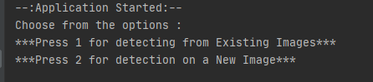

Figure 1:Menu

Option 1: Will ask you to enter the name of the Image without extension, And will show the result as per below.

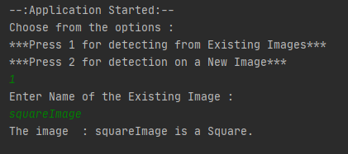

Figure 2:Sub menu Option1

Option 2:

Press 2 for live new Image, A prompt message will appear which ask you the name of the image for which you want to store and after entering the name a new window will appear which ask you to take snap shot using web cam. And algorithm will run on the new image and detect the shape.

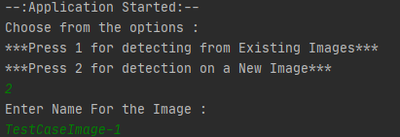

Figure 3:Option 2 enter Name

A new window will open as below.

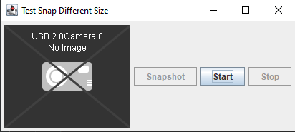

Figure 4:Open Camera

Press Start Button to see the live preview.

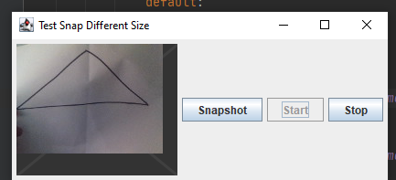

Figure 5:Start Button Click

Press Snapshot Button to take picture, and picture will be save in the directory and will return the name of the shape.

# Demo Test Cases Images

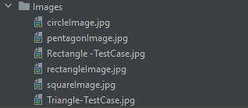

Figure 6:Demo test Cases