Technical Analysis of Model Evaluation Plots



Figure 1: Cluster visualization using dimensionality reduction techniques.

This image illustrates a set of clustered points, likely obtained via a dimensionality reduction technique such as PCA or t-SNE. The separation of these clusters implies effective feature extraction and class discrimination, crucial for classification or anomaly detection tasks.

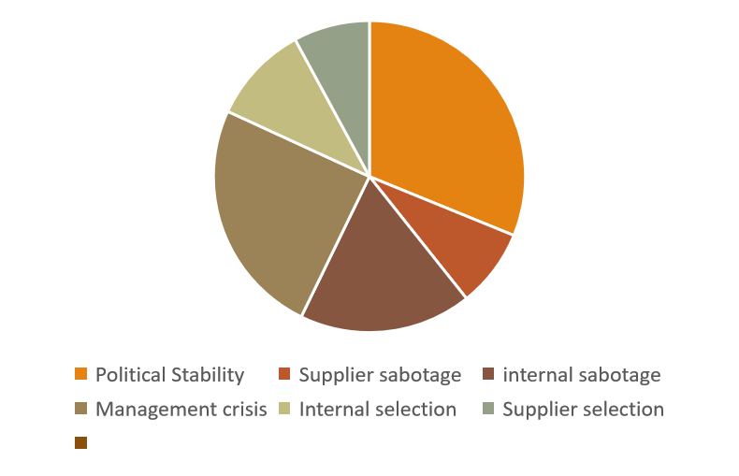

Figure 2: Confusion matrix highlighting classification accuracy.

The figure shows a confusion matrix, a standard evaluation tool for classification algorithms. High diagonal values indicate good classification accuracy, whereas the off-diagonal values reflect misclassification rates.

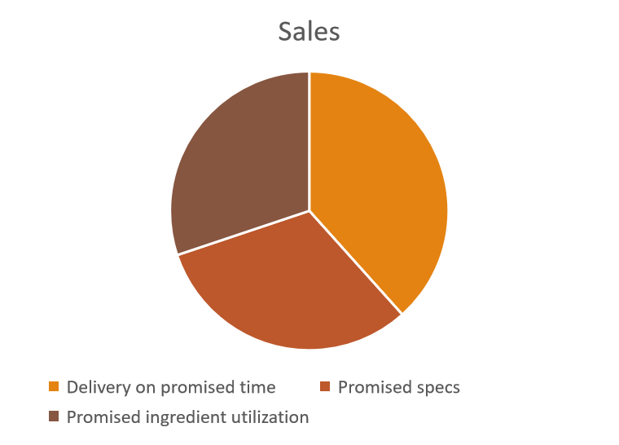

Figure 3: ROC or PR curve showing model performance.

This plot likely displays a ROC or PR curve. A curve closer to the top-left or upper-right corner indicates better classification performance, with AUC quantifying the model's discriminative power.



Figure 4: Bar chart showing performance metrics with error bars.

This image shows a bar graph with error bars, representing metrics across models or experimental setups. Error bars likely denote standard deviation or confidence intervals from multiple runs.

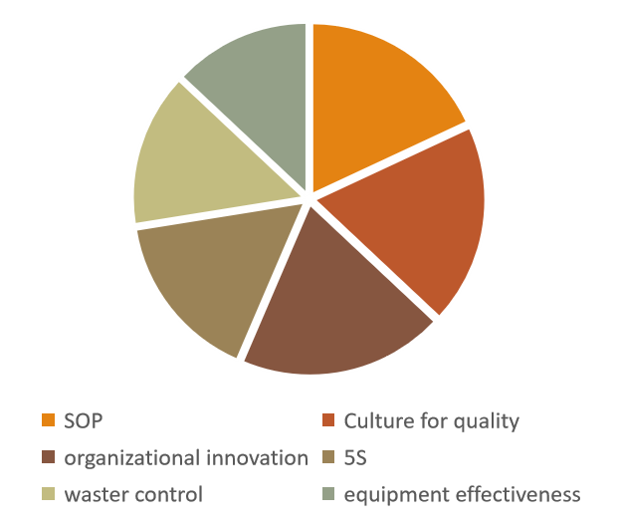

Figure 5: Line plot of training dynamics across epochs.

This image features a line graph with trajectories across epochs or time steps, likely showing loss or accuracy. Convergence behaviors help evaluate model training stability and performance.

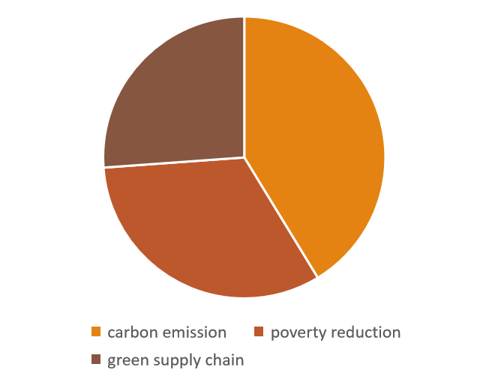

Figure 6: Heatmap matrix representing variable correlations or activations.

This heatmap matrix may represent a correlation matrix, attention map, or activation matrix. The coloration denotes relational strengths between variables, aiding in feature selection and interpretability.



Figure 7: Grouped bar chart comparing model configurations.

This graph compares model accuracy or performance under different feature sets. Grouped bars with color coding suggest evaluations across consistent metrics, common in ablation studies.



Figure 8: Scatter plot of 2D projections from high-dimensional space.

This scatter plot likely shows a 2D projection of high-dimensional data. Well-separated clusters suggest effective feature representation learning by the applied model.

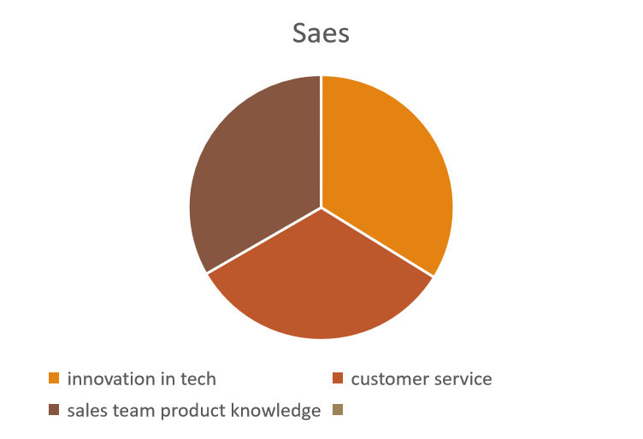

Figure 9: Epoch-wise validation metric progression.

This image shows curve progression over epochs—potentially validation loss or accuracy. The curve behavior reflects model learning dynamics and convergence.

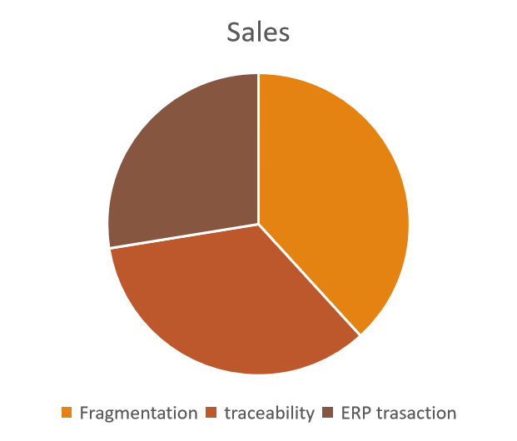

Figure 10: Distribution plot (violin or box) of category-wise values.

The final image depicts a violin or box plot comparing distributions. These plots offer insights into central tendency, spread, and outliers, aiding fairness or robustness evaluation.