D7054E Final Project
Retail Sales, Customer Churn, and Customer Segmentation: A Data-Driven Study
Talha Imran
Data Science Programming (D7054E)
2026

Introduction
This project aims to analyze retail order data to understand and predict sales value, identify customers likely to churn, and segment the customer base into meaningful behavioural groups by applying supervised and unsupervised machine learning techniques.

1. Methodology
This section describes the techniques and procedures followed to address the four problems defined for this project. The workflow was implemented in a single Jupyter Notebook, which allowed code, results, and visualizations to be produced sequentially and reviewed together.
The dataset was downloaded programmatically using the kagglehub library directly within the notebook. This approach retrieves and loads the data automatically, removing the need for a manual download or an external storage step.

1.1 Problems
The project is structured around four clearly defined problems:

1.1.1 Sales Prediction
The first objective is to predict the Sales value of an individual order line from order and product characteristics. Since Sales is a continuous variable, this is formulated as a regression problem. The goal is to quantify how quantity, discount, product category/sub-category, region, and customer segment relate to order value.

1.1.2 Customer Churn Classification
The second objective is to identify customers who have likely stopped purchasing (churned) based on their historical order behaviour. Churn is expressed as a binary label, so this is formulated as a classification problem. The aim is to determine whether Recency, Frequency, and Monetary (RFM) features are sufficient to distinguish churned from active customers.

1.1.3 Customer Segmentation
The third objective is to group customers into behaviourally distinct segments using their RFM features. This corresponds to an unsupervised machine learning problem, using clustering to reveal natural groupings such as high-value customers, regular customers, and lapsed customers, without any predefined labels.

1.1.4 Correlation & Feature Engineering
The fourth objective is to explore the relationships between order-level variables (discount, profit, category) and to engineer new customer-level features (RFM and a derived churn label) that make the classification and clustering problems possible in the first place.

1.2 Notebook Implementation
The project was implemented as a single notebook-based workflow, allowing sequential and interactive execution of the full pipeline, from data loading to visualization and model evaluation. A single lightweight class, DataLoader, is used only for the data-retrieval step while every other stage (cleaning, feature engineering, modelling, and visualization) is implemented as plain, sequential code rather than a larger class hierarchy, since Object-Oriented Programming is explicitly optional in the assignment specification.
Advantages of the notebook-based approach:
- Interactive and linear workflow with immediate feedback.
- Integration of code, outputs, and visualizations in one place.
- No need for a complex project/module structure for a project of this scale.
Disadvantages of the notebook-based approach:
- Less modular than a multi-file project, which can make later reuse harder.
- Potential issues with execution order if cells are not run top to bottom.

1.2.1 Correlation & Feature Engineering
Before model training, the relationships between discount, profit, and product category were examined and formally tested using two hypotheses (see Section 1.6 for the statistical tests used). Based on these insights and the structure of the raw order-level data, a set of new customer-level features was engineered:
- Recency: the number of days between a customer's most recent order and a fixed reference date (one day after the dataset's last recorded order).
- Frequency: the number of distinct orders placed by a customer.
- Monetary: the total Sales value across all of a customer's orders.
- Average Order Value: Monetary divided by Frequency, separating "spends a lot per visit" from "visits often".
- Churned (label): a binary flag, set to 1 when a customer's Recency exceeds a fixed threshold (180 days).

1.2.2 Sales Prediction
Four models suitable for predicting a continuous variable were compared. The data was split 80% training / 20% testing. All four models were trained on identically scaled features (StandardScaler), since scaling does not change Linear Regression's or Random Forest's/Gradient Boosting's predictions, but is required for SGD Regressor to converge reliably.

1. Linear Regression
A simple linear approach that models the relationship between features and the target by minimizing the sum of squared errors.
- Advantages: easy to interpret, fast to train, works well when relationships are approximately linear.
- Disadvantages: poor performance with non-linear relationships, sensitive to outliers.
2. SGD Regressor
Also a linear model, but fitted using iterative gradient descent instead of the closed-form solution.
- Advantages: scales well to very large datasets, flexible loss functions.
- Disadvantages: sensitive to feature scaling and learning-rate/iteration settings, not guaranteed to reach the same optimum as the closed-form solution.
3. Random Forest Regressor
An ensemble method that builds multiple decision trees on random subsets of data and averages their predictions.
- Advantages: handles non-linear relationships and interactions automatically, robust to outliers.
- Disadvantages: less interpretable than linear models, can be slower to train.
4. Gradient Boosting Regressor
An ensemble technique that sequentially builds trees, where each new tree corrects the errors of the previous ones.
- Advantages: typically the highest predictive performance of the four, captures complex non-linear relationships well.
- Disadvantages: more sensitive to hyperparameters, slower to train than Random Forest, can overfit if not regularized.

1.2.3 Customer Churn Classification
Two models were compared for the churn classification task, trained directly on the RFM features (no scaling was applied, since Random Forest is scale-invariant and Logistic Regression's coefficients remain interpretable at the features' natural scale). The data was split 80% training / 20% testing, using stratified sampling to preserve the same churn ratio in both sets. Both models used class_weight="balanced" to account for the imbalance between churned and active customers.
1. Logistic Regression
A linear model for binary classification that estimates the probability of the positive class.
- Advantages: simple, fast, interpretable coefficients.
- Disadvantages: assumes a linear decision boundary between classes.

2. Random Forest Classifier
The classification counterpart of the Random Forest Regressor described above, built from an ensemble of decision trees.
- Advantages: captures non-linear decision boundaries, provides feature importance.
- Disadvantages: less interpretable than logistic regression, can overfit on small datasets if not tuned.

1.2.4 Customer Segmentation
K-Means clustering was applied to the scaled RFM features (Recency, Frequency, Monetary) to identify customer segments. We chose the number of clusters, k, using the elbow method. Because a 2-dimensional scatter plot of only two of the three RFM features can visually hide real separation that exists along the third feature, Principal Component Analysis (PCA) was additionally applied to project all three features into two components for a fairer visual assessment of cluster separation, and a pair plot was produced to examine every pairwise combination of the three features directly.
K-Means Clustering
- Advantages: simple, computationally efficient, works well when clusters are roughly spherical.
- Disadvantages: requires specifying k in advance, sensitive to feature scale and outliers (addressed here via StandardScaler).

1.3 Dataset Description

1.3.1 Sample Superstore Dataset
The dataset used in this study is sourced from Kaggle ("Sample Superstore") and contains 9,994 individual order-line records from a US-based retailer. Each row represents one product line within an order, and the dataset contains 21 columns covering order information, customer information, geography, product information, and financial metrics.
Key feature groups include:
- Order information: Order ID, Order Date, Ship Date, Ship Mode (categorical/date).
- Customer information: Customer ID, Customer Name, Segment (categorical).
- Geography: Country, City, State, Postal Code, Region (categorical).
- Product information: Product ID, Category, Sub-Category, Product Name (categorical).
- Financial metrics: Sales, Quantity, Discount, Profit (continuous/numerical).
The dataset contains no missing values in any column. One duplicate row is documented for this dataset and is removed during preprocessing. For this study, the target variables are Sales (regression) and a derived Churned label (classification), and Recency/Frequency/Monetary is used for clustering.

1.4 Data Cleaning and Preprocessing
Several data quality checks were performed. Column names were converted to lowercase, snake_case for consistency (e.g. "Order Date" to order_date). Order Date and Ship Date were converted from text to proper datetime values, which is required for the recency calculation used later in feature engineering. The dataset was checked for duplicate rows, and the one known duplicate was removed.
Identifier columns (Row ID, Order ID, Customer ID, Customer Name, Product ID, Product Name) were removed before modeling, as they uniquely label a row or entity rather than describing it, and including them risks a model memorizing identities instead of learning generalizable patterns. The remaining features were split into categorical and numerical groups to guide the exploratory analysis. For the regression task, categorical features were one-hot encoded using pd.get_dummies(..., drop_first=True).

1.4.1 Feature Engineering
As described in Section 1.2.1, the RFM features and the churn label were engineered from the cleaned order-level data by aggregating to one row per customer. This is the feature table used for both the classification and clustering tasks.

1.5 Experimental Setup
The experimental environment consisted of a locally run Jupyter Notebook (Python 3.11), using pandas, scikit-learn, scipy, matplotlib, and seaborn. The dataset was retrieved via the Kaggle API through the kagglehub package, which downloads and locally caches the data on first use.

1.5.1 Block Diagram
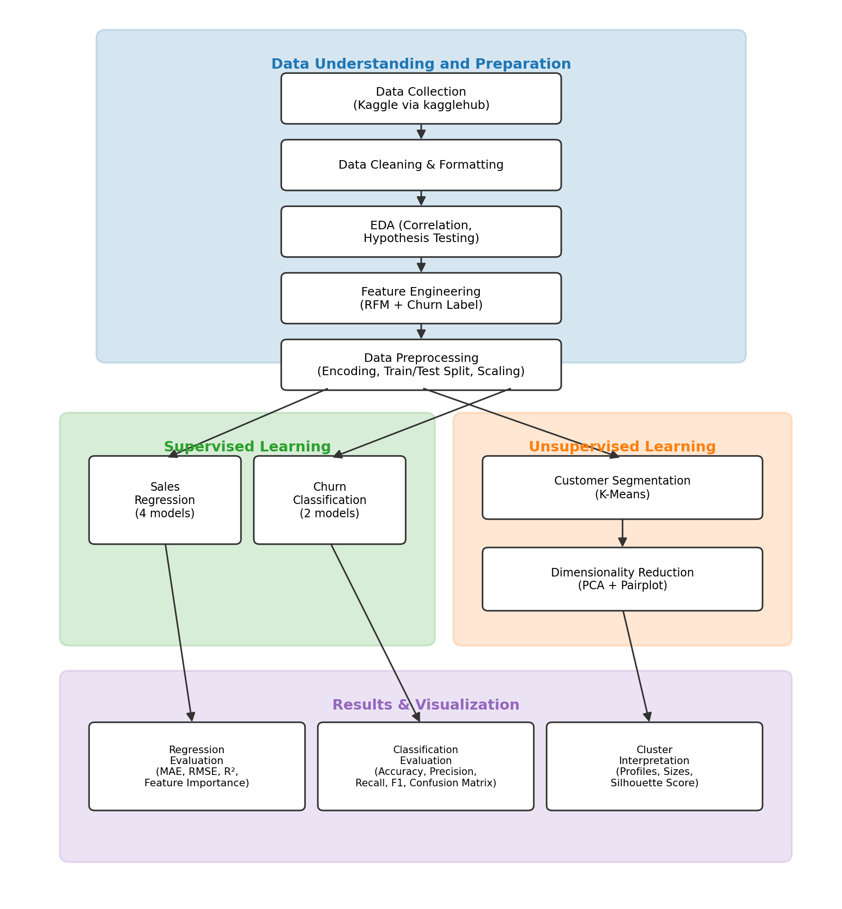
Figure 1: Block diagram of the data science pipeline.
The block diagram illustrates the main components of the pipeline: data understanding and preparation (collection, cleaning, exploratory analysis, feature engineering, and preprocessing), followed by parallel supervised learning (sales regression and churn classification) and unsupervised learning (customer segmentation and dimensionality reduction) branches, which both feed into a shared results and visualization stage. Although the diagram suggests a strictly linear flow, the notebook environment allowed for some non-linear, iterative execution while developing and validating each stage.

1.6 Evaluation Measures
This section describes the evaluation metrics used to assess each stage of the project.

1.6.1 Correlation & Hypothesis Testing
Pearson correlation was used to quantify the linear relationship between discount and profit. A one-way ANOVA (F-statistic) was used to test whether mean profit differs across the three product categories, since this comparison involves three groups rather than two.

1.6.2 Sales Prediction
- Mean Absolute Error (MAE): the average absolute difference between predicted and actual sales, in the same units as the target.
- Root Mean Squared Error (RMSE): penalizes larger errors more heavily than MAE, useful when large deviations are particularly undesirable.
- R² Score: the proportion of variance in Sales explained by the model, values closer to 1 indicate a better fit.

1.6.3 Customer Churn Classification
- Accuracy: the overall proportion of correct predictions.
- Precision, Recall, and F1-score (on the churned class): needed alongside accuracy because the churn label is imbalanced (~74.5% / 25.5%), so accuracy alone could hide a model that rarely predicts churn correctly.
- Confusion Matrix: shows the count of correct and incorrect predictions for each class.

1.6.4 Customer Segmentation
- Elbow Method (inertia vs. k): used to select a reasonable number of clusters.
- Silhouette Score: measures how well-separated the resulting clusters are, from -1 (poor) to 1 (well-separated).

2. Results
The following results were obtained directly from the notebook, which allows each stage's outputs to be presented both as tables and as figures. Interpretation of these results is provided separately in Section 3 (Discussion).

2.1 Exploratory Data Analysis

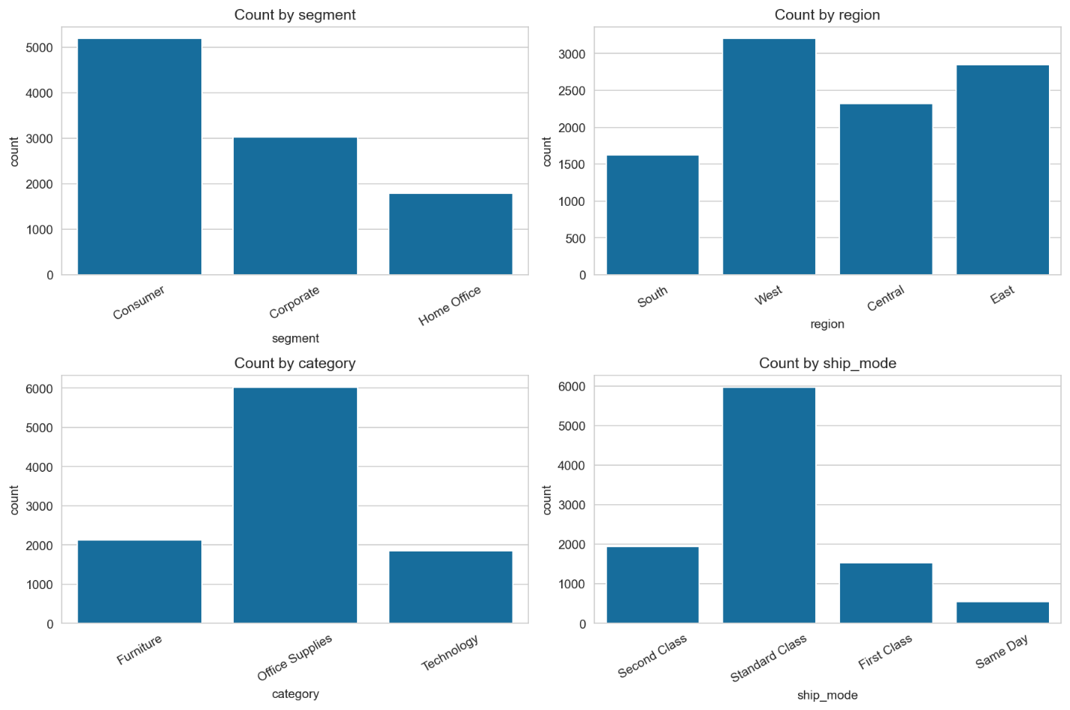

Figure 2: Distribution of key categorical variables (Segment, Region, Category, Ship Mode).
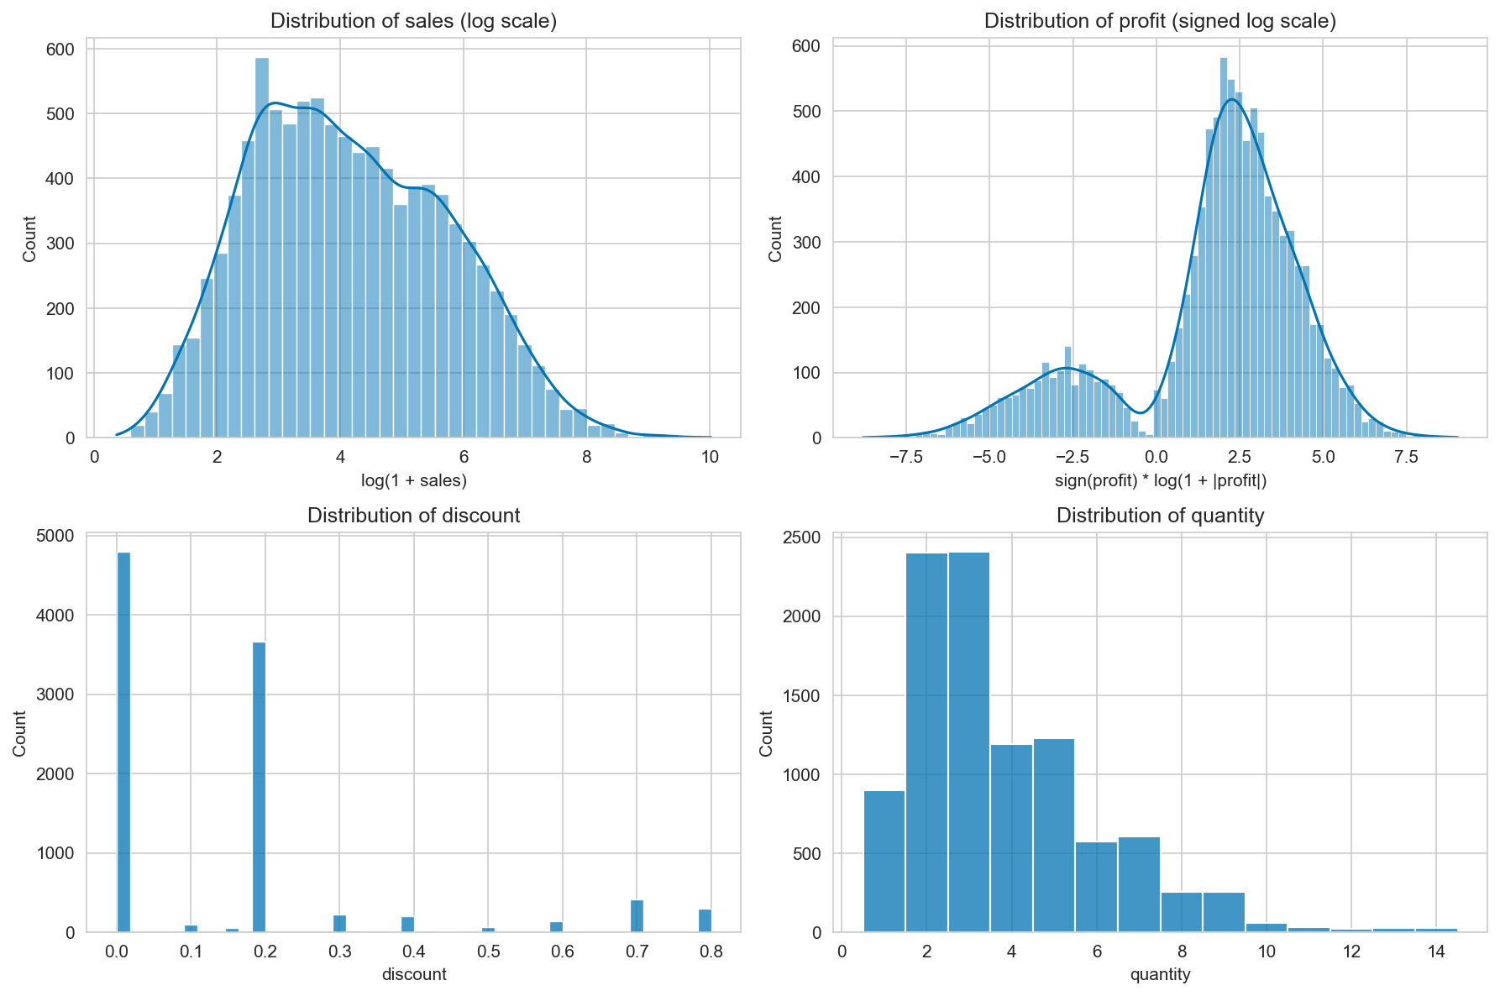
Figure 3: Distribution of key continuous variables, using log-scale transforms for Sales and Profit and discrete histograms for Discount and Quantity.

2.2 Correlation & Feature Engineering
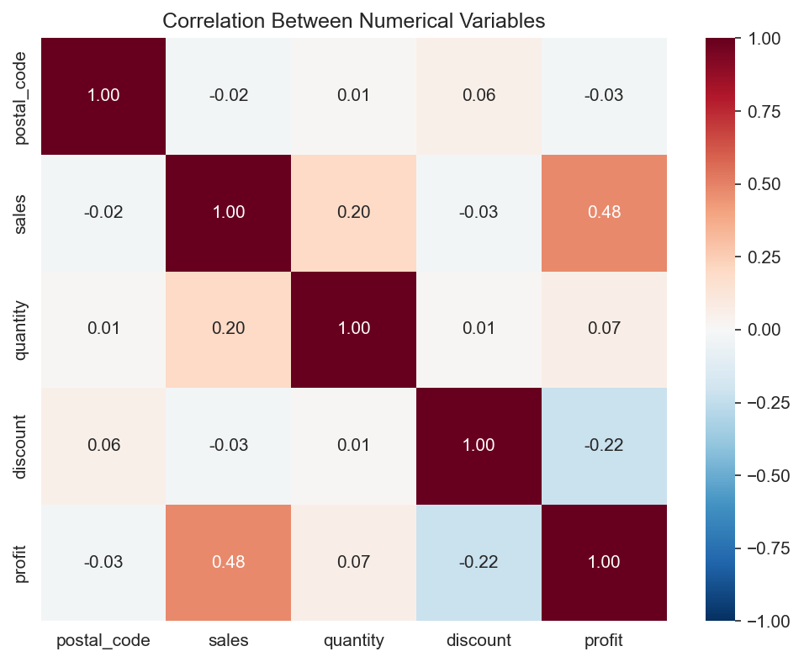
Figure 4: Correlation between numerical variables.
Two hypotheses were formulated and tested:
Hypothesis | Statistic | Statistic Type | p-value
Discount vs Profit | -0.219 | Pearson r | 2.702e-109
Profit by Category | 54.311 | F-statistic | 3.470e-24
Table 1: Hypothesis testing results.

2.3 Sales Prediction
Model | MAE | RMSE | R²
Linear Regression | 226.32 | 693.28 | 0.186
SGD Regressor | 227.38 | 699.83 | 0.171
Random Forest | 211.38 | 689.99 | 0.194
Gradient Boosting | 198.97 | 673.64 | 0.232
Table 2: Sales regression model comparison.
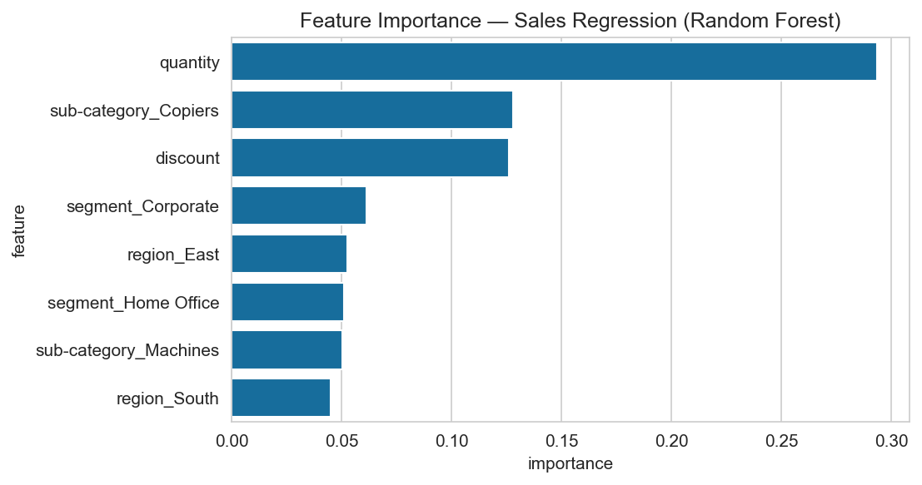
Figure 5: Random Forest feature importance for sales prediction.
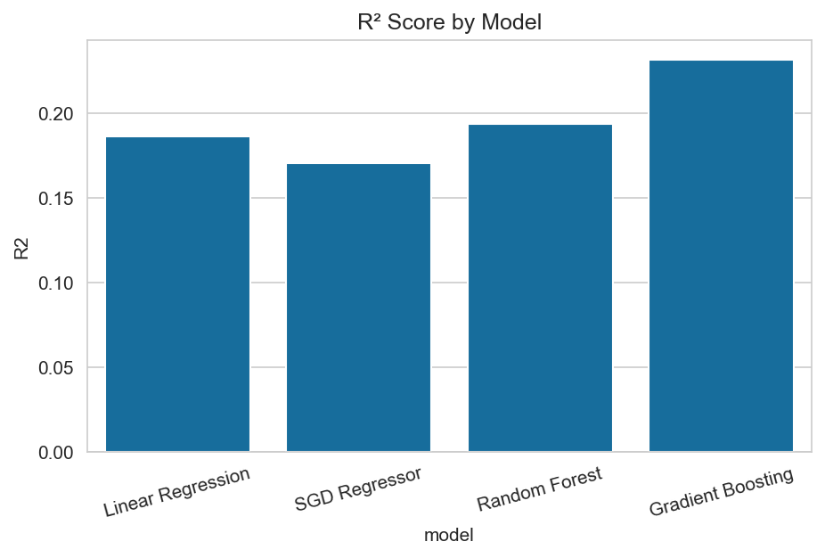
Figure 6: R² score comparison across the four regression models.
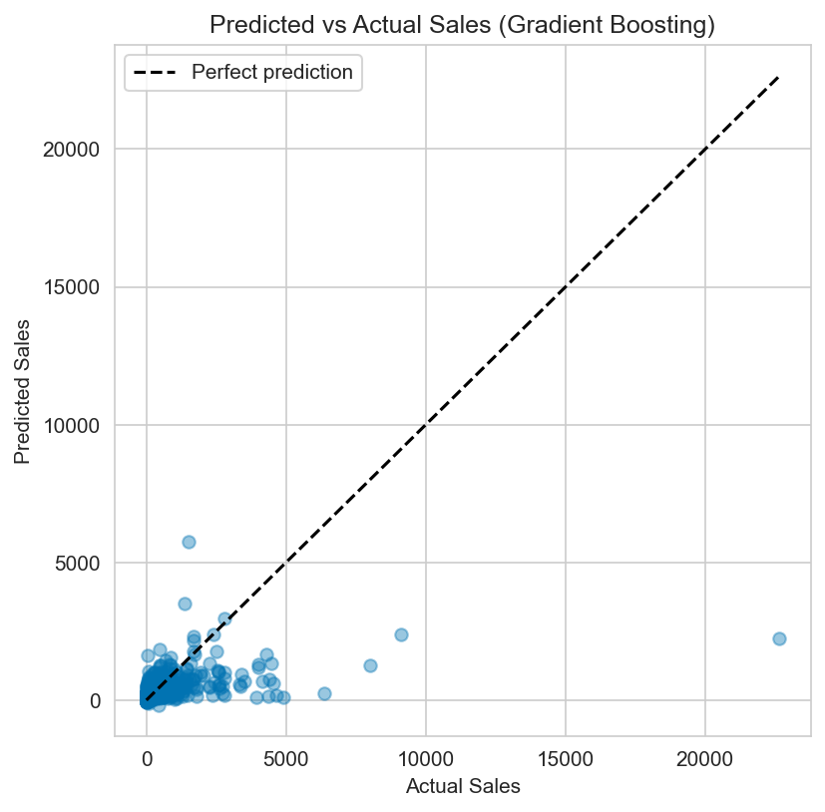
Figure 7: Predicted vs. actual Sales for the best-performing model (Gradient Boosting).

2.4 Customer Churn Classification
Model | Accuracy | Precision | Recall | F1
Logistic Regression | 0.994 | 0.976 | 1.000 | 0.988
Random Forest | 0.994 | 0.976 | 1.000 | 0.988
Table 3: Churn classification model comparison.

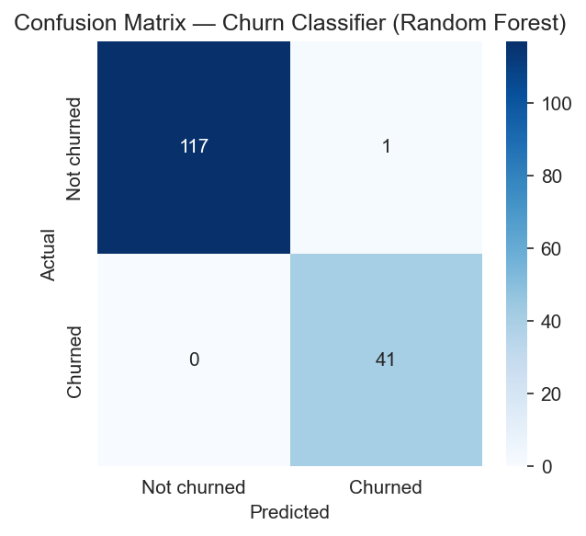
Figure 8: Confusion matrix for the Random Forest churn classifier.
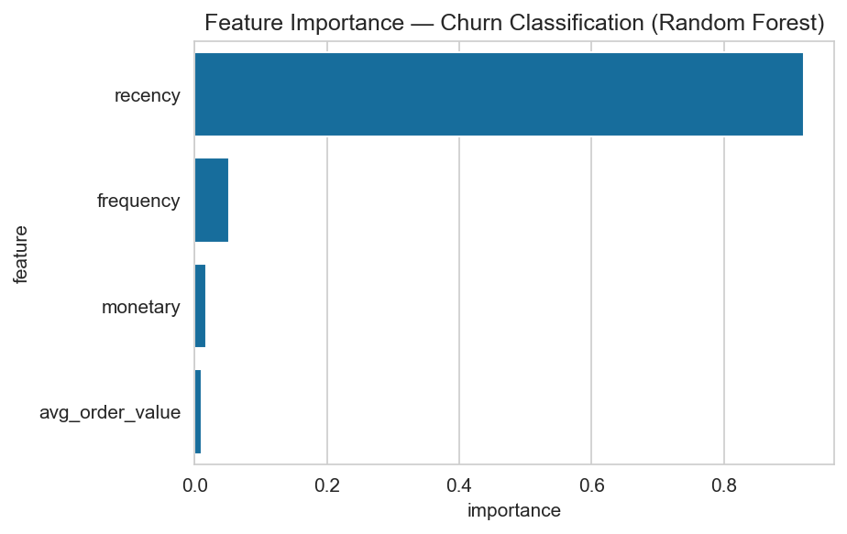
Figure 9: Random Forest feature importance for churn classification.

2.5 Customer Segmentation
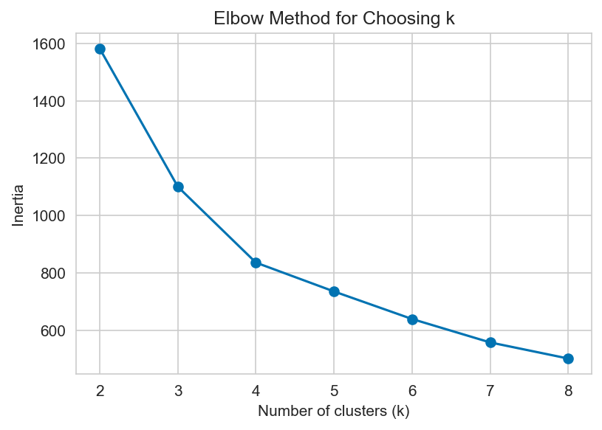
Figure 10: Elbow method for selecting the number of clusters (k).

With k = 4, the resulting silhouette score was 0.355.
Cluster | Recency (days) | Frequency (orders) | Monetary ($)
0 | 72.74 | 8.52 | 3,322.22
1 | 101.20 | 4.73 | 1,669.69
2 | 123.72 | 8.30 | 9,479.55
3 | 559.49 | 3.70 | 1,470.23
Table 4: Mean RFM values per cluster.
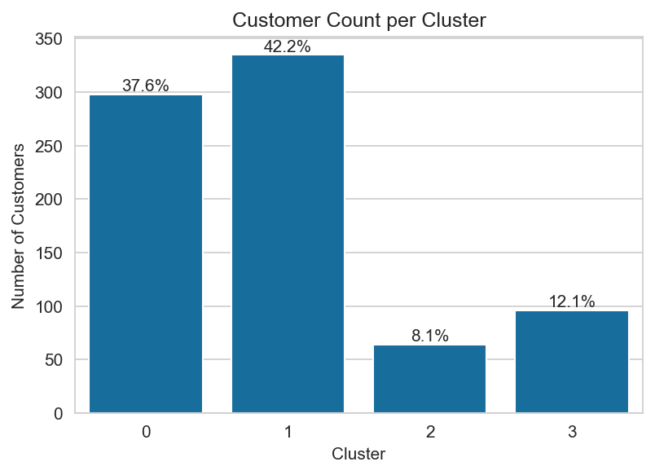
Figure 11: Number and percentage of customers per cluster.
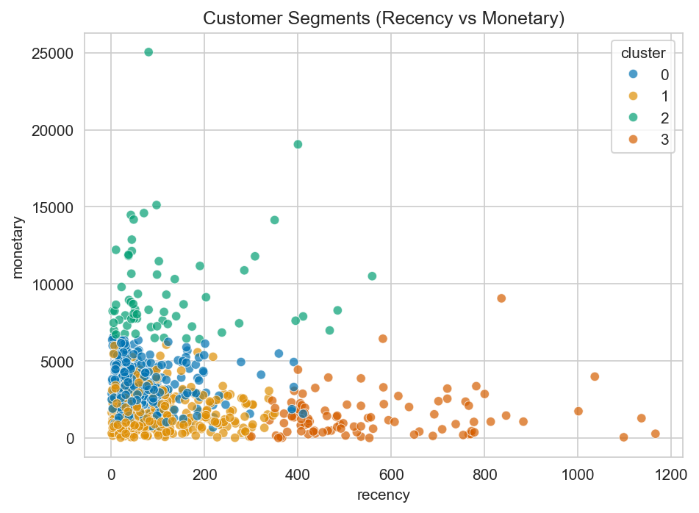
Figure 12: Customer segments plotted on Recency vs. Monetary.
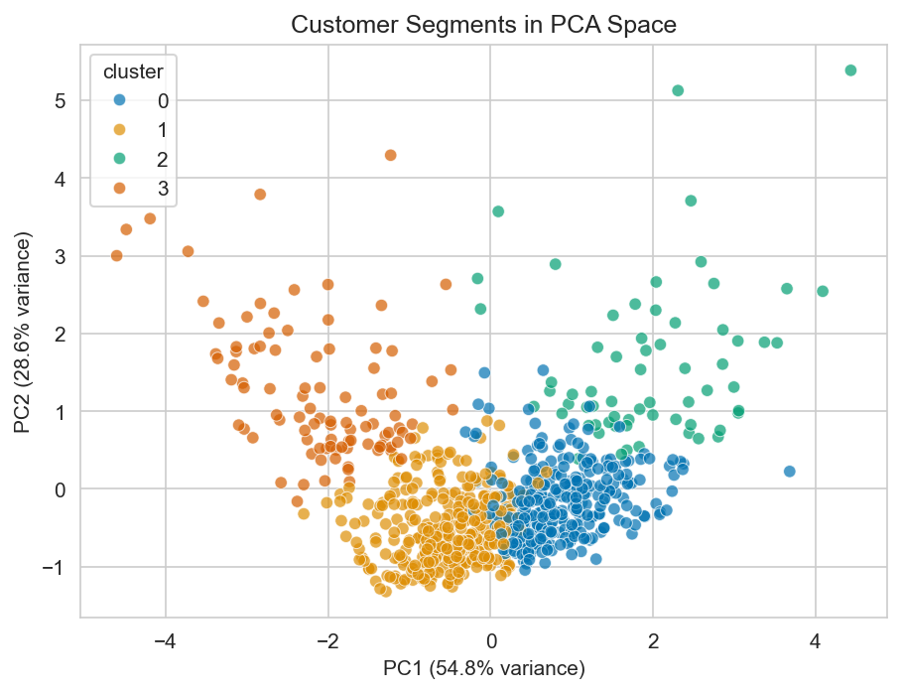
Figure 13: Customer segments projected into 2 principal components (83.4% of variance captured).
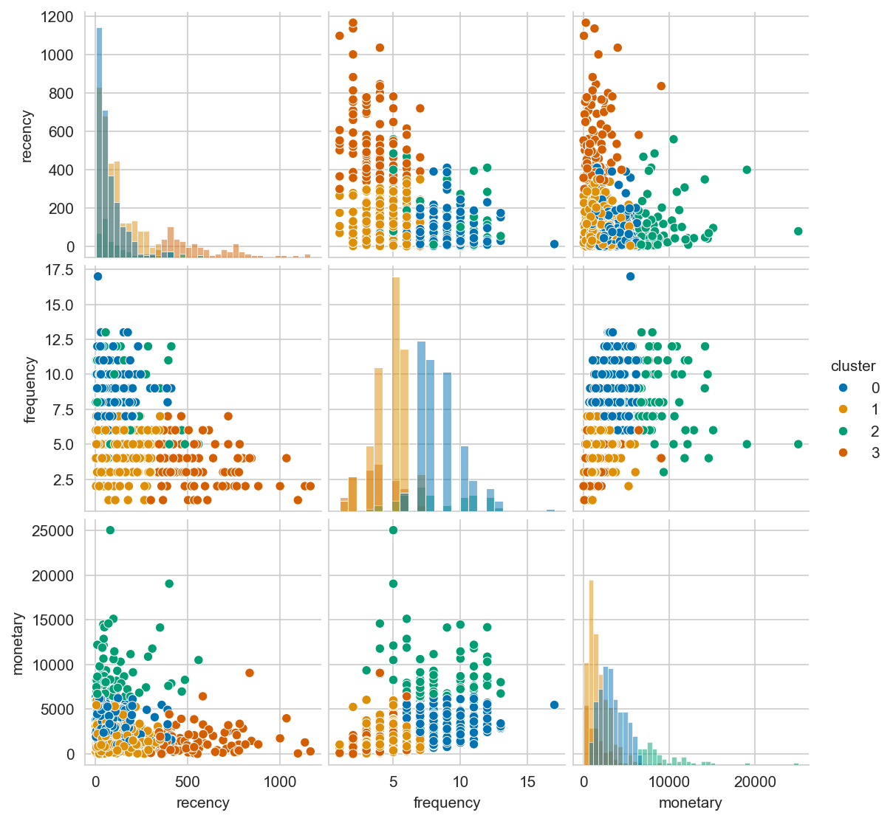
Figure 14: Pairwise relationships between Recency, Frequency, and Monetary, colored by cluster.
Interpretation of clusters:
- Cluster 0 ("loyal regulars"): most recently active (Recency ≈ 73 days), high purchase frequency, moderate spend.
- Cluster 1 ("occasional customers"): moderately recent, noticeably lower purchase frequency and spend than Cluster 0.
- Cluster 2 ("VIP customers"): by far the highest average spend, comparable frequency to Cluster 0, but the smallest group (8.1% of customers).
- Cluster 3 ("lapsed customers"): by far the highest Recency (≈ 559 days), the clearest sign of disengagement, representing 12.1% of customers.

3. Discussion

3.1 Exploratory Data Analysis
Looking at the categorical distributions, my dataset is clearly not balanced. Office Supplies orders outnumber Furniture and Technology combined, Standard Class dominates shipping mode, and most customers fall into the Consumer segment rather than Corporate or Home Office. I think this is worth keeping in mind for the rest of the analysis, since a result based on a small group (like Same Day shipping, which barely appears in the data) is naturally less reliable than one based on a large group.
My first attempt at plotting Sales and Profit on their normal scale was hard to read, since both variables are so skewed that a handful of very large orders made everything else look flat. After switching to a log scale (and a signed log scale for Profit, since it can be negative), I could actually see the shape of the data. What stood out to me is that Profit looks bimodal on this scale and there is a smaller peak around a moderate loss and a larger peak around a moderate profit, rather than everything spreading randomly around zero. That suggests discounting is creating two somewhat distinct groups of orders, rather than just adding noise to profit.

3.2 Correlation & Feature Engineering
Both of my hypotheses came back statistically significant, with very small p-values. Because my sample size is fairly large (9,994 rows), I have to keep in mind that even a modest effect can produce a tiny p-value, so the correlation coefficient itself (-0.219) tells me more about how strong the relationship actually is than the p-value does. The correlation heatmap backs this up and adds a bit more context. Sales and Profit turned out to be my strongest relationship overall (0.48), while Quantity only weakly correlates with Sales (0.20), which surprised me a little, since I expected buying more units to matter more than it apparently does. It seems like which product is bought matters more for order value than how many units are purchased.

3.3 Sales Prediction
Gradient Boosting was the best of my four models (R² = 0.232), but even that is fairly low, my features can only explain a modest part of why Sales values vary. Looking at feature importance helped me understand why Quantity and Discount matter, but a lot of what actually determines an order's price probably comes down to exactly which product was bought, and I don't have that as a feature, only category and sub-category. One thing that caught my attention was that the sub-category Copiers had unusually high importance compared to every other sub-category. My guess is that copiers are priced very differently from typical office supplies, so the model is essentially using that one sub-category as a shortcut for this is an expensive item rather than learning a general pricing rule.
The predicted-vs-actual plot made this limitation a lot clearer to me than the R² number alone did. Almost every point sits below the "perfect prediction" line, especially for the highest-value orders and the model is consistently underpredicting big sales. There is one order in particular (the most expensive one in the whole dataset) where the model predicted a fairly ordinary value even though the actual sale was huge. That tells me the model is decent for typical orders but has basically no way to catch rare, very large ones, since nothing in my features flags an order as unusual in advance.
I also noticed that SGD Regressor actually did slightly worse than plain Linear Regression (R² 0.171 vs. 0.186), which surprised me at first since I assumed a more advanced, iterative method would automatically do better. That is not always true, Linear Regression solves for the exact optimum directly, while SGD Regressor's default settings do not guarantee it converges all the way to that same point.

3.4 Customer Churn Classification
At first glance, both classifiers look extremely good (F1 = 0.988, only one misclassification out of 159 customers), and my first instinct was to just report that as a success. But when I looked at feature importance, Recency alone accounted for 92% of the Random Forest's decisions, and then I remembered that I had actually built the churned label using a 180-day Recency cutoff myself back in Section 1.2.1. So, the model is not really discovering some hidden behavioural pattern, it is mostly just re-learning the exact rule I used to create the label in the first place. I think it is more honest to say this result mainly reflects the way I defined churn, rather than treating the high accuracy as a genuine achievement about predicting customer behaviour from independent signals.

3.5 Customer Segmentation
The elbow plot did not have one obvious sharp bend, it was more of a gradual curve, so choosing k = 4 was a judgment call on my part rather than an exact answer the plot gave me. The resulting silhouette score (0.355) is moderate rather than high, which makes sense to me as real customer data rarely clusters as cleanly as a textbook example would.
Even so, the cluster profiles make sense when I look at them. Cluster 2 (VIP customers) has by far the highest average spend, but it is also my smallest group at only 8.1% of customers, while Clusters 0 and 1 together make up almost 80% of the customer base at noticeably lower spend. Cluster 3 (lapsed customers, 12.1%) stands out with a Recency far higher than any other group, which to me clearly marks it as the customers who have stopped ordering. In my first scatter plot (Recency vs. Monetary), Clusters 0 and 1 looked like they were overlapping, but the pairplot cleared this up, and the frequency-vs-recency panel shows the two clusters are actually well separated by Frequency, which the original two-feature scatter plot never displayed. That was a good reminder that a 2D plot can hide a real difference that exists in a dimension it does not show. The PCA plot, which captured 83.4% of the total variance in just two components, backs this up further, while Clusters 2 and 3 separate out clearly at opposite ends of the plot, matching how different they are in the original RFM table.

4. Conclusion
Working through this project gave me a much more complete picture of what a data science workflow actually involves, beyond just calling fit() and predict(). Cleaning the data, engineering the RFM features, and picking appropriate models required me to keep asking why a result came out the way it did, rather than just reporting a metric and moving on. The modest regression R², the churn classifier's dependence on its own label definition, and the moderate but still interpretable clustering result all needed a second look before I actually understood what they meant.
I also learned something from the process itself, and my first dataset choice (Airbnb listings for New York City) turned out to be a small, incomplete extract with several key columns entirely empty, and my second choice (the full Online Retail II dataset) turned out to be too large to work with comfortably for a project this size. Only after switching to the Superstore dataset did I have something clean and appropriately sized to actually build on. That taught me to check a dataset's completeness and size before committing significant time to modeling it.
Overall, this project let me apply regression, classification, and clustering to one connected business problem, and pushed me to critically read my own results instead of taking a good-looking metric at face value.

References
[1] Sample Superstore Dataset. https://www.kaggle.com/datasets/vivek468/superstore-dataset-final Accessed: 2026-09-26.
[2] GitHub - kagglehub. https://github.com/Kaggle/kagglehub Accessed: 2026-09-25.
[3] What is Linear Regression? https://www.ibm.com/think/topics/linear-regression Accessed: 2026-09-26.
[4] What is Random Forest? https://www.ibm.com/think/topics/random-forest Accessed: 2026-09-26.
[5] What is Gradient Boosting? https://www.ibm.com/think/topics/gradient-boosting Accessed: 2026-09-26.
[6] What is k-means clustering? https://www.ibm.com/think/topics/k-means-clustering Accessed: 2026-09-26.
[7] scikit-learn documentation. https://scikit-learn.org/stable/ Accessed: 2026-09-26.
[8] SciPy stats documentation (pearsonr, f_oneway). https://docs.scipy.org/doc/scipy/reference/stats.html Accessed: 2026-09-26.

