Name: Talha Irfan

CMS ID: 053-24-0013

Receiving Authority: Dr Khursheed Ali

[ Sukkur Institute of Business Administration University ]

Department of Computer Science

Software Quality Engineering

Lab 01

BS - V SOFTWARE ENGINEERING
Fall 2026
SECTION “A”
Instructor: Dr Khursheed Ali
Date : 14_August_2026
Table of Contents
SQE Lab 01 2
GitHub Repository URL: 2
Repository Structure: 2
Overall Structure: 2
Local Repository Structure: 3
GitHub Repository Structure: 3
Three or more issues: 4
GitHub Project Board: 4
README file: 4
Git Command Execution Evidence: 6
Questions & Answers: 7
1. What is Git? 7
2. What is GitHub? 8
3. What is the difference between Git and GitHub? 8
4. Why should .gitignore be used? 8
5. What is an issue in GitHub? 8
6. Why are labels useful for SQE? 8

SQE Lab 01

GitHub Repository URL:
https://github.com/TalhaIrfan-dev/sqe-library-management

Repository Structure:

Overall Structure:
sqe-library-management/
│
├── .github/
│ └── workflows/
│ └── readme.md
│
├── docs/
│ └── SQE_Lab_01_Report.docx
│
├── screenshots/
│ ├── Commands_result/
│ │ ├── git status.png
│ │ ├── git diff.png
│ │ ├── git add.png
│ │ ├── git commit.png
│ │ ├── git log.png
│ │ └── git push.png
│ │
│ ├── commits.png
│ ├── Issues.png
│ ├── Labels.png
│ ├── Project_board.png
│ └── Repository.png
│
├── src/
├── tests/
├── .gitignore
├── LICENSE
└── README.md

Local Repository Structure:
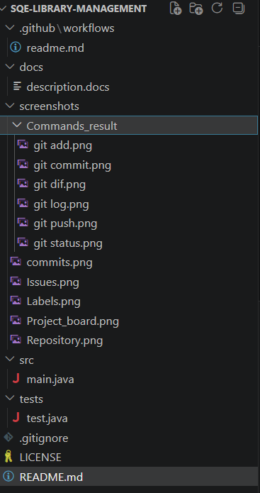

GitHub Repository Structure:
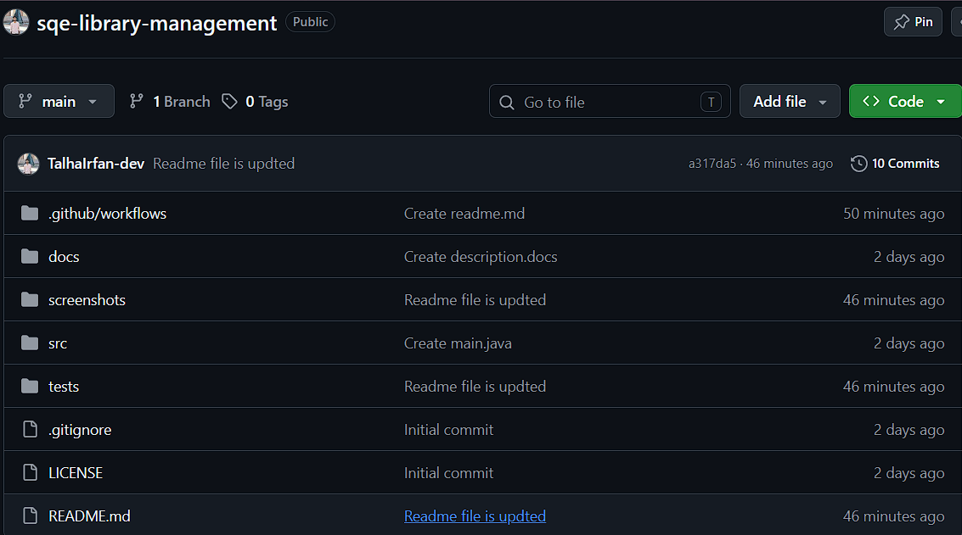

Three or more issues:
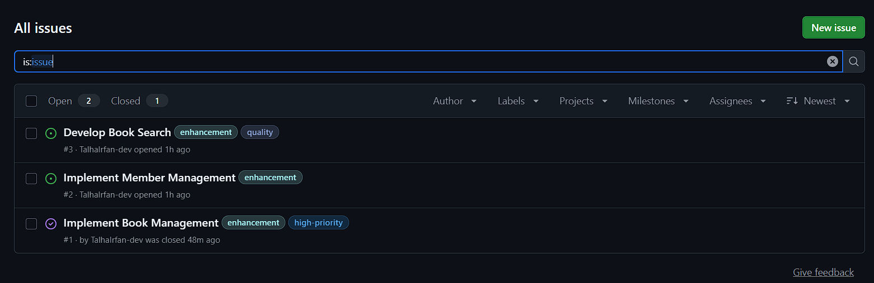

GitHub Project Board:
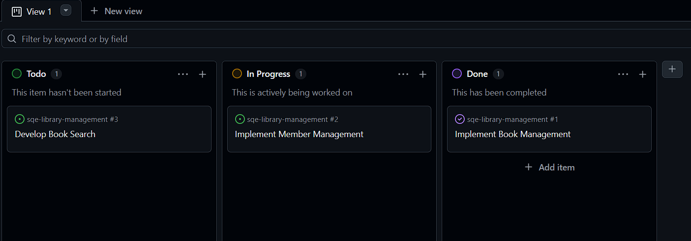

README file:
# SQE Library Management
## Project Description
The **SQE Library Management System** is a software project developed as part of the **Software Quality Engineering (SQE)** course. The project focuses on applying software engineering and software quality practices using a GitHub-based development workflow.
The system is designed to manage basic library operations, including **book management, member management, and book searching**.

## Main Features
* **Book Management** — Add, update, delete, and view book information.
* **Member Management** — Add, update, delete, and view member information.
* **Book Search** — Search for books and check their availability.

## Project Structure
```text
sqe-library-management/
│
├── src/
├── tests/
├── docs/
├── screenshots/
├── .github/
│ └── workflows/
│
├── README.md
├── LICENSE
└── .gitignore
```
## GitHub Project Management
GitHub is used for version control and project management. The project includes GitHub Issues for tracking tasks, labels for categorizing issues, and a GitHub Project board for monitoring task progress.

## Project Objective
The objective of this project is to practice software quality activities within a professional GitHub-based development workflow, including version control, issue tracking, testing, documentation, and project management.
---
## 👨‍💻 Author
**Talha Irfan**
BS Software Engineering
Sukkur IBA University

Git Command Execution Evidence:
The required Git tasks were performed successfully during the lab. The screenshots below provide evidence of the commands executed and their corresponding results, including git status, git diff, git add, git commit, git log, and git push. The complete set of command screenshots is also available in the screenshots/Commands_result/ folder of the GitHub repository.

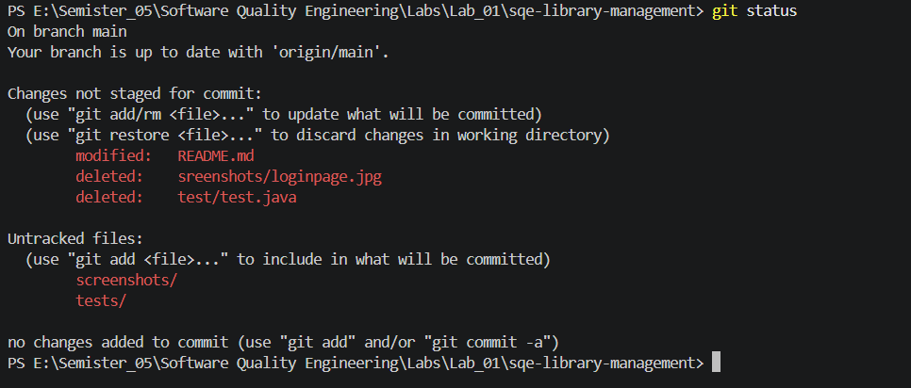
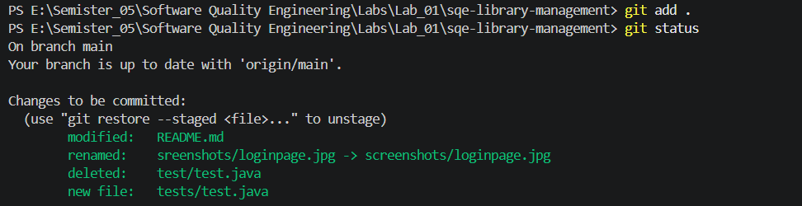
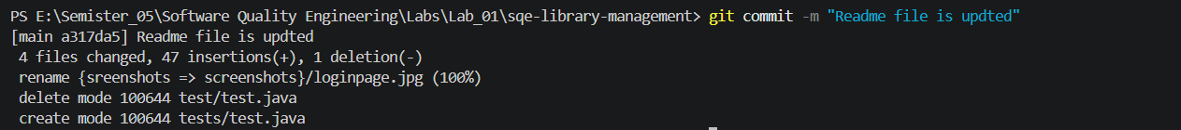
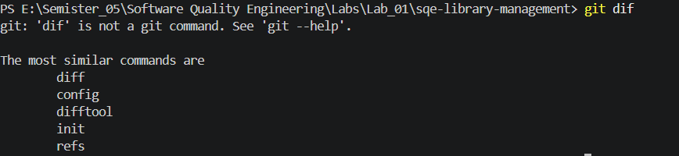
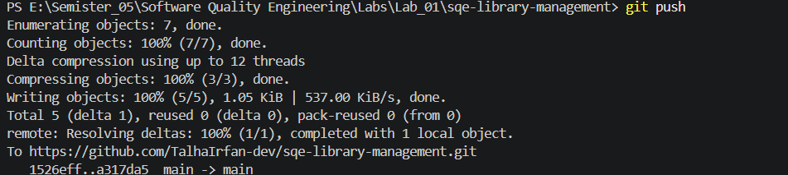
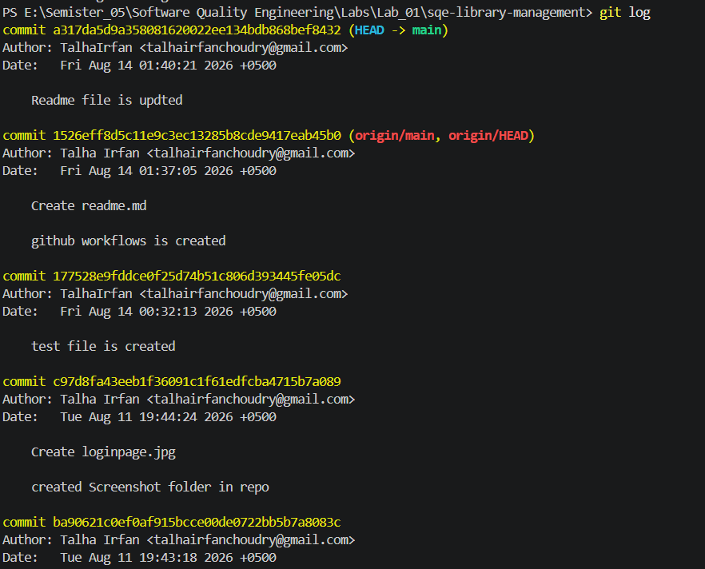

Questions & Answers:

What is Git?
Git is a distributed version control system used to track changes in source code and other project files. It allows developers to save different versions of their work, create branches, make commits, and return to previous versions when needed.

What is GitHub?
GitHub is an online platform that hosts Git repositories. It allows developers to store their projects online, collaborate with others, manage issues, review code, and track project development.

What is the difference between Git and GitHub?
Git and GitHub are related but different. Git is a version control system that is primarily used on a local computer to track and manage changes in a project. GitHub is an online platform that hosts Git repositories and provides additional collaboration and project management features.
For example, Git is used to create commits and manage branches locally, while GitHub can be used to store the repository online, create Issues, manage Projects, and collaborate with other developers.

Why should .gitignore be used?
The .gitignore file is used to specify files and directories that Git should not track or upload to the repository. It helps keep the repository clean by excluding unnecessary files such as temporary files, compiled files, IDE-specific files, and sensitive configuration files.
For example, files such as .class files, build directories, and environment configuration files can be included in .gitignore.

What is an issue in GitHub?
A GitHub Issue is a tool used to record and track tasks, bugs, features, improvements, or other work related to a project. Issues help developers organize project work and monitor its progress.
For example, in this project, Issues were created for Implement Book Management (this issue was labeled as high priority means it should be handled first), Implement Member Management, and Develop Book Search.

Why are labels useful for SQE?
Labels are useful in Software Quality Engineering because they help categorize and organize GitHub Issues according to their type, priority, or purpose. They make it easier to identify and manage different types of project activities.
For example, labels such as bug, enhancement, testing, documentation, high-priority, and quality can be used to classify and track different issues in the project.

THE END

