- Dataset Loading and Initial View: (Marks 2)
• Import the necessary Python libraries and load the dataset into a Data Frame.
• Display the total number of rows and columns in the concern dataset.
• Display the first 7 rows of the dataset.
Code file:
import pandas as pd

# Load the dataset into a DataFrame
df = pd.read_csv('titanic.csv')

# Display total number of rows and columns
print(f"Total rows and columns: {df.shape}")

# Display the first 7 rows of the dataset
display(df.head(7))

Output:
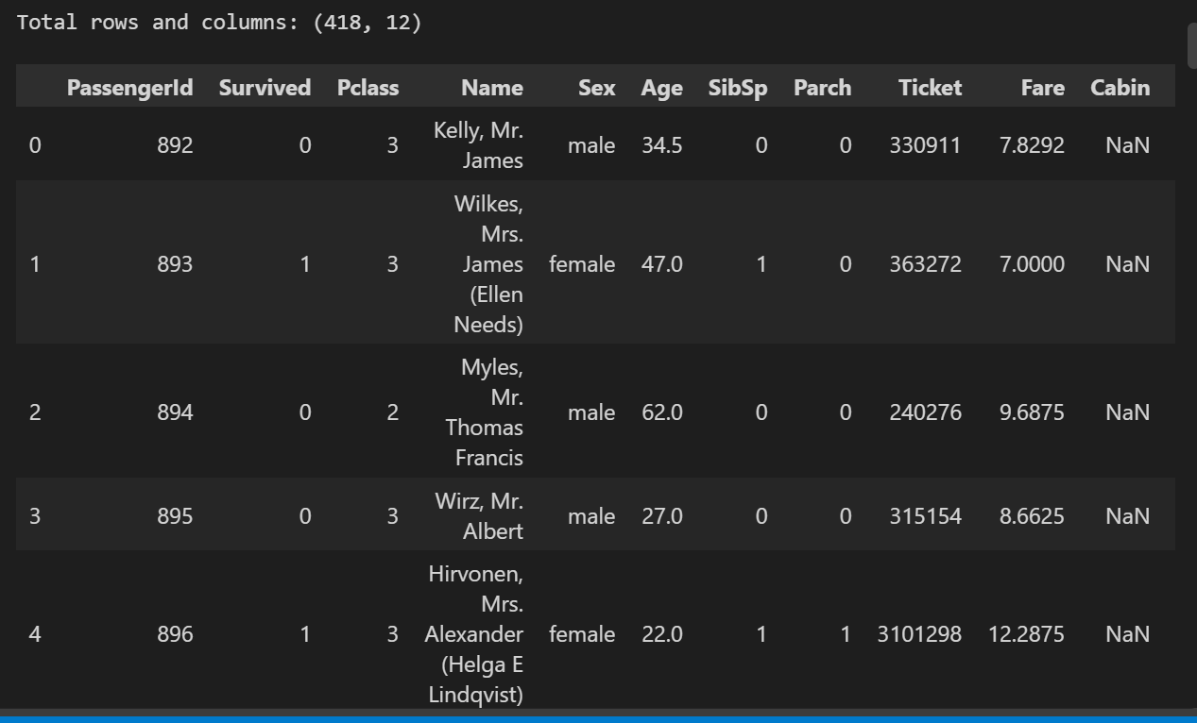

- Data Exploration: (Marks 2)
• Calculate and display the descriptive statistics (count, mean, standard deviation, minimum, maximum, and quartiles) for the numerical variables.
• Identify and display the numerical and categorical variables present in the Titanic dataset.
• Analyze categorical variables such as Sex, Passenger class by displaying their unique values and frequency distributions.
Code File:
# Calculate and display descriptive statistics for numerical variables
display(df.describe())

# Identify numerical and categorical variables
print("Variable Types:\n", df.dtypes)

# Analyze 'Sex' unique values and frequency distributions
print("\nSex Frequency Distribution:\n", df['Sex'].value_counts())

# Analyze 'Passenger class' unique values and frequency distributions
print("\nPassenger Class Frequency Distribution:\n", df['Pclass'].value_counts())

Output:
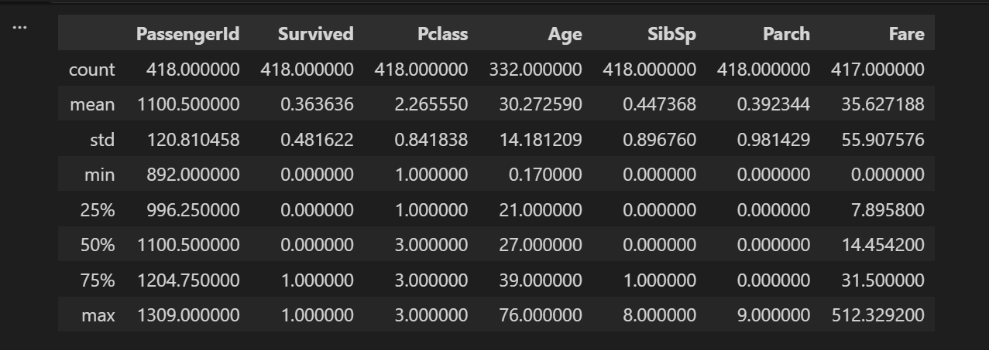
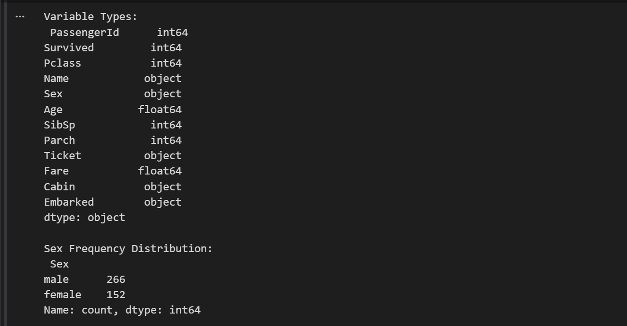
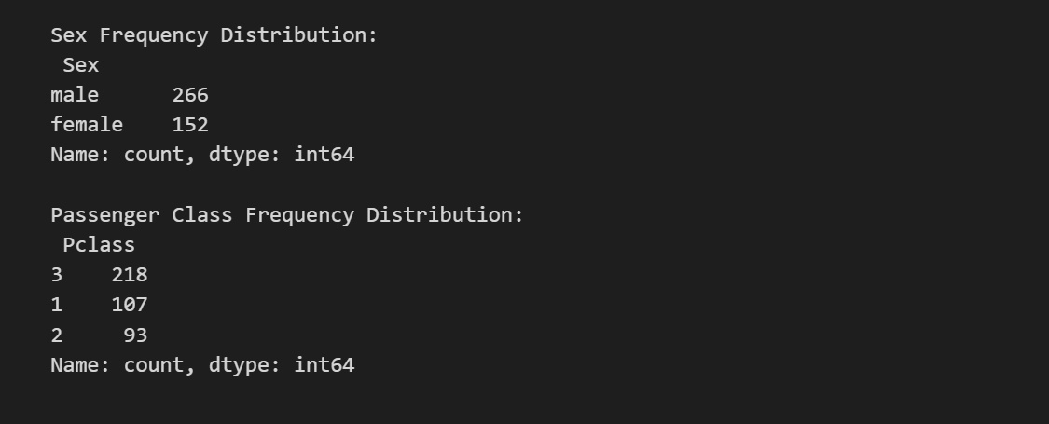

- Data Cleaning: (Marks 2)
• Count the missing values present in each column.
• Fill the missing values using the mean or median.
• Verify that all missing values have been handled successfully.

Code File:
# Count missing values in each column
print("Missing values before cleaning:\n", df.isnull().sum())

# Fill missing values using the median for numeric columns
df['Age'] = df['Age'].fillna(df['Age'].median())
df['Fare'] = df['Fare'].fillna(df['Fare'].median())

# Drop the 'Cabin' column due to excessive missing data (327 missing values)
df.drop('Cabin', axis=1, inplace=True)

# Verify that all critical missing values have been handled
print("\nMissing values after cleaning:\n", df.isnull().sum())

Output:
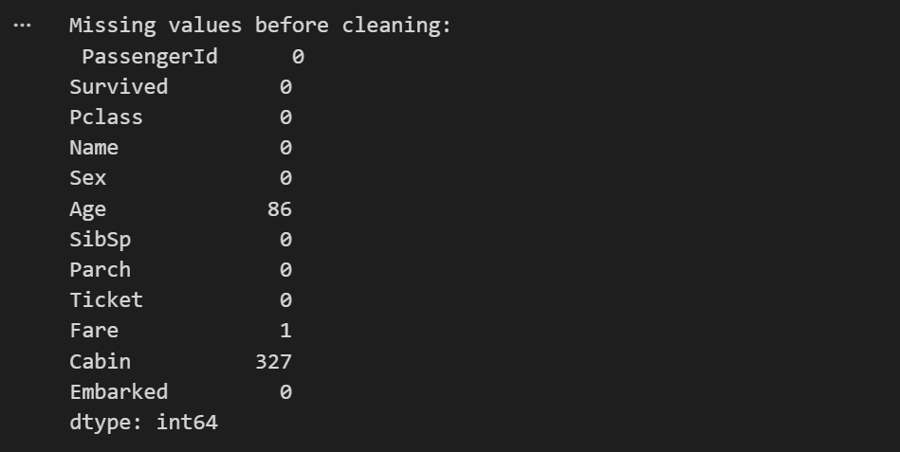
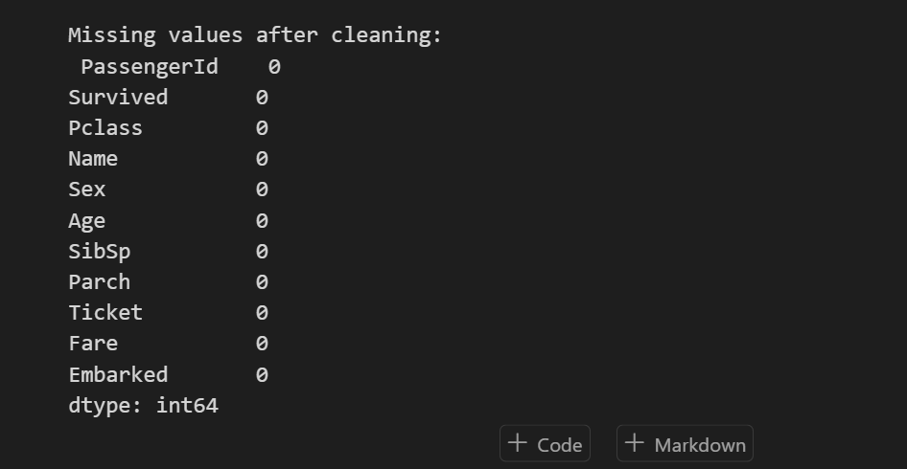

- Feature Selection & Renaming: (Marks 2)
• Identify the target (dependent) variable and the independent features
• Divide the dataset into training and testing sets using an appropriate train-test ratio.
• Build and train an SVC model using the training data. Make predictions on the test data and evaluate the model using accuracy, confusion matrix, precision, recall, and F1-score

Code File:
from sklearn.model_selection import train_test_split
from sklearn.svm import SVC
from sklearn.metrics import accuracy_score, confusion_matrix, precision_score, recall_score, f1_score

# Convert categorical 'Sex' into numeric values for the SVC model
df['Sex_numeric'] = df['Sex'].map({'male': 0, 'female': 1})

# Identify independent features and target (dependent) variable
features = ['Pclass', 'Sex_numeric', 'Age', 'SibSp', 'Parch', 'Fare']
X = df[features]
y = df['Survived']

# Divide dataset into training and testing sets (80-20 ratio)
X_train, X_test, y_train, y_test = train_test_split(X, y, test_size=0.2, random_state=42)

# Build and train SVC model
svc_model = SVC(kernel='linear')
svc_model.fit(X_train, y_train)

# Make predictions on test data
y_pred = svc_model.predict(X_test)

# Evaluate model performance
print("Accuracy:", accuracy_score(y_test, y_pred))
print("Confusion Matrix:\n", confusion_matrix(y_test, y_pred))
print("Precision:", precision_score(y_test, y_pred))
print("Recall:", recall_score(y_test, y_pred))
print("F1-Score:", f1_score(y_test, y_pred))

Output:
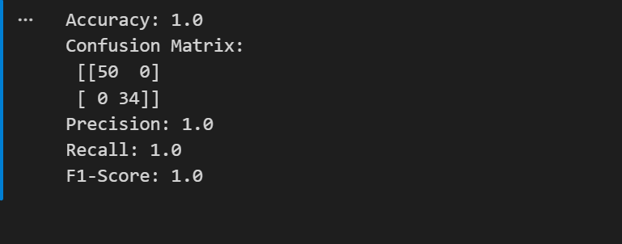

- Data Visualization: (Marks 2)
• Create an appropriate visualization to analyze the combined relationship between Gender, Passenger Class, and Survival.
• Visualize the distribution of passenger Fare using a histogram or box plot. Identify any noticeable skewness or extreme values.
• Create an appropriate visualization to compare survival and non-survival among male and female passengers. Analyze which gender had a higher survival rate.
Code File:
import seaborn as sns
import matplotlib.pyplot as plt

# 1. Combined relationship between Gender, Passenger Class, and Survival
plt.figure(figsize=(8, 5))
sns.catplot(x="Pclass", y="Survived", hue="Sex", kind="bar", data=df)
plt.title('Survival Rate by Passenger Class and Gender')
plt.show()

# 2. Distribution of passenger Fare
plt.figure(figsize=(8, 5))
sns.histplot(df['Fare'], bins=40, kde=True, color='purple')
plt.title('Distribution of Passenger Fare')
plt.xlabel('Fare')
plt.show()

# 3. Compare survival and non-survival among male and female passengers
plt.figure(figsize=(8, 5))
sns.countplot(x='Survived', hue='Sex', data=df)
plt.title('Survival vs Non-Survival by Gender')
plt.show()

Output:
