Section_19: MiddleWare
Introduction to Middleware:
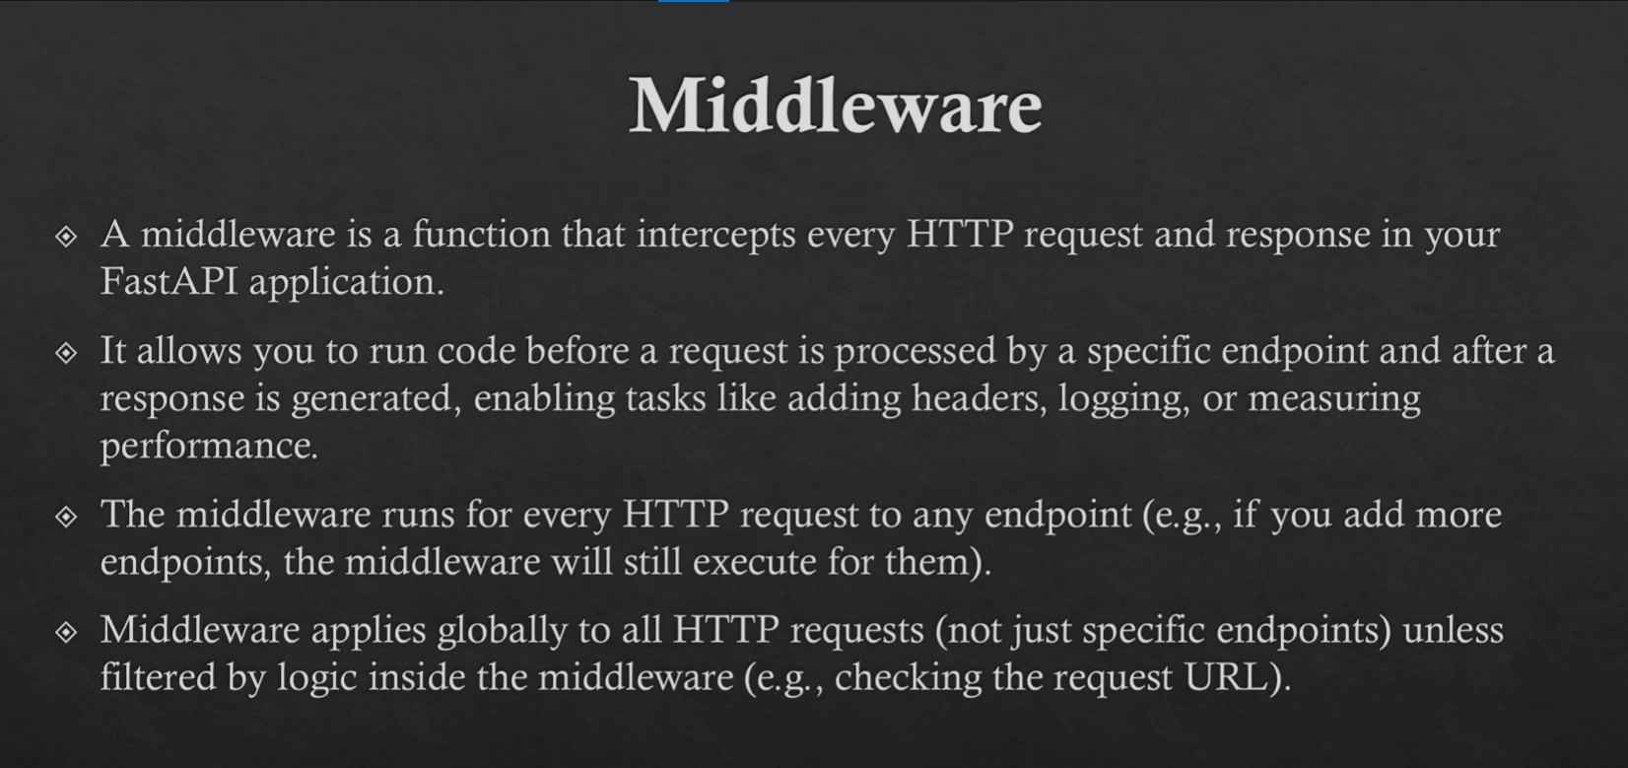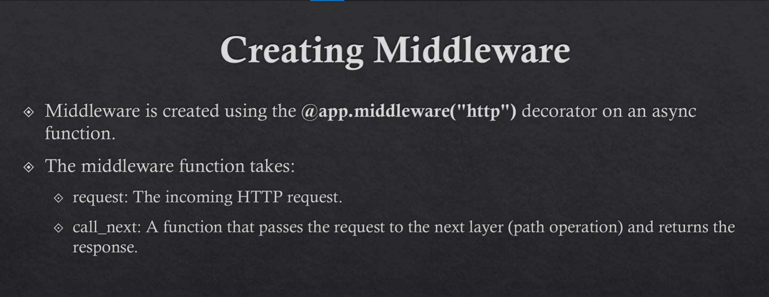

Create Middleware (Chapter 72)

What is Middleware?
Middleware is a function that runs before and after every request in a FastAPI application.
It sits between the client request and the endpoint.
Flow:
Client Request → Middleware (Before) → Endpoint → Middleware (After) → Client Response
Middleware is commonly used for:
- Logging requests
- Authentication / API key validation
- Measuring performance
- Adding custom headers
- Handling security checks

Project Setup

Step 1: Install FastAPI
pip install "fastapi[standard]"

Step 2: Create Project Structure
Create the following folder structure:
app/
│
├── __init__.py
└── main.py

Creating a Middleware
In main.py
from fastapi import FastAPI, Request

app = FastAPI()
#Creating middleware
@app.middleware("http")
async def my_first_middleware(request: Request, call_next):

print("Middleware: Before processing the request")
print(f"Request: {request.method} {request.url}")

response = await call_next(request)

print("Middleware: After processing the request, before returning response")
print(f"Response status code: {response.status_code}")

return response

Explanation of Middleware Code
@app.middleware("http")
Registers a middleware that runs for all HTTP requests.

request: Request
Contains details about the incoming request such as:
- Method (GET, POST, etc.)
- URL
- Headers
- Query parameters
Example:
request.method
request.url
request.headers

call_next(request)
This passes the request to the next step in the chain, which is usually the endpoint function.
response = await call_next(request)
Without this line, the request will never reach the endpoint.

response
After the endpoint finishes execution, the response comes back through the middleware where we can:
- Modify it
- Log it
- Add headers

Example Endpoints
@app.get("/users")
async def get_users():
print("Endpoint inside get_users")
@app.get("/product")
async def get_product():
print("Endpoint inside get_product")

Running the Application
Run the FastAPI development server:
fastapi dev main.py
Server will start at:
http://127.0.0.1:8000
API Documentation:
http://127.0.0.1:8000/docs

Middleware Execution Example
When you open:
http://127.0.0.1:8000/docs
Console output:
Middleware: Before processing the request
Request: GET http://127.0.0.1:8000/docs
Middleware: After processing the request, before returning response
Response status code: 200

When you call:
GET /users
Console output:
Middleware: Before processing the request
Request: GET http://127.0.0.1:8000/users

Endpoint inside get_users

Middleware: After processing the request, before returning response
Response status code: 200

When you call:
GET /product
Console output:
Middleware: Before processing the request
Request: GET http://127.0.0.1:8000/product

Endpoint inside get_product

Middleware: After processing the request, before returning response
Response status code: 200

Important Middleware Use Cases
Middleware can be used for:

1️ API Key Validation
api_key = request.headers.get("x-api-key")
Validate API keys before the request reaches the endpoint.

2️ Authentication / Login Checking
Verify if the user is authenticated before accessing protected routes.

3️ Request Logging
Log every request for monitoring and debugging.
Example:
GET /users
POST /login
DELETE /product

4️ Performance Monitoring
Measure request processing time.
Example:
Start Time
End Time
Total Processing Time

5️ Adding Custom Headers
Example:
response.headers["X-App-Version"] = "1.0"

Best Practices for Middleware

⚠️ Avoid Heavy Tasks
Middleware runs for every request, so heavy operations will slow down your API.
Avoid:
- Large database queries
- Long computations
- Heavy file operations

✅ Good Middleware Tasks
Use middleware for lightweight operations, such as:
- Logging
- Authentication checks
- Request validation
- Adding headers
- Measuring performance

Summary
- Middleware executes before and after every request
- It can inspect and modify requests and responses
- call_next(request) passes the request to the endpoint
- Avoid heavy tasks inside middleware to keep the API fast

Chapter 73 — Multiple Middleware and Execution Order

What is Multiple Middleware?
FastAPI allows us to create multiple middleware functions in the same application.
Each middleware processes the request in sequence before it reaches the endpoint and again after the endpoint returns a response.

Middleware Execution Order
When multiple middleware are defined:

Request Phase
Middleware executes from bottom → top

Response Phase
Middleware executes from top → bottom
This creates a stack (layer) behavior similar to wrapping functions.
Request Flow

Client
↓
2nd Middleware (Before)
↓
1st Middleware (Before)
↓
Endpoint
Response Flow

Endpoint
↓
1st Middleware (After)
↓
2nd Middleware (After)
↓
Client

This pattern is called the Middleware Stack.

Example: Multiple Middleware

main.py
from fastapi import FastAPI, Request

app = FastAPI()

# First Middleware
@app.middleware("http")
async def my_first_middleware(request: Request, call_next):
print("1st Middleware: Before processing the request")

response = await call_next(request)

print("1st Middleware: After processing the request, before returning response")
return response

# Second Middleware
@app.middleware("http")
async def my_second_middleware(request: Request, call_next):
print("2nd Middleware: Before processing the request")

response = await call_next(request)

print("2nd Middleware: After processing the request, before returning response")
return response

@app.get("/users")
async def get_users():
print("Endpoint inside get_users")

Running the Server
Start the development server:
fastapi dev main.py

Server URL:
http://127.0.0.1:8000
API Docs:
http://127.0.0.1:8000/docs

Testing the Endpoint
Call the endpoint:
GET /users
Example:
http://127.0.0.1:8000/users

Console Output
2nd Middleware: Before processing the request
1st Middleware: Before processing the request

Endpoint inside get_users

1st Middleware: After processing the request, before returning response
2nd Middleware: After processing the request, before returning response

Understanding the Execution Order

Step-by-step execution:

1️⃣ Request arrives
The last defined middleware executes first
2nd Middleware (Before)

2️⃣ Next middleware executes
1st Middleware (Before)

3️⃣ Endpoint runs
Endpoint inside get_users

4️⃣ Response travels back
Response passes through middleware in reverse order
1st Middleware (After)

5️⃣ Final middleware executes
2nd Middleware (After)

Visual Representation
Client Request
↓
2nd Middleware (Before)
↓
1st Middleware (Before)
↓
Endpoint
↓
1st Middleware (After)
↓
2nd Middleware (After)
↓
Client Response

Important Notes

1️ Middleware acts like layers
Each middleware wraps around the next middleware or endpoint.

2️ Order of definition matters
The middleware written last in the code runs first for incoming requests.
Example order in code:
1st middleware
2nd middleware
Execution order:
Request → 2nd → 1st → Endpoint
Response → 1st → 2nd

3️ Always call call_next(request)
Without this line:
response = await call_next(request)
The request will never reach the endpoint.

Common Real-World Middleware Order
In real production APIs the order often looks like:
1. Logging Middleware
2. Authentication Middleware
3. Rate Limiting Middleware
4. Performance Monitoring Middleware
5. Endpoint

Summary
- FastAPI supports multiple middleware
- Middleware executes like a stack
- Request phase → bottom to top
- Response phase → top to bottom
- The last defined middleware runs first

Chapter 74 — Separate Middleware File

1. Why Separate Middleware Files?
In large applications, it is not recommended to write everything inside main.py.
Instead, we separate middleware into its own file to keep the project:
- Clean
- Organized
- Scalable
- Easy to maintain

Common Practice in Large Projects
In many projects (similar to Django-style structure):
users/
middlewares.py
products/
middlewares.py
orders/
middlewares.py

Each module manages its own middleware logic.

Current Approach (Simpler Structure)
For now, we create a single middleware file inside the app folder.

2. Application Folder Structure
app/
│
├── __init__.py
├── main.py
└── middlewares.py

File Purpose
File | Purpose
__init__.py | Makes the folder a Python package
main.py | Entry point of FastAPI application
middlewares.py | Contains all middleware functions

3. Creating Middleware File

File: middlewares.py
from fastapi import Request

# First Middleware
async def my_first_middleware(request: Request, call_next):
print("1st Middleware Before processing the request")

response = await call_next(request)

print("1st Middleware After processing the request")
return response

# Second Middleware
async def my_second_middleware(request: Request, call_next):
print("2nd Middleware Before processing the request")

response = await call_next(request)

print("2nd Middleware After processing the request")
return response

4. Understanding Middleware Components

Request
request: Request
Represents the incoming HTTP request.
It contains:
- headers
- body
- query parameters
- cookies
- request metadata

call_next
response = await call_next(request)
This function:
- Passes the request to the next middleware
- Eventually reaches the endpoint
- Returns the response
Flow:
Middleware → Middleware → Endpoint → Middleware → Middleware

5. Registering Middleware in FastAPI

File: main.py
from fastapi import FastAPI
from app.middlewares import my_first_middleware, my_second_middleware

app = FastAPI()

# Middleware registration
app.middleware("http")(my_first_middleware)
app.middleware("http")(my_second_middleware)

@app.get("/users")
async def get_users():
print("End points Inside get users endpoint ")

@app.get("/post")
async def get_product():
print("End points Inside get product end points")

6. Important Rule — Middleware Execution Order
Middleware follows a Bottom-to-Top Registration Order.
Example:
app.middleware("http")(my_first_middleware)
app.middleware("http")(my_second_middleware)

Execution Order:
1️⃣ my_second_middleware (Before Request)
2️⃣ my_first_middleware (Before Request)

3️⃣ Endpoint executes

4️⃣ my_first_middleware (After Request)
5️⃣ my_second_middleware (After Request)

7. Visual Request Flow
Client Request
│
▼
Second Middleware (Before)
│
▼
First Middleware (Before)
│
▼
Endpoint Execution
│
▼
First Middleware (After)
│
▼
Second Middleware (After)
│
▼
Response Sent to Client

8. Running the Application
Access the API documentation:
http://127.0.0.1:8000/docs

9. Console Output Example

When hitting /docs
2nd Middleware Before processing the request
1st Middleware Before processing the request
1st Middleware After processing the request
2nd Middleware After processing the request

When hitting /users
2nd Middleware Before processing the request
1st Middleware Before processing the request
End points Inside get users endpoint
1st Middleware After processing the request
2nd Middleware After processing the request

Chapter 75 — Path Specific Middleware

1. Concept
In previous chapters, middleware was global.
That means:
- Middleware runs for every request
- It processes all endpoints
- It cannot differentiate between paths
Example:
/users
/products
/orders
All middleware executes for every path.

2. Path-Specific Middleware
Path-specific middleware allows middleware logic to run only for specific routes.
We achieve this by checking:
request.url.path
Example:
if request.url.path.startswith("/users")

This means:
- Middleware runs only when request path matches
- For other paths → middleware skips its logic

3. Middleware File

middlewares.py
from fastapi import Request

# User Path-Specific Middleware
async def user_only_middleware(request: Request, call_next):
if request.url.path.startswith("/users"):
print("User Middleware: Before Processing the Request")
response = await call_next(request)
print("User Middleware: After Processing the Request, Before Returning the response")
return response
else:
print(f"User Middleware: Skipping middleware for {request.url.path}")
response = await call_next(request)
return response

# Product Path-Specific Middleware
async def product_only_middleware(request: Request, call_next):
if request.url.path.startswith("/products"):
print("Product Middleware: Before Processing the Request")
response = await call_next(request)
print("Product Middleware: After Processing the Request, Before Returning the response")
return response
else:
print(f"Product Middleware: Skipping middleware for {request.url.path}")
response = await call_next(request)
return response

# Global Middleware
async def My_Middleware(request: Request, call_next):
print("My Middleware: Before Processing the Request")
response = await call_next(request)
print("My Middleware: After Processing the Request, Before Returning the response")
return response

4. Registering Middleware

main.py
from fastapi import FastAPI
from app.middlewares import user_only_middleware, product_only_middleware, My_Middleware

app = FastAPI()

app.middleware("http")(user_only_middleware)
app.middleware("http")(product_only_middleware)
app.middleware("http")(My_Middleware)

@app.get("/users")
async def get_users():
print("End points Inside get users endpoint")

@app.get("/products")
async def get_product():
print("End points Inside get product end points")

5. Middleware Behavior
Even if middleware is path-specific, it still runs globally, but its logic may skip execution.
So:
- Middleware still executes
- But conditional logic decides whether to process or skip

6. Example — /users Request
Output:
My Middleware: Before Processing the Request
Product Middleware: Skipping middleware for /users
User Middleware: Before Processing the Request
End points Inside get users endpoint
User Middleware: After Processing the Request , Before Returning the response
My Middleware: After Processing the Request, Before Returning the response

Explanation:
Middleware | Behavior
My_Middleware | Runs normally
product_only_middleware | Skipped
user_only_middleware | Executed

7. Example — /products Request
Output:
My Middleware: Before Processing the Request
Product Middleware: Before Processing the Request
User Middleware: Skipping middleware for /products
End points Inside get product end points
Product Middleware: After Processing the Request, Before Returning the response
My Middleware: After Processing the Request, Before Returning the response

Explanation:
Middleware | Behavior
My_Middleware | Runs normally
product_only_middleware | Executed
user_only_middleware | Skipped

Chapter 76 — Built-in Middleware
FastAPI provides several built-in middleware for common tasks like HTTPS redirection and host validation.

1. HTTPS Redirect Middleware
Purpose: Automatically redirect all HTTP requests to HTTPS.

Usage:
from fastapi.middleware.httpsredirect import HTTPSRedirectMiddleware

app.add_middleware(HTTPSRedirectMiddleware)

Behavior:
- Checks every incoming request.
- If request is HTTP (http://), redirects to HTTPS (https://).
- Returns a 307 Temporary Redirect, without hitting the endpoint.

Example with curl
Without middleware (HTTP request):
curl -i http://127.0.0.1:8000/users
Output:
HTTP/1.1 200 OK
...
null

With middleware enabled:
curl -i http://127.0.0.1:8000/users
Output:
HTTP/1.1 307 Temporary Redirect
Location: https://127.0.0.1:8000/users

Explanation:
- Browser: Follows redirect automatically → appears to work.
- curl: Does not follow redirect → shows 307, no JSON output.
Tip: On local development, disable HTTPSRedirectMiddleware to avoid 307 redirect issues.
For testing HTTPS locally:
uvicorn main:app --reload --ssl-keyfile key.pem --ssl-certfile cert.pem

2. Trusted Host Middleware
Purpose: Restrict requests to specific hostnames to improve security.

Usage:
from fastapi.middleware.trustedhost import TrustedHostMiddleware

app.add_middleware(
TrustedHostMiddleware,
allowed_hosts=["localhost", "127.0.0.1"]
)

Behavior:
- Accepts requests only from hosts listed in allowed_hosts.
- Blocks other hosts with Invalid host header.

Example with curl
Valid host:
curl -H "Host: localhost" http://127.0.0.1:8000/users
Output:
{"Data": "All users data"}

Invalid host:
curl -H "Host: google.com" http://127.0.0.1:8000/users
Output:
Invalid host header
Use case: Production deployments to allow only your domain to access the API.

3. Key Takeaways
- HTTPSRedirectMiddleware
  - Redirects HTTP → HTTPS (307 Temporary Redirect).
  - Meant for production with SSL.
  - Can cause empty responses in local development.
- TrustedHostMiddleware
  - Validates request host.
  - Can be safely used in development and production.
- Development tip
  - Disable HTTPSRedirectMiddleware locally.
  - Only enable it when running with proper SSL.

💡 Summary Table
Middleware | Purpose | Local Dev Use | Production Use
HTTPSRedirectMiddleware | Redirect HTTP → HTTPS | Usually disabled | ✅ Required with SSL
TrustedHostMiddleware | Restrict requests to allowed hosts | ✅ Useful | ✅ Required for domain security

Chapter 77 — ASGI Middleware

1. What is ASGI Middleware?
- ASGI Middleware is a custom or third-party middleware that follows the ASGI specification.
- Unlike FastAPI’s @app.middleware("http") functions, ASGI middleware is typically implemented as a class.
- They wrap an ASGI app and can perform pre-processing and post-processing for requests.

2. ASGI Middleware Structure

Key Points:
- Middleware is a class.
- Constructor __init__ receives:
  - app → the ASGI app to wrap
  - Optional configuration parameters (e.g., prefix)
- __call__ is an async method that receives:
  - scope → request metadata (type, path, headers, etc.)
  - receive → async function to receive request data
  - send → async function to send response

3. Example Middleware

File: app/middlewares.py
class CustomLoggingMiddleware:
def __init__(self, app, prefix="LOG"):
self.app = app
self.prefix = prefix

async def __call__(self, scope, receive, send):
print(f"{self.prefix}: Before processing request (scope: {scope['type']})")
await self.app(scope, receive, send)
print(f"{self.prefix}: After processing request")

Explanation:
- Prints a message before and after processing each request.
- scope['type'] tells whether the request is HTTP, WebSocket, etc.

4. Using ASGI Middleware in FastAPI

File: main.py
from fastapi import FastAPI
from app.middlewares import CustomLoggingMiddleware

app = FastAPI()

# Add ASGI middleware
app.add_middleware(CustomLoggingMiddleware, prefix="CUSTOM_LOG")

@app.get("/users")
async def get_users():
print("Endpoint: Inside get_users endpoint")
return {"data": "All Users Data"}

@app.get("/products")
async def get_products():
print("Endpoint: Inside get_products endpoint")
return {"data": "All Products Data"}

5. Middleware Execution Flow
When a request hits /users or /products:
- CustomLoggingMiddleware → prints "Before processing request"
- FastAPI endpoint executes → prints endpoint message
- CustomLoggingMiddleware → prints "After processing request"
Visual Flow:
Client Request
│
▼
CustomLoggingMiddleware (Before)
│
▼
FastAPI Endpoint
│
▼
CustomLoggingMiddleware (After)
│
▼
Response Sent

6. Key Points
- ASGI Middleware works at the ASGI level, so it can handle HTTP, WebSocket, and other protocols.
- More flexible than FastAPI’s function-based middleware.
- Useful for:
  - Logging requests globally
  - Adding headers
  - Performance monitoring
  - Cross-protocol features

7. Summary
Feature | FastAPI Middleware | ASGI Middleware
Type | Function (@app.middleware) | Class (__call__)
Protocol | HTTP only | Any ASGI protocol (HTTP, WebSocket)
Use case | Simple request/response hooks | Advanced logging, cross-protocol, reusable libraries
Configurable | Limited | Fully customizable via class parameters

💡 Tip:
Use ASGI middleware when you need class-based, reusable, protocol-agnostic middleware. Use FastAPI middleware for simple HTTP request hooks.

