SECTION 39: POSTMAN
In postman we have multiple option we can use and try requests like https, graphql …..
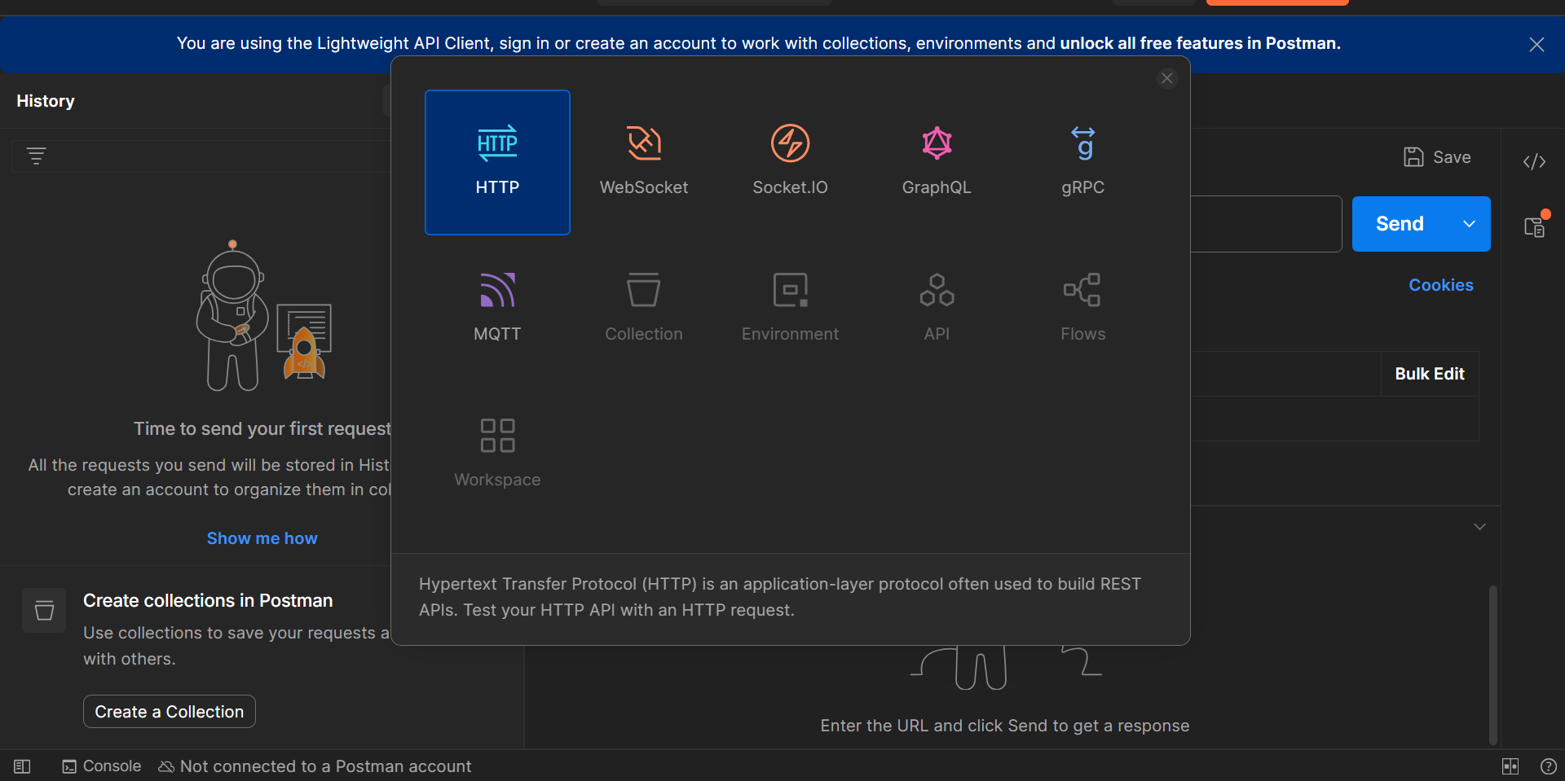

We can also create our different work spaces as we want
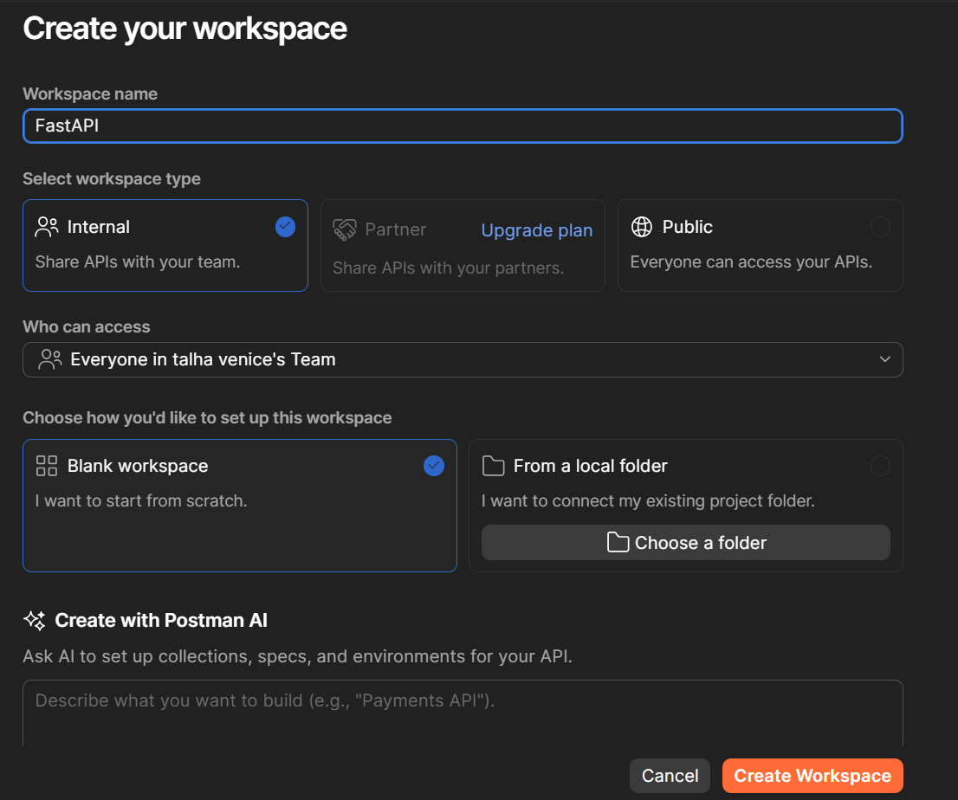

We can also create the collection this workspace :
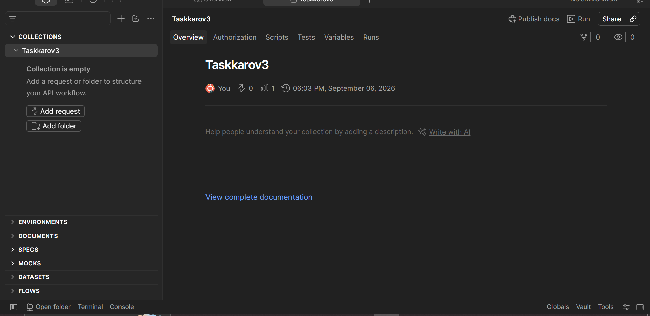
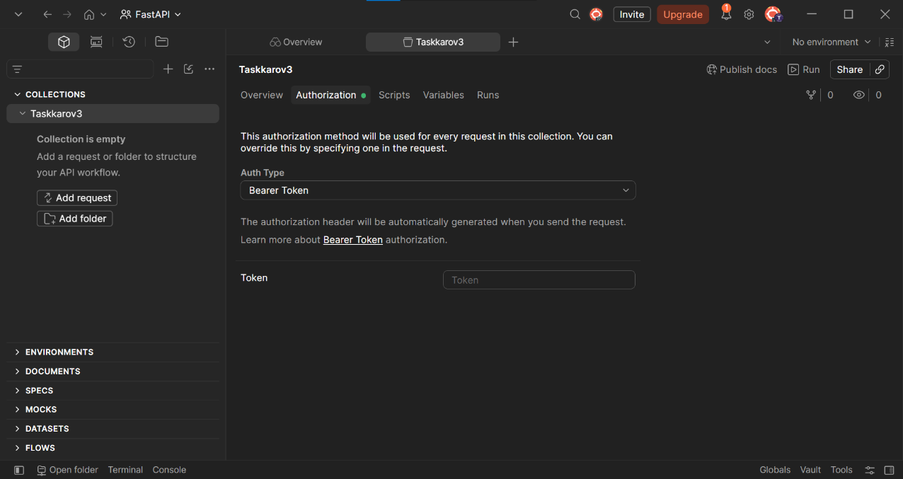

In this collection

In this collection we have multiple options like authentication, scripts,variables and run
Now we also add request inside this
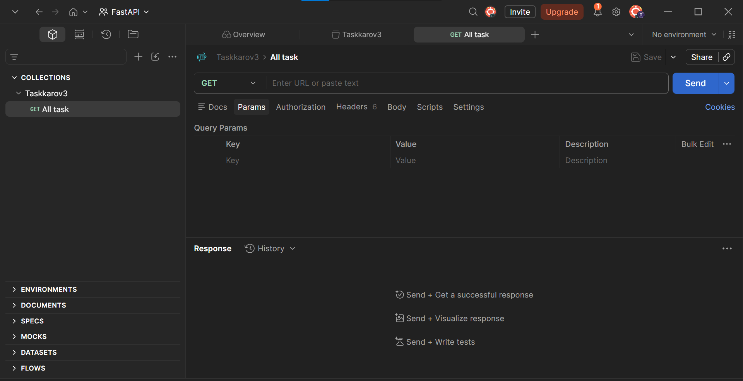

After than open command prompt and run our project
So project that we already make the taskkrov3 so activate the virtual enviroment and run that project
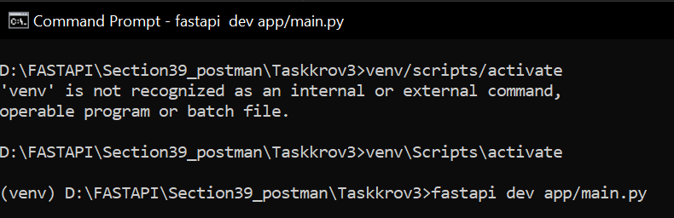

So after find the route for ALL TASK that we set inside the project and test inside the post man
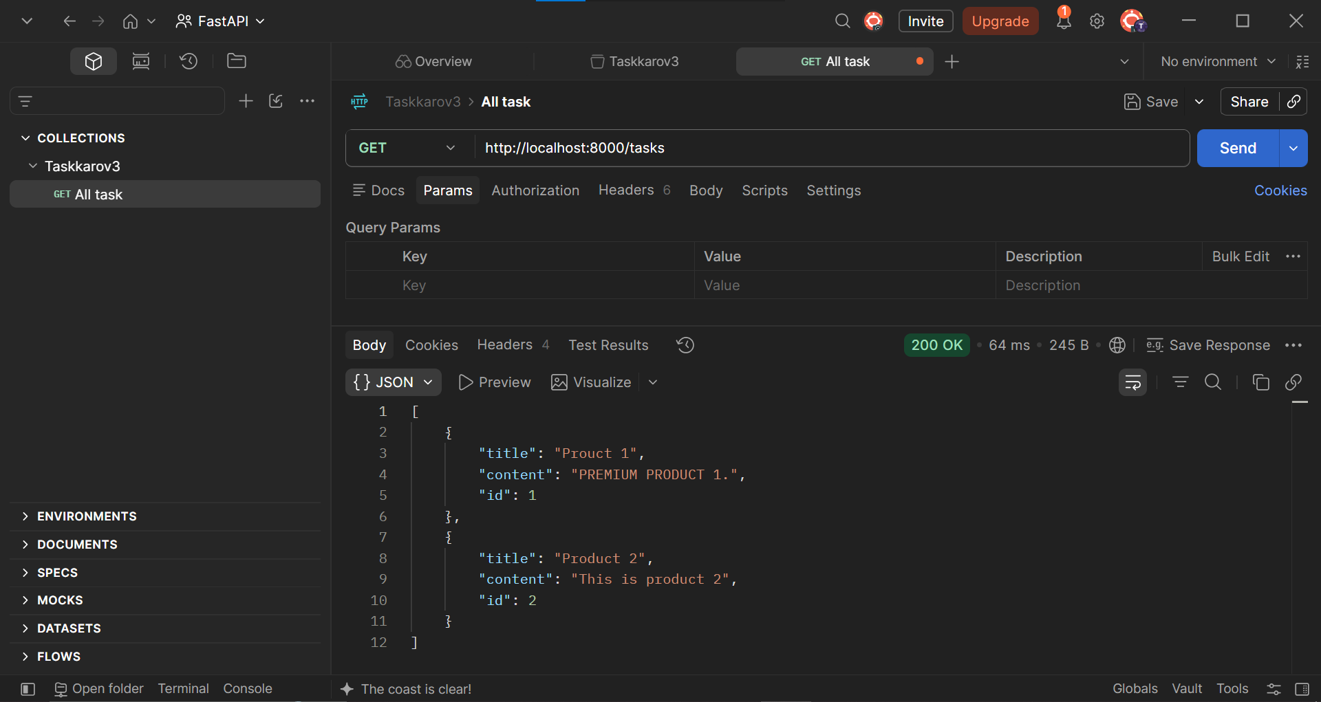
Enter the url in the postman and see the result .So here we see our results
For saving just press the control + s

Same like this we create the different requests and test these requests
Like for onetask (taking,getting 1 single task)
So now we see for single task
Single task:
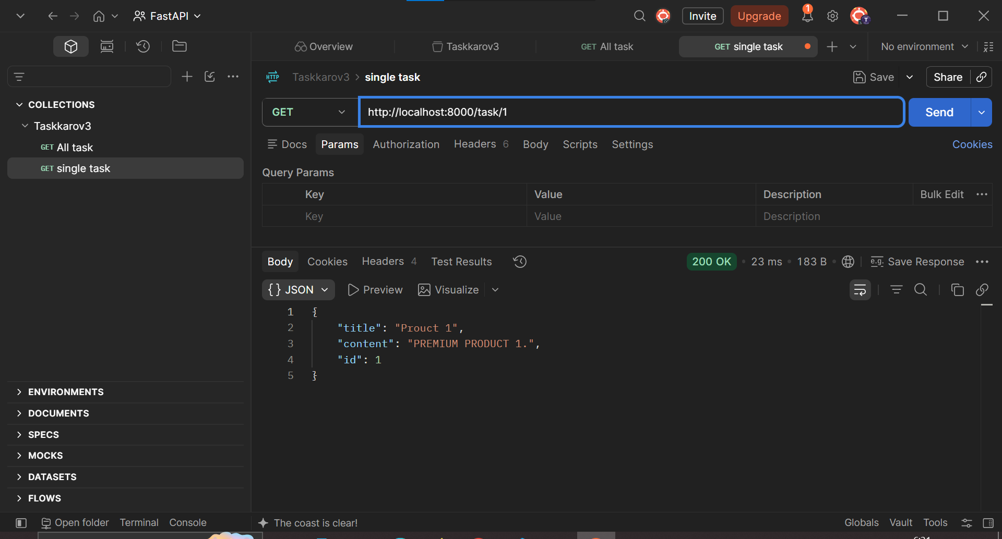

Now we see in our url :
http://localhost:8000
this is common in all our request so we can make it variable
for making the variable we have different methods by clicking on the enviroment
so we also make the collection variable go into the collections
and than go into the variables
and here write the name of the variable and our common url that we want to make the variable of that
and than press control+s to save
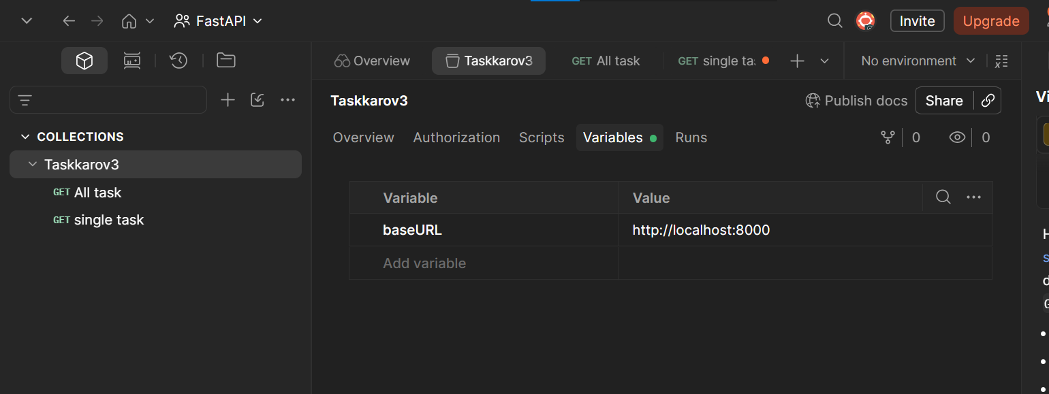

Now we set our variable now go into the request and
Instead of written the common url
Write the base url inside the brackets and than write the acutal difference url
{{baseURL}}/task/1

