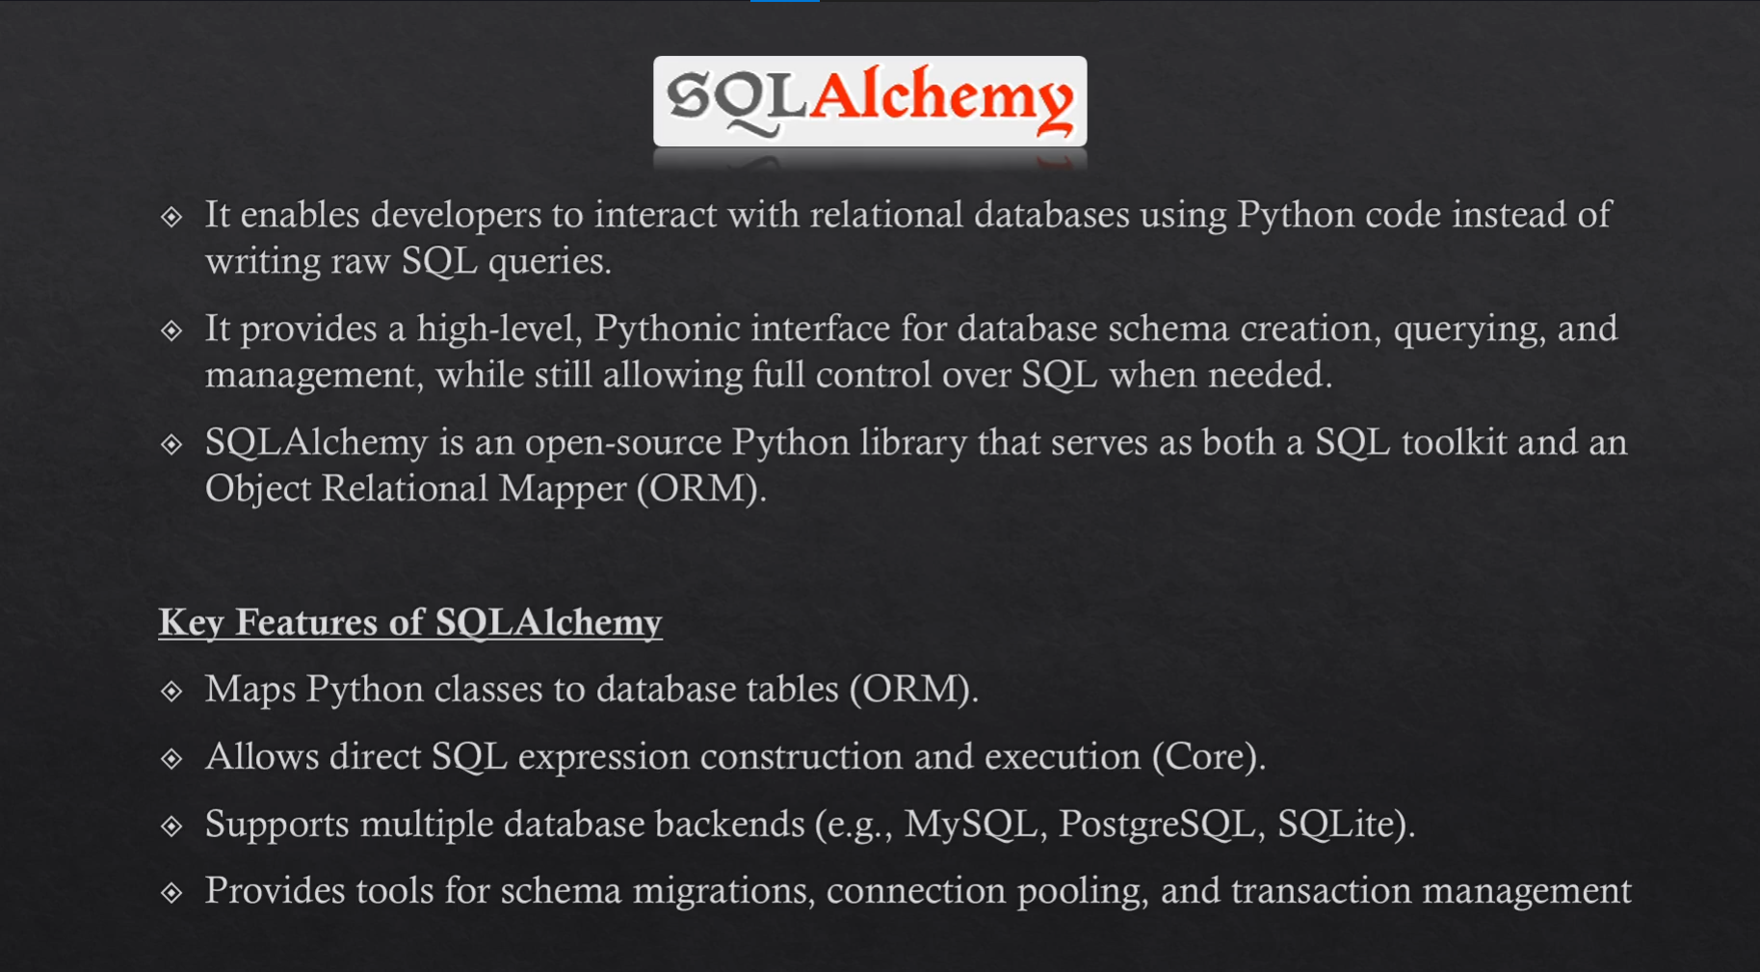

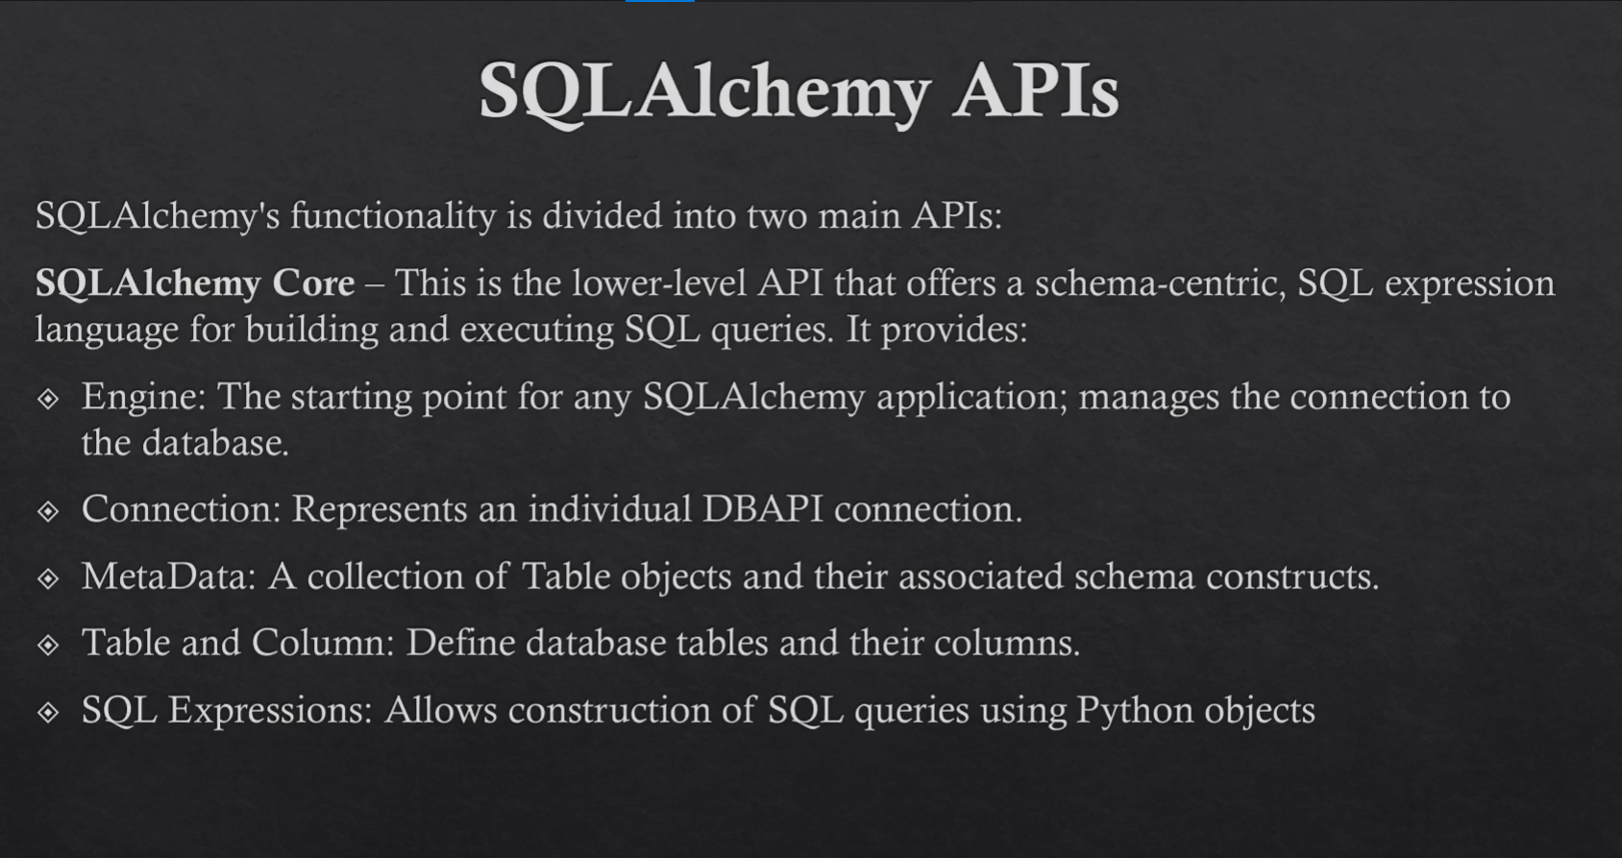

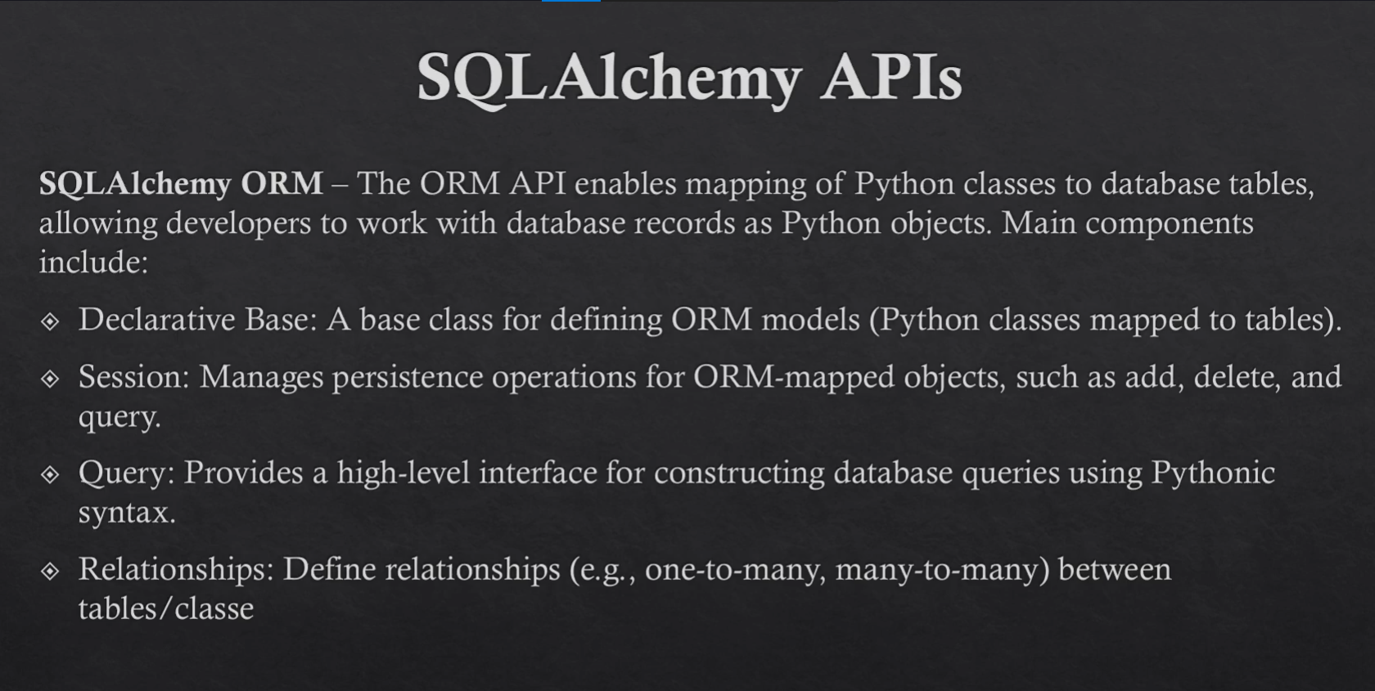

Install SqlAlchemy and Create Engine:

✅ Install SQLAlchemy and Create Engine (Step-by-Step)

🔹 1. Create Project & Activate Virtual Environment (One Time)
(You already know this part, but for completeness in notes)
python -m venv venv
venv\Scripts\activate # Windows
# or
source venv/bin/activate # Linux/Mac

🔹 2. Install SQLAlchemy
pip install SQLAlchemy

🔹 3. Check SQLAlchemy Version (Optional but Good Practice)
Open Python shell:
python
Then:
import sqlalchemy
sqlalchemy.__version__
exit()
This confirms SQLAlchemy is installed correctly ✅

🔹 4. Create db.py File and Create Engine
Now create a file called db.py and write this:
from sqlalchemy import create_engine
DATABASE_URL = "sqlite:///./sqlite.db"
engine = create_engine(DATABASE_URL,echo=True) # ECHO ALWAYS TRUE DURING DEBUGGING
# THIS JUST THE ENGINE DATABASE CONNECTION ESTABLISHED TILL NOW ...
Explain upper code:
from sqlalchemy import create_engine

# ==================================================
# Database URL
# ==================================================
# For SQLite:
# sqlite:///./sqlite.db
# Means: create/use a file named "sqlite.db" in current directory

DATABASE_URL = "sqlite:///./sqlite.db"

# ==================================================
# Create Engine
# ==================================================
# echo=True -> shows all SQL queries in terminal (very useful for debugging)
engine = create_engine(
DATABASE_URL,
echo=True # Keep True during development, False in production
)

# ==================================================
# At this point:
# ✔ Engine is created
# ✔ Database connection is configured
# ❌ No tables yet
# ❌ No models yet
# ❌ No session yet
# ==================================================

🧠 What is engine in SQLAlchemy?
- engine is the core connection to the database
- It:
  - Knows which database to connect to
  - Knows how to connect (SQLite, PostgreSQL, MySQL, etc.)
  - Sends SQL queries to the database
- Think of it like:
🔌 Engine = Plug that connects your Python app to the database

🧾 What Does This Line Mean?
DATABASE_URL = "sqlite:///./sqlite.db"
- sqlite:// → database type (SQLite)
- /./sqlite.db → file path
- Result: a file named sqlite.db will be created in your project folder

🖨️ What Does echo=True Do?
engine = create_engine(DATABASE_URL, echo=True)
- Shows all SQL queries in the terminal
- Very helpful for:
  - Learning
  - Debugging
  - Seeing what SQLAlchemy is actually doing
- In production:
echo=False

Create database tables :
Here we already create db.py with load engine and now make another file tables.py
In this tables.py
First import engine
Than make meta deta

📁 Project Structure
project/
│── db.py
│── tables.py
│── main.py

1️ db.py — Create Database Engine

from sqlalchemy import create_engine

# ==================================================
# Database URL
# ==================================================
# SQLite database file will be created in project folder
DATABASE_URL = "sqlite:///./sqlite.db"

# ==================================================
# Create Engine
# ==================================================
# echo=True -> shows SQL queries in terminal (good for learning/debugging)
engine = create_engine(
DATABASE_URL,
echo=True
)

# ==================================================
# At this stage:
# ✔ Engine is created
# ✔ Database connection is configured
# ❌ No tables yet
# ❌ No data yet
# ==================================================

2️ tables.py — Define Tables Using SQLAlchemy Core
from sqlalchemy import MetaData, Table, Column, Integer, String
from db import engine

# ==================================================
# Metadata object
# ==================================================
# Metadata stores table definitions
metadata = MetaData()

# ==================================================
# User Table
# ==================================================
users = Table(
"users",
metadata,
Column("id", Integer, primary_key=True),
Column("name", String(length=50), nullable=False),
Column("email", String, nullable=False, unique=True),
Column("phoneno", String, nullable=False),
)

# ==================================================
# Address Table
# ==================================================
address = Table(
"address",
metadata,
Column("id", Integer, primary_key=True),
Column("street", String(length=50), nullable=False),
Column("dist", String, nullable=False),
Column("country", String, nullable=False),
)

# ==================================================
# Create Tables in Database
# ==================================================
def create_tables():
metadata.create_all(engine)
print("✅ Tables created successfully!")

# ==================================================
# Drop Tables in Database (Optional / For Testing)
# ==================================================
# def drop_tables():
# metadata.drop_all(engine)
# print("❌ Tables dropped successfully!")

3️ main.py — Run Table Creation
from tables import create_tables

# ==================================================
# Create Tables
# ==================================================
if __name__ == "__main__":
create_tables()

Now run:
python main.py
You should see SQL CREATE TABLE queries in the terminal because echo=True ✅
And a file sqlite.db will be created 🎉

🧠 What You Just Did (Important Concepts)

🔹 engine
- Handles connection to database
- Sends SQL to DB

🔹 MetaData()
- Container that stores table definitions

🔹 Table(...)
- Defines a table structure in Python
- Does NOT create table until create_all() is called

🔹 metadata.create_all(engine)
- Actually creates tables in the database
- If table already exists → it will NOT recreate it

⚠️ Small Fixes from Your Original Code
- ❌ Date, DateTime imports not used → removed
- ❌ product_db.get(product_db,{})-style mistakes avoided
- ✅ Added print messages for feedback
- ✅ Cleaned comments and formatting
- ✅ Added if __name__ == "__main__" guard

📝 Short Notes for Your Lecture
- SQLAlchemy Core uses:
  - Engine → connection
  - MetaData → table registry
  - Table → table definition
- Tables are not created until:
- metadata.create_all(engine)
- echo=True shows actual SQL queries
- This approach is schema-first (you define tables manually)

One to One , One to Many , Many to Many Relationship :
from db import engine
from sqlalchemy import MetaData, Table, Column, Integer, String, ForeignKey

metadata = MetaData()

# ==================================================
# Users Table
# ==================================================
user = Table(
"users",
metadata,
Column("id", Integer, primary_key=True),
Column("name", String(length=50), nullable=False),
Column("email", String, nullable=False, unique=True),
Column("phoneno", String, nullable=False),
)

# ==================================================
# ONE TO ONE RELATIONSHIP
# Each user has one profile
# ==================================================
profile = Table(
"profile",
metadata,
Column("id", Integer, primary_key=True),
Column(
"user_id",
Integer,
ForeignKey("users.id", ondelete="CASCADE"),
nullable=False,
unique=True, # ensures one profile per user
),
Column("bio", String, nullable=False),
Column("address", String, nullable=False),
)

# ==================================================
# ONE TO MANY RELATIONSHIP
# Each user can have multiple posts
# ==================================================
posts = Table(
"posts",
metadata,
Column("id", Integer, primary_key=True),
Column("user_id", Integer, ForeignKey("users.id", ondelete="CASCADE"), nullable=True),
Column("title", String, nullable=False),
Column("content", String, nullable=False),
)

# ==================================================
# MANY TO MANY RELATIONSHIP
# Users can have multiple addresses, and addresses can belong to multiple users
# ==================================================
address = Table(
"address",
metadata,
Column("id", Integer, primary_key=True),
Column("street", String, nullable=False),
Column("content", String, nullable=False)
)

# Association Table to implement many-to-many
user_address_association = Table(
"user_address_association",
metadata,
Column(
"user_id", Integer,
ForeignKey("users.id", ondelete="CASCADE"),
primary_key=True
),
Column(
"address_id", Integer,
ForeignKey("address.id", ondelete="CASCADE"),
primary_key=True
),
)

# ==================================================
# Function to create all tables
# ==================================================
def create_tables():
metadata.create_all(engine)
print("✅ Tables created successfully!")

CRUD OPERATION CORE SQLAlchemy:

db.py — Create Engine
from sqlalchemy import create_engine

# SQLite database URL
DATABASE_URL = "sqlite:///./sqlite.db"

# Create engine (echo=True shows SQL queries in terminal, useful for learning/debugging)
engine = create_engine(DATABASE_URL, echo=True)

tables.py — Define Tables
from db import engine
from sqlalchemy import MetaData, Table, Column, Integer, String, ForeignKey

metadata = MetaData()

# ==================================================
# Users Table
# ==================================================
users = Table(
"users",
metadata,
Column("id", Integer, primary_key=True),
Column("name", String(length=50), nullable=False),
Column("email", String, nullable=False, unique=True),
Column("phoneno", String, nullable=True),
)

# ==================================================
# Posts Table (One user -> Many posts)
# ==================================================
posts = Table(
"posts",
metadata,
Column("id", Integer, primary_key=True),
Column("user_id", Integer, ForeignKey("users.id", ondelete="CASCADE"), nullable=True),
Column("title", String, nullable=False),
Column("content", String, nullable=False),
)

# ==================================================
# Create all tables
# ==================================================
def create_tables():
metadata.create_all(engine)
print("✅ Tables created successfully!")

services.py — CRUD Operations
from db import engine
from tables import users, posts
from sqlalchemy import insert, select, delete, update

# ==================================================
# CREATE (Insert)
# ==================================================

def create_user(name: str, email: str, phoneno: str | None = None):
with engine.connect() as conn:
stmt = insert(users).values(name=name, email=email, phoneno=phoneno)
conn.execute(stmt)
conn.commit()

def create_post(user_id: int, title: str, content: str):
with engine.connect() as conn:
stmt = insert(posts).values(user_id=user_id, title=title, content=content)
conn.execute(stmt)
conn.commit()

# ==================================================
# READ (Select)
# ==================================================

# Get single user by ID
def get_user_by_id(user_id: int):
with engine.connect() as conn:
stmt = select(users).where(users.c.id == user_id)
result = conn.execute(stmt).first()
return result

# Get all users
def get_all_users():
with engine.connect() as conn:
stmt = select(users)
result = conn.execute(stmt).fetchall()
return result

# Get all posts of a specific user
def get_posts_by_user(user_id: int):
with engine.connect() as conn:
stmt = select(posts).where(posts.c.user_id == user_id)
result = conn.execute(stmt).fetchall()
return result

# ==================================================
# UPDATE
# ==================================================

# Update user email
def update_user_email(user_id: int, new_email: str):
with engine.connect() as conn:
stmt = update(users).where(users.c.id == user_id).values(email=new_email)
conn.execute(stmt)
conn.commit()

# Update all posts title of a user
def update_user_posts_title(user_id: int, new_title: str):
with engine.connect() as conn:
stmt = update(posts).where(posts.c.user_id == user_id).values(title=new_title)
conn.execute(stmt)
conn.commit()

# ==================================================
# DELETE
# ==================================================

# Delete a post by post ID
def delete_post(post_id: int):
with engine.connect() as conn:
stmt = delete(posts).where(posts.c.id == post_id)
conn.execute(stmt)
conn.commit()

main.py — Test Your CRUD
from tables import create_tables
from services import *

# Create tables
create_tables()

# ==================================================
# CREATE DATA
# ==================================================
# create_user("sonam", "sonam@example.com", "1234567890")
# create_user("bajwa", "bajwa@example.com")
# create_user("raj", "raj@example.com")

# create_post(1, "Hello World", "This is Sonam's first post")
# create_post(2, "Bajwa's Post", "Hi from Bajwa")

# ==================================================
# READ DATA
# ==================================================
# print(get_user_by_id(1))
# print(get_all_users())
# print(get_posts_by_user(2))

# ==================================================
# UPDATE DATA
# ==================================================
# update_user_email(1, "sonam@newdomain.com")
# update_user_posts_title(2, "Updated title for Bajwa")

# ==================================================
# DELETE DATA
# ==================================================
# delete_post(2)

What You Learned in This CRUD
Operation | SQLAlchemy Core Function
CREATE | insert(table).values(...)
READ (one) | select(table).where(...)
READ (all) | select(table)
UPDATE | update(table).where(...).values(...)
DELETE | delete(table).where(...)
Execute | conn.execute(stmt)
Save | conn.commit()

Group by order by :

services.py — ORDER BY & GROUP BY (Clean Version)
from db import engine
from tables import users, posts
from sqlalchemy import insert, select, asc, desc, func

# ==================================================
# CREATE (Insert)
# ==================================================

def create_user(name: str, email: str, phoneno: str | None = None):
with engine.connect() as conn:
stmt = insert(users).values(name=name, email=email, phoneno=phoneno)
conn.execute(stmt)
conn.commit()

def create_post(user_id: int, title: str, content: str):
with engine.connect() as conn:
stmt = insert(posts).values(user_id=user_id, title=title, content=content)
conn.execute(stmt)
conn.commit()

# ==================================================
# ORDER BY
# ==================================================

# 1️⃣ Get All Users Ordered by Name (A → Z)
def get_users_ordered_by_name():
with engine.connect() as conn:
stmt = select(users).order_by(asc(users.c.name))
result = conn.execute(stmt).fetchall()
return result

# 2️⃣ Get All Posts Latest First (Descending by ID)
def get_posts_latest_first():
with engine.connect() as conn:
stmt = select(posts).order_by(desc(posts.c.id))
result = conn.execute(stmt).fetchall()
return result

# ==================================================
# GROUP BY
# ==================================================

# 3️⃣ Count how many posts each user has
def get_post_count_per_user():
with engine.connect() as conn:
stmt = (
select(
posts.c.user_id,
func.count(posts.c.id).label("total_posts")
)
.group_by(posts.c.user_id)
)
result = conn.execute(stmt).fetchall()
return result

# ==================================================
# ADVANCED: GROUP BY + ORDER BY
# ==================================================

# 4️⃣ Get users with most posts first
def get_post_count_per_user_ordered():
with engine.connect() as conn:
stmt = (
select(
posts.c.user_id,
func.count(posts.c.id).label("total_posts")
)
.group_by(posts.c.user_id)
.order_by(desc(func.count(posts.c.id)))
)
result = conn.execute(stmt).fetchall()
return result

What SQL Is Being Generated?

🔹 ORDER BY (A → Z)
SELECT * FROM users ORDER BY name ASC;

🔹 ORDER BY Latest First
SELECT * FROM posts ORDER BY id DESC;

🔹 GROUP BY (Count Posts Per User)
SELECT user_id, COUNT(id) AS total_posts
FROM posts
GROUP BY user_id;

🔹 GROUP BY + ORDER BY
SELECT user_id, COUNT(id) AS total_posts
FROM posts
GROUP BY user_id
ORDER BY COUNT(id) DESC;

Important Concepts Explained

asc() and desc()
order_by(asc(users.c.name))
order_by(desc(posts.c.id))
- asc() → Ascending (A-Z, 1-9)
- desc() → Descending (Z-A, 9-1)

func.count()
func.count(posts.c.id)
- func allows SQL functions:
  - count
  - sum
  - avg
  - max
  - min

.label("total_posts")
This renames the column result:
Instead of:
count_1
You get:
total_posts

📌 What You Just Mastered
Concept | SQLAlchemy Core
ORDER BY ASC | order_by(asc(column))
ORDER BY DESC | order_by(desc(column))
GROUP BY | .group_by(column)
COUNT | func.count(column)
Rename column | .label("name")

RAW SQL:

services.py
from db import engine
from sqlalchemy import text

# ==================================================
# RAW SQL INSERT
# ==================================================
# Using parameterized query (Safe from SQL injection)

def raw_sql_insert():
with engine.connect() as conn:
stmt = text("""
INSERT INTO users (name, email)
VALUES (:name, :email)
""")

conn.execute(
stmt,
{"name": "Talha", "email": "talha@gmail.com"}
)

conn.commit()
print("✅ Raw SQL Insert Successful")

# ==================================================
# RAW SQL SELECT
# ==================================================

def raw_sql_select():
with engine.connect() as conn:
stmt = text("""
SELECT * FROM users
WHERE email = :email
""")

result = conn.execute(
stmt,
{"email": "talha@gmail.com"} # THIS IS PASSING PARAMETER
)

return result.fetchall() # Fetch data properly

main.py
from tables import create_tables
from services import raw_sql_insert, raw_sql_select

# Create tables (only run once)
create_tables()

# Insert using raw SQL
raw_sql_insert()

# Fetch using raw SQL
users = raw_sql_select()
print(users)

🧠 What You Just Learned

🔹 text() Function
from sqlalchemy import text
- Allows you to write pure SQL
- Used when:
  - Core syntax is too complex
  - You want full SQL control

🔹 Parameter Binding (Very Important)
WHERE email = :email
{"email": "talha@gmail.com"}

Why?
✅ Prevents SQL Injection
❌ Never do this:
text(f"SELECT * FROM users WHERE email = '{email}'")
That is dangerous.

What SQL Is Actually Executed

INSERT
INSERT INTO users (name, email)
VALUES ('Talha', 'talha@gmail.com');

SELECT
SELECT * FROM users WHERE email = 'talha@gmail.com';

Important Notes
- Always use :parameter_name
- Always pass parameters as dictionary
- Always call conn.commit() for INSERT/UPDATE/DELETE
- For SELECT → use:
  - .fetchall()
  - .first()
  - .scalar()

Advanced RAW SQL Example (Optional Upgrade)
You can also do:
def raw_sql_count():
with engine.connect() as conn:
stmt = text("SELECT COUNT(*) FROM users")
result = conn.execute(stmt)
return result.scalar()

When Should You Use RAW SQL?
Use Case | Why
Complex JOIN | Easier than Core
Performance tuning | Optimized SQL
Database-specific features | Native SQL required
Stored procedures | Direct call

💎 Pro-Level Tip
Even when using RAW SQL, you're still using SQLAlchemy's:
- Connection management
- Transaction handling
- Security protection (if parameters used correctly)
So it's safe + powerful

