RIPHAH INTERNATIONAL UNIVERSITY
Faculty of Computing
Department of Computer Science

Car Rental Management System

Database Management System - Semester Project Report

Student Name | Talha Aftab
SAP ID | 63091
Section | BSCS 4-1
Instructor | Mr. Ihtisham Ullah
Course | Database Management System
Semester | 4th
Session | Spring 2026
University | Riphah International University Islamabad I-14
Submission Date | 4 May 2026

1. Introduction
The Car Rental Management System is a relational database project designed to manage the core operations of a vehicle rental business. The system stores and organizes information related to customers, vehicles, bookings, payments, and staff, ensuring data consistency and reducing the manual workload associated with rental operations.

The project applies the database concepts covered throughout the semester, including entity-relationship modeling, relational schema design, normalization up to the Third Normal Form (3NF), constraint enforcement, and advanced SQL query writing. The implementation is carried out using Oracle SQL, which was used in lab sessions throughout the course.

The system is capable of tracking vehicle availability in real time, managing booking schedules, calculating rental costs automatically, and generating revenue and usage reports through SQL queries and views. These features make it a practical and complete database solution for a small to medium-scale car rental operation.

2. Objectives
The following objectives were defined for this project:

- Design a structured and normalized relational database for a car rental business.
- Model all entities, attributes, and relationships using the Chen notation Entity-Relationship Diagram.
- Implement the database schema in Oracle SQL with appropriate primary keys, foreign keys, and constraints.
- Normalize the schema to Third Normal Form (3NF) to eliminate data redundancy.
- Automate derived values such as rental duration and total cost using Oracle triggers.
- Create meaningful database views for reporting purposes.
- Write advanced SQL queries covering joins, subqueries, and aggregation functions.
- Populate the database with realistic sample data to demonstrate query functionality.

3. Entity-Relationship Diagram
The Entity-Relationship (ER) diagram below follows Chen notation as taught in the course. Entities are represented by rectangles, attributes by ovals, primary key attributes by underlined ovals, derived attributes by dashed ovals, and relationships by diamonds. Cardinality ratios are marked on the connecting lines.

3.1 Entities and Attributes

Entity | Attributes | Primary Key
CUSTOMER | customer_id, full_name, email, phone, license_no, address, created_at | customer_id
VEHICLE | vehicle_id, make, model, year, plate_no, category, daily_rate, status | vehicle_id
STAFF | staff_id, full_name, role, email, phone | staff_id
BOOKING | booking_id, customer_id (FK), vehicle_id (FK), staff_id (FK), start_date, end_date, total_days*, total_cost, status | booking_id
PAYMENT | payment_id, booking_id (FK), pay_date, amount, method, status | payment_id

* total_days is a derived attribute, computed from end_date minus start_date (shown as dashed oval in the ERD).

3.2 Relationships

Relationship | Entities Involved | Cardinality | Description
MAKES | CUSTOMER, BOOKING | 1 : N | One customer can make many bookings
ASSIGNED TO | VEHICLE, BOOKING | 1 : N | One vehicle can appear in many bookings
MANAGES | STAFF, BOOKING | 1 : N | One staff member can manage many bookings
HAS | BOOKING, PAYMENT | 1 : 1 | Each booking has exactly one payment

3.3 ER Diagram

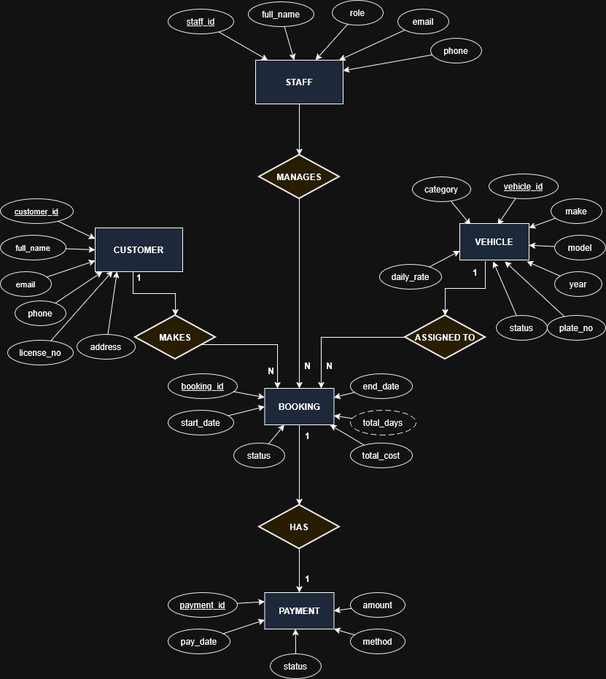

4. Schema Design
The relational schema was derived directly from the ER diagram. Each entity was translated into a table with appropriate columns, data types, primary keys, foreign keys, and constraints. Oracle SQL sequences and triggers were used to implement auto-incrementing primary keys, as the project runs on Oracle 11g Express Edition which does not support the IDENTITY syntax.

4.1 Normalization
All tables in the schema satisfy the requirements of the Third Normal Form (3NF).

First Normal Form (1NF): All tables contain only atomic values. Each column holds a single value, there are no repeating groups, and every row is uniquely identified by its primary key.
Second Normal Form (2NF): All tables have single-column primary keys, so partial dependencies cannot exist. Every non-key attribute depends on the entire primary key.
Third Normal Form (3NF): No transitive dependencies exist in any table. Non-key attributes depend only on the primary key and not on other non-key attributes. For example, in the BOOKING table, total_cost depends on the vehicle daily rate and the rental duration, both of which are resolved through the foreign key to VEHICLE and the computed trigger logic, not through another non-key attribute.

4.2 Tables

Table 1: STAFF
Column | Data Type | Constraint | Description
staff_id | NUMBER | PRIMARY KEY | Auto-generated unique identifier
full_name | VARCHAR2(100) | NOT NULL | Full name of the staff member
role | VARCHAR2(50) | NOT NULL, CHECK (Manager/Agent/Mechanic) | Staff role
email | VARCHAR2(100) | NOT NULL, UNIQUE | Staff email address
phone | VARCHAR2(20) | NOT NULL | Contact phone number

Table 2: CUSTOMER
Column | Data Type | Constraint | Description
customer_id | NUMBER | PRIMARY KEY | Auto-generated unique identifier
full_name | VARCHAR2(100) | NOT NULL | Full name of the customer
email | VARCHAR2(100) | NOT NULL, UNIQUE | Customer email address
phone | VARCHAR2(20) | NOT NULL | Contact number
license_no | VARCHAR2(50) | NOT NULL, UNIQUE | Driving license number
address | VARCHAR2(255) | NULL | Residential address
created_at | DATE | DEFAULT SYSDATE | Account creation date

Table 3: VEHICLE
Column | Data Type | Constraint | Description
vehicle_id | NUMBER | PRIMARY KEY | Auto-generated unique identifier
make | VARCHAR2(50) | NOT NULL | Vehicle manufacturer
model | VARCHAR2(50) | NOT NULL | Vehicle model name
year | NUMBER(4) | CHECK (2000-2030) | Manufacturing year
plate_no | VARCHAR2(20) | NOT NULL, UNIQUE | Registration plate number
category | VARCHAR2(30) | CHECK (Economy/Standard/SUV/Luxury/Van) | Vehicle category
daily_rate | NUMBER(8,2) | CHECK > 0 | Daily rental rate in PKR
status | VARCHAR2(20) | DEFAULT Available | Current availability status

Table 4: BOOKING
Column | Data Type | Constraint | Description
booking_id | NUMBER | PRIMARY KEY | Auto-generated unique identifier
customer_id | NUMBER | FOREIGN KEY -> CUSTOMER | References customer
vehicle_id | NUMBER | FOREIGN KEY -> VEHICLE | References vehicle
staff_id | NUMBER | FOREIGN KEY -> STAFF | References staff
start_date | DATE | NOT NULL | Rental start date
end_date | DATE | NOT NULL, > start_date | Rental end date
total_days | NUMBER | Computed by trigger | Duration in days (derived)
total_cost | NUMBER(10,2) | Computed by trigger | Total rental cost in PKR
status | VARCHAR2(20) | CHECK (Pending/Active/Completed/Cancelled) | Booking status

Table 5: PAYMENT
Column | Data Type | Constraint | Description
payment_id | NUMBER | PRIMARY KEY | Auto-generated unique identifier
booking_id | NUMBER | FOREIGN KEY -> BOOKING, UNIQUE | References booking (1:1)
pay_date | DATE | DEFAULT SYSDATE | Date of payment
amount | NUMBER(10,2) | CHECK > 0 | Amount paid in PKR
method | VARCHAR2(30) | CHECK (Cash/Credit Card/Debit Card/Online) | Payment method
status | VARCHAR2(20) | DEFAULT Pending | Payment status

4.3 Schema SQL Script
The following script creates all tables, sequences, triggers, and views.

-- STAFF table and sequence
CREATE TABLE STAFF (
staff_id NUMBER PRIMARY KEY,
full_name VARCHAR2(100) NOT NULL,
role VARCHAR2(50) NOT NULL
CONSTRAINT chk_staff_role
CHECK (role IN ('Manager','Agent','Mechanic')),
email VARCHAR2(100) NOT NULL CONSTRAINT uq_staff_email UNIQUE,
phone VARCHAR2(20) NOT NULL
);

CREATE SEQUENCE seq_staff_id START WITH 1 INCREMENT BY 1;

CREATE OR REPLACE TRIGGER trg_staff_id
BEFORE INSERT ON STAFF FOR EACH ROW
BEGIN
SELECT seq_staff_id.NEXTVAL INTO :NEW.staff_id FROM DUAL;
END;
/

(Remaining tables follow the same pattern. Full script provided in the appendix and GitHub repository.)

4.4 Views
Three views were created to simplify common reporting queries.

View Name | Description
vw_active_rentals | Shows all currently active bookings with customer and vehicle details
vw_revenue_by_category | Aggregates total revenue, booking count, and average revenue per vehicle category
vw_customer_history | Summarizes each customer's total rentals, total spending, and last rental date

5. SQL Queries and Outputs
This section presents all SQL queries written for the system, organized by category. Each query is accompanied by a brief statement of purpose and the corresponding output captured from Oracle SQL Developer.

5.1 Join Queries

Query 1: All Bookings with Customer, Vehicle and Staff Details
Purpose: Retrieves full details of every booking by joining all four core tables.
SELECT b.booking_id, c.full_name AS customer_name,
v.make || ' ' || v.model AS vehicle,
v.plate_no, s.full_name AS handled_by,
b.start_date, b.end_date, b.total_days,
b.total_cost, b.status
FROM BOOKING b
JOIN CUSTOMER c ON b.customer_id = c.customer_id
JOIN VEHICLE v ON b.vehicle_id = v.vehicle_id
JOIN STAFF s ON b.staff_id = s.staff_id
ORDER BY b.booking_id;

Output:
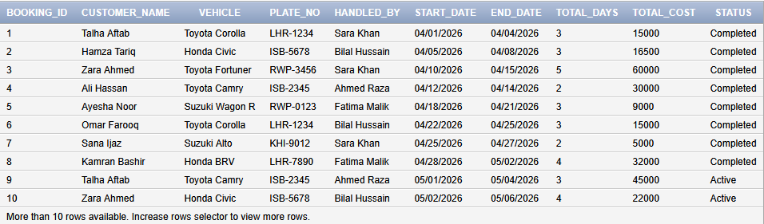

Query 2: Completed Bookings with Payment Details
Purpose: Lists all completed bookings joined with their corresponding payment records.
SELECT b.booking_id, c.full_name AS customer_name,
v.make || ' ' || v.model AS vehicle,
b.total_cost, p.amount AS amount_paid,
p.method AS payment_method,
p.pay_date, p.status AS payment_status
FROM BOOKING b
JOIN CUSTOMER c ON b.customer_id = c.customer_id
JOIN VEHICLE v ON b.vehicle_id = v.vehicle_id
JOIN PAYMENT p ON b.booking_id = p.booking_id
WHERE b.status = 'Completed'
ORDER BY p.pay_date;

Output:
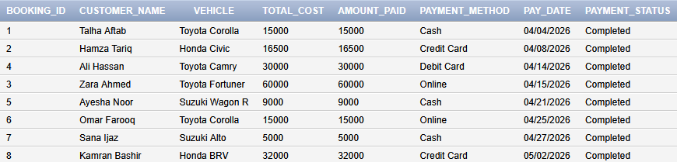

Query 3: Customer Booking Count (Including Customers with No Bookings)
Purpose: Uses a LEFT JOIN to include customers who have not made any bookings.
SELECT c.customer_id, c.full_name, c.phone,
COUNT(b.booking_id) AS total_bookings
FROM CUSTOMER c
LEFT JOIN BOOKING b ON c.customer_id = b.customer_id
GROUP BY c.customer_id, c.full_name, c.phone
ORDER BY total_bookings DESC;

Output:
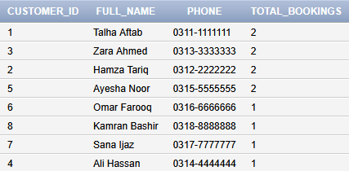

Query 4: Active Rentals with Customer Contact and Vehicle Details
Purpose: Shows all currently ongoing rentals with customer contact information.
SELECT b.booking_id, c.full_name AS customer_name,
c.phone AS customer_phone,
v.make || ' ' || v.model AS vehicle,
v.plate_no, v.category,
b.start_date, b.end_date,
b.total_days, b.total_cost
FROM BOOKING b
JOIN CUSTOMER c ON b.customer_id = c.customer_id
JOIN VEHICLE v ON b.vehicle_id = v.vehicle_id
WHERE b.status = 'Active'
ORDER BY b.start_date;

Output:

Query 5: Revenue Generated per Staff Member
Purpose: Calculates the total revenue and number of bookings handled by each staff member.
SELECT s.staff_id, s.full_name AS staff_name, s.role,
COUNT(b.booking_id) AS bookings_handled,
SUM(p.amount) AS total_revenue_generated
FROM STAFF s
JOIN BOOKING b ON s.staff_id = b.staff_id
JOIN PAYMENT p ON b.booking_id = p.booking_id
WHERE p.status = 'Completed'
GROUP BY s.staff_id, s.full_name, s.role
ORDER BY total_revenue_generated DESC;

Output:
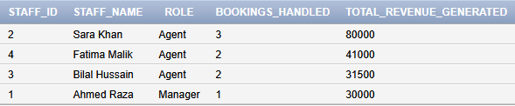

5.2 Subquery Queries

Query 6: Customers Who Spent More Than the Average Customer Spending
Purpose: Uses a nested subquery to compare each customer's total spending against the overall average.
SELECT c.customer_id, c.full_name, c.email,
SUM(b.total_cost) AS total_spent
FROM CUSTOMER c
JOIN BOOKING b ON c.customer_id = b.customer_id
GROUP BY c.customer_id, c.full_name, c.email
HAVING SUM(b.total_cost) > (
SELECT AVG(total_per_customer)
FROM (
SELECT SUM(total_cost) AS total_per_customer
FROM BOOKING
GROUP BY customer_id
)
)
ORDER BY total_spent DESC;

Output:
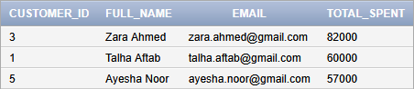

Query 7: Vehicles That Have Never Been Booked
Purpose: Uses a NOT IN subquery to identify vehicles with no booking records.
SELECT vehicle_id,
make || ' ' || model AS vehicle,
plate_no, category, daily_rate, status
FROM VEHICLE
WHERE vehicle_id NOT IN (
SELECT DISTINCT vehicle_id FROM BOOKING
);

Output:
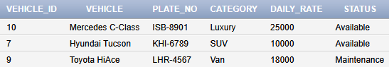

Query 8: Most Expensive Booking with Full Details
Purpose: Uses a scalar subquery to locate the booking with the highest total cost.
SELECT b.booking_id, c.full_name AS customer_name,
v.make || ' ' || v.model AS vehicle,
b.total_days, b.total_cost
FROM BOOKING b
JOIN CUSTOMER c ON b.customer_id = c.customer_id
JOIN VEHICLE v ON b.vehicle_id = v.vehicle_id
WHERE b.total_cost = (
SELECT MAX(total_cost) FROM BOOKING
);

Output:

Query 9: Customers Who Have Rented an SUV
Purpose: Uses an IN subquery to find customers with at least one SUV booking.
SELECT DISTINCT c.customer_id, c.full_name,
c.phone, c.email
FROM CUSTOMER c
WHERE c.customer_id IN (
SELECT b.customer_id
FROM BOOKING b
JOIN VEHICLE v ON b.vehicle_id = v.vehicle_id
WHERE v.category = 'SUV'
);

Output:
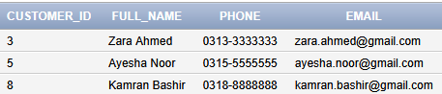

Query 10: Vehicles with Daily Rate Above Average
Purpose: Uses a scalar subquery to filter vehicles priced above the fleet average.
SELECT vehicle_id,
make || ' ' || model AS vehicle,
category, daily_rate, status
FROM VEHICLE
WHERE daily_rate > (
SELECT AVG(daily_rate) FROM VEHICLE
)
ORDER BY daily_rate DESC;

Output:
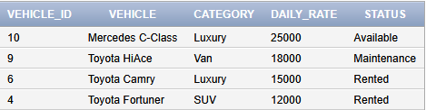

5.3 Aggregation Queries

Query 11: Overall Revenue and Booking Statistics
Purpose: Provides a summary of total revenue, average booking value, and payment range.
SELECT COUNT(b.booking_id) AS total_bookings,
SUM(p.amount) AS total_revenue,
ROUND(AVG(p.amount), 2) AS avg_booking_value,
MAX(p.amount) AS highest_payment,
MIN(p.amount) AS lowest_payment
FROM BOOKING b
JOIN PAYMENT p ON b.booking_id = p.booking_id
WHERE p.status = 'Completed';

Output:

Query 12: Revenue Breakdown by Vehicle Category
Purpose: Groups completed payment data by vehicle category to show which category generates the most revenue.
SELECT v.category,
COUNT(b.booking_id) AS total_bookings,
SUM(p.amount) AS total_revenue,
ROUND(AVG(b.total_days), 1) AS avg_rental_days,
MAX(p.amount) AS max_payment
FROM VEHICLE v
JOIN BOOKING b ON v.vehicle_id = b.vehicle_id
JOIN PAYMENT p ON b.booking_id = p.booking_id
WHERE p.status = 'Completed'
GROUP BY v.category
ORDER BY total_revenue DESC;

Output:
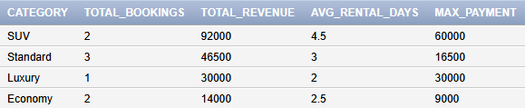

Query 13: Monthly Booking and Revenue Summary
Purpose: Uses TO_CHAR to group bookings by month and summarizes revenue collected each month.
SELECT TO_CHAR(b.start_date, 'YYYY-MM') AS month,
COUNT(b.booking_id) AS total_bookings,
SUM(b.total_cost) AS total_cost,
SUM(p.amount) AS collected_revenue
FROM BOOKING b
JOIN PAYMENT p ON b.booking_id = p.booking_id
WHERE p.status = 'Completed'
GROUP BY TO_CHAR(b.start_date, 'YYYY-MM')
ORDER BY month;

Output:
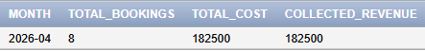

Query 14: Payment Method Usage Breakdown
Purpose: Counts transactions and totals revenue per payment method to identify the most used methods.
SELECT method,
COUNT(*) AS total_transactions,
SUM(amount) AS total_amount,
ROUND(AVG(amount), 2) AS avg_amount
FROM PAYMENT
WHERE status = 'Completed'
GROUP BY method
ORDER BY total_amount DESC;

Output:
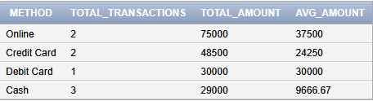

Query 15: Top 3 Most Rented Vehicles
Purpose: Uses ROWNUM with a subquery to return the three vehicles with the most bookings.
SELECT * FROM (
SELECT v.vehicle_id,
v.make || ' ' || v.model AS vehicle,
v.plate_no, v.category,
COUNT(b.booking_id) AS times_rented
FROM VEHICLE v
JOIN BOOKING b ON v.vehicle_id = b.vehicle_id
GROUP BY v.vehicle_id, v.make, v.model,
v.plate_no, v.category
ORDER BY times_rented DESC
)
WHERE ROWNUM <= 3;

Output:
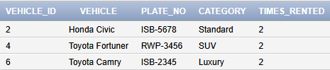

5.4 View Queries

Query 16: Active Rentals View
Purpose: Queries the vw_active_rentals view to display all ongoing rentals.
SELECT * FROM vw_active_rentals;

Output:
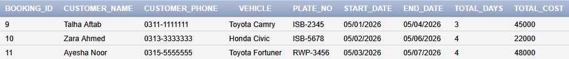

Query 17: Revenue by Category View
Purpose: Queries the vw_revenue_by_category view to show revenue grouped by vehicle type.
SELECT * FROM vw_revenue_by_category;

Output:
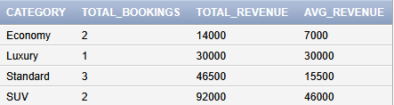

Query 18: Customer History View
Purpose: Queries the vw_customer_history view to show each customer's rental history and total spending.
SELECT * FROM vw_customer_history ORDER BY total_spent DESC;

Output:
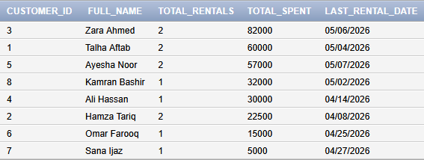

6. Conclusion
This project demonstrates the end-to-end design and implementation of a relational database system for a car rental business using Oracle SQL. Beginning with a conceptual Entity-Relationship Diagram and progressing through schema design, normalization, and query development, the project covers all major topics studied in the Database Management System course.

The schema comprises five interrelated tables, each enforcing data integrity through primary keys, foreign keys, check constraints, and unique constraints. Triggers were used to automate the computation of rental duration and cost, reducing the possibility of data entry errors. Three views were created to simplify access to commonly needed reports.

Eighteen SQL queries were written to demonstrate proficiency in inner joins, left joins, multi-table joins, correlated subqueries, nested subqueries, and aggregation functions including COUNT, SUM, AVG, MAX, and MIN. The queries cover practical reporting scenarios such as revenue analysis, vehicle utilization, customer spending patterns, and payment tracking.

Overall, the project provided hands-on experience with the complete database development lifecycle and reinforced the theoretical concepts covered throughout the semester.

7. GitHub Repository
The complete project including the schema script, data insertion script, and all SQL queries has been uploaded to the following GitHub repository:

GitHub Repository Link: Github Link

Repository contents:

- car_rental_schema_11g.sql - Full schema with tables, sequences, triggers, and views
- car_rental_data.sql - Sample data insertion script
- car_rental_queries.sql - All 18 SQL queries
- README.md - Project description and setup instructions

