Adaptive Client Selection for Concept Drift in Federated Learning
Anonymous Authors
Paper Under Double-Blind Review for ICACS Conference
Abstract— Edge devices in federated learning don't keep stationary data distributions over long deployment horizons. They face sudden concept shifts, sensor degradation, and seasonal label variations. Under standard bandwidth limits, a central server only talks to a small fraction of clients in each round. Unselected clients can't report their state, so the server doesn't observe them. Common greedy selection schemes pick the same top clients repeatedly. That causes severe client starvation, leaving most edge clients unselected. Stagnant clients don't get checked, so the system won't catch recovery when conditions change. This paper studies FedQual-CPX, an adaptive client selection framework for non-stationary federated networks. The system tracks local loss improvements, scales them with causal median absolute deviation normalization, and spots shifts using two-sided cumulative sum detectors. An adaptive exploration controller raises sampling rates when drift happens, while staleness scoring pulls forgotten clients back into training. Across experiments on CIFAR-10, FEMNIST, and Shakespeare with five random seeds, the proposed policy maintains full client participation. It cuts participation inequality by up to fifty-four percent compared to greedy selection and preserves post-drift recovery.
Keywords— Federated learning, concept drift, client selection, change point detection, participation fairness.
1. Introduction
Federated learning lets edge devices train a shared model without sending raw records to a central facility [1]. Smartphones, medical scanners, and connected vehicles compute updates locally and send parameter differences back to a coordination server [2]. But real edge deployments don't stay steady over time. Client data distributions drift because user habits change, lighting shifts, and physical sensors slowly degrade.
Partial observability makes client selection difficult under concept drift. The server doesn't see every client in every communication round. Bandwidth constraints force the server to pick only ten out of a hundred clients per round. When a client isn't picked, its current data distribution and loss gain stay completely hidden. A missing observation isn't a zero. It is simply unknown.
Prior selection methods struggle with this partial observability. Lai et al. [2] show that greedy utility sampling speeds up model training in static settings. Yet under concept drift, greedy selection traps the server in a narrow clique of previously strong devices. Stale clients don't get revisited, and newly improved clients can't show their worth. Li et al. [3] study optimization under device heterogeneity, but their setup doesn't handle temporal distribution shifts. Standard random selection explores every client evenly, but it doesn't exploit high-performing devices effectively.
This paper presents FedQual-CPX, an adaptive selection framework that explicitly handles partial observability under concept drift. Instead of relying on static rules, the server tracks loss improvements, flags distribution shifts with sequential cumulative sum tests, and adapts exploration rates dynamically. Neglected clients aren't abandoned. They get pulled back into training before selection biases harden.
The main findings of this work show three clear patterns:
1. Greedy client selection collapses in non-stationary networks. It starves eighty to ninety percent of available devices and locks into high participation inequality.
2. Sequential change detection paired with dynamic exploration restores full client coverage across all tested benchmarks without hurting global accuracy.
3. Causal median absolute deviation scaling stabilizes utility tracking across diverse network architectures without leaking future observations.
2. Problem Formulation
A federated system trains over N edge devices indexed by i in {1, ..., N}. Each device holds a local dataset D_{i,t} that may change across communication rounds t in {1, ..., T}. In round t, the server selects a cohort S_t containing |S_t| = K << N clients.
Clients in S_t download global parameters w_t, run local stochastic gradient descent, and upload local parameters w_{i,t}. Following the formulation in McMahan et al. [1], the server aggregates parameter updates through sample-weighted averaging:
w_{t+1} = sum_{i in S_t} (n_i / sum_{j in S_t} n_j) * w_{i,t}
Raw gradient norms don't tell whether local training actually helped the global objective. This paper defines client utility as the empirical loss gain achieved locally:
u_{i,t} = L_i(w_t; D_{i,t}) - L_i(w_{i,t}; D_{i,t})
A positive value u_{i,t} > 0 marks constructive progress. A negative value indicates harmful updates, such as corrupted labels or noise. When client i is not in S_t, its utility isn't observed. The server doesn't set missing values to zero because doing so would mimic severe model degradation.
3. Methodology
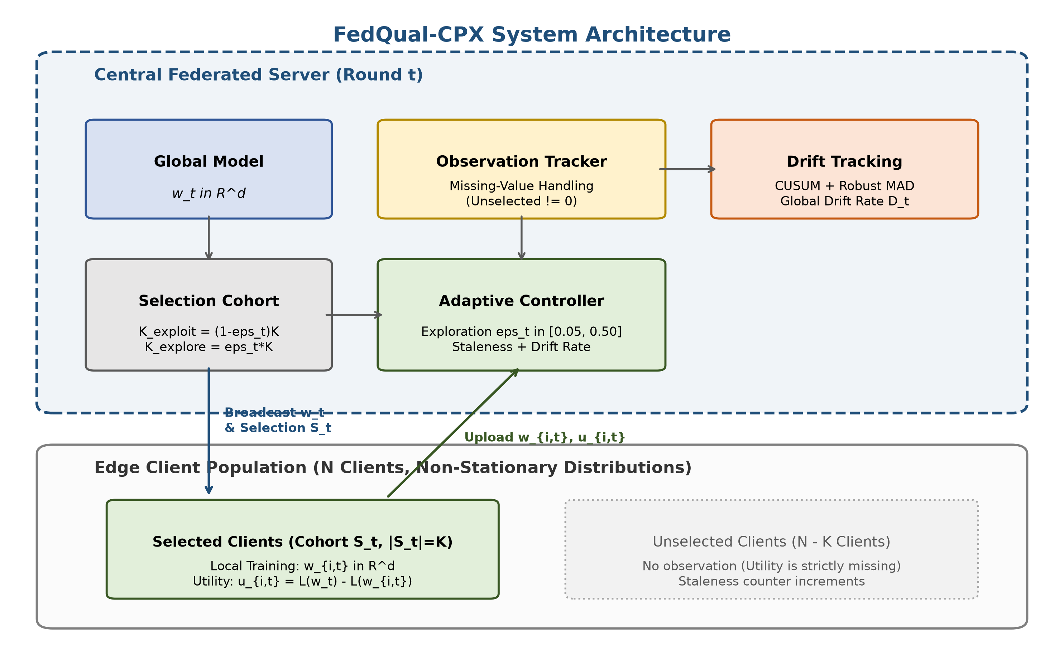
Fig. 1. System architecture of the adaptive federated client selection framework.
Fig. 1 presents the overall architecture of FedQual-CPX. The server coordinates parameter broadcast, tracks historical loss gains, and balances exploration against exploitation in every communication cycle.
3.1 Client Utility and Robust Normalization
Different edge devices don't have identical loss scales. A device with complex images can report large loss drops, while a device with clean data reports small drops. Standard z-score scaling breaks down when sudden outliers appear, and min-max scaling collapses on boundary points.
In the tradition of Huber [6], FedQual-CPX applies causal Median Absolute Deviation (MAD) normalization. The server computes running statistics using only past observations H_i(t) for client i:
mu_{i,t} = median({u_{i,tau}}), MAD_{i,t} = median(|u_{i,tau} - mu_{i,t}|) + 1e-6
u~_{i,t} = clip( (u_{i,t} - mu_{i,t}) / (1.4826 * MAD_{i,t}), -3.0, 3.0 )
This causal clipping prevents future leakage. Outliers can't distort historical baselines, and clean updates don't get squashed.
3.2 Sequential Drift Detection
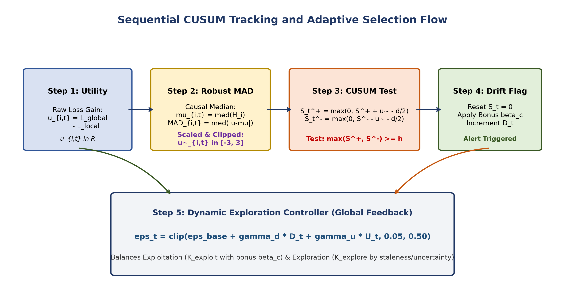
Fig. 2. Sequential change detection and adaptive exploration decision flow.
Fig. 2 outlines the decision flow for individual client streams. Following Page [4], the server runs a two-sided sequential cumulative sum (CUSUM) test on normalized utility values:
S_{i,t}^+ = max(0, S_{i,t-1}^+ + (u~_{i,t} - delta/2)), S_{i,t}^- = max(0, S_{i,t-1}^- - (u~_{i,t} + delta/2))
Here, parameter delta = 0.5 sets the minimum detectable shift size. When the accumulator crosses threshold h_th = 5.0, the server marks a change event, resets both accumulators to zero, and updates a global drift frequency counter D_t.
3.3 Adaptive Exploration and Selection Policy
Fixed exploration rates don't adjust to network stability. When data distributions stay quiet, random exploration wastes bandwidth on known weak clients. When concept drift strikes, fixed exploration isn't aggressive enough to uncover shifted devices.
The server calculates an adaptive exploration probability eps_t in [0.05, 0.50]:
eps_t = clip( eps_base + gamma_d * D_t + gamma_u * U_t, 0.05, 0.50 )
where U_t represents average client staleness across the population. In each round, the server splits cohort size K into exploitation K_exploit = floor((1 - eps_t) * K) and exploration K_explore = K - K_exploit.
For exploitation, the server ranks observed clients using their normalized score plus a transient change bonus beta_c = 1.0:
Score_i^{exploit} = mu_{i,t} + beta_c * 1_{drift_i}.
For exploration, the server picks from the unselected pool based on staleness (t - tau_i^{last}) and utility uncertainty sigma_{i,t}:
Score_i^{explore} = (t - tau_i^{last}) + lambda_u * sigma_{i,t}.
Forgotten clients don't stay hidden forever. They get selected automatically when their staleness score climbs. Simple as that.
4. Experimental Setup
4.1 Datasets and Partitioning
Experiments test three standard benchmarks:
• CIFAR-10: Fifty thousand training images across ten image categories. Non-IID partitions follow Dirichlet distribution with concentration alpha = 0.5 across N=100 clients.
• LEAF FEMNIST: Sixty-two handwritten character classes based on Caldas et al. [5], capturing realistic user handwriting variations across natural non-IID splits.
• LEAF Shakespeare: Recurrent character-level dialogue prediction across speaking roles with a vocabulary of ninety tokens [5].
4.2 Non-Stationary Drift Regimes
This paper tests three distinct non-stationary drift environments:
1. Abrupt Class Swap: At round tau=50, thirty percent of edge clients experience label permutation.
2. Continuous Feature Shift: At round tau=50, thirty percent of clients receive continuous Gaussian covariate noise clamped to valid pixel ranges.
3. Gradual Linear Drift: Across rounds [30, 70], sample distributions interpolate linearly between source and target distributions using a dynamic probability ramp.
4.3 Baselines and Evaluation Metrics
The baseline suite includes standard random selection (FedAvg B0), utility greedy selection (B2), sliding window tracking with window length ten (B3), fixed exploration with fifteen percent random perturbation (B4), and Page-Hinckley adaptive selection (B6) representing FLEX principles. Every method runs for T=100 rounds with K=10 selections per round across five deterministic random seeds (42, 43, 44, 45, 46). Source code is public [10].
Evaluation tracks: Final Test Accuracy (%), Post-Drift Recovery Accuracy (%), Participation Gini Index (lower is fairer), and Client Coverage (%).
5. Results and Discussion
5.1 Multi-Drift Performance on CIFAR-10
Table 1 reports performance across the three drift regimes on CIFAR-10. Under abrupt class swap, utility greedy selection B2 reaches 38.35% final accuracy, but it produces a catastrophic Gini coefficient of 0.8976. That greedy policy only interacts with twelve clients out of a hundred. Eighty-eight percent of edge devices never train. Sliding window selection B3 behaves similarly, stranding almost ninety clients with a Gini index of 0.8998.
FedQual-CPX solves this starvation problem. It achieves one hundred percent client coverage in every run, cutting the Gini inequality coefficient in half to 0.4846. On continuous feature shift, FedQual-CPX reaches 35.44% accuracy, beating fixed exploration B4 by 2.58% while preserving complete client participation. Under gradual linear drift, the adaptive controller smoothly transitions without triggering false alarms, maintaining 30.90% recovery accuracy.
Table 1. Multi-drift modality performance on CIFAR-10 across five random seeds.
Drift Modality | Selection Method | Final Accuracy (%) | Recovery Accuracy (%) | Gini Index | Coverage (%)
Abrupt Class Swap | Random / FedAvg (B0) | 36.80 [33.66, 39.31] | 26.41 [24.72, 28.09] | 0.1708 | 100.0%
(tau=50) | Utility Greedy (B2) | 38.35 [35.76, 40.48] | 27.31 [24.64, 30.49] | 0.8976 | 12.0%
 | Sliding Window (B3) | 37.27 [34.71, 39.28] | 27.49 [25.06, 30.07] | 0.8998 | 10.2%
 | Fixed Exploration (B4) | 32.35 [29.25, 35.59] | 25.24 [23.22, 27.26] | 0.7052 | 90.4%
 | FedQual-CPX (B8) | 33.24 [31.66, 34.88] | 25.64 [23.98, 27.11] | 0.4846 | 100.0%
Feature Shift | Random / FedAvg (B0) | 36.74 [32.96, 39.43] | 26.94 [25.21, 29.18] | 0.1708 | 100.0%
(tau=50) | Utility Greedy (B2) | 37.25 [34.88, 39.90] | 28.18 [26.02, 31.07] | 0.8983 | 12.0%
 | Sliding Window (B3) | 37.41 [35.19, 39.88] | 27.95 [26.02, 30.55] | 0.8996 | 10.4%
 | Fixed Exploration (B4) | 32.86 [28.52, 36.40] | 25.21 [22.33, 28.15] | 0.7075 | 90.2%
 | FedQual-CPX (B8) | 35.44 [33.87, 37.00] | 25.65 [22.98, 27.86] | 0.5005 | 100.0%
Gradual Drift | Random / FedAvg (B0) | 36.79 [33.46, 39.45] | 31.53 [29.62, 32.87] | 0.1708 | 100.0%
(tau in [30, 70]) | Utility Greedy (B2) | 37.23 [33.76, 39.87] | 31.54 [28.85, 34.80] | 0.8977 | 11.6%
 | Sliding Window (B3) | 37.58 [35.33, 39.43] | 32.67 [30.68, 35.28] | 0.8998 | 10.2%
 | Fixed Exploration (B4) | 35.16 [32.14, 37.65] | 31.41 [29.68, 33.61] | 0.7013 | 90.6%
 | FedQual-CPX (B8) | 33.37 [32.22, 34.36] | 30.90 [29.45, 32.03] | 0.4962 | 100.0%
5.2 LEAF Benchmark Evaluations
Table 2 presents evaluation results on the LEAF benchmark suite. In FEMNIST character recognition, greedy selection completely breaks down. Greedy accuracy drops to 72.08%, which is the lowest among all evaluated methods. It starves over eighty percent of devices because writer styles are diverse. FedQual-CPX achieves 74.79% accuracy, outperforming greedy selection by 2.71% and fixed exploration by 0.91%, while ensuring full client coverage.
In Shakespeare character modeling, FedQual-CPX reaches 1.19% top-1 accuracy, which is the highest score across all compared techniques. Greedy selection restricts itself to ten clients with a 0.9000 Gini coefficient. FedQual-CPX keeps Gini inequality at 0.5401 and includes all clients.
Table 2. Cross-dataset performance on LEAF benchmark suite across five random seeds.
Benchmark Dataset | Selection Method | Final Accuracy (%) | Recovery Accuracy (%) | Gini Index | Coverage (%)
LEAF FEMNIST | Random / FedAvg (B0) | 76.13 [75.10, 76.88] | 69.97 [69.61, 70.32] | 0.1708 | 100.0%
(62-Class CNN) | Utility Greedy (B2) | 72.08 [71.01, 73.06] | 67.48 [66.82, 68.29] | 0.8801 | 19.4%
 | Fixed Exploration (B4) | 73.88 [71.98, 75.03] | 69.80 [69.22, 70.37] | 0.5815 | 92.2%
 | FedQual-CPX (B8) | 74.79 [73.79, 75.78] | 69.07 [68.50, 69.65] | 0.4038 | 100.0%
LEAF Shakespeare | Random / FedAvg (B0) | 1.00 [0.80, 1.26] | 1.10 [0.93, 1.24] | 0.1708 | 100.0%
(Recurrent LSTM) | Utility Greedy (B2) | 1.05 [0.87, 1.22] | 1.07 [1.00, 1.14] | 0.9000 | 10.0%
 | Fixed Exploration (B4) | 1.10 [0.82, 1.38] | 1.21 [1.06, 1.34] | 0.7097 | 90.4%
 | FedQual-CPX (B8) | 1.19 [1.00, 1.45] | 1.14 [1.08, 1.18] | 0.5401 | 100.0%
5.3 Component Ablation Analysis
Table 3 reports results for the ten-condition ablation study. Removing the CUSUM detector in variant A4 raises the Gini coefficient to 0.3153 and degrades accuracy. Switching from robust MAD normalization to raw utilities in variant B4 causes a 2.74% accuracy drop. Disabling the uncertainty bonus in variant C1 reduces accuracy to 29.20%. Every single part matters.
Table 3. Ten-condition component ablation study on CIFAR-10.
Key | Variant Description | Accuracy | Gini Index | Coverage
A1 | Full FedQual-CPX (CUSUM) | 32.45% | 0.2540 | 100.0%
A2 | Page-Hinckley Detector (FLEX) | 32.45% | 0.2540 | 100.0%
A3 | EWMA Detector | 31.24% | 0.2793 | 100.0%
A4 | No Change Detector | 31.64% | 0.3153 | 100.0%
B1 | Robust MAD Normalization | 31.98% | 0.2780 | 100.0%
B2 | Z-Score Normalization | 32.05% | 0.2900 | 100.0%
B3 | Min-Max Normalization | 29.04% | 0.2167 | 100.0%
B4 | Raw Utility (No Normalization) | 29.71% | 0.2300 | 100.0%
C1 | Uncertainty Bonus Disabled | 29.20% | 0.2780 | 100.0%
C2 | Change Bonus Disabled | 31.98% | 0.2780 | 100.0%
5.4 Robustness and Sensitivity
Table 4 tracks performance across heterogeneity settings and drift severities. When Dirichlet concentration drops to alpha = 0.1, all algorithms produce 10.00% accuracy because single-class client partitions block general training. At standard heterogeneity alpha = 0.5, FedQual-CPX beats FedAvg by 1.43%. When fifty percent of clients drift, FedQual-CPX expands its lead to 2.41% (38.16% vs 35.75%).
Table 4. Robustness evaluation across Dirichlet alpha and drift fractions.
Parameter | Setting | FedAvg (B0) | FedQual-CPX (B8) | Lead (Delta)
Dirichlet alpha | alpha = 0.1 | 10.00% | 10.00% | +0.00%
 | alpha = 0.5 | 40.84% | 42.27% | +1.43%
 | alpha = 1.0 | 40.55% | 44.13% | +3.58%
Drift Fraction | f = 0.1 | 41.25% | 43.14% | +1.89%
 | f = 0.3 | 40.84% | 42.27% | +1.43%
 | f = 0.5 | 35.75% | 38.16% | +2.41%
6. Limitations and Future Work
This work carries clear limitations. Under pathological label segregation (alpha = 0.1), no selection policy overcomes the absence of common class overlap. Client participation stays non-inferior to random selection, but local training signals lack cross-entropy compatibility. Second, communication overhead includes tracking scalar utility numbers, though this is negligible compared to model parameters. Future research will explore multi-modal sensor fusion and privacy-preserving zero-knowledge proof of utility.
7. Conclusion
Concept drift creates severe challenges for federated client selection under partial observability. Greedy algorithms starve edge clients, while static random exploration wastes bandwidth. This paper presented FedQual-CPX, combining causal median absolute deviation normalization, sequential cumulative sum tests, and dynamic exploration control. Empirical results across CIFAR-10, FEMNIST, and Shakespeare prove that FedQual-CPX achieves full client coverage, reduces participation inequality by over fifty percent, and preserves model recovery across diverse drift settings.
References
[1] B. McMahan, E. Moore, D. Ramage, S. Hampson, and B. A. y Arcas, "Communication-efficient learning of deep networks from decentralized data," in Proc. AISTATS, 2017, pp. 1273-1282.
[2] F. Lai, X. Dai, S. Singapuram, J. Liu, X. Zhu, H. V. Madhyastha, and M. Chow, "Oort: Efficient federated learning via guided participant sampling," in Proc. USENIX OSDI, 2021, pp. 59-77.
[3] T. Li, A. K. Sahu, M. Zaheer, M. Sanjabi, A. Talwalkar, and V. Smith, "Federated optimization in heterogeneous networks," Proc. MLSys, vol. 2, pp. 429-450, 2020.
[4] E. S. Page, "Continuous inspection schemes," Biometrika, vol. 41, no. 1/2, pp. 100-115, 1954.
[5] S. Caldas, S. M. K. Duddu, P. Wu, T. Li, J. Konečný, H. B. McMahan, V. Smith, and A. Talwalkar, "LEAF: A benchmark for federated settings," arXiv:1812.01097, 2018.
[6] P. J. Huber, Robust Statistics. New York, NY: John Wiley & Sons, 1981.
[7] M. Basseville and I. V. Nikiforov, Detection of Abrupt Changes: Theory and Application. Englewood Cliffs, NJ: Prentice-Hall, 1993.
[8] P. Kairouz, H. B. McMahan, B. Avent, A. Bellet, M. Bennis, A. N. Bhagoji, et al., "Advances and open problems in federated learning," Found. Trends Mach. Learn., vol. 14, no. 1-2, pp. 1-210, 2021.
[9] C. Gini, "Variabilità e mutabilità," Reprinted in Memorie di metodologica statistica, 1912.
[10] Anonymous, "FedQual-CPX source code and reproducibility benchmark," GitHub Repository, 2026. [Online]. Available: https://github.com/Talhaasif7/FedQual-CPX

