**LAB # 02**

**ArrayList and Vector in JAVA**

**OBJECTIVE:** To implement ArrayList and Vector.

**Lab Tasks**

1. Write a program that initializes Vector with 10 integers in it. Display all the integers and sum of these integers.

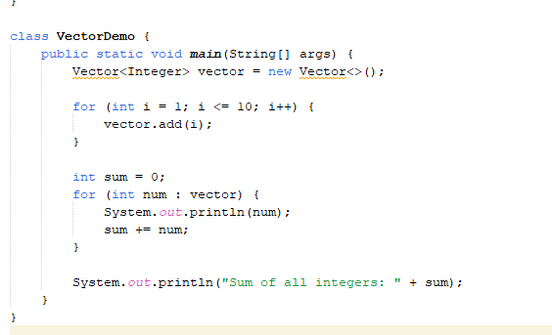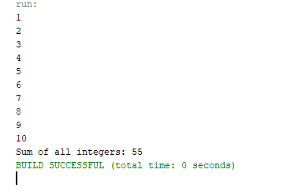

1. Create a ArrayList of string. Write a menu driven program which:
   * 1. Displays all the elements
     2. Displays the largest String

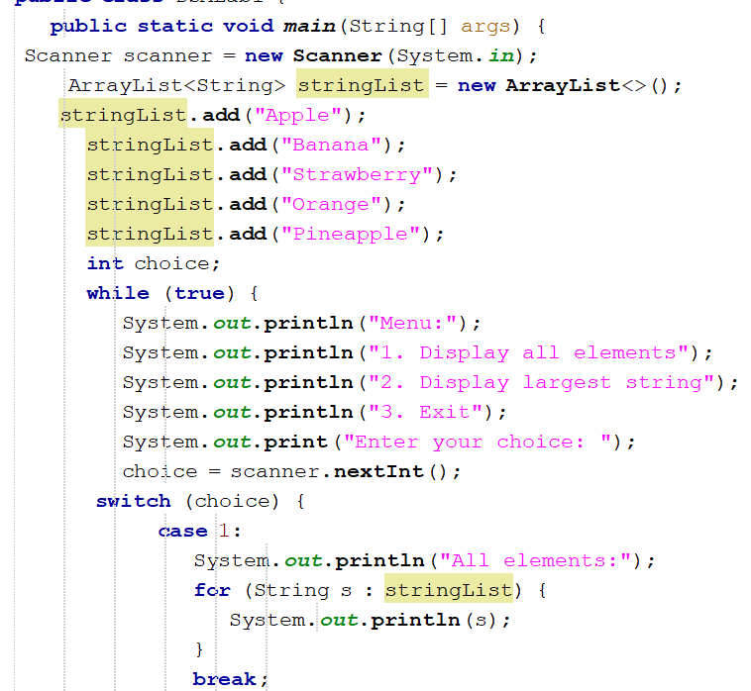

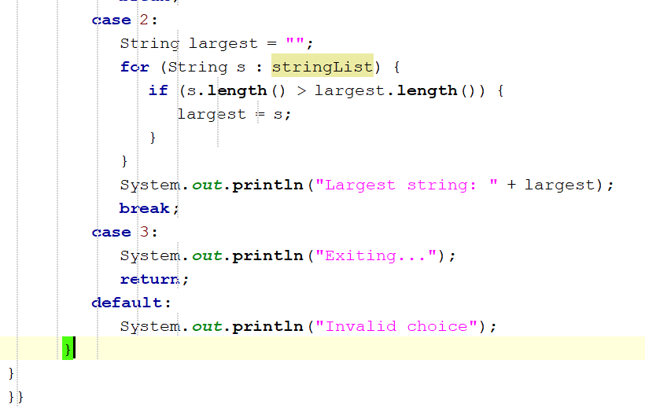

**OUTPUT**

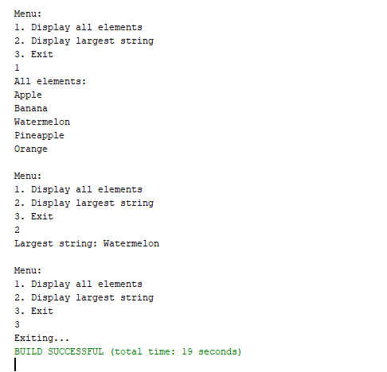

1. Create a Arraylist storing Employee details including Emp_id, Emp_Name, Emp_gender, Year_of_Joining (you can also add more attributes including these). Then sort the employees according to their joining year using Comparator and Comparable interfaces.

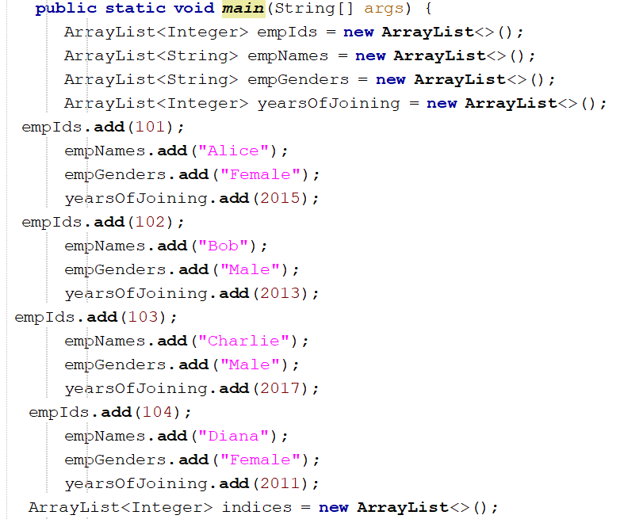

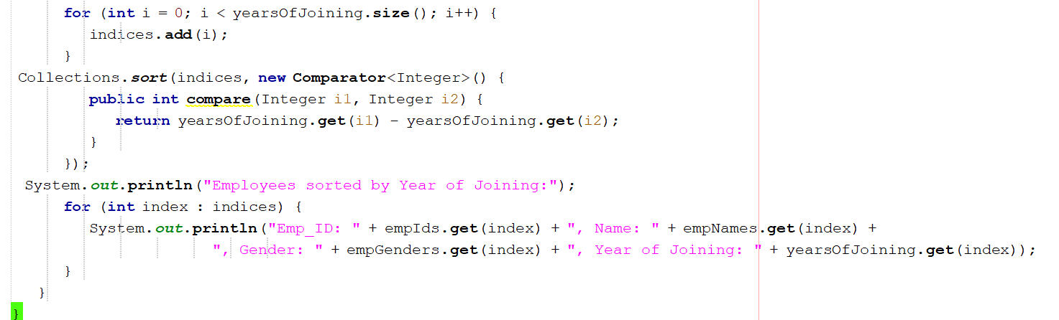

**OUTPUT**

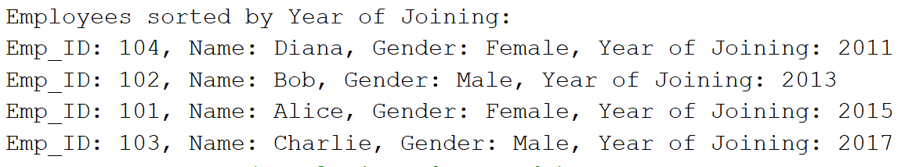

1. Write a program that initializes Vector with 10 integers in it.

* 1. Display all the integers • Sum of these integers.
  2. Find Maximum Element in Vector

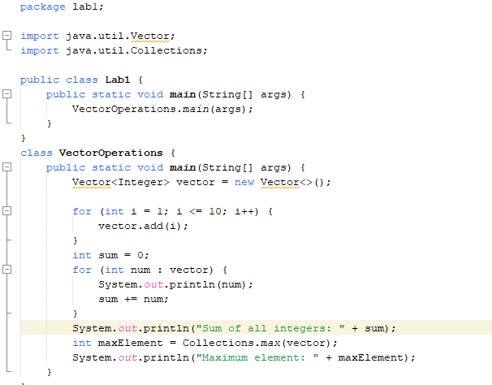

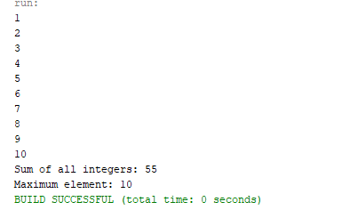

1. Find the k-th smallest element in a sorted ArrayList

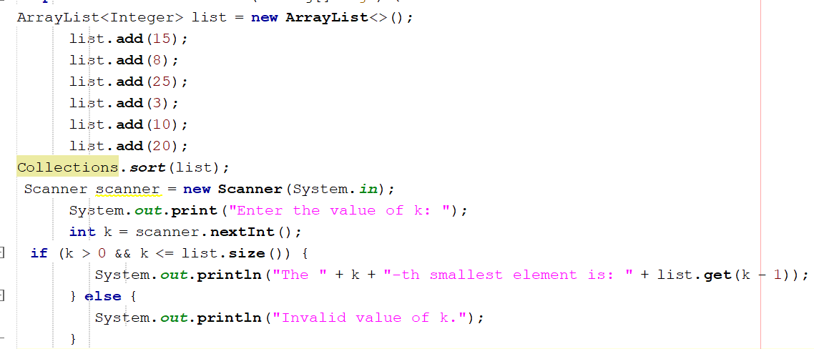

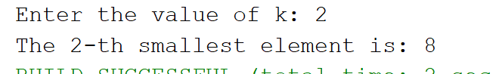

1. 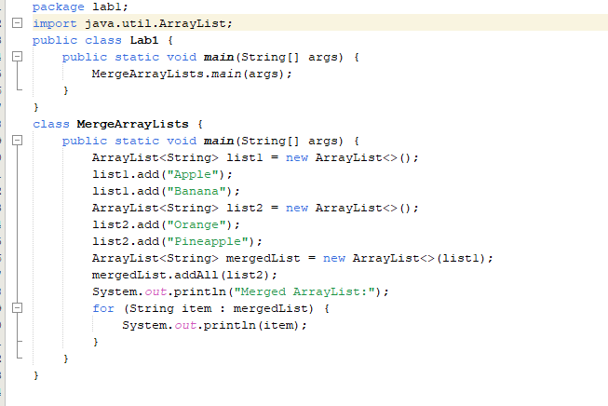Write a program to merge two ArrayLists into one.

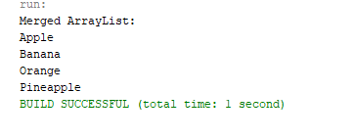

## Home Tasks

1. Create a Vector storing integer objects as an input.
   1. Sort the vector
   2. Display largest number
   3. Display smallest number

OUTPUT:

1. Write a java program which takes user input and gives hashcode value of those inputs using hashCode () method.

OUTPUT:

## 3. Scenario based

Create a java project, suppose you work for a company that needs to manage a list of employees. Each employee has a unique combination of a name and an ID. Your goal is to ensure that you can track employees effectively and avoid duplicate entries in your system.

Requirements

a. Employee Class: You need to create an Employee class that includes:

* name: The employee's name (String).
* id: The employee's unique identifier (int).
* Override the hashCode() and equals() methods to ensure that two employees are considered equal if they have the same name and id.

1. Employee Management: You will use a HashSet to store employee records. This will help you avoid duplicate entries.
2. Operations: Implement operations to:

* Add new employees to the record.
* Check if an employee already exists in the records. • Display all employees.

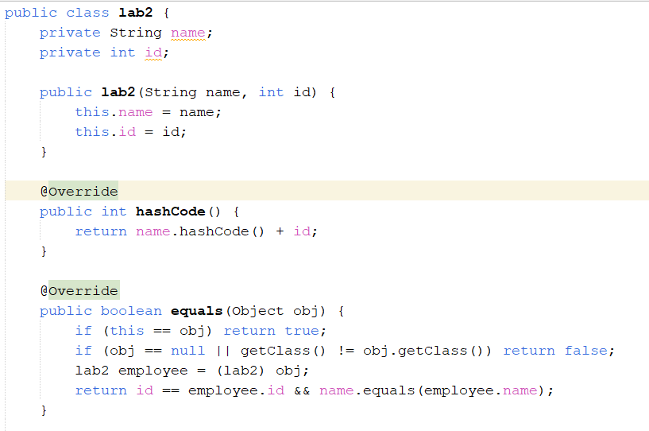

4.Create a Color class that has red, green, and blue values. Two colors are considered equal if their RGB values are the same

