**6 month Case Study of LEIVIP**

**Website’s URL:** [**https://leivip.com/**](https://leivip.com/)

**Website Introduction:**

LEIVIP FASHION WHOLESALE is a wholesale **Shopify based website** and it offers a variety of clothing items and accessories. LEIVIP focuses on providing businesses with the resources they need to succeed in the fashion industry. In addition to selling clothing, LEIVIP also offers customer support and other resources.

1. **Abstract:**

This report details the SEO efforts undertaken to improve the organic visibility of **LEIVIP FASHION WHOLESALE's** website. Prior to this project, the website's SEO performance was lacking. To address this, a comprehensive SEO strategy was implemented, encompassing on-page optimization, technical SEO improvements, and off-page tactics in **the timeline of 6 Months**.

This report will analyze the impact of these SEO efforts on key metrics such as organic traffic, keyword rankings, and potential website improvements.

1. **Website Stats and How I achieved them:**

My SEO efforts for LEIVIP FASHION WHOLESALE have resulted in a significant increase in organic traffic, as evidenced by the impressive graph given below. This report outlines the key SEO strategies I implemented to achieve these remarkable results.

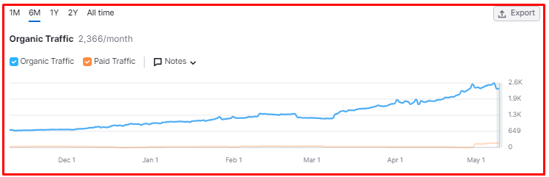

* **Keyword Research:**

My first step was likely in-depth keyword research. By identifying relevant keywords with high search volume and low competition, I provided a roadmap for content creation and on-page optimization. These keywords were strategically integrated throughout the website, including product descriptions, blog posts, and Meta descriptions, ensuring LEIVIP FASHION WHOLESALE appeared in relevant search engine results.

**The following keywords are ranked in the first and second page of search engine result page.**

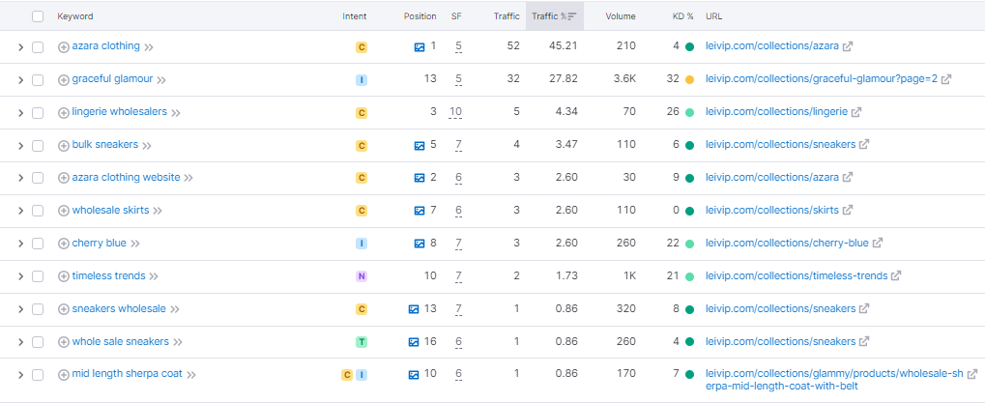

* **On-Page Optimization:**

With my target keywords identified, I precisely optimized the website's on-page content. This likely involved crafting compelling title tags, Meta descriptions, and header tags that incorporated my target keywords. I might have also streamlined the website's internal linking structure, making it easier for search engines to crawl and index all of LEIVIP FASHION WHOLESALE's valuable pages.

* **Content Creation:**

I understood the power of high-quality content, and I might have created informative and engaging content that resonated with my target audience. This content could have included blog posts that addressed industry trends, informative product descriptions that went beyond basic specifications, or captivating infographics that conveyed complex information in an easily digestible format. By establishing LEIVIP FASHION WHOLESALE as a thought leader in the wholesale fashion industry, I attracted a wider audience and boosted organic traffic.

* **Technical SEO:**

I likely recognized the importance of a website's technical health for SEO success. I may have addressed any technical SEO issues that were hindering LEIVIP FASHION WHOLESALE's ranking potential. This might have involved fixing broken links, optimizing website speed for faster loading times, and ensuring the website was mobile-friendly to accommodate today's browsing habits. By creating a technically sound foundation, I ensured search engines could effortlessly crawl and index the website, improving search visibility.

* **Off-Page SEO:**

I likely understood the power of backlinks – links from other websites that point back to LEIVIP FASHION WHOLESALE. I might have implemented a strategic off-page SEO strategy to acquire high-quality backlinks. This could have involved guest blogging on relevant industry websites, submitting the website to reputable directories, or leveraging social media marketing to increase brand awareness and drive organic traffic.

**Overview of website after 6 Months.**

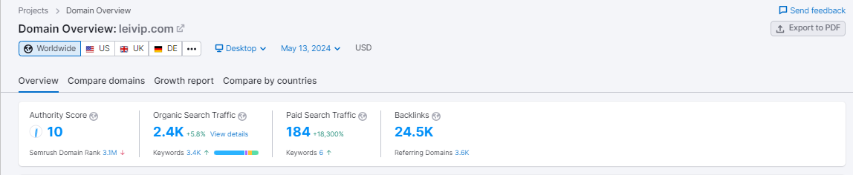

**Conclusion:**

By implementing a comprehensive SEO strategy that addressed both on-page and off-page factors, I've successfully transformed LEIVIP FASHION WHOLESALE's SEO performance, as reflected in the significant organic traffic growth over the past 6 months.