**4 month Case Study of Lyramodest**

**Website’s URL:** [**https://lyramodest.com/**](https://lyramodest.com/)

**Website Introduction:**

Lyra Modest is a clothing brand that focuses on modest fashion that is built on Shopify Platform. Their main focus is on modest fashion principles which can offers different items like active wear swimwear, restore wear and kids wear.

**Abstract:**

The website was initially plagued by numerous issues and suffered from minimal traffic, as indicated in the given chart below. Over a span of four months, I worked on it to rectify these issues through a comprehensive strategy focusing on on-page, off-page, and technical SEO. The concerted efforts yielded commendable results, culminating in a noticeable improvement in the website's performance.

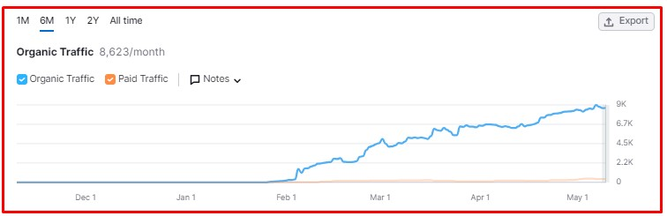

This graph clearly explains that till February the traffic graph becomes down and from that it starts improvement and getting more traffic.

**SEO Issues Identified in this site before:**

1. **Slow Page Load Speed**: Pages took an unnecessary amount of time to load, negatively impacting user experience and search engine rankings.
2. **Thin Content:** Pages contained minimal or insufficient content, providing little value to users and weakening search engine visibility.
3. **Duplicate Content:** Multiple pages featured identical or highly similar content, leading to confusion for search engines and potential penalties.
4. **Lack of Mobile Optimization:** The website was not adequately optimized for mobile devices, resulting in poor user experience and lower rankings in mobile search results.
5. **Inconsistent URL Structure:** URLs across the website lacked regularity, making it difficult for search engines to crawl and index content effectively.
6. **Missing XML Sitemap:** The website lacked an XML sitemap, delaying search engines ability to discover and index all relevant pages efficiently.
7. **Broken Internal Links:** Internal links within the website directed users to non-existent pages, causing frustration and negatively impacting search engine crawlability.
8. **No Off-page at all:** The site DA, PA was not up to the mark.

**SEO Strategies Applied:**

1. **Addressed Technical Issues:** Conducted a comprehensive audit to identify and resolve technical issues such as site speed optimizations, schema markup implementation, and SSL certificate installation to improve overall website performance and search engine visibility.
2. **Implemented 301 Redirects for 3xx Redirection Errors**: Redirected outdated or broken URLs to relevant and functional pages to ensure smooth user experience and maintain search engine rankings.
3. **Resolved 4xx Client Error Responses:** Fixed broken links and resolved server errors to enhance website accessibility and prevent negative impact on search engine indexing.
4. **Optimized Sitemap Structure:** Restructured the XML sitemap to include all relevant pages and ensure proper organization, facilitating search engine crawlability and indexing.
5. **Optimized Page Load Speed:** Implemented various techniques such as image optimization, browser caching, and modification of CSS and JavaScript files to improve page load speed and enhance user experience and search engine rankings.
6. **Added Meta Descriptions:** Crafted unique and compelling Meta descriptions for each page to improve click-through rates in search engine results pages (SERPs) and enhance user engagement.
7. **Implemented Alt Text for Images:** Added descriptive alt text to images across the website to improve accessibility for visually impaired users and enhance image search optimization.
8. **Enhanced Internal Linking Strategy:** Implemented a structured internal linking strategy to improve website navigation, distribute link equity, and enhance search engine crawlability and indexing.
9. **Expanded Content:** Developed high-quality, informative content to enrich existing pages and address thin content issues, improving relevance and authority in search engine rankings.
10. **Removed Duplicate Content:** found and fixed pages with the same content. I either removed them or combined them into one strong page. This helps search engines and users understand better and avoids any penalties.
11. **Standardized URL Structure:** Implemented consistent URL structure across the website, including relevant keywords and logical hierarchy, to improve crawlability, indexability, and user understanding.
12. **Off-page Optimization:** Implemented off-page SEO strategies such as building high-quality backlinks from authoritative websites, engaging in social media promotion, and participating in relevant online communities to enhance website authority, increase referral traffic, and improve search engine rankings.

**Website Stats after these Implementation:**As you can see The Keywords mentioned below are all ranking on first page of SERP with higher volume

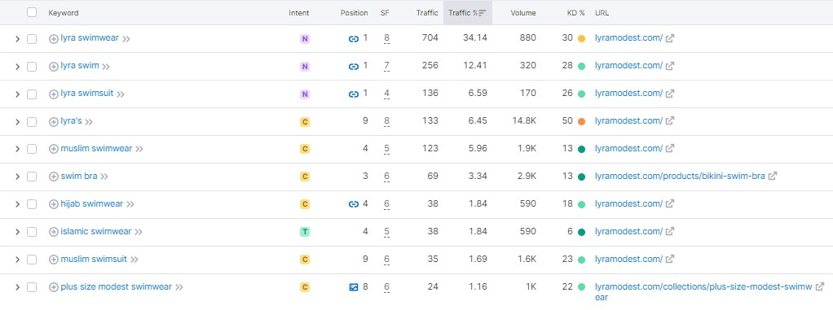

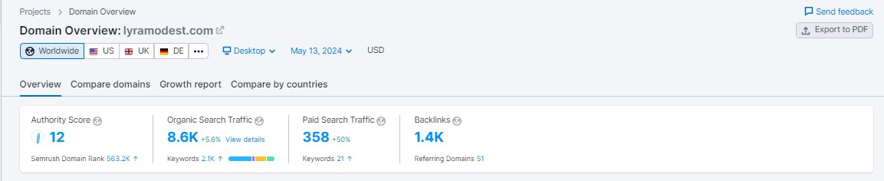  
  
  
  
  
  
  
  
  
  
  
  
  
  
  
  
  
  
  
  
  
  
  
  
  
  
  
  
  
  
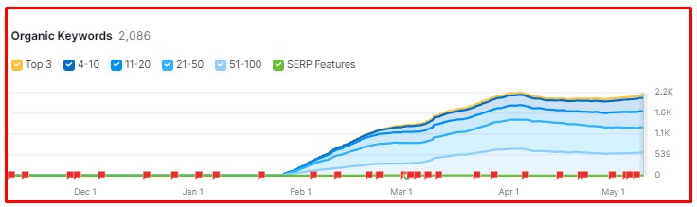  
  
  
  
  
  
  
  
  
  
**These are the results after implementing the SEO Strategies mentioned above.**