

AI CLINIC ASSISTANT

AI AGENT


SEPTEMBER 29, 2025
APP AURA
Office#4, Commercial area KB colony, new Airport Road, Lahore Cantt, Pakistan

Contents
Introduction 2
Problem Statement 2
Solution 3
Tech Stack 3
Features: 3
For Admin 3
For User 3
For receptionist 4
Ai Agent 4
Starting with Admin 5
User’s side: 7
Chat Scenario: 9
Call Scenario: 12
Cost (Rough projection) 15
Conclusion 16

Introduction:
The AI Clinic Assistant is a smart tool that helps clinics manages patient more easily. Clinic’s often struggle with long wait, missed appointments and busy staff. Our AI appointment
assistant solves this by handling appointments, reminders, patient queries (Complaints, Updates, Cancellation and if they require any kind of help they are struggling with). This saves time, reduce workload, reduce the cost of too much staff and gives the patient a faster and more affordable experience.

Problem Statement:
Many hospitals face’s issue of appointment handling sometimes its missed, sometimes when a receptionist is busy in a call and at that right moment some other calls they can’t book an appointment , also hospitals have 3-4 receptionist minimum per shift of 8 hours increasing cost of the hospitals. (To check the cost details proceed at end).

Solution:
For these kind of problems we have our Ai agent which can handle these things easily, fully integrated with security. This service is for user’s, for admin and for receptionist’s. This service will lower the cost of staff from 40-50% keeping hospital’s working more easy and better for user-experience.
(Features are below this page).

Tech Stack:
- Python
- FastApi
- MongoDb
- React js
- Vapi
- Make.com

Features:
This Assistant have 3 parts we will see 1 by 1.
For Admin:
- Check history (Add update cancel) of Appointments.
- Check history (Add update cancel) of chats and call logs (by decrypting )
- Check cost on his dashboard that Ai is utilizing.
- Check how many users are using this service.
- Can also updates the bot configuration’s like voice and prompt if he wants to add something.
- Only Admin can see the history of how users are utilizing AI, how they chat, how they talk, all data is encrypted and only admin can decrypt it by logging in.
For User:
- Can book an appointment by chat or by call.
- Can update or cancel an appointment by chat or call.
- Can see the history of chats and calls on his dashboard.
- Will receive a confirmation email.
- Can see his appointment history.
For receptionist:
- Can see only the Appointment details, cancellations and updates.
Ai Agent:
- Inbound calls.
- Automatic outbound calls.
- Chat
- Sending Automatic confirmation emails.
- Handle every type of user request.

Flow of Service

Starting with Admin
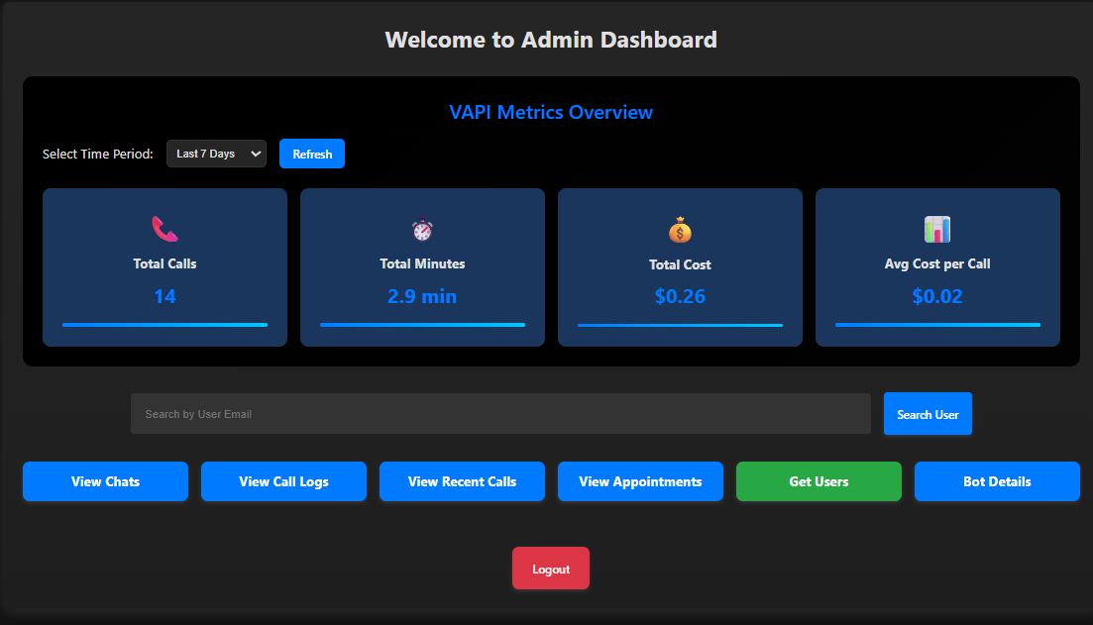
The calls, minutes cost you seeing is the cost of Ai and total calls done to Ai agent.
View chat → you can see all users chat.
View call logs → you can see call logs transcripts etc.
View Recent calls → You can see the last 10 or selected calls number and breakdown its call cost like this.
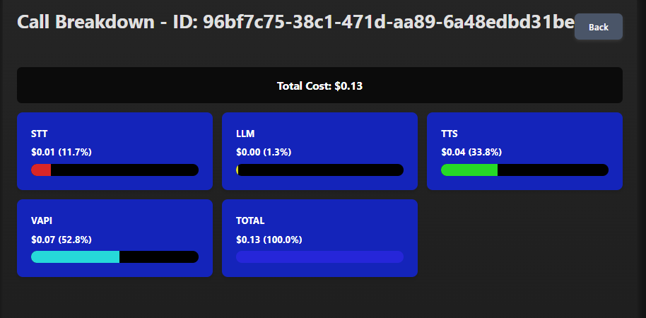

Get User → you can see all users with details like:
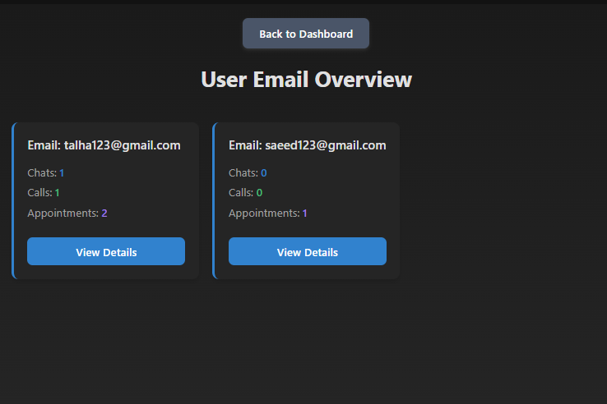
Bot Details → you can update the bots configurations like voice, transcriber with cost detection to lower the cost and latency.

User’s side:
User login page →

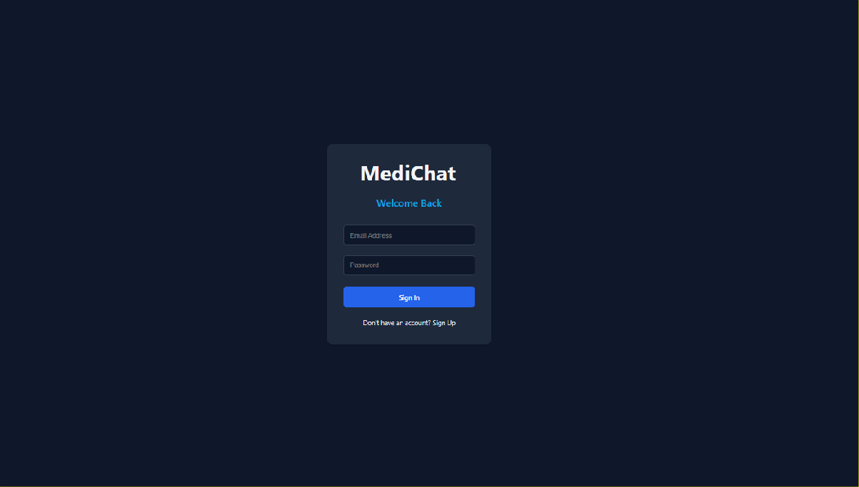
User dashboard → you can see appointments upcoming, recent, Active inactive.

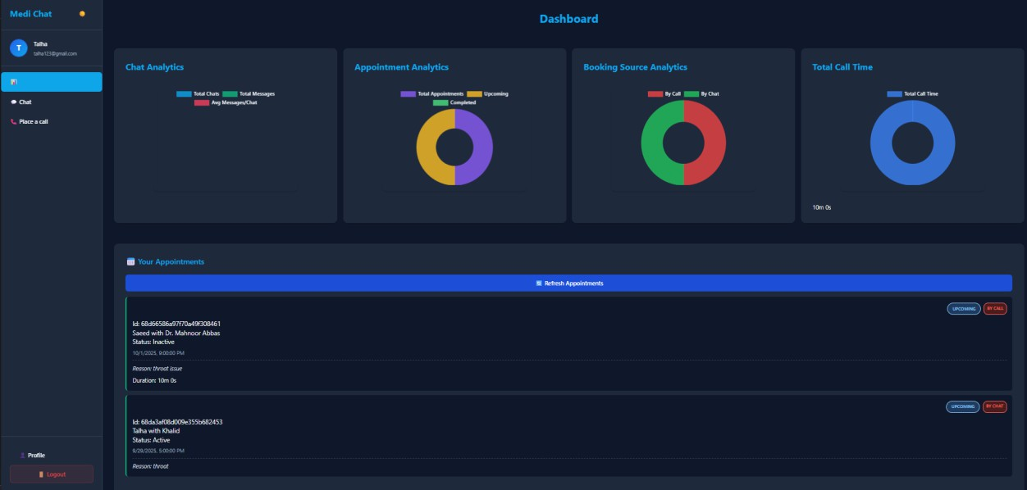

Chat button → you can chat with AI to book also history are saved for data security.
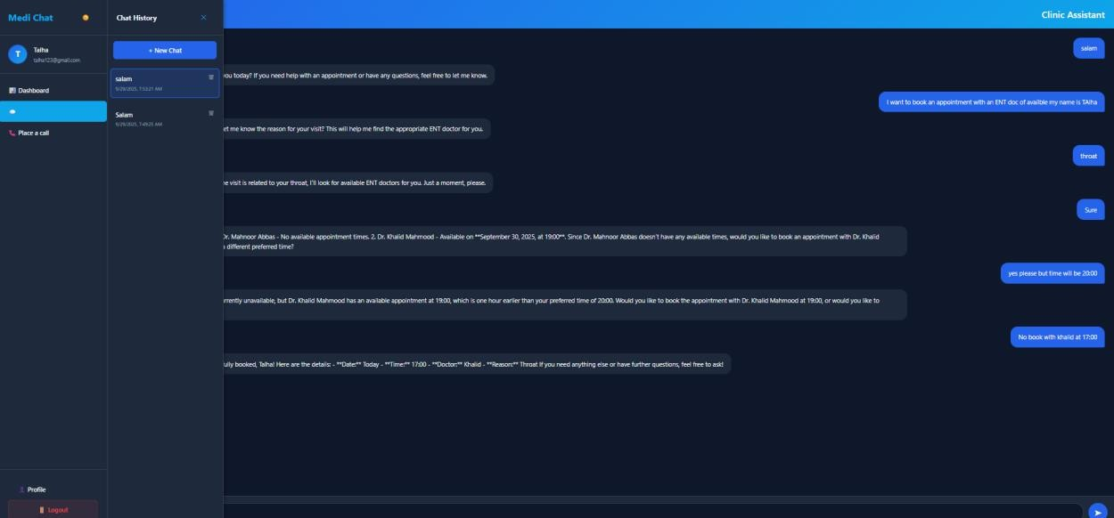

Call button → you can call on website with AI no phone number needed and also all the transcript is saved in database.

Chat Scenario:
User wants to book an appointment with an ENT doctor. Having throat issue. Vapi have the same data stored in database.

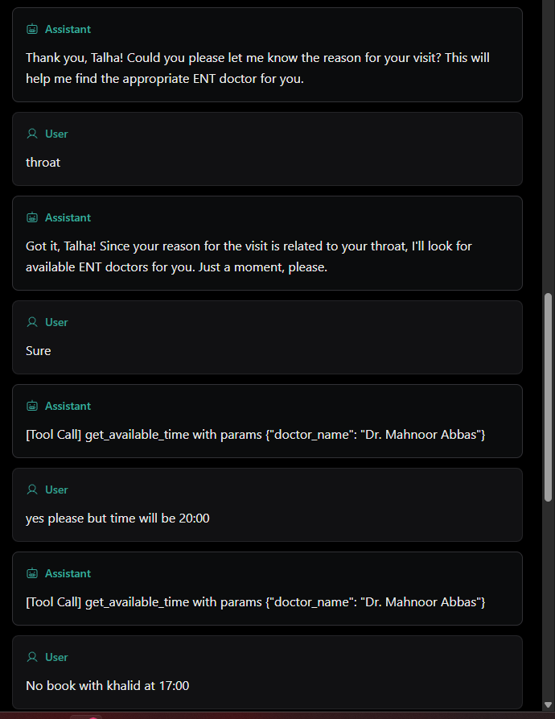
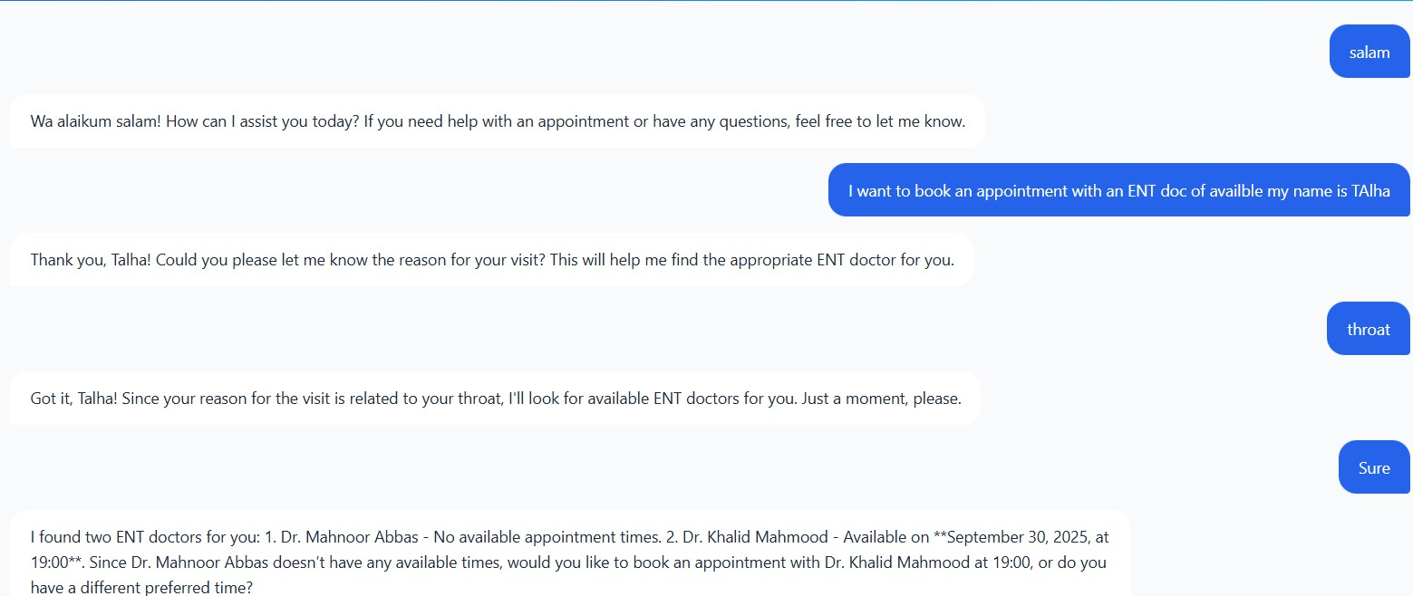

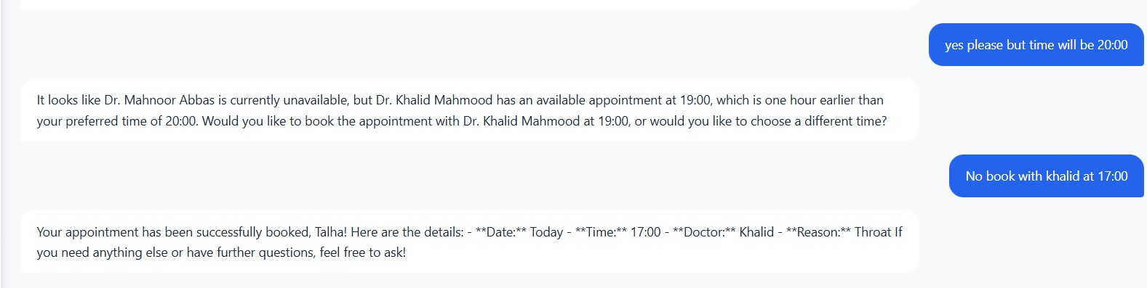
Here is the details in database and on user dashboard.
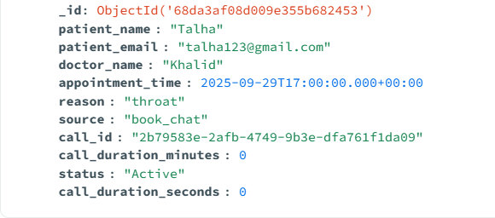

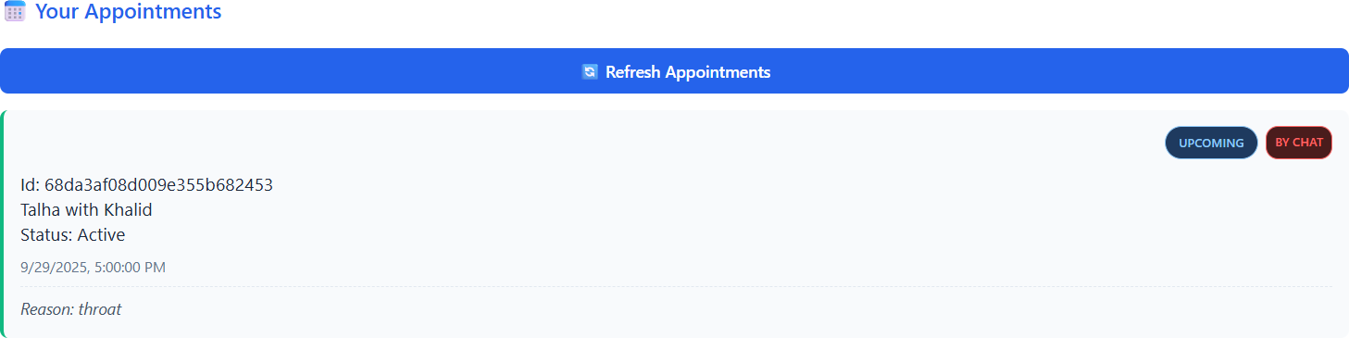

Now if he wants to cancel, just use that id showing on user dashboard. Again Vapi AI have same data stored.
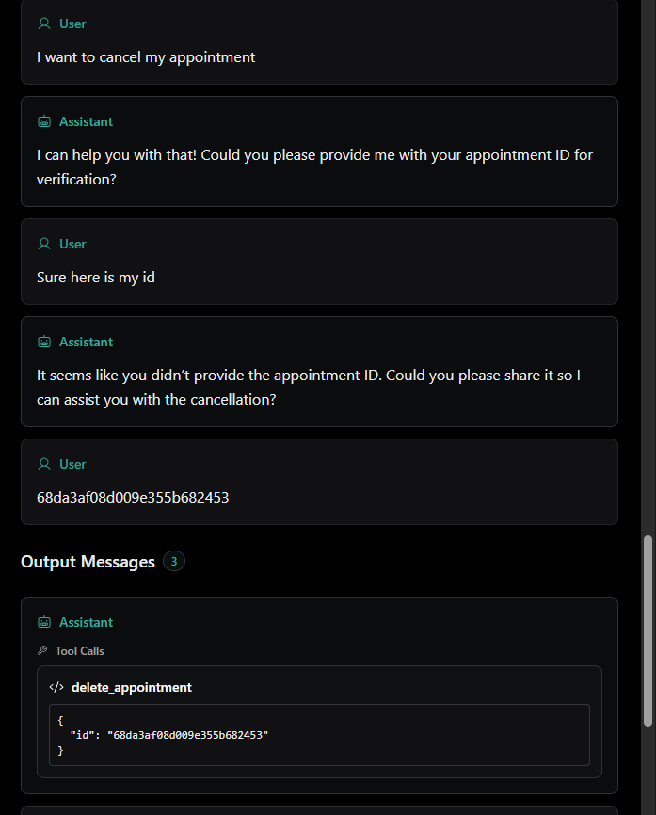

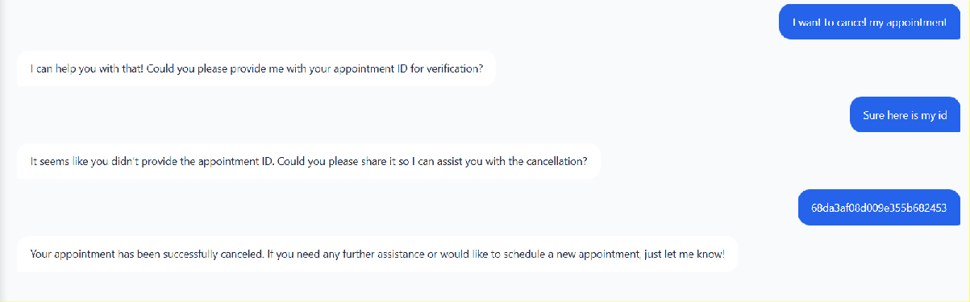
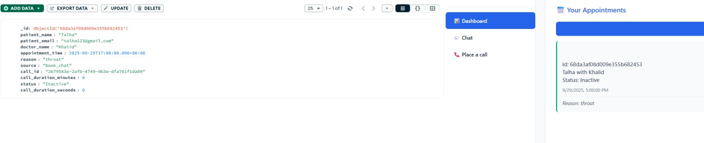

Now you can see status is Inactive now.

Now if user want to update the time of his appointment use that same id. Vapi have same messages stored.

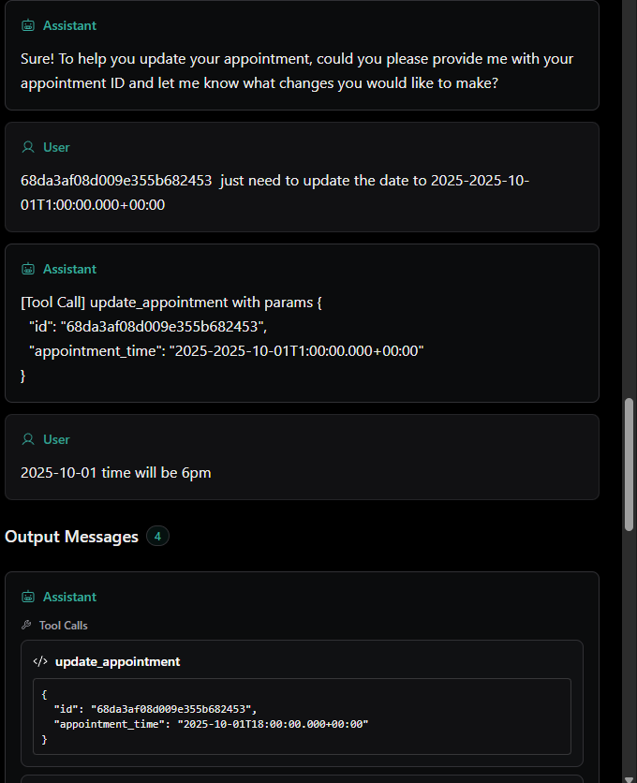
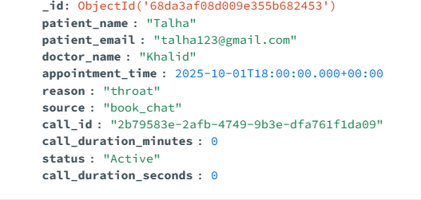

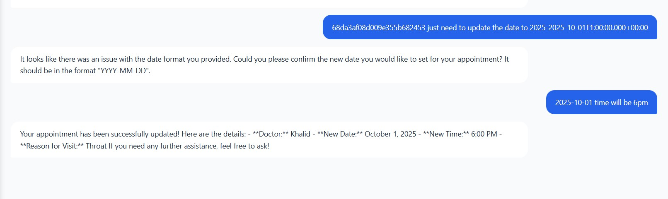

Messages of users are encrypted and only user can decrypt it when he logs in
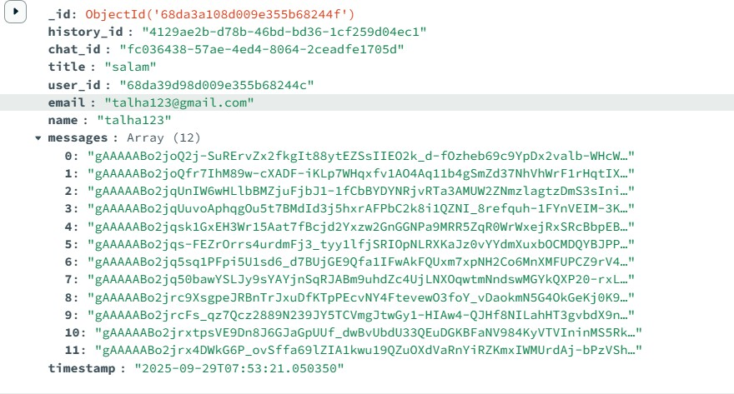

Call Scenario 1:
Go on user dashboard and you can see the calls button like that at top right corner just click it and you will get a pop-up like:
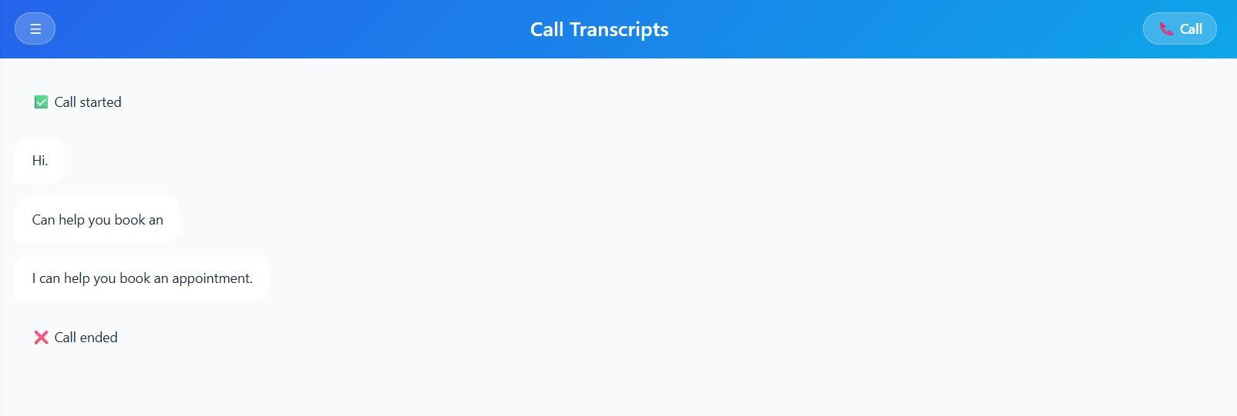

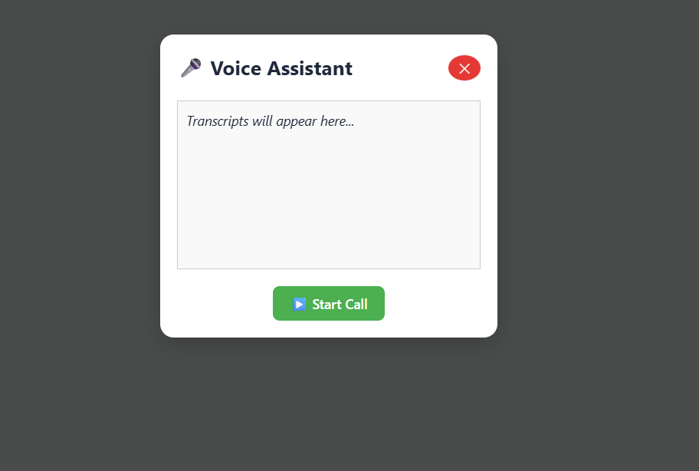

Here is call logs database everything is encrypted same like chat only user with that email can decrypt it to see the transcript.
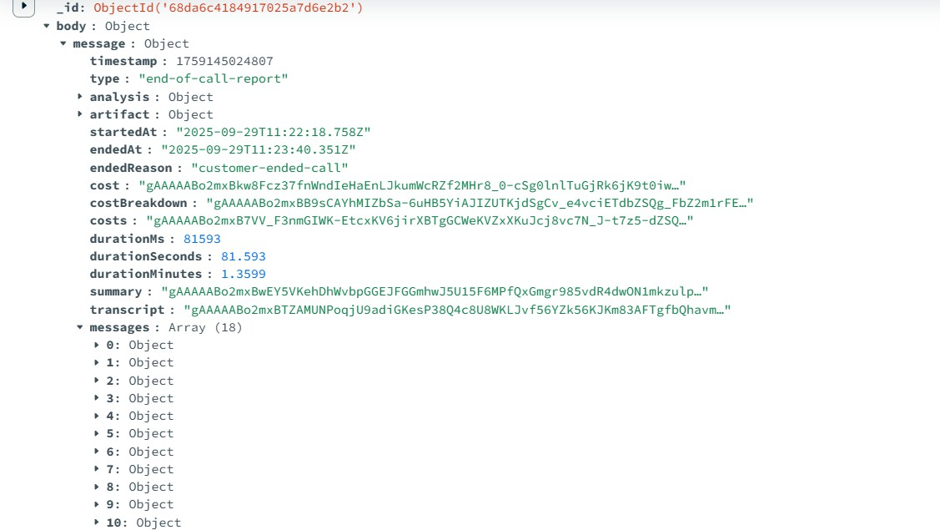

fced8840-1790-4fa8-a8d4-040b8b8f24c3-1759145022866-d34f19c8-
1487-477a-905f-9947780efff2-stereo.wav
Call Scenario 2:

User calls with his phone number → To Ai Agent number → Same things happened → Same database scenario → both calls are same difference is the user’s reliability.

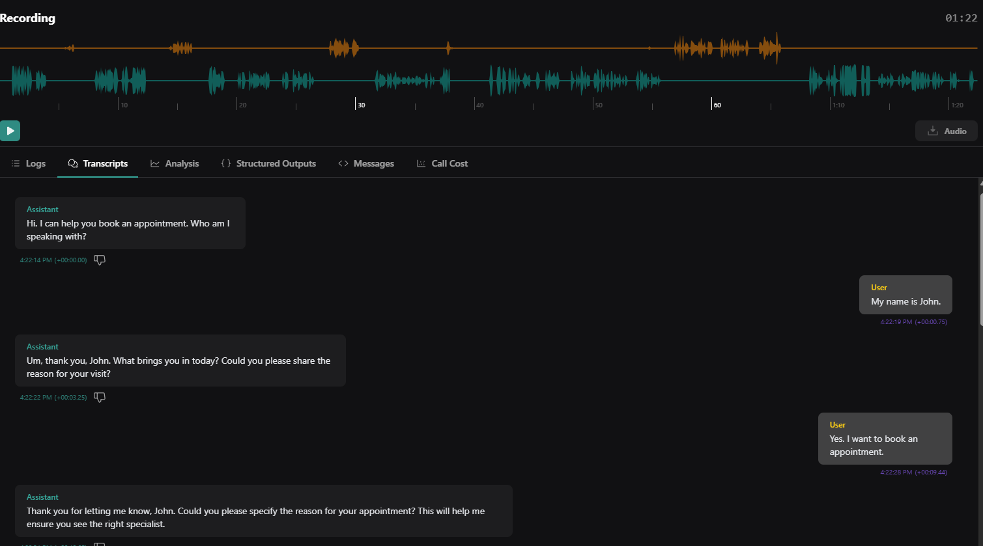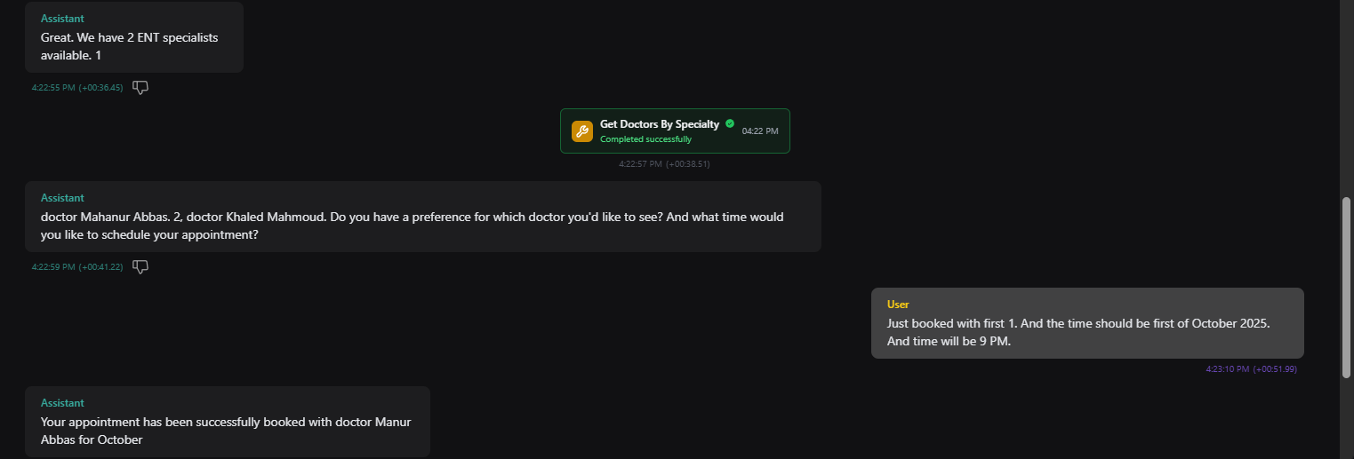

How the data is encrypting and decrypting?
User chat or call → Send’s to database and encryption key generates a cipher text that is unreadable → save in database.
User wants to see his history → Click on chat or call history → request goes to database he use that same encryption key to decrypt it → User can now his history by decrypting.

Email Scenario:

When the Make.com webhook received the data from database the same data of appointment. He will automatically sends the email to patient email he received in data. Like below:

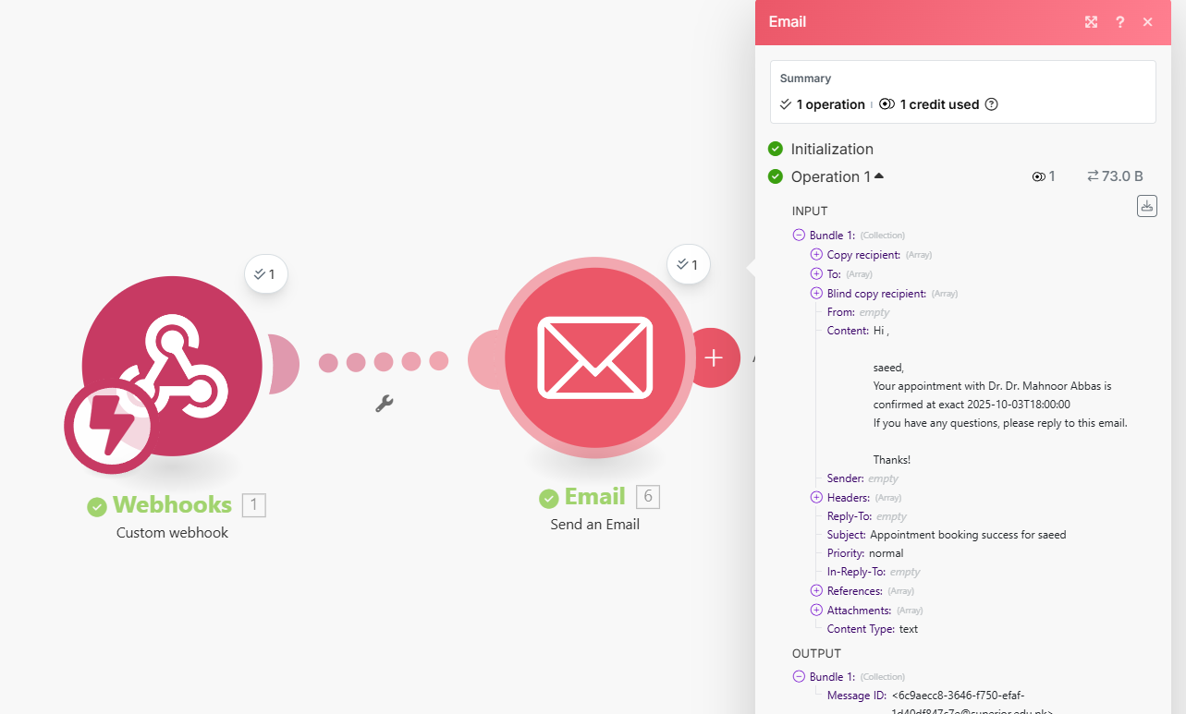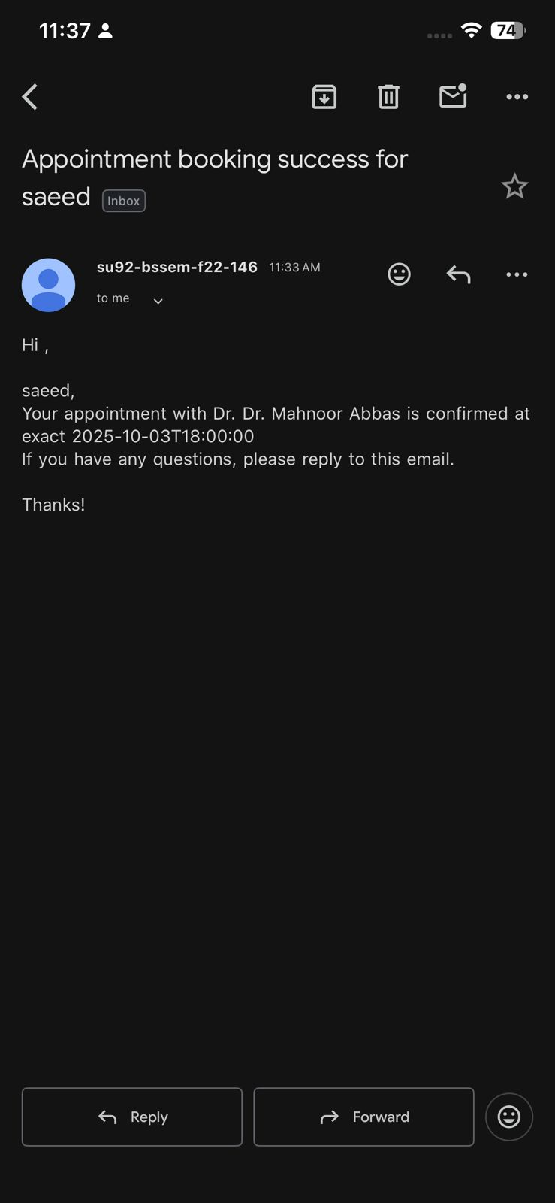

Cost (Rough projection):

AI Cost | Hospital’s receptionist cost | What hospitals are saving?
0.1$/min | 8 hours 3 shifts. 18$/hour | Now hospital don’t  need 3 receptionist per shift. Now only needs 1 to see bookings and  managing.
Let’s say 1000 min AI utilized.  0.1x1000 =100$ | For 1 day with 2 receptionist per shift 36x24=864$ | For 1 day  18x24 = 432$
Monthly let say 0.1X 20000=2000$ | Monthly it is 25920$.  Remember its  according to 24 hours. | Monthly it is 12960$.  Remember its  according to 24 hours.
For 1 year:  2000x12 = 24000$ | For 1 year  12960x12 = 311040$ | For 1 year  12960x12 = 155520$

Now with 1 receptionist/shift no need of 2 now 155520+24000
=179,520$
Before when two receptionist 311040 – 179520 = 131520$
Usually hospitals have more than 2 receptionists per shift but we will considering minimum to show how much this will save you the cost and much better and easy 24/7 experience.

Conclusion:
Now with our Ai agent, With 3 receptionists at a time hospitals still missed some booking leading to cause an issue, long waits. Now with this service user just go to web/app to just chat and book an appointment and they can place a call too. With this service
hospital’s cost will be saved a lot and it’s still better have 24/7 availability. So the main part of this service are:
For hospital → lowers the cost, easy handling of appointment.
For users → with internet can place call, chat and see his history

