**Name: m.talha**

**Rollno: 214**

**Section: a**

**LAB # 03**

**K-NEAREST NEIGHBOR (KNN) ALGORITHM**

**OBJECTIVE**

Implementing K-Nearest Neighbor (KNN) algorithm to classify the data set.

Task1:

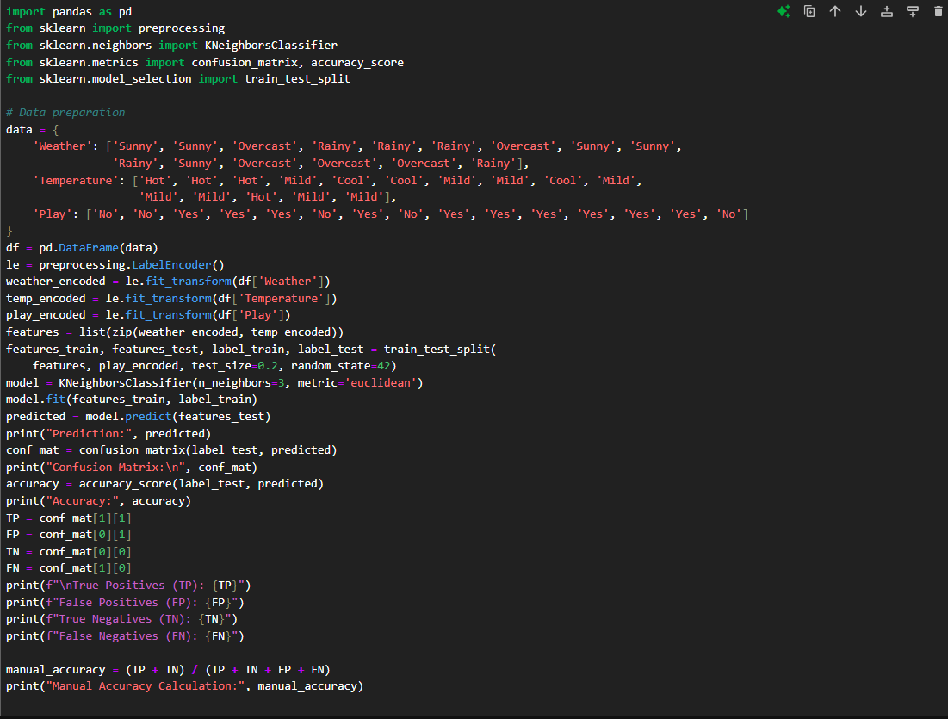

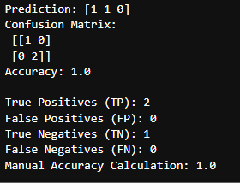

Task2:

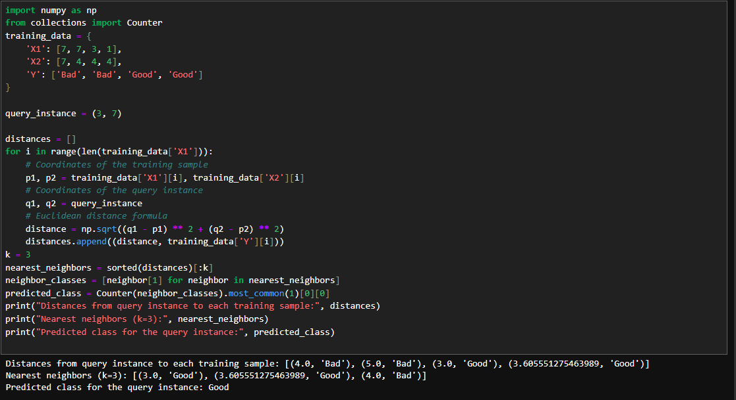

HOME ASSIGNMENT:

