

**PRACTICAL LAB**

**DIGITAL LOGIC DESIGN**

**Assign by: SIR ABDUL RAFAY**

**Prepared by: Muhammed Talha Siddiqui**

**Which gates are categorized as UNIVERSAL GATES and how they are used?**

A universal gate is a gate which can implement any Boolean function without need to use any other gate type. **The NAND and NOR gates are universal gates**. In practice, this is advantageous since NAND and NOR gates are economical and easier to fabricate and are the basic gates used in all IC digital logic families.

Working of **NAND gate:**

To prove that any Boolean function can be implemented using only NAND gates, we will show that the AND, OR, and NOT operations can be performed using only these gates.

**Implementing an Inverter Using only NAND Gate:**

All NAND input pins connect to the single input **A** gives an output **A’**

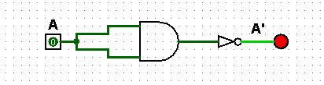

Implementing OR using only NAND Gate:

The OR Gate is replaced by a NAND gate with all its inputs complemented by NAND gate inverters.

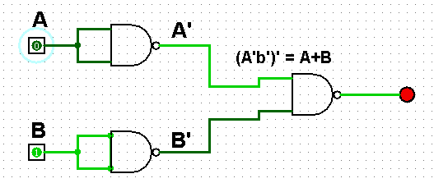

Working of **NOR gate:**

To prove that any Boolean function can be implemented using only NOR gates, we will show that the AND, OR, and NOT operations can be performed using only these gates.

All NOR input pins connected to the input signal **A** while all other input pins are connected to logic **0**. The output will be **A.**

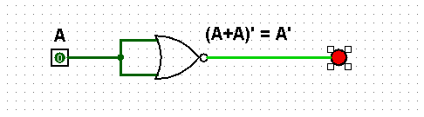

**Implementing OR using only NOR gate:**

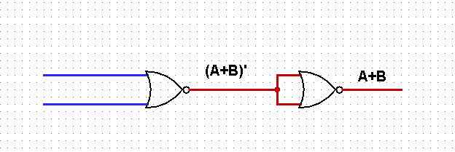

Implement AND using only NOR gates:

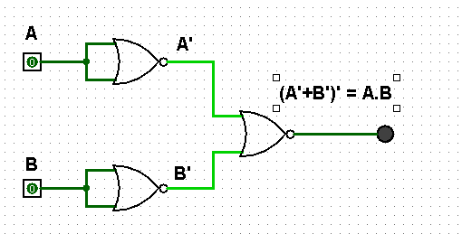

**Thus, the NOR gate and NAND is Universal gate**

**2. Verify the Truth Table for AND Gate and OR Gate.**

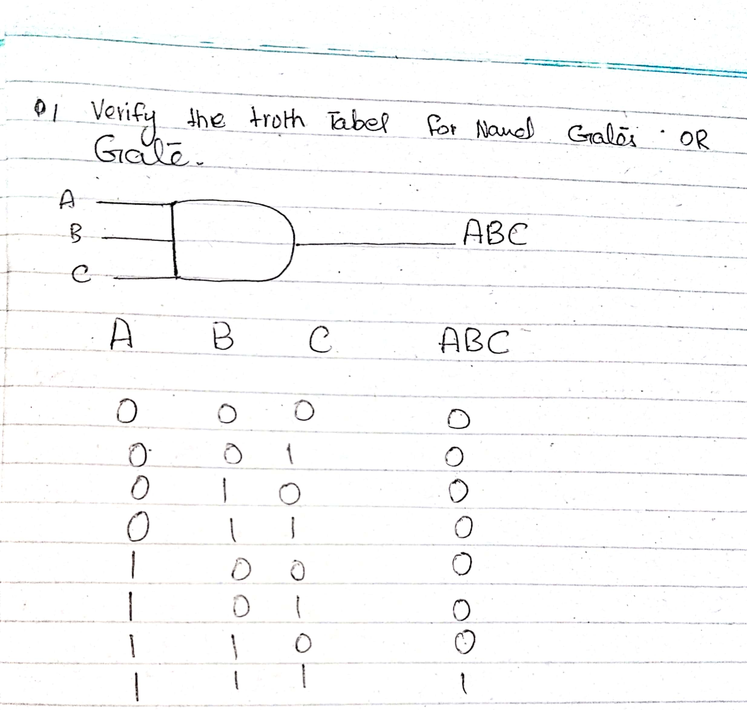

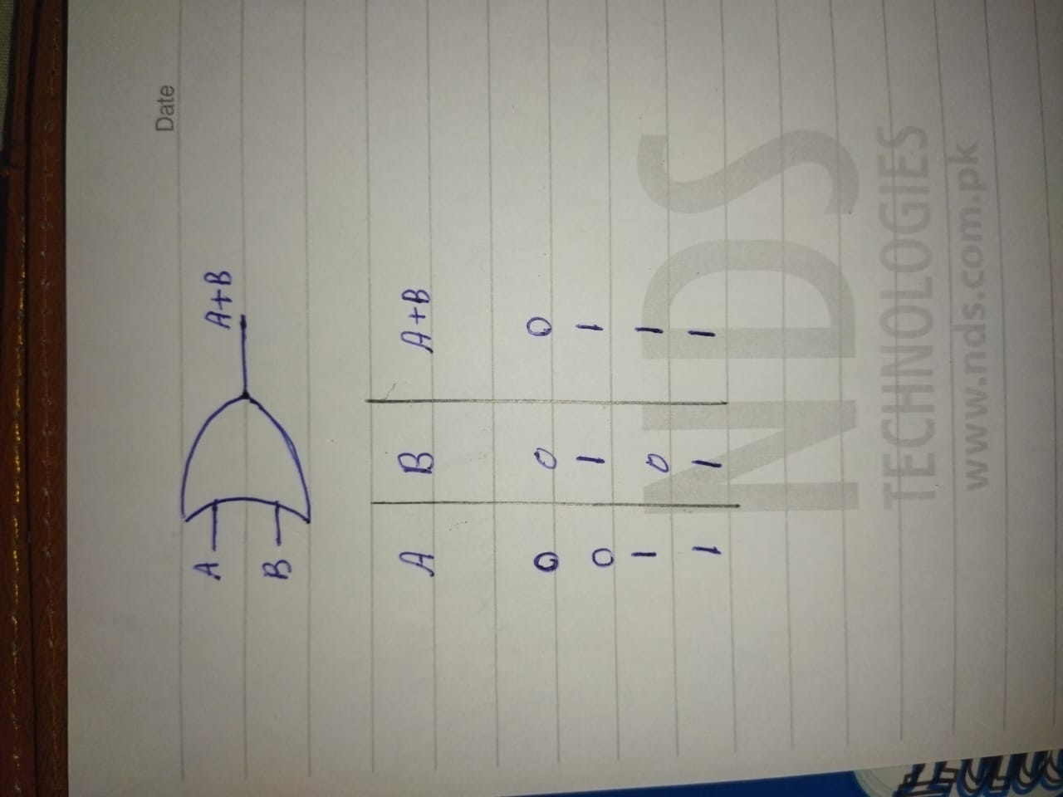

**3. Verify the Truth Table for NOR Gate and NAND Gate.**

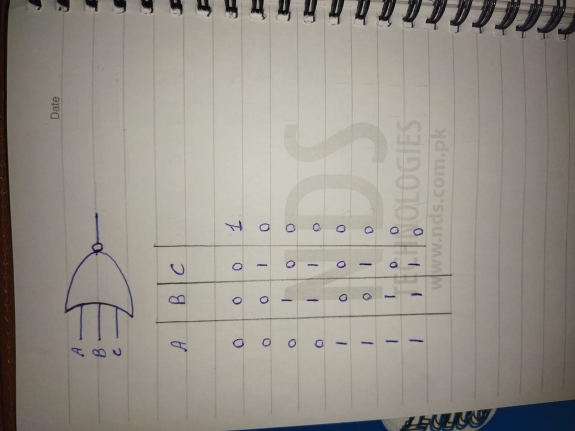

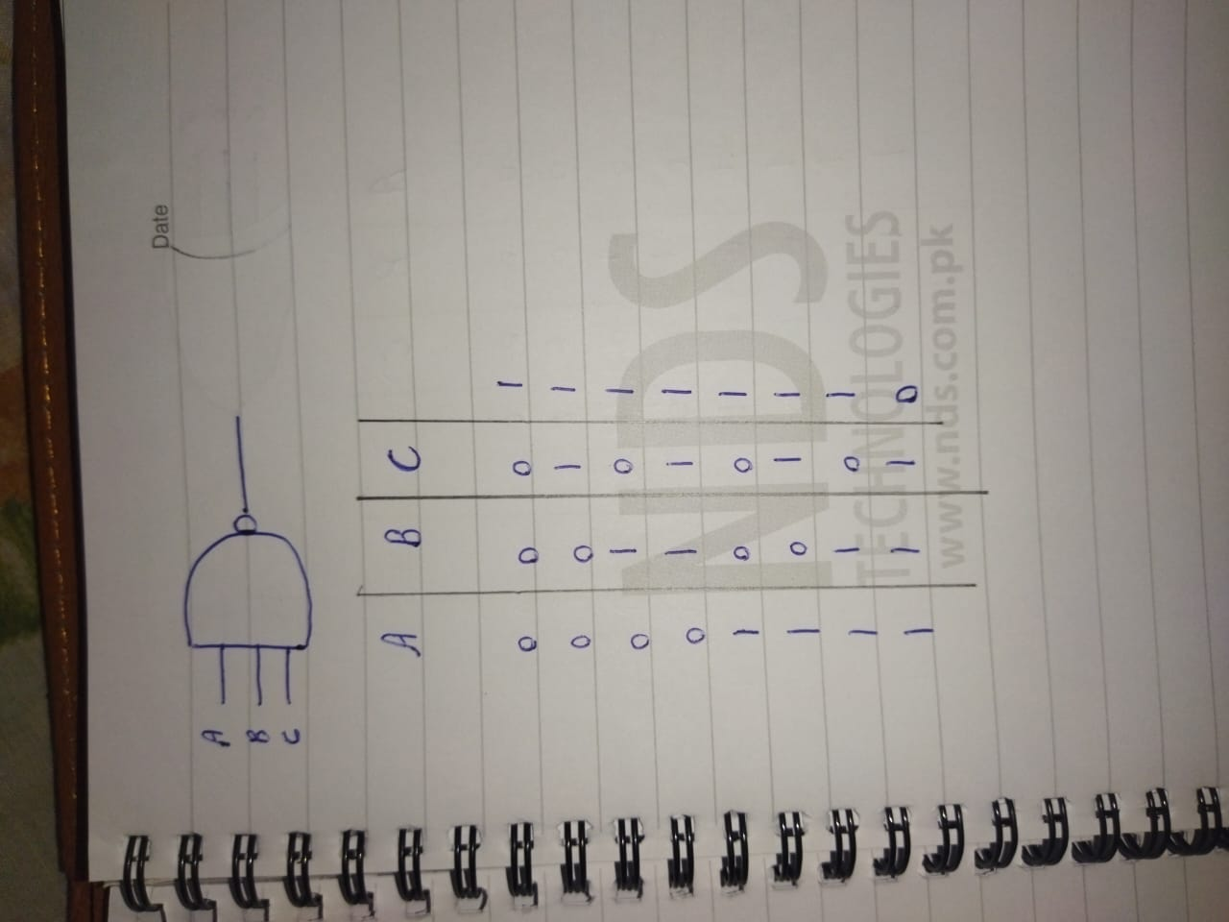

**4. Verify the Truth Table for XOR Gate and XNOR Gate.**

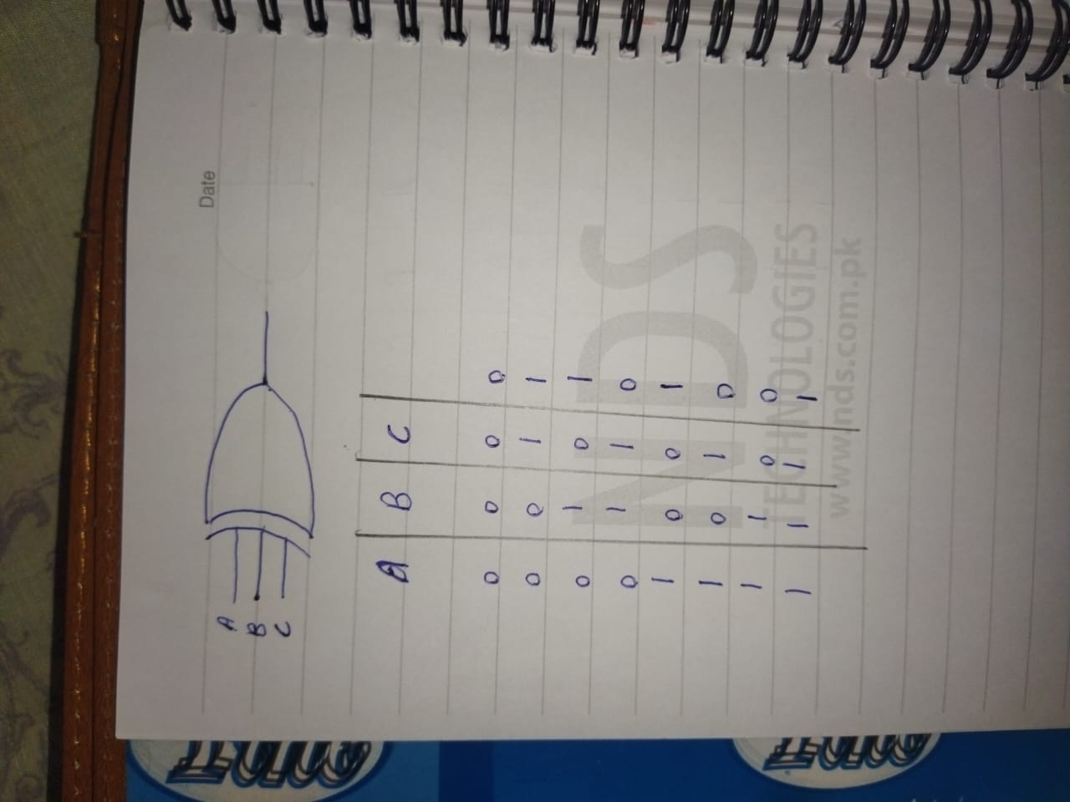

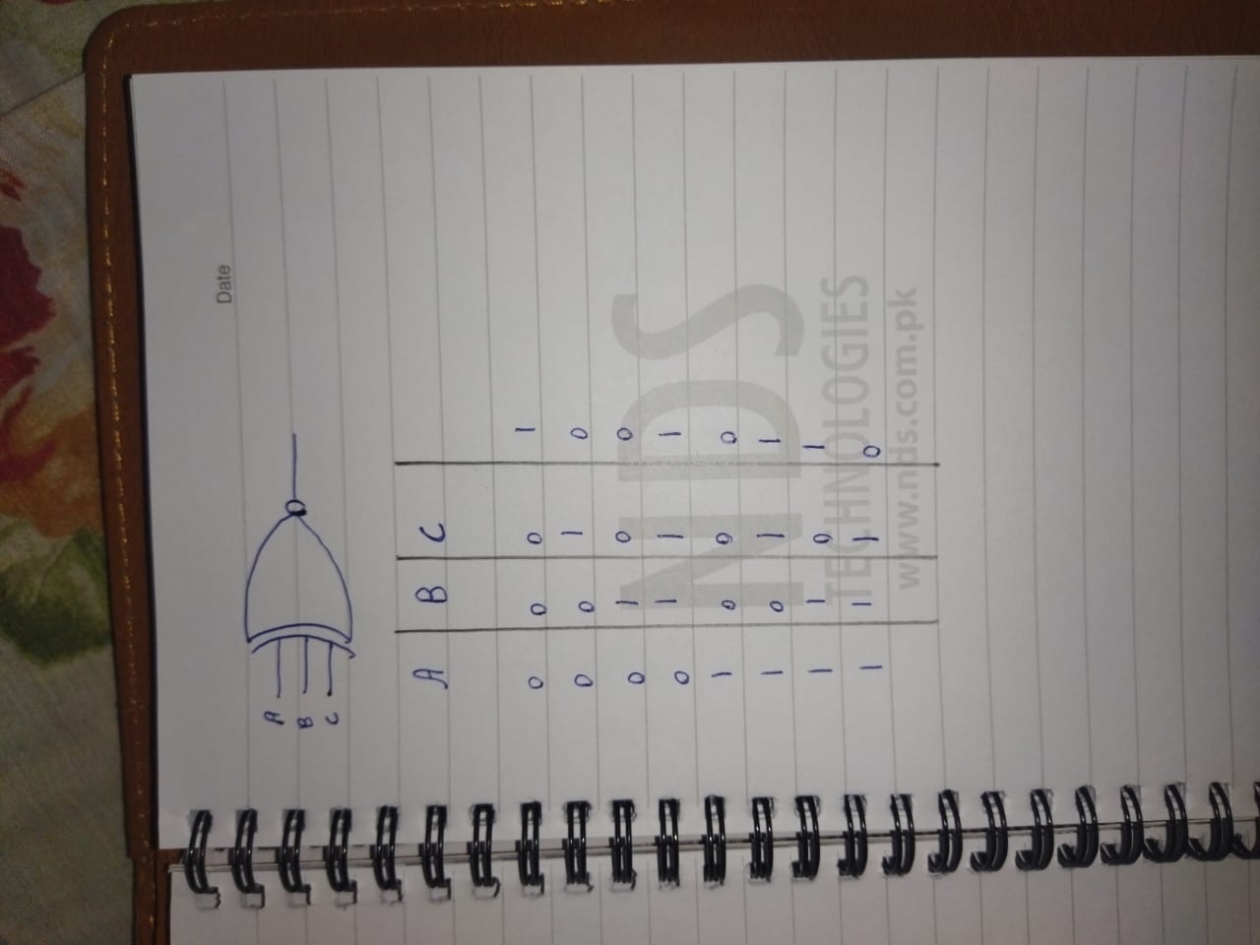

**Convert the following logic gate circuit into a Boolean expression, writing Boolean sub-expressions next to each gate output in the diagram:**

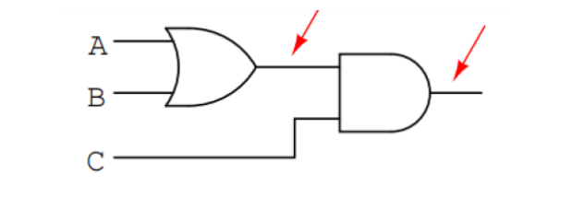

**Answer #1: A+B | Answer #2: A+B.C**

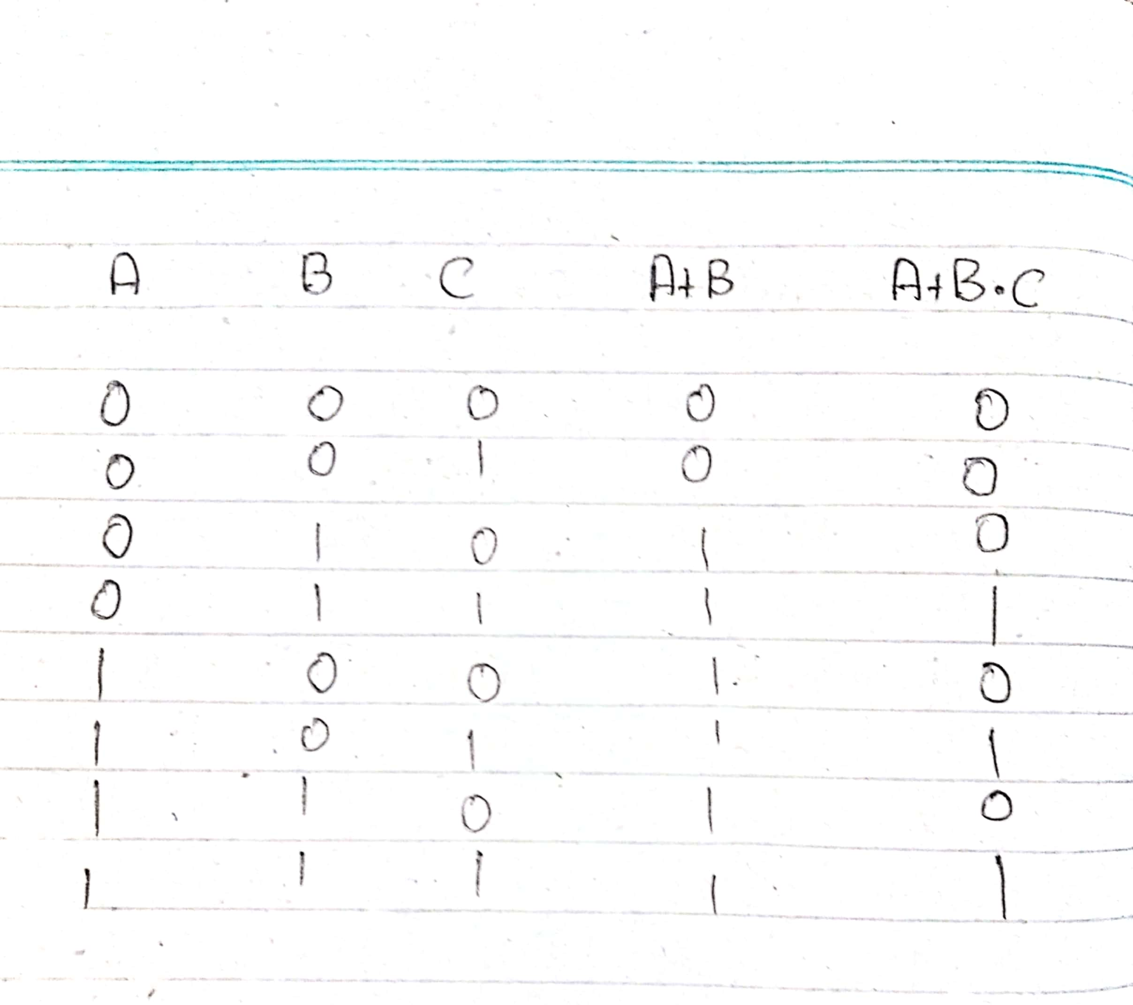

**Draw the following function in Circuit maker**

1. **F = 𝑿’YZ + 𝑿’Y𝒁’ + XZ**

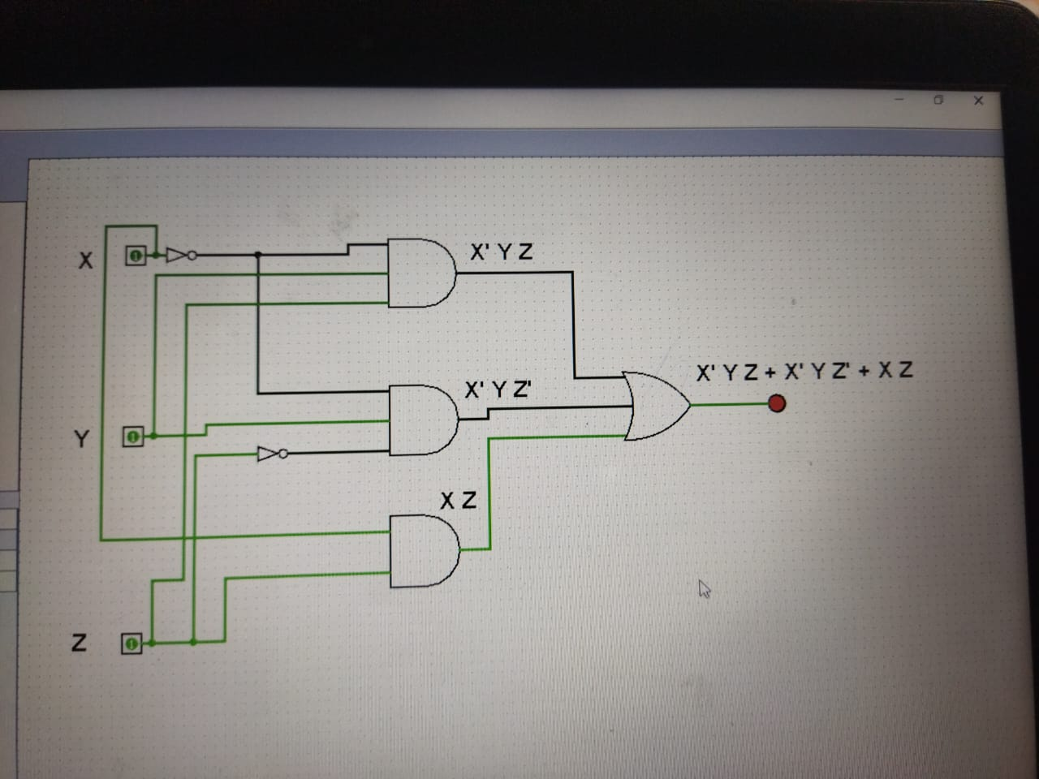

1. **F=𝑿’Z + X𝒀’Z +YZ’**

