Supplementary C: Molecular Subtypes Covariates

# C.1 Technical Variability and Potential Sources of Bias

## C.1.1 Within CodeSet Replication

## *Table SC1*: Comparison of within site replicates on 100 samples

### A - Confusion Matrix

|  |  |  |  |  |  |
| --- | --- | --- | --- | --- | --- |
|  | Final Originals | C1.MES | C2.IMM | C4.DIF | C5.PRO |
| Predicted Replicates |  |  |  |  |  |
| C1.MES |  | 23 | 0 | 0 | 0 |
| C2.IMM |  | 0 | 18 | 3 | 0 |
| C4.DIF |  | 0 | 0 | 28 | 2 |
| C5.PRO |  | 0 | 0 | 1 | 25 |

### B - Overall Metrics

|  |  |  |
| --- | --- | --- |
| Metric |  | P value |
| accuracy | 0.94 (0.87 - 0.98) | < 0.001 |
| kappa | 0.92 (0.86 - 0.98) |  |

### C - By-Class Metrics

|  |  |  |  |  |  |  |  |
| --- | --- | --- | --- | --- | --- | --- | --- |
| Class | Sensitivity | Specificity | PPV | NPV | F1 | Detection Prevalence | Balanced Accuracy |
| C1.MES | 1.00 | 1.00 | 1.00 | 1.00 | 1.00 | 0.23 | 1.00 |
| C2.IMM | 1.00 | 0.96 | 0.86 | 1.00 | 0.92 | 0.21 | 0.98 |
| C4.DIF | 0.88 | 0.97 | 0.93 | 0.94 | 0.90 | 0.30 | 0.92 |
| C5.PRO | 0.93 | 0.99 | 0.96 | 0.97 | 0.94 | 0.26 | 0.96 |

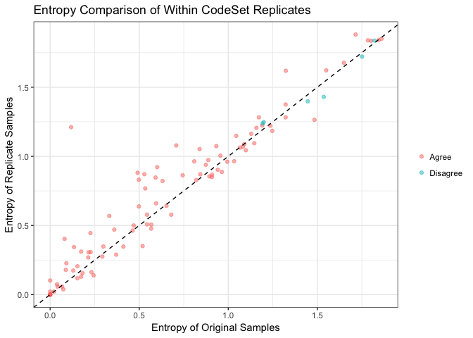

## C.1.2 Cross-site Replication

## Fleiss' Kappa for m Raters  
##   
## Subjects = 47   
## Raters = 3   
## Kappa = 1   
##   
## z = 19.5   
## p-value = 0

## C.1.3 Cross CodeSet Replication

## *Table SC2*: Comparison of predictions from the “OTTA original” CodeSet with the “OTTA Mixed” CodeSet

### A - Confusion Matrix

|  |  |  |  |  |  |
| --- | --- | --- | --- | --- | --- |
|  | Predicted Original Labels | C1.MES | C2.IMM | C4.DIF | C5.PRO |
| Predicted Mixed CodeSet Replicate Labels |  |  |  |  |  |
| C1.MES |  | 25 | 1 | 0 | 0 |
| C2.IMM |  | 0 | 20 | 0 | 0 |
| C4.DIF |  | 1 | 0 | 34 | 0 |
| C5.PRO |  | 0 | 0 | 1 | 18 |

### B - Overall Metrics

|  |  |  |
| --- | --- | --- |
| Metric |  | P value |
| accuracy | 0.97 (0.91 - 0.99) | < 0.001 |
| kappa | 0.96 (0.91 - 1) |  |

### C - By-Class Metrics

|  |  |  |  |  |  |  |  |
| --- | --- | --- | --- | --- | --- | --- | --- |
| Class | Sensitivity | Specificity | PPV | NPV | F1 | Detection Prevalence | Balanced Accuracy |
| C1.MES | 0.96 | 0.99 | 0.96 | 0.99 | 0.96 | 0.26 | 0.97 |
| C2.IMM | 0.95 | 1.00 | 1.00 | 0.99 | 0.98 | 0.20 | 0.98 |
| C4.DIF | 0.97 | 0.98 | 0.97 | 0.98 | 0.97 | 0.35 | 0.98 |
| C5.PRO | 1.00 | 0.99 | 0.95 | 1.00 | 0.97 | 0.19 | 0.99 |

## *Table SC3:* Comparison of predictions from the “OTTA original” CodeSet with the “OTTA Classifier Only” CodeSet

### A - Confusion Matrix

|  |  |  |  |  |  |
| --- | --- | --- | --- | --- | --- |
|  | Predicted Original Labels | C1.MES | C2.IMM | C4.DIF | C5.PRO |
| Predicted Classifier Only Labels |  |  |  |  |  |
| C1.MES |  | 37 | 0 | 1 | 0 |
| C2.IMM |  | 0 | 22 | 1 | 0 |
| C4.DIF |  | 1 | 0 | 26 | 0 |
| C5.PRO |  | 0 | 0 | 0 | 15 |

### B - Overall Metrics

|  |  |  |
| --- | --- | --- |
| Metric |  | P value |
| accuracy | 0.97 (0.92 - 0.99) | < 0.001 |
| kappa | 0.96 (0.91 - 1) |  |

### C - By-Class Metrics

|  |  |  |  |  |  |  |  |
| --- | --- | --- | --- | --- | --- | --- | --- |
| Class | Sensitivity | Specificity | PPV | NPV | F1 | Detection Prevalence | Balanced Accuracy |
| C1.MES | 0.97 | 0.98 | 0.97 | 0.98 | 0.97 | 0.37 | 0.98 |
| C2.IMM | 1.00 | 0.99 | 0.96 | 1.00 | 0.98 | 0.22 | 0.99 |
| C4.DIF | 0.93 | 0.99 | 0.96 | 0.97 | 0.95 | 0.26 | 0.96 |
| C5.PRO | 1.00 | 1.00 | 1.00 | 1.00 | 1.00 | 0.15 | 1.00 |

## *Table SC4:* Comparison of predictions from the “OTTA Mixed” CodeSet with the “OTTA Classifier Only” Codeset

### A - Confusion Matrix

|  |  |  |  |  |  |
| --- | --- | --- | --- | --- | --- |
|  | Predicted Mixed CodeSet Labels | C1.MES | C2.IMM | C4.DIF | C5.PRO |
| Predicted Classifer Only CodeSet Labels |  |  |  |  |  |
| C1.MES |  | 20 | 0 | 0 | 1 |
| C2.IMM |  | 1 | 15 | 1 | 0 |
| C4.DIF |  | 0 | 0 | 27 | 0 |
| C5.PRO |  | 0 | 0 | 0 | 15 |

### B - Overall Metrics

|  |  |  |
| --- | --- | --- |
| Metric |  | P value |
| accuracy | 0.96 (0.89 - 0.99) | < 0.001 |
| kappa | 0.95 (0.89 - 1.01) |  |

### C - By-Class Metrics

|  |  |  |  |  |  |  |  |
| --- | --- | --- | --- | --- | --- | --- | --- |
| Class | Sensitivity | Specificity | PPV | NPV | F1 | Detection Prevalence | Balanced Accuracy |
| C1.MES | 0.95 | 0.98 | 0.95 | 0.98 | 0.95 | 0.26 | 0.97 |
| C2.IMM | 1.00 | 0.97 | 0.88 | 1.00 | 0.94 | 0.21 | 0.98 |
| C4.DIF | 0.96 | 1.00 | 1.00 | 0.98 | 0.98 | 0.34 | 0.98 |
| C5.PRO | 0.94 | 1.00 | 1.00 | 0.98 | 0.97 | 0.19 | 0.97 |

## Fleiss’ Kappa

The Fleiss’ Kappa was calculated for the 98 unique samples common between the OTTA original CodeSet and OTTA Mixed CodeSet, across all three CodeSets.

## Fleiss' Kappa for m Raters  
##   
## Subjects = 98   
## Raters = 3   
## Kappa = 0.782   
##   
## z = 25   
## p-value = 0

# C.2 Anatomical Site Variability

## *Table SC5:* Comparison of anatomical site, 53 matched pairs adnexa and omentum

### A - Confusion Matrix

|  |  |  |  |  |  |
| --- | --- | --- | --- | --- | --- |
|  | Final Adnexal | C1.MES | C2.IMM | C4.DIF | C5.PRO |
| Predicted Omentum |  |  |  |  |  |
| C1.MES |  | 14 | 7 | 15 | 8 |
| C2.IMM |  | 0 | 2 | 3 | 3 |
| C4.DIF |  | 0 | 1 | 0 | 0 |
| C5.PRO |  | 0 | 0 | 0 | 0 |

### B - Overall Metrics

|  |  |  |
| --- | --- | --- |
| Metric |  | P value |
| accuracy | 0.3 (0.18 - 0.44) | 0.76 |
| kappa | 0.06 (-0.1 - 0.23) |  |

### C - By-Class Metrics

|  |  |  |  |  |  |  |  |
| --- | --- | --- | --- | --- | --- | --- | --- |
| Class | Sensitivity | Specificity | PPV | NPV | F1 | Detection Prevalence | Balanced Accuracy |
| C1.MES | 1.0 | 0.23 | 0.32 | 1.00 | 0.48 | 0.83 | 0.62 |
| C2.IMM | 0.2 | 0.86 | 0.25 | 0.82 | 0.22 | 0.15 | 0.53 |
| C4.DIF | 0.0 | 0.97 | 0.00 | 0.65 | NA | 0.02 | 0.49 |
| C5.PRO | 0.0 | 1.00 | NA | 0.79 | NA | 0.00 | 0.50 |

## *Table SC6:* Molecular subtype by anatomical sampling site

|  |  |  |  |  |  |  |
| --- | --- | --- | --- | --- | --- | --- |
| Levels | ADNEXAL | OMENTUM | LOWER GENITAL TRACK | UPPER GENITAL TRACK | PERITONEAL | PRESUMED ADNEXAL |
| C1.MES | 384(25.3%) | 248(71.7%) | 0(0%) | 8(50%) | 32(45.7%) | 439(23.3%) |
| C2.IMM | 394(26%) | 67(19.4%) | 1(100%) | 2(12.5%) | 16(22.9%) | 434(23.1%) |
| C4.DIF | 473(31.2%) | 24(6.9%) | 0(0%) | 2(12.5%) | 12(17.1%) | 642(34.1%) |
| C5.PRO | 264(17.4%) | 7(2%) | 0(0%) | 4(25%) | 10(14.3%) | 366(19.5%) |

## Adnexal Site Associations

### Adenxal vs Omentum

|  |  |  |  |
| --- | --- | --- | --- |
| statistic | p.value | parameter | method |
| 291.1 | 8.241e-63 | 3 | Pearson’s Chi-squared test |

### Adnexal vs Presumed Adnexal

|  |  |  |  |
| --- | --- | --- | --- |
| statistic | p.value | parameter | method |
| 8.39 | 0.03861 | 3 | Pearson’s Chi-squared test |

### Adnexal vs Other

|  |  |  |  |
| --- | --- | --- | --- |
| statistic | p.value | parameter | method |
| 20.06 | 0.0001646 | 3 | Pearson’s Chi-squared test |

# C.3 Biological Characterization of the Subtypes

## C.3.1 Correlation with Clinical and Pathological Parameters

### BRCA1/2 Mutations

|  |  |  |  |  |
| --- | --- | --- | --- | --- |
| Levels | all wildtypes | pathogenic BRCA1 mutation | pathogenic BRCA2 mutation | pathogenic NOS |
| C1.MES | 201(30%) | 45(34.1%) | 22(30.6%) | 1(50%) |
| C2.IMM | 153(22.8%) | 28(21.2%) | 13(18.1%) | 0(0%) |
| C4.DIF | 202(30.1%) | 48(36.4%) | 25(34.7%) | 1(50%) |
| C5.PRO | 115(17.1%) | 11(8.3%) | 12(16.7%) | 0(0%) |

### *Table SC7:* Cohort characteristics for all cases by subtype

Cohort characteristics for all cases by subtype

|  |  |  |  |  |  |  |  |
| --- | --- | --- | --- | --- | --- | --- | --- |
| Variable | Levels | C1.MES | C2.IMM | C4.DIF | C5.PRO | Total | PValue |
|  | N | 1111 | 914 | 1153 | 651 | 3829 | OneWay_Test |
| **Age at Diagnosis** | Mean (se) | 61.5( ± 0.3 ) | 60.5( ± 0.4 ) | 57.9( ± 0.3 ) | 62.7( ± 0.4 ) | 60.4( ± 0.2 ) | < 0.001 |
|  | Median (IQR) | 62( ± 14 ) | 60( ± 15 ) | 58( ± 15 ) | 63( ± 14 ) | 61( ± 15 ) |  |
|  | Missing | 35 | 19 | 21 | 24 | 99 |  |
|  |  |  |  |  |  |  | PearsonChi_square |
| **Stage** | low | 54(5.1%) | 163(18.9%) | 278(25.4%) | 107(17.3%) | 602(16.6%) | < 0.001 |
|  | high | 996(94.9%) | 698(81.1%) | 816(74.6%) | 510(82.7%) | 3020(83.4%) |  |
|  | Missing | 61 | 53 | 59 | 34 | 207 |  |
| **Residual Disease** | no residual | 123(22.9%) | 149(36.3%) | 213(42.1%) | 129(42.3%) | 614(34.9%) | < 0.001 |
|  | any residual | 413(77.1%) | 261(63.7%) | 293(57.9%) | 176(57.7%) | 1143(65.1%) |  |
|  | Missing | 575 | 504 | 647 | 346 | 2072 |  |
| **Necrosis** | none | 350(37%) | 217(28.6%) | 277(31.1%) | 141(28.4%) | 985(31.8%) | < 0.001 |
|  | <=20% | 556(58.8%) | 465(61.2%) | 562(63.1%) | 315(63.4%) | 1898(61.4%) |  |
|  | >20% | 39(4.1%) | 78(10.3%) | 52(5.8%) | 41(8.2%) | 210(6.8%) |  |
|  | Missing | 166 | 154 | 262 | 154 | 736 |  |
| **BRCA 1/2** | all wildtypes | 201(74.7%) | 153(78.9%) | 202(73.2%) | 115(83.3%) | 671(76.5%) | 0.38 |
|  | pathogenic BRCA1 mutation | 45(16.7%) | 28(14.4%) | 48(17.4%) | 11(8%) | 132(15.1%) |  |
|  | pathogenic BRCA2 mutation | 22(8.2%) | 13(6.7%) | 25(9.1%) | 12(8.7%) | 72(8.2%) |  |
|  | pathogenic NOS | 1(0.4%) | 0(0%) | 1(0.4%) | 0(0%) | 2(0.2%) |  |
|  | Missing | 842 | 720 | 877 | 513 | 2952 |  |
| **Race** | white | 566(78.7%) | 518(80.1%) | 683(81.3%) | 366(85.3%) | 2133(80.9%) | 0.02 |
|  | hispanic | 151(21%) | 121(18.7%) | 153(18.2%) | 62(14.5%) | 487(18.5%) |  |
|  | other | 2(0.3%) | 8(1.2%) | 4(0.5%) | 1(0.2%) | 15(0.6%) |  |
|  | Missing | 392 | 267 | 313 | 222 | 1194 |  |
| **Anatomical Site** | adnexal | 384(34.6%) | 394(43.1%) | 473(41%) | 264(40.6%) | 1515(39.6%) | < 0.001 |
|  | omentum | 248(22.3%) | 67(7.3%) | 24(2.1%) | 7(1.1%) | 346(9%) |  |
|  | peritoneal | 32(2.9%) | 16(1.8%) | 12(1%) | 10(1.5%) | 70(1.8%) |  |
|  | upper genital track | 8(0.7%) | 2(0.2%) | 2(0.2%) | 4(0.6%) | 16(0.4%) |  |
|  | lower genital track | 0(0%) | 1(0.1%) | 0(0%) | 0(0%) | 1(0%) |  |
|  | presumed adnexal | 439(39.5%) | 434(47.5%) | 642(55.7%) | 366(56.2%) | 1881(49.1%) |  |

### *Table SC8:* Cohort characteristics for all known adnexal sites by subtype

Cohort characteristics for all known ovarian site by subtype

|  |  |  |  |  |  |  |  |
| --- | --- | --- | --- | --- | --- | --- | --- |
| Variable | Levels | C1.MES | C2.IMM | C4.DIF | C5.PRO | Total | PValue |
|  | N | 384 | 394 | 473 | 264 | 1515 | OneWay_Test |
| **Age at Diagnosis** | Mean (se) | 59.6( ± 0.5 ) | 59.9( ± 0.5 ) | 58.2( ± 0.5 ) | 61.9( ± 0.6 ) | 59.7( ± 0.3 ) | < 0.001 |
|  | Median (IQR) | 60( ± 11.5 ) | 60( ± 15 ) | 58( ± 14 ) | 63( ± 12 ) | 60( ± 13 ) |  |
|  | Missing | 12 | 13 | 19 | 15 | 59 |  |
|  |  |  |  |  |  |  | PearsonChi_square |
| **Stage** | low | 21(5.7%) | 75(20.3%) | 106(23.9%) | 45(18.3%) | 247(17.3%) | < 0.001 |
|  | high | 345(94.3%) | 295(79.7%) | 337(76.1%) | 201(81.7%) | 1178(82.7%) |  |
|  | Missing | 18 | 24 | 30 | 18 | 90 |  |
| **Residual Disease** | no residual | 25(20.8%) | 71(41%) | 99(44.4%) | 52(41.3%) | 247(38.5%) | < 0.001 |
|  | any residual | 95(79.2%) | 102(59%) | 124(55.6%) | 74(58.7%) | 395(61.5%) |  |
|  | Missing | 264 | 221 | 250 | 138 | 873 |  |
| **Necrosis** | none | 147(39.2%) | 98(25.8%) | 159(34.5%) | 76(30%) | 480(32.7%) | < 0.001 |
|  | <=20% | 208(55.5%) | 236(62.1%) | 270(58.6%) | 159(62.8%) | 873(59.4%) |  |
|  | >20% | 20(5.3%) | 46(12.1%) | 32(6.9%) | 18(7.1%) | 116(7.9%) |  |
|  | Missing | 9 | 14 | 12 | 11 | 46 |  |
| **BRCA 1/2** | all wildtypes | 43(67.2%) | 54(76.1%) | 63(72.4%) | 33(82.5%) | 193(73.7%) | 0.80 |
|  | pathogenic BRCA1 mutation | 14(21.9%) | 12(16.9%) | 15(17.2%) | 5(12.5%) | 46(17.6%) |  |
|  | pathogenic BRCA2 mutation | 7(10.9%) | 5(7%) | 8(9.2%) | 2(5%) | 22(8.4%) |  |
|  | pathogenic NOS | 0(0%) | 0(0%) | 1(1.1%) | 0(0%) | 1(0.4%) |  |
|  | Missing | 320 | 323 | 386 | 224 | 1253 |  |
| **Race** | white | 222(81.9%) | 198(78.3%) | 245(81.1%) | 119(79.9%) | 784(80.4%) | 0.82 |
|  | hispanic | 48(17.7%) | 54(21.3%) | 57(18.9%) | 30(20.1%) | 189(19.4%) |  |
|  | other | 1(0.4%) | 1(0.4%) | 0(0%) | 0(0%) | 2(0.2%) |  |
|  | Missing | 113 | 141 | 171 | 115 | 540 |  |

### *Table SC9:* Median Follow-up Time in Years and Events by Final Subtype

OS Median Follow-up Time in Years by Final Predictions

|  |  |  |  |  |
| --- | --- | --- | --- | --- |
| Class | Observation Time | Censoring Time | Reverse KM | Events |
| Full Cohort | 3.3 | 2.9 | 8.8 | 2533 |
| C1.MES | 2.6 | 2.4 | 8.4 | 827 |
| C2.IMM | 3.9 | 3.2 | 8.7 | 563 |
| C4.DIF | 4.1 | 3.4 | 9.3 | 697 |
| C5.PRO | 3.1 | 2.8 | 8.5 | 446 |

PFS Median Follow-up Time in Years by Final Predictions

|  |  |  |  |  |
| --- | --- | --- | --- | --- |
| Class | Observation Time | Censoring Time | Reverse KM | Events |
| Full Cohort | 1.3 | 1.1 | 6.7 | 1710 |
| C1.MES | 1.1 | 1.0 | 5.6 | 611 |
| C2.IMM | 1.4 | 1.2 | 8.0 | 391 |
| C4.DIF | 1.4 | 1.3 | 6.9 | 436 |
| C5.PRO | 1.3 | 1.2 | 5.1 | 272 |

## C.3.3 Survival Analysis

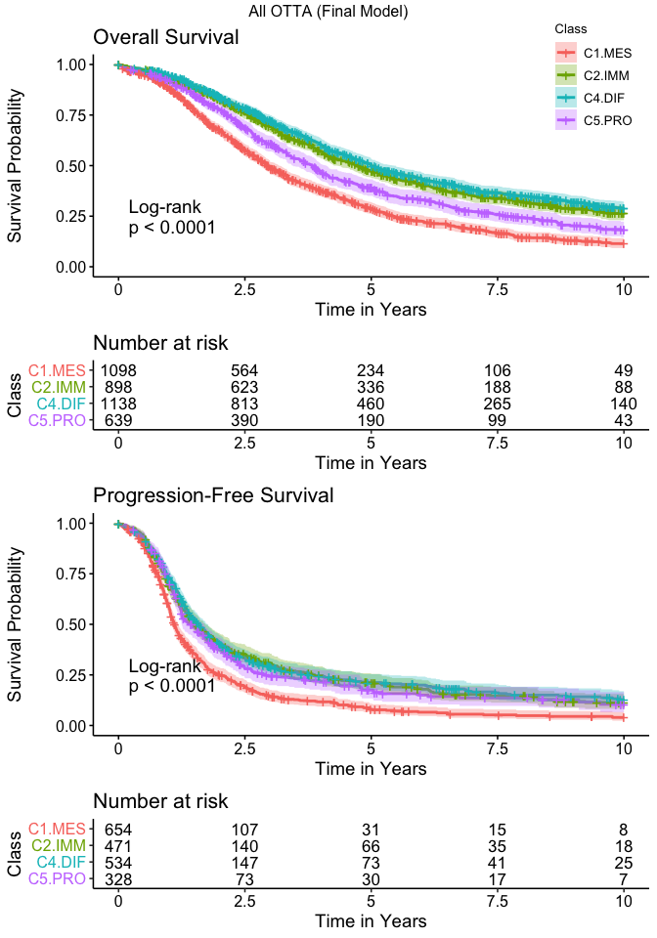

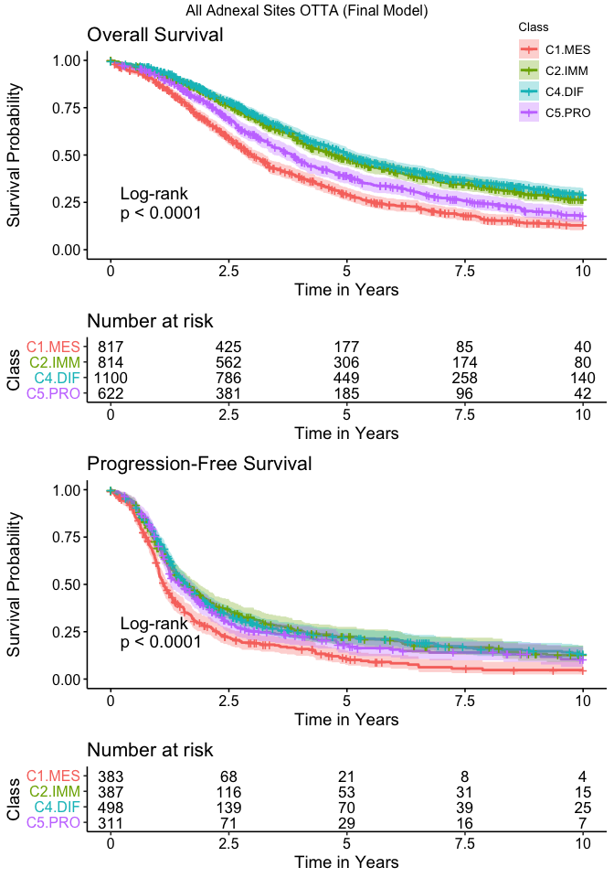

### *Table SC10:* Multivariable survival analysis of overall and progression-free survival, adjusting for final subtype, residual disease, BRCA mutation, age, stage, and CD8

Multivariable Analyses: all covariates

|  |  |  |  |  |
| --- | --- | --- | --- | --- |
|  | # of events / n |  | Hazard Ratio (95% CI) | LRT P-value |
| **OS** | 159 / 229 |  |  |  |
| Final Subtype (reference group: C1.MES) |  | C2.IMM | 1.05 (0.66-1.65) | 0.9595 |
|  |  | C4.DIF | 0.92 (0.59-1.44) |  |
|  |  | C5.PRO | 0.95 (0.56-1.6) |  |
| Residual Disease (reference group: no residual) |  | any residual | 2.23 (1.51-3.28) | < 0.0001 |
| BRCA 1/2 mutation (reference group: all wildtypes) |  | pathogenic BRCA1 mutation | 1.01 (0.63-1.61) | 0.0003 |
|  |  | pathogenic BRCA2 mutation | 0.23 (0.1-0.53) |  |
|  |  | pathogenic NOS | 0.93 (0.12-7.09) |  |
| Age |  |  | 1.02 (1-1.04) | 0.0165 |
| Stage (reference group: low) |  | high | 1.95 (0.98-3.87) | 0.0396 |
| CD8 (reference group: none) |  | low | 0.95 (0.55-1.64) | 0.0014 |
|  |  | med | 0.58 (0.35-0.96) |  |
|  |  | high | 0.32 (0.16-0.63) |  |
| **PFS** | 176 / 208 |  |  |  |
| Final Subtype (reference group: C1.MES) |  | C2.IMM | 1.53 (0.98-2.39) | 0.2683 |
|  |  | C4.DIF | 1.31 (0.86-2) |  |
|  |  | C5.PRO | 1.08 (0.64-1.85) |  |
| Residual Disease (reference group: no residual) |  | any residual | 1.86 (1.31-2.65) | 0.0005 |
| BRCA 1/2 mutation (reference group: all wildtypes) |  | pathogenic BRCA1 mutation | 0.79 (0.51-1.24) | 0.1647 |
|  |  | pathogenic BRCA2 mutation | 0.54 (0.29-1.02) |  |
|  |  | pathogenic NOS | 0.45 (0.06-3.38) |  |
| Age |  |  | 1 (0.99-1.01) | 0.9549 |
| Stage (reference group: low) |  | high | 3.75 (1.9-7.4) | < 0.0001 |
| CD8 (reference group: none) |  | low | 1.29 (0.73-2.26) | 0.1501 |
|  |  | med | 0.96 (0.58-1.57) |  |
|  |  | high | 0.66 (0.35-1.26) |  |

### *Table SC11:* Multivariable survival analysis of overall and progression-free survival, adjusting for final subtype, residual disease, age, stage, and CD8

Multivariable Analyses: all covariates except BRCA 1/2

|  |  |  |  |  |
| --- | --- | --- | --- | --- |
|  | # of events / n |  | Hazard Ratio (95% CI) | LRT P-value |
| **OS** | 494 / 724 |  |  |  |
| Final Subtype (reference group: C1.MES) |  | C2.IMM | 0.7 (0.54-0.92) | 0.0477 |
|  |  | C4.DIF | 0.78 (0.62-0.99) |  |
|  |  | C5.PRO | 0.77 (0.59-1.02) |  |
| Residual Disease (reference group: no residual) |  | any residual | 1.74 (1.4-2.16) | < 0.0001 |
| Age |  |  | 1.02 (1.01-1.03) | 0.0001 |
| Stage (reference group: low) |  | high | 2.13 (1.49-3.03) | < 0.0001 |
| CD8 (reference group: none) |  | low | 0.95 (0.7-1.29) | 0.0396 |
|  |  | med | 0.77 (0.59-1.01) |  |
|  |  | high | 0.67 (0.48-0.93) |  |
| **PFS** | 539 / 669 |  |  |  |
| Final Subtype (reference group: C1.MES) |  | C2.IMM | 0.77 (0.59-0.99) | 0.2140 |
|  |  | C4.DIF | 0.88 (0.7-1.1) |  |
|  |  | C5.PRO | 0.85 (0.64-1.11) |  |
| Residual Disease (reference group: no residual) |  | any residual | 1.67 (1.37-2.04) | < 0.0001 |
| Age |  |  | 1 (1-1.01) | 0.3303 |
| Stage (reference group: low) |  | high | 2.6 (1.84-3.69) | < 0.0001 |
| CD8 (reference group: none) |  | low | 1.2 (0.89-1.62) | 0.1614 |
|  |  | med | 1.03 (0.8-1.34) |  |
|  |  | high | 0.86 (0.62-1.19) |  |

### *Table SC12:* Multivariable survival analysis of overall and progression-free survival, adjusting for final subtype, BRCA mutation, age, stage, and CD8

Multivariable Analyses: all covariates except residual disease

|  |  |  |  |  |
| --- | --- | --- | --- | --- |
|  | # of events / n |  | Hazard Ratio (95% CI) | LRT P-value |
| **OS** | 346 / 509 |  |  |  |
| Final Subtype (reference group: C1.MES) |  | C2.IMM | 0.77 (0.56-1.05) | 0.0096 |
|  |  | C4.DIF | 0.62 (0.47-0.83) |  |
|  |  | C5.PRO | 0.68 (0.5-0.94) |  |
| BRCA 1/2 mutation (reference group: all wildtypes) |  | pathogenic BRCA1 mutation | 1.08 (0.76-1.53) | < 0.0001 |
|  |  | pathogenic BRCA2 mutation | 0.31 (0.18-0.52) |  |
|  |  | pathogenic NOS | 1.56 (0.21-11.32) |  |
| Age |  |  | 1.03 (1.02-1.04) | < 0.0001 |
| Stage (reference group: low) |  | high | 2.99 (2.15-4.18) | < 0.0001 |
| CD8 (reference group: none) |  | low | 0.86 (0.61-1.22) | 0.0001 |
|  |  | med | 0.8 (0.59-1.08) |  |
|  |  | high | 0.41 (0.26-0.63) |  |
| **PFS** | 221 / 255 |  |  |  |
| Final Subtype (reference group: C1.MES) |  | C2.IMM | 1.28 (0.87-1.88) | 0.0801 |
|  |  | C4.DIF | 0.88 (0.63-1.24) |  |
|  |  | C5.PRO | 0.69 (0.45-1.05) |  |
| BRCA 1/2 mutation (reference group: all wildtypes) |  | pathogenic BRCA1 mutation | 0.89 (0.59-1.34) | 0.0255 |
|  |  | pathogenic BRCA2 mutation | 0.45 (0.26-0.79) |  |
|  |  | pathogenic NOS | 0.8 (0.11-5.91) |  |
| Age |  |  | 1.01 (1-1.02) | 0.1705 |
| Stage (reference group: low) |  | high | 3.87 (2.21-6.78) | < 0.0001 |
| CD8 (reference group: none) |  | low | 1.21 (0.76-1.92) | 0.0647 |
|  |  | med | 0.95 (0.64-1.4) |  |
|  |  | high | 0.6 (0.35-1.04) |  |

### *Table SC13:* Multivariable survival analysis of overall and progression-free survival, adjusting for final subtype, BRCA mutation, age and stage

Multivariable Analyses: all covariates except CD8

|  |  |  |  |  |
| --- | --- | --- | --- | --- |
|  | # of events / n |  | Hazard Ratio (95% CI) | LRT P-value |
| **OS** | 391 / 494 |  |  |  |
| Final Subtype (reference group: C1.MES) |  | C2.IMM | 0.87 (0.67-1.13) | 0.0139 |
|  |  | C4.DIF | 0.72 (0.55-0.94) |  |
|  |  | C5.PRO | 1.22 (0.89-1.68) |  |
| Residual Disease (reference group: no residual) |  | any residual | 1.96 (1.53-2.52) | < 0.0001 |
| BRCA 1/2 mutation (reference group: all wildtypes) |  | pathogenic BRCA1 mutation | 0.74 (0.55-0.99) | 0.0006 |
|  |  | pathogenic BRCA2 mutation | 0.49 (0.33-0.72) |  |
|  |  | pathogenic NOS | 1.19 (0.29-4.87) |  |
| Age |  |  | 1.02 (1.01-1.03) | 0.0031 |
| Stage (reference group: low) |  | high | 2.25 (1.36-3.73) | 0.0005 |
| **PFS** | 417 / 470 |  |  |  |
| Final Subtype (reference group: C1.MES) |  | C2.IMM | 1.18 (0.91-1.52) | 0.3475 |
|  |  | C4.DIF | 0.93 (0.72-1.21) |  |
|  |  | C5.PRO | 1.15 (0.84-1.58) |  |
| Residual Disease (reference group: no residual) |  | any residual | 1.79 (1.42-2.26) | < 0.0001 |
| BRCA 1/2 mutation (reference group: all wildtypes) |  | pathogenic BRCA1 mutation | 0.72 (0.54-0.95) | 0.0107 |
|  |  | pathogenic BRCA2 mutation | 0.61 (0.43-0.88) |  |
|  |  | pathogenic NOS | 0.8 (0.2-3.27) |  |
| Age |  |  | 1 (0.99-1.01) | 0.5821 |
| Stage (reference group: low) |  | high | 3.06 (1.9-4.93) | < 0.0001 |

### *Table SC14:* Multivariable survival analysis of overall and progression-free survival, adjusting for final subtype, residual disease, BRCA mutation, age, stage, and CD8 (adnexal sites only)

Multivariable Analyses on Adnexal Sites Only: all covariates

|  |  |  |  |  |
| --- | --- | --- | --- | --- |
|  | # of events / n |  | Hazard Ratio (95% CI) | LRT P-value |
| **OS** | 80 / 108 |  |  |  |
| Final Subtype (reference group: C1.MES) |  | C2.IMM | 1.51 (0.73-3.12) | 0.2755 |
|  |  | C4.DIF | 0.82 (0.43-1.55) |  |
|  |  | C5.PRO | 0.68 (0.31-1.5) |  |
| Residual Disease (reference group: no residual) |  | any residual | 3.98 (2.27-6.98) | < 0.0001 |
| BRCA 1/2 mutation (reference group: all wildtypes) |  | pathogenic BRCA1 mutation | 0.96 (0.5-1.86) | 0.0002 |
|  |  | pathogenic BRCA2 mutation | 0.12 (0.04-0.38) |  |
|  |  | pathogenic NOS | 0.9 (0.11-7.17) |  |
| Age |  |  | 1.04 (1.01-1.06) | 0.0014 |
| Stage (reference group: low) |  | high | 1.91 (0.81-4.54) | 0.1207 |
| CD8 (reference group: none) |  | low | 0.76 (0.31-1.91) | 0.0432 |
|  |  | med | 0.59 (0.27-1.29) |  |
|  |  | high | 0.22 (0.07-0.68) |  |
| **PFS** | 91 / 106 |  |  |  |
| Final Subtype (reference group: C1.MES) |  | C2.IMM | 2.06 (1.06-4) | 0.0940 |
|  |  | C4.DIF | 1.27 (0.71-2.27) |  |
|  |  | C5.PRO | 0.74 (0.33-1.66) |  |
| Residual Disease (reference group: no residual) |  | any residual | 2.26 (1.38-3.69) | 0.0010 |
| BRCA 1/2 mutation (reference group: all wildtypes) |  | pathogenic BRCA1 mutation | 0.63 (0.33-1.2) | 0.0349 |
|  |  | pathogenic BRCA2 mutation | 0.35 (0.15-0.8) |  |
|  |  | pathogenic NOS | 0.5 (0.06-3.88) |  |
| Age |  |  | 1.01 (0.99-1.03) | 0.2573 |
| Stage (reference group: low) |  | high | 3.44 (1.49-7.98) | 0.0013 |
| CD8 (reference group: none) |  | low | 0.89 (0.36-2.18) | 0.1163 |
|  |  | med | 0.57 (0.27-1.2) |  |
|  |  | high | 0.32 (0.11-0.89) |  |

### *Table SC15:* Multivariable survival analysis of overall and progression-free survival, adjusting for final subtype, residual disease, age, stage, and CD8 (adnexal sites only)

Multivariable Analyses on Adnexal Sites Only: all covariates except BRCA 1/2

|  |  |  |  |  |
| --- | --- | --- | --- | --- |
|  | # of events / n |  | Hazard Ratio (95% CI) | LRT P-value |
| **OS** | 238 / 333 |  |  |  |
| Final Subtype (reference group: C1.MES) |  | C2.IMM | 0.94 (0.61-1.46) | 0.7935 |
|  |  | C4.DIF | 0.89 (0.61-1.3) |  |
|  |  | C5.PRO | 0.81 (0.53-1.24) |  |
| Residual Disease (reference group: no residual) |  | any residual | 1.97 (1.43-2.7) | < 0.0001 |
| Age |  |  | 1.01 (1-1.03) | 0.0295 |
| Stage (reference group: low) |  | high | 2.09 (1.31-3.35) | 0.0010 |
| CD8 (reference group: none) |  | low | 0.96 (0.61-1.52) | 0.0304 |
|  |  | med | 0.62 (0.42-0.92) |  |
|  |  | high | 0.62 (0.37-1.04) |  |
| **PFS** | 261 / 325 |  |  |  |
| Final Subtype (reference group: C1.MES) |  | C2.IMM | 0.96 (0.63-1.45) | 0.2631 |
|  |  | C4.DIF | 0.86 (0.61-1.22) |  |
|  |  | C5.PRO | 0.67 (0.44-1.02) |  |
| Residual Disease (reference group: no residual) |  | any residual | 1.94 (1.44-2.6) | < 0.0001 |
| Age |  |  | 1.01 (1-1.02) | 0.2710 |
| Stage (reference group: low) |  | high | 2.08 (1.36-3.19) | 0.0004 |
| CD8 (reference group: none) |  | low | 0.91 (0.58-1.44) | 0.0177 |
|  |  | med | 0.65 (0.44-0.96) |  |
|  |  | high | 0.49 (0.29-0.82) |  |

### *Table SC16:* Multivariable survival analysis of overall and progression-free survival, adjusting for final subtype, BRCA mutation, age, stage, and CD8 (adnexal sites only)

Multivariable Analyses on Adnexal Sites Only: all covariates except residual disease

|  |  |  |  |  |
| --- | --- | --- | --- | --- |
|  | # of events / n |  | Hazard Ratio (95% CI) | LRT P-value |
| **OS** | 99 / 131 |  |  |  |
| Final Subtype (reference group: C1.MES) |  | C2.IMM | 0.82 (0.45-1.48) | 0.0270 |
|  |  | C4.DIF | 0.55 (0.32-0.95) |  |
|  |  | C5.PRO | 0.4 (0.2-0.79) |  |
| BRCA 1/2 mutation (reference group: all wildtypes) |  | pathogenic BRCA1 mutation | 1.03 (0.56-1.89) | < 0.0001 |
|  |  | pathogenic BRCA2 mutation | 0.13 (0.04-0.37) |  |
|  |  | pathogenic NOS | 1.7 (0.22-13.16) |  |
| Age |  |  | 1.03 (1.01-1.06) | 0.0021 |
| Stage (reference group: low) |  | high | 3.37 (1.57-7.22) | 0.0005 |
| CD8 (reference group: none) |  | low | 0.81 (0.38-1.74) | 0.0317 |
|  |  | med | 0.53 (0.28-0.98) |  |
|  |  | high | 0.29 (0.12-0.7) |  |
| **PFS** | 113 / 129 |  |  |  |
| Final Subtype (reference group: C1.MES) |  | C2.IMM | 1.45 (0.83-2.54) | 0.0751 |
|  |  | C4.DIF | 0.87 (0.53-1.43) |  |
|  |  | C5.PRO | 0.58 (0.29-1.14) |  |
| BRCA 1/2 mutation (reference group: all wildtypes) |  | pathogenic BRCA1 mutation | 0.67 (0.37-1.22) | 0.0300 |
|  |  | pathogenic BRCA2 mutation | 0.38 (0.18-0.79) |  |
|  |  | pathogenic NOS | 0.84 (0.11-6.39) |  |
| Age |  |  | 1.01 (1-1.03) | 0.1404 |
| Stage (reference group: low) |  | high | 3.64 (1.8-7.36) | 0.0001 |
| CD8 (reference group: none) |  | low | 1.1 (0.53-2.32) | 0.0481 |
|  |  | med | 0.66 (0.37-1.18) |  |
|  |  | high | 0.37 (0.16-0.85) |  |

### *Table SC17:* Multivariable survival analysis of overall and progression-free survival, adjusting for final subtype, BRCA mutation, age and stage (adnexal sites only)

Multivariable Analyses on Adnexal Sites Only: all covariates except CD8

|  |  |  |  |  |
| --- | --- | --- | --- | --- |
|  | # of events / n |  | Hazard Ratio (95% CI) | LRT P-value |
| **OS** | 186 / 231 |  |  |  |
| Final Subtype (reference group: C1.MES) |  | C2.IMM | 1.03 (0.68-1.55) | 0.1349 |
|  |  | C4.DIF | 0.81 (0.54-1.21) |  |
|  |  | C5.PRO | 1.41 (0.87-2.29) |  |
| Residual Disease (reference group: no residual) |  | any residual | 2.99 (2.07-4.31) | < 0.0001 |
| BRCA 1/2 mutation (reference group: all wildtypes) |  | pathogenic BRCA1 mutation | 0.72 (0.47-1.1) | 0.0015 |
|  |  | pathogenic BRCA2 mutation | 0.36 (0.2-0.65) |  |
|  |  | pathogenic NOS | 0.84 (0.11-6.2) |  |
| Age |  |  | 1.03 (1.01-1.04) | 0.0003 |
| Stage (reference group: low) |  | high | 2.39 (1.27-4.48) | 0.0033 |
| **PFS** | 204 / 229 |  |  |  |
| Final Subtype (reference group: C1.MES) |  | C2.IMM | 1.28 (0.86-1.89) | 0.5105 |
|  |  | C4.DIF | 1.02 (0.7-1.5) |  |
|  |  | C5.PRO | 1.24 (0.78-1.99) |  |
| Residual Disease (reference group: no residual) |  | any residual | 2.21 (1.58-3.09) | < 0.0001 |
| BRCA 1/2 mutation (reference group: all wildtypes) |  | pathogenic BRCA1 mutation | 0.64 (0.42-0.97) | 0.0075 |
|  |  | pathogenic BRCA2 mutation | 0.48 (0.28-0.8) |  |
|  |  | pathogenic NOS | 0.46 (0.06-3.38) |  |
| Age |  |  | 1.01 (1-1.03) | 0.0647 |
| Stage (reference group: low) |  | high | 2.96 (1.65-5.3) | 0.0001 |

# C.4 Genes in the Classifier

## Network Diagrams

### Combined Pathways

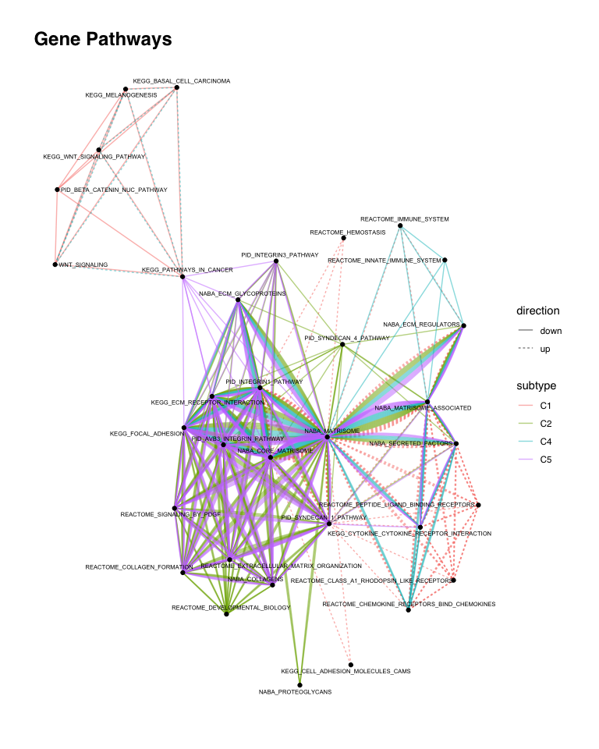

### Pathways by Subtype

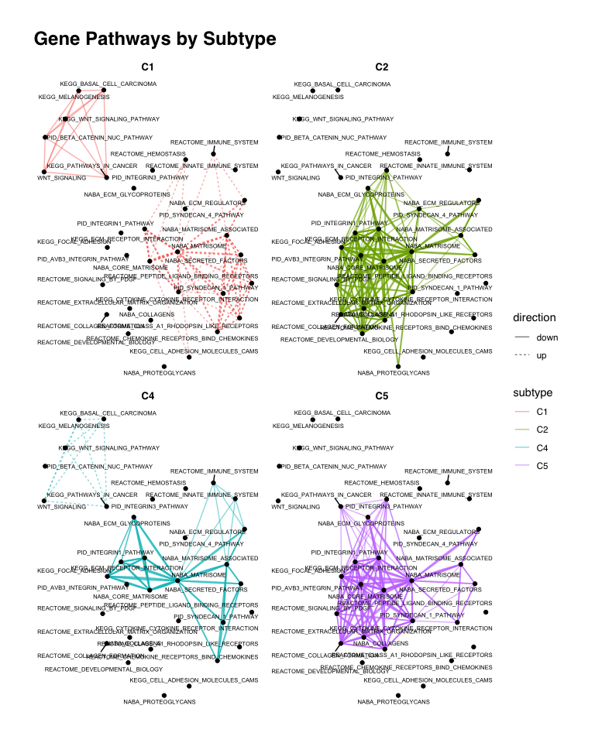

### Pathways by Direction

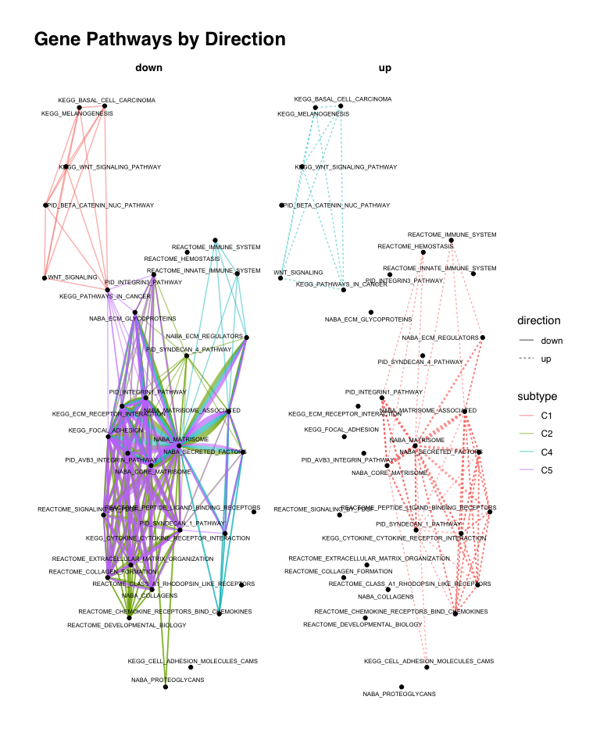

### Heatmap

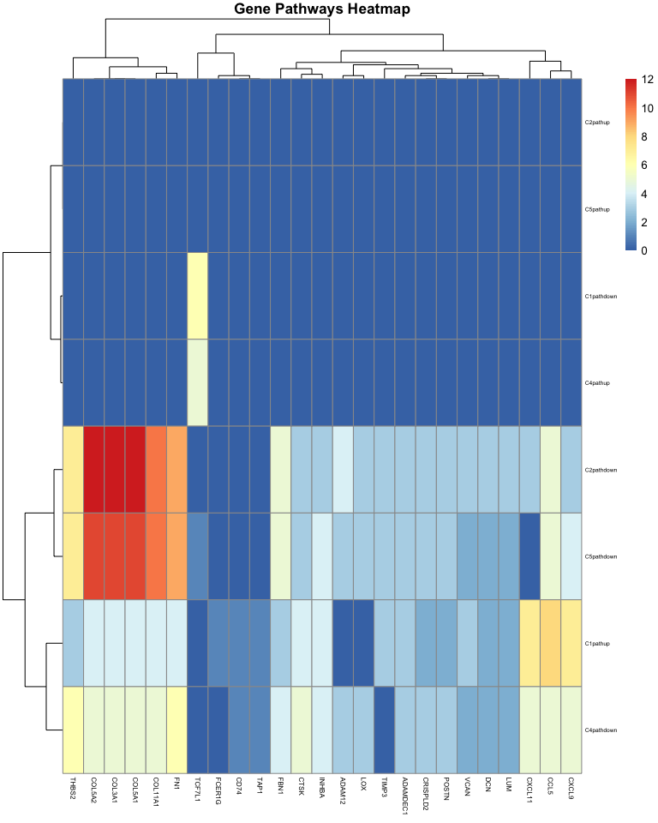

## Gene Expression Distribution on Top Genes

### All-Array

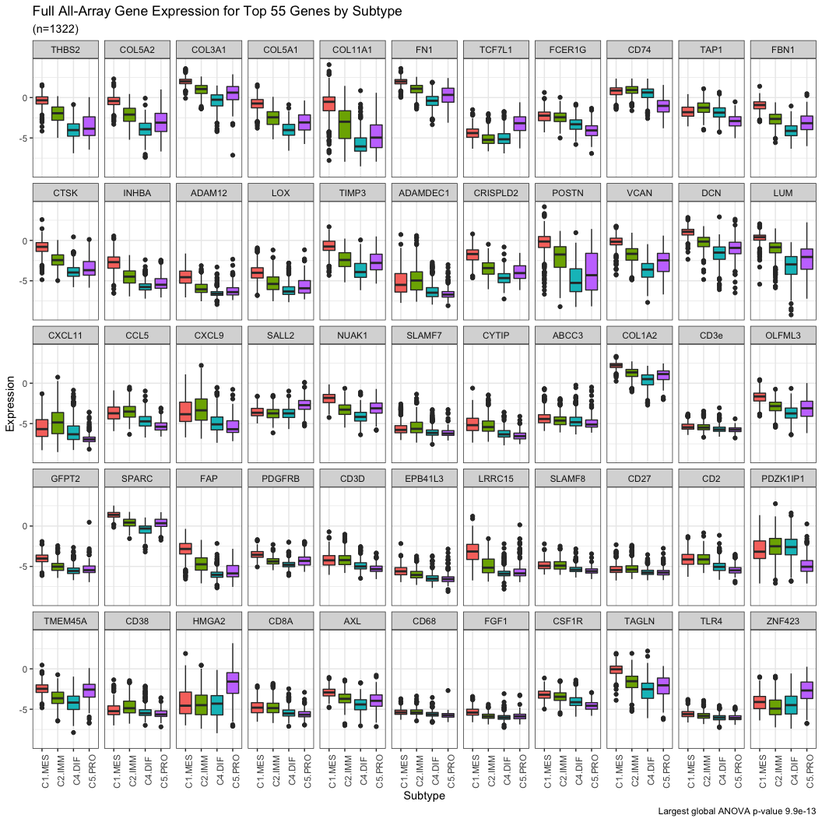

### NanoString

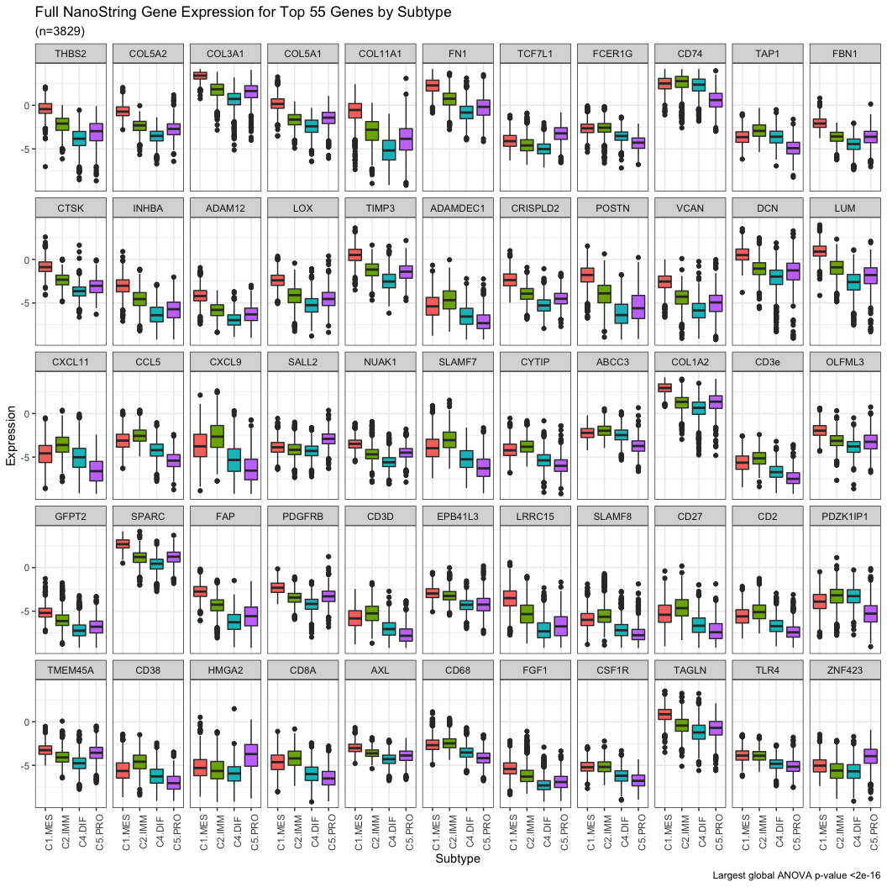

### TCGA

