F29SE2 Software Engineering in Java 2
8. Menus & Text
8.1. Introduction

- based on a rolling example of a text editor

- saw state chart in Lecture 1:
select close/contents written to file
INITIAL
EDIT
select open/file contents editable
select new/empty contents editable
select edit/
contents changed
select save/contents written to file
select exit/return to host system

- will now focus on new methods to:

- display/manipulate scrollable text

- open/save files from directory

- conduct simple standard dialogs

8.2. Editable Text

- JTextField is one line of text

JTextArea extends
javax.swing.text.JTextComponent

- multiple lines of plain, unformatted text

- user can edit text

JTextArea
(String text, int rows, int columns)

text ==> text to be edited

rows ==> number of displayed rows

columns ==> number of displayed columns

public String setText(String text)

- overrides all text with text

public String append(String text)

- adds text at end

public String getText()

- returns text as single String
import java.awt.*;
import java.awt.event.*;
import javax.swing.*;
import java.io.*;

class Edit1 extends JFrame
{ JTextArea ta;

Edit1()
{ ta = new JTextArea("",24,80);

add(BorderLayout.CENTER,ta);
}
}

class TestEdit1
{ static BufferedReader fin;

public static void
main(String [] args) throws IOException
{ Edit1 e = new Edit1();
e.setTitle("edit1");
e.setSize(400,200);
e.setVisible(true);
e.addWindowListener
(new WindowAdapter()
{ public void
windowClosing(WindowEvent e)
{ System.exit(0); }
});

fin = new BufferedReader
(new FileReader("test.txt"));
String next = fin.readLine();
while(next!=null)
{ e.ta.append(next);
next = fin.readLine();
}
}
}

- test.txt:

Once upon a time there were three little computers
called Boris, Doris and Horace. One day Boris was having
difficulty opening a file.

"I just can't open this file!" said Boris sadly. "Maybe there's something
wrong with my H: drive."
"Maybe it's a network problem," said Doris. "I can't access the printer."
"And I can't get onto the Internet," said Horace.

Just then, along came the Nice Computer Manager.

"Hello computers!" said the Nice Computer Manager.
"Hello Nice Computer Manager!" said the computers.
"How are you all today?" asked the Nice Computer Manager.
"I can't open a file," said Boris, sadly.
"And I can't access the printer," said Doris, glumly.
"And I can't get onto the Internet," said Horace, gloomily.
"Don't worry," said the Nice Computer Manager. "You're all being replaced by
a shiney new laptop!"

The End.

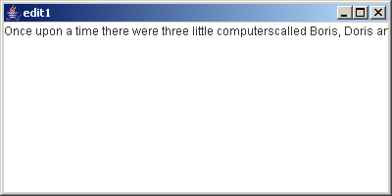

- all text on one line

- need to wrap lines

public void
setLineWrap(Boolean wrap)

Edit1()
{ ta = new JTextArea("",24,80);
ta.setLineWrap(true);

add(BorderLayout.CENTER,ta);
}

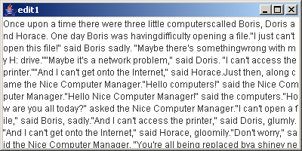

- need to add line termination

public static void
main(String [] args) throws IOException
{ Edit1 e = new Edit1();
...
String next = fin.readLine();
while(next!=null)
{ e.ta.append(next+"\n");
next = fin.readLine();
}
}

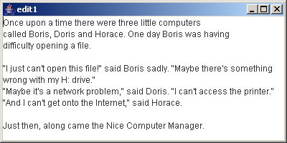

- can add/delete text using the mouse & keyboard

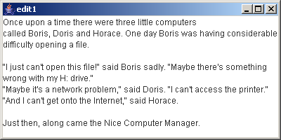

- NB no drag & drop

- NB no right button menu

- text doesn’t scroll
8.3. Scrolling

JScrollPane
extends JComponent
implements
Accessible, ScrollPaneConstants

public JScrollPane()
public JScrollPane(Component view)

- constructs a JScrollPane container for JComponent view

- allows horizontal & vertical scrolling

- can change presence of these with:

public setHorizontalScrollBarPolicy
(int policy)

public setVerticalScrollBarPolicy
(int policy)

- where policy is a ScrollPaneConstants:

HORIZONTAL_SCROLLBAR_ or
VERTICAL_SCROLLBAR_ followed by:

ALWAYS AS_NEEDED NEVER

- add JComponent with:

public void
setViewportView(Component view)

- change Edit1 to provide vertical scrolling

- have wrap round so don’t need horizontal scrolling

- horizontal scrolling is poor for text manipulation

...
class Edit2 extends JFrame
{ JScrollPane sp;
JTextArea ta;

Edit2()
{ sp = new JScrollPane();
sp.setHorizontalScrollBarPolicy
(ScrollPaneConstants.
HORIZONTAL_SCROLLBAR_NEVER);

ta = new JTextArea("",24,80);
ta.setLineWrap(true);

sp.setViewportView(ta);

add(BorderLayout.CENTER,sp);
}
}

class TestEdit2
{ static BufferedReader fin;

public static void
main(String [] args) throws IOException
{ Edit2 e = new Edit2(); ... }
}

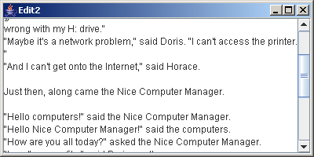
8.4. Menus

- all contemporary windows interfaces provide menu bars with:

- selectable pop-up/pull-down menus of:

- selectable menu items

JMenuBar extends JComponent
implements Accessible, MenuElement

JMenuBar()

- creates a new JMenuBar

- can be added to any component

setJMenuBar(JMenuBar menubar)

- places menubar at the top of a JFrame

JMenu extends JMenuItem
implements Accessible, MenuElement

JMenu(String s)

- creates a new JMenu identified by s

jmenubar.add(jmenu)

- adds jmenu to jmenubar

JMenuItem extends AbstractButton
implements Accessible, menuElement

JMenuItem(String text)

- creates a new menu item identified by text

jmenu.add(jmemuitem)

- adds jmenuitem to jmenu

- e.g. add menu bar to editor with a menu for File with options for Open, New, Close and Exit

...
class Edit3 extends JFrame
{ JScrollPane sp;
JTextArea ta;

JMenuBar jb;
JMenu file;
JMenuItem MNew,MOpen,MClose,MExit;

Edit3()
{ sp = new JScrollPane();
sp.setHorizontalScrollBarPolicy
(ScrollPaneConstants.
HORIZONTAL_SCROLLBAR_NEVER);

ta = new JTextArea("",24,80);
ta.setLineWrap(true);

sp.setViewportView(ta);

add(BorderLayout.CENTER,sp);

jb = new JMenuBar();
file = new JMenu("File");

MNew = new JMenuItem("New");
MOpen = new JMenuItem("Open");
MClose = new JMenuItem("Close");
MExit = new JMenuItem("Exit");

file.add(MNew);
file.add(MOpen);
file.add(MClose);
file.add(MExit);

jb.add(file);

setJMenuBar(jb);
}
}

class TestEdit3
{ static BufferedReader fin;

public static void main(String [] args)
throws IOException
{ Edit3 e = new Edit3();
...
}
}

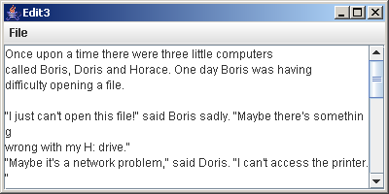

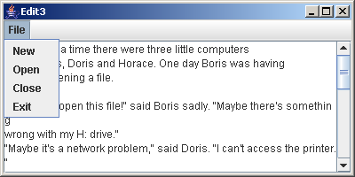
- now need to associate actions with the options

- AbstractButton causes ActionEvent

...
class Edit3 extends JFrame
implements ActionListener
{ ...

Edit3()
{ ...

MNew.addActionListener(this);
MOpen.addActionListener(this);
MClose.addActionListener(this);
MExit.addActionListener(this);
...
}

public void actionPerformed(ActionEvent e)
{ if(e.getSource()==MNew)
System.out.println("New");
else
if(e.getSource()==MOpen)
System.out.println("Open");
else
if(e.getSource()==MClose)
System.out.println("Close");
else
if(e.getSource()==MExit)
System.out.println("Exit");
}
}

class TestEdit3
{ ... }

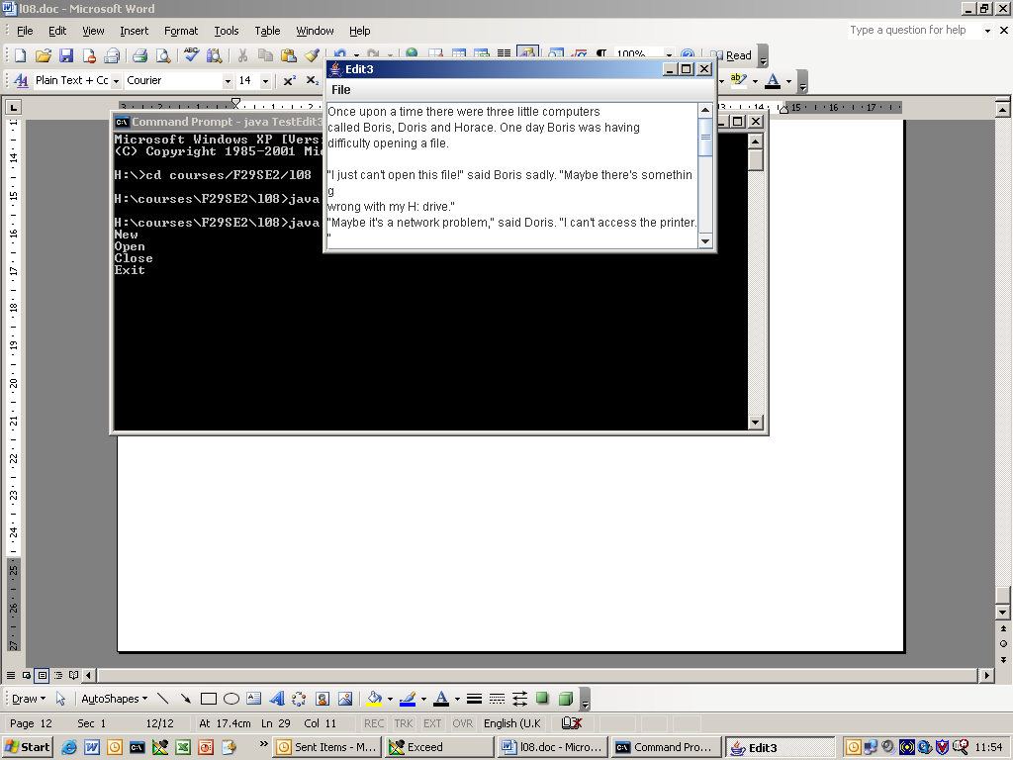

- next develop state machine within actionPerformed

- introduce state variable:

boolean editing

setEditable(boolean e)

- changes JComponent editable status

- initially, not editing and text area is not editable

...
class Edit3 extends JFrame implements ActionListener
{ ...
Edit3()
{ ...
ta.setEditable(false);

editing = false;
...
}

public void actionPerformed(ActionEvent e)
{ if(!editing)
{ if(e.getSource()==MNew)
{ System.out.println("New");
editing = true;
ta.setEditable(true);
}
else
if(e.getSource()==MOpen)
{ System.out.println("Open");
editing = true;
ta.setEditable(true);
}
if(e.getSource()==MExit)
System.out.println("Exit");
}
else
if(e.getSource()==MClose)
{ System.out.println("Close");
editing = false;
ta.setEditable(false);
}
}
}
...

- now add actions
8.5. File Chooser

- Swing provides a standard GUI for file system navigation

JFileChooser extends JComponent
implements Accessible

JFileChooser()

- create JFileChooser component for current directory

- standard dialogues

showOpenDialog(Component parent)

- to open file

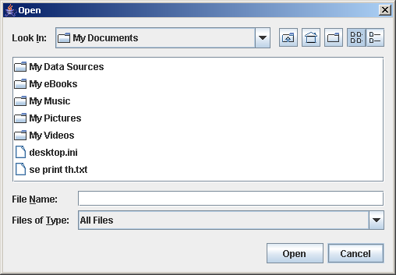
showSaveDialog(Component parent)

- to save file

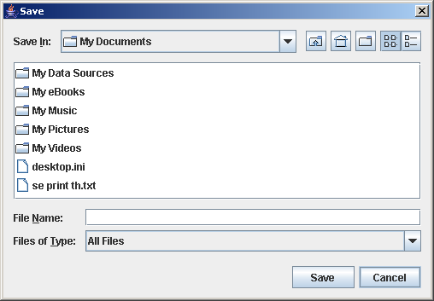

- both return constants:

APPROVE_OPTION for Open/Save buttons
CANCEL_OPTION for Cancel button

File getSelectedFile()

- returns selected file

...
class Edit3 extends JFrame implements ActionListener
{ ...
public void doOpen()
{ try{
int response = files.showOpenDialog(this);
if(response==JFileChooser.APPROVE_OPTION)
{ File f = files.getSelectedFile();
BufferedReader fin =
new BufferedReader(new FileReader(f));
String next = fin.readLine();
while(next!=null)
{ ta.append(next+"\n");
next = fin.readLine();
}
fin.close();
editing = true;
ta.setEditable(true);
}
}catch(IOException e){};
}

public void doClose()
{ try{
int response = files.showSaveDialog(this);
if(response==JFileChooser.APPROVE_OPTION)
{ File f = files.getSelectedFile();
BufferedWriter fout =
new BufferedWriter(new FileWriter(f));
fout.write(ta.getText());
fout.close();
editing = false;
ta.setEditable(false);
}
}catch(IOException e){};
}

public void doExit()
{ System.exit(0); }

public void doNew()
{ ta.setText("");
editing = true;
ta.setEditable(true);
}

public void actionPerformed(ActionEvent e)
{ if(!editing)
{ if(e.getSource()==MNew)
doNew();
else
if(e.getSource()==MOpen)
doOpen();
if(e.getSource()==MExit)
doExit();
}
else
if(e.getSource()==MClose)
doClose();
}
}

class TestEdit3
{ ... }

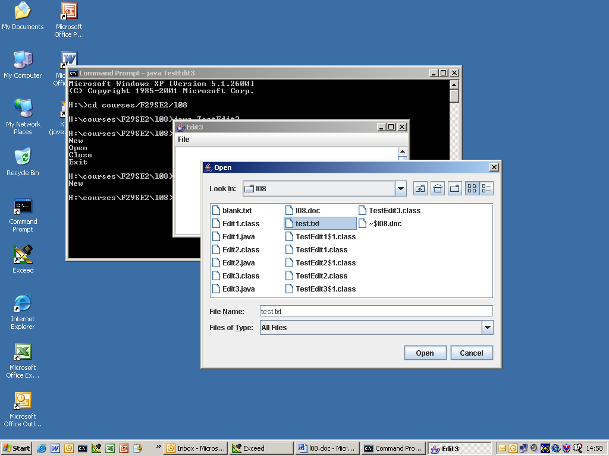

- can’t exit if editing?
8.6. Dialogs

- JFileChooser is an example of a dialog

- dialog is a common restricted specialised frame

- e.g. OK button

- e.g. YES/NO option

- e.g. simple text entry

- base dialogs on:

JOptionPane extends JComponent
implements Accessible

JOptionPane()

- creates new dialog

- OK dialog

public static void showMessageDialog
(Component parent, Object message,
String title, int messagetype,
Icon icon)

- 1, 2, 3 & 4 parameter versions

message ==> string for display
messagetype ==>

WARNING_MESSAGE
QUESTION_MESSAGE
INFORMATION_MESSAGE
ERROR_MESSAGE
PLAIN_MESSAGE

- affect look and feel

icon ==> icon to display with message

class JOP extends JFrame
{ JOptionPane jop;

JOP()
{ jop = new JOptionPane();
jop.showMessageDialog
(this,"Proceed?","Proceed",
JOptionPane.QUESTION_MESSAGE);
}
}

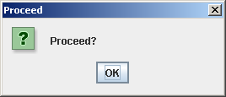

e.g Yes/No dialog

public static int showConfirmDialog
(Component parent, Object message,
String title, int optiontype,
int messagetype, Icon icon)

- 2, 4 & 5 parameter versions

optiontype ==>

DEFAULT_OPTION (Okay)
YES_NO_OPTION
YES_NO_CANCEL_OPTION
OK_CANCEL_OPTION

- returns:

OK_OPTION
CANCEL_OPTION
YES_OPTION
NO_OPTION
CLOSED_OPTION (window closed without selection)

...
jop.showConfirmDialog
(this,"Danger!","Danger",
JOptionPane.YES_NO_CANCEL_OPTION,
JOptionPane.WARNING_MESSAGE);
...

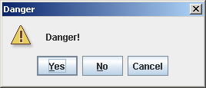
- e.g. text input

public static String showInputDialog
(Component parent, Object message,
String title, int messagetype)

- 1 & 2 parameter versions

- returns entered String

...
String input =
jop.showInputDialog
(this,"Choice:","Choice",
JOptionPane.INFORMATION_MESSAGE);
...

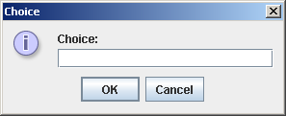

- also a version with pull down menu of options
- modify editor to allow exit without save

...
class Edit4 extends JFrame implements ActionListener
{ ...
public void doExit()
{ JOptionPane op = new JOptionPane();
int response =
op.showConfirmDialog
(this,"Exit without Close?","Exit",
JOptionPane.OK_CANCEL_OPTION,
JOptionPane.QUESTION_MESSAGE);
if(response==JOptionPane.OK_OPTION)
System.exit(0);
}
...
}

class TestEdit4
{ static BufferedReader fin;

public static void main(String [] args)
{ Edit4 e = new Edit4(); ... }
}

