404 NEWBIES SUPPORT HUB
Team Working Agreement / Charter
Northstar Retail Co. - Footwear Business
CONFIDENTIAL - INTERNAL USE ONLY | Effective: 12th Aug 2026

1. Team Purpose
Our team will collaboratively design, build, test and document the Northstar Support Deflection MVP within the five-day sprint. The MVP will focus on two high-volume customer-support categories for Northstar Retail Co.'s footwear business:
• Order-status enquiries.
• Stock-availability enquiries.
Our objective is to demonstrate a reliable, user-friendly self-service approach that can reduce unnecessary manual support-ticket handling.

2. Team Principles
• Ownership: Every task has one clearly identified owner.
• Transparency: Work, blockers and progress are visible through the project board and repository.
• Accountability: Members communicate early when deadlines or commitments are at risk.
• Quality: Work is reviewed and tested before being marked complete.
• Respect: Disagreements will be addressed professionally and based on the project's objectives and evidence.

3. Communication
• WhatsApp will be used for urgent team communication and coordination.
• GitHub will be the source of truth for technical work.
• The project board will be the source of truth for task status.
• Important decisions affecting scope, architecture or deadlines will be documented in the repository or project board.
• Members will respond to important team communication within an agreed reasonable period during active sprint hours.
• Blockers will be communicated as soon as they are identified rather than being reported at the deadline.

4. Task Management
Every task must have:
• A unique task ID.
• An owner.
• A priority.
• A clear Definition of Done.
• An estimated effort of four hours or less.
No task may remain as a large or undefined 'black box' task. If a task is expected to exceed four hours, it must be divided into smaller checkable tasks.

5. Board Discipline
Members must update the project board on the same day that meaningful work occurs.
The following status flow will be used:
Backlog → Ready → In Progress → In Review → Testing → Done
A task may only move to Done when its Definition of Done has been satisfied.

6. Git and Branching Convention
Branches will follow: <type>/<task-id>-<short-description>
Members will avoid working directly on the main branch except where the team explicitly agrees it is safe and appropriate.

7. Commit Convention
Commits must follow: <type>: <what changed> - <why it matters>
Commits such as wip, updates, final, or similarly vague messages will not be used.

8. Code Review
Where practical, significant technical changes will be reviewed by another team member before being considered complete.
Reviewers will check:
• Correctness.
• Readability.
• Alignment with the task.
• Error handling.
• Testing.
• Unnecessary complexity.
Feedback will be treated as an opportunity to improve the product rather than as personal criticism.

9. Testing
The team will test both:
• Expected/happy-path scenarios.
• Failure and edge-case scenarios.
At minimum, the final MVP must demonstrate successful handling of valid and invalid order/product searches.

10. Contribution Balance
Every member is expected to make meaningful and visible contributions. Contribution may include: Code, Testing, Documentation, UX/design, Research, Code review, Integration, Project-board management.
However, contribution must be genuine and traceable. The team will not manufacture commits, edits or tasks simply to create the appearance of participation.

11. Blockers and Escalation
If a member becomes blocked for more than a reasonable working period, they will communicate the blocker to the team rather than remaining inactive.
If a member has no visible activity for two consecutive working days, the team lead will first contact the member privately to identify the problem.
If the issue continues, the team will escalate according to the agreed team process and redistribute time-sensitive work where necessary.

12. Conflict Resolution
When disagreements occur:
1. The members involved will explain their positions.
2. The team will return to the project requirements and Definition of Done.
3. The team will select the option that best serves the MVP within the available time.
4. If no agreement is reached, the team lead will facilitate a decision.
5. Decisions will be documented when they materially affect the project.
Personal attacks, blame, public embarrassment and withholding information will not be tolerated.

13. Scope Control
The team will prioritize a reliable MVP over unnecessary feature.
New features may only be added when:
• The core MVP remains on schedule.
• The feature can be completed without compromising required deliverables.
• The team agrees that it provides meaningful value.

14. Definition of Success
The sprint will be considered successful when:
• At least two support categories work end-to-end.
• The prototype is demonstrable.
• The project contains meaningful automated/manual testing.
• The repository and board provide a clear audit trail.
• Contributions are balanced and genuine.
• The go-live readiness note is complete.
• The team can explain both what works and what remains outside the MVP.

15. Team Commitment
By signing this Charter, each member confirms that they understand the expectations above and will communicate honestly, contribute meaningfully and support the team's shared objective.
Team Commitment & Signatures
By signing this Charter, each member confirms that they understand the expectations above and will communicate honestly, contribute meaningfully and support the team's shared objective.
Role | Name | Signature | Date
Team Member 1 | Valary Talia Akoth | 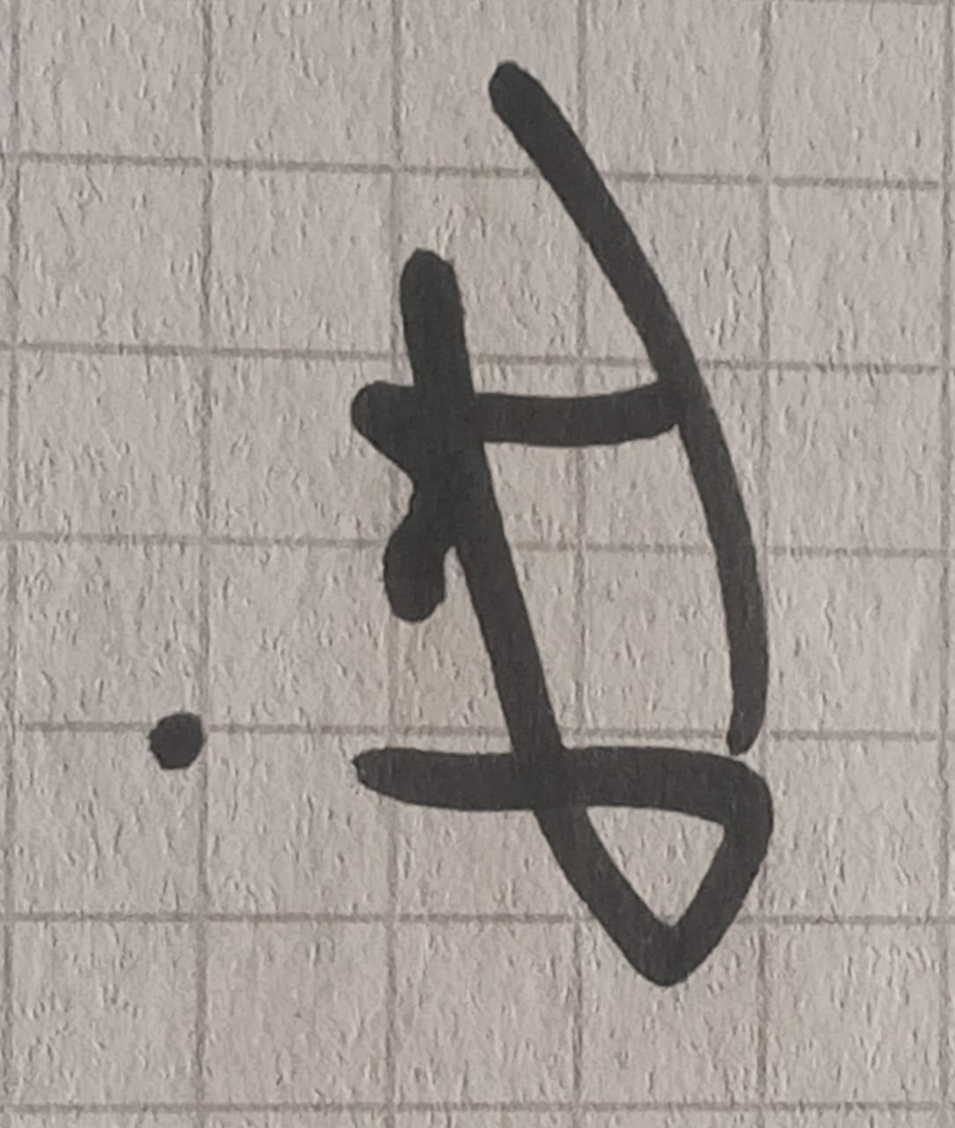 | 11/08/2026
Team Member 2 | Mwenda Muthuri | M.M | 11/08/2026
Team Member 3 | Rukiah Ntoinya | R. N | 11/08/2026
Team Member 4 | Adram Omondi | __________ | _________
Team Lead | Innocent Odhiambo | 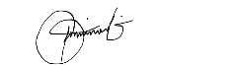 | 11/08/2026

