Assignment 5
Lior Breitmen – 212733257, Talia Seada – 211551601
Part A: myping.cpp
In this part we implemented a ping request and reply, where the source was our local address (127.0.0.1) and the destination was google address (8.8.8.8).
When we ran the file we printed only the reply massege (type 0).
In the follwing images we can see the echo reply (type: 0) and the RTT in microseconds and miliseconds:
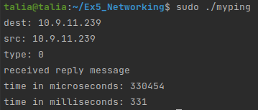

In the following images we can see it in wireshark that the request type is 8 and the reply type is 0, and make sure that the checksum is Good:
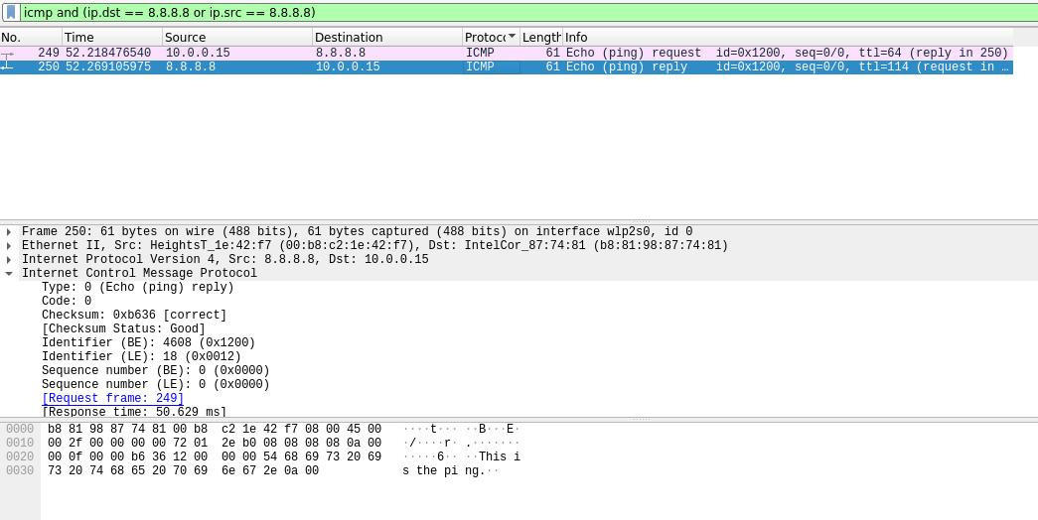

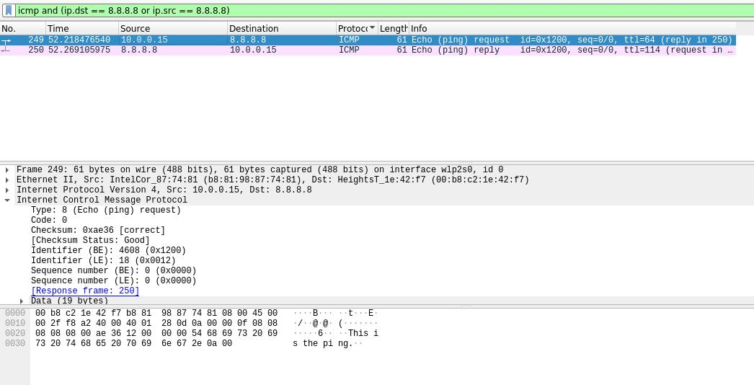

In summery, we can see that the ping request was successfully sent, and also the ECHO REPLY, when for the REQUEST type was 8 (ECHO) and the REPLY type was 0 (ECHO REPLY) as axpected, and the checksum was good.
Part B: sniffer.c
In this part we needed to “sniff” packets, where the protocol is ICMP. We needed to print the CODE, TYPE, IP_DST, IP_SRC.
We used the “ping” file we created for part A, and created a “sniffer” file to sniff the ICMP packets. (The wireshark images we showed above show the same).
The results were the same (as showed above) since we used the same file where the source and destination are the same.

