POWER ELECTRONICS IN AUTOMATIC CONTROL

**Content :**

This project is made out of five parts :

1. Design
2. Simulation
3. Control
4. Advanced model and simulation
5. Validation of control algorithm with advanced model

**Resume :**

This project focuses on the modeling, simulation, and control of a power electronics converter system using MATLAB-Simulink. Initially, an ideal switched-mode model is developed, emphasizing the behavior of the circuit during transistor conduction and blocking states. The study then evolves into a more advanced simulation using Simscape and Simscape Electrical, incorporating real-world non-idealities such as component tolerances and parasitic effects.

A closed-loop control strategy is also implemented using the Guillemin-Truxal method to minimize overshoot and improve the settling time of the output voltage. The effectiveness of the controller is validated through simulation under different sampling conditions. Overall, the project offers a comprehensive approach to designing and optimizing power electronic systems in both ideal and realistic scenarios.

**Part one : Design**

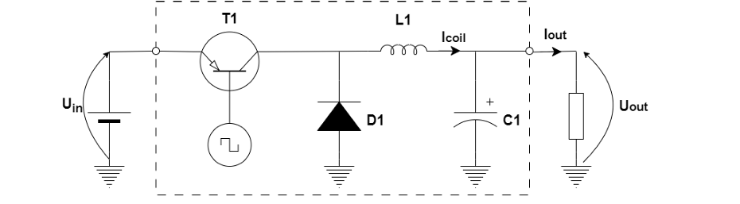The chosen converter is a DC buck converter with the following electrical structure :

This type of power electronic converter is working in switching mode to increase power and cost efficiency. In this mode, the controlling transistor is in blocking mode (no current is folowing, open circuit) or saturation mode (conduction, like a short circuit), avoiding active mode (flowing current is proportional to the base current). Switching mode is reached by applying a PWM signal on the base of the transistor, obtaining a similar waveform with higher amplitude. The mean voltage of the output is proportional with the duty cycle of the PWM signal.

On the output square wave signal filtering is applied to smooth out current and voltage ripples, obtaining a mostly continuous output voltage up to a chosen maximum current. The filter consists of an L1 inductor and C1 capacitor, with a helping D1 diode to provide path for the inductor current. The two performance indicators we use are the inductor current ripple and output voltage ripple, which shows the amplitude of the periodic variation of voltage/current.

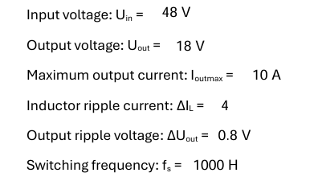

Next, there is calculated the relevant component information and also real electrical components for the circuit chosen.

The given information are the following values :

The relevant formulas :

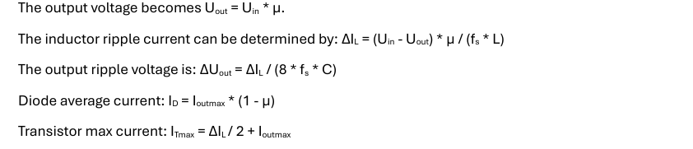

From where it results that :

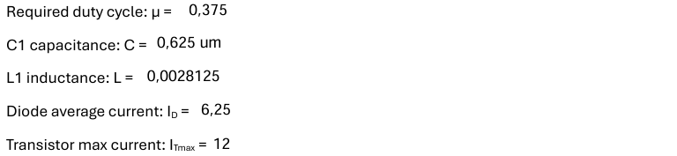

And the chosen components are :

C1 part number: <https://ro.mouser.com/ProductDetail/TAIYO-YUDEN/MLASH32NSB5684MTNA01?qs=sGAEpiMZZMuMW9TJLBQkXugdD5SwFUVxkFuTNdQNbLA%3D>

L1 part number: <https://www.audiohobby.eu/en/jantzen-air-cored-wire-coil/8520-jantzen-air-core-coil-3mh-awg15-064ohm-000-1894.html>

T1 part number: <https://www.twinschip.com/2SC3552-Transistor-12A-800V>

D1 part number: <https://www.tme.eu/en/details/p4ke47ca-lf/bidirectional-tvs-tht-diodes/littelfuse/p4ke47ca/>

**Part two : Simulation**

The studied electrical circuit has two modes, depending on the state of the transistor: transistor is saturated and conducting electrical current; transistor is blocked, no current flowing through it.

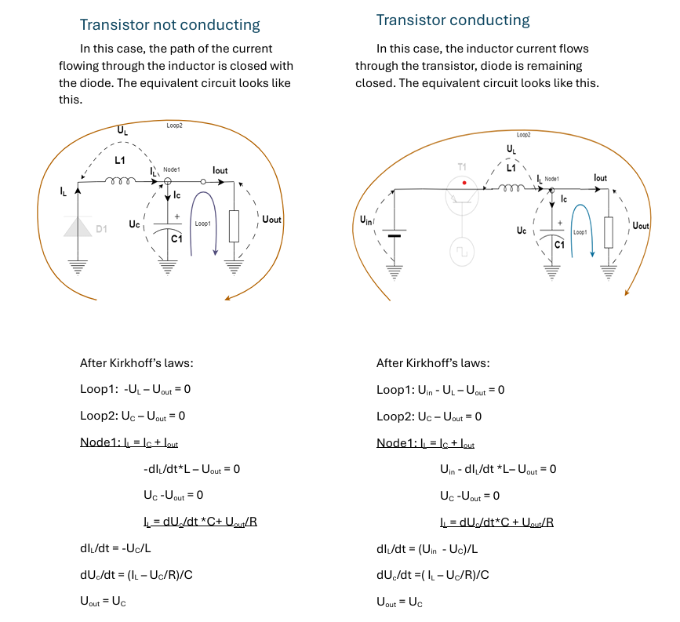The used model type is Switched mode model, where we describe every different configuration given by switches states. In this case, we study two different scenarios.

Summarizing the two systems of equation, we can obtain a generic one, introducing µ:

Where µ = 1 shows, the transistor is conducting. µ = 0 means, the transistor is blocked.

Next, there is the implementation of the system of equation described before in MATLAB-Simulink.

Input of the system is µ, output is Uout. Load resistance is calculated from output maximum current and output voltage and the PWM signal with the requested frequency and calculated duty cycle as input in the model is generated.

a) Using the calculated C and L values, the coil current and output voltage is ploted out, and the current and voltage ripple measured.

b) Next, we’re changing C and L values to the chosen components’ nominal value and plotting the coil current from a) and b) on the same graph, the output voltage from a) and b) on an other graph.

c) Changing the input PWM signal to a constant which value is the duty cycle calculated in the Part1 of the project (between 0 and 1) + measuring overshoot (if exists) and settling time.

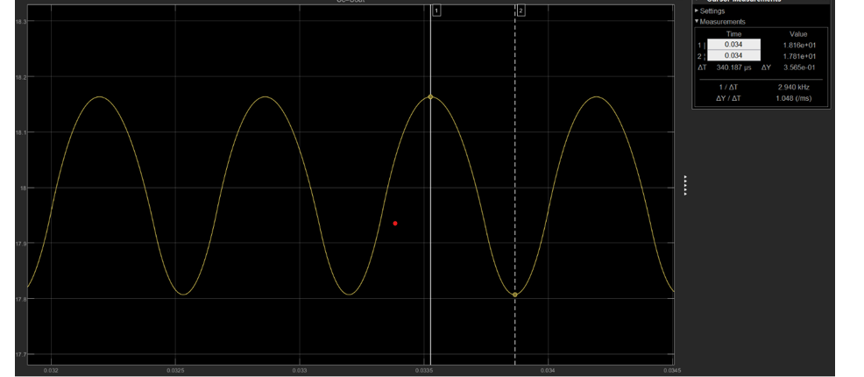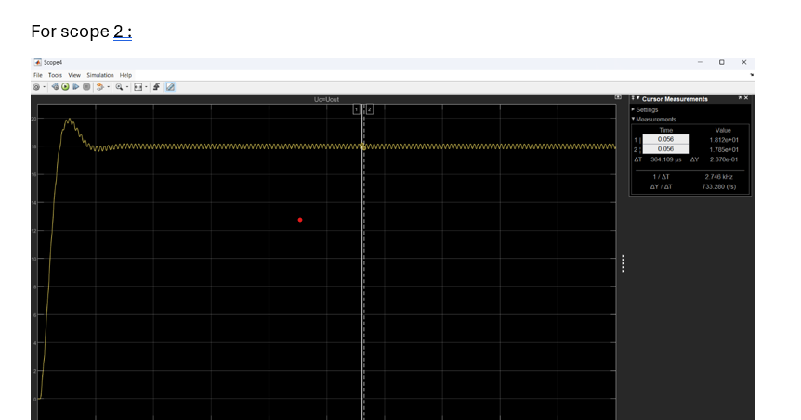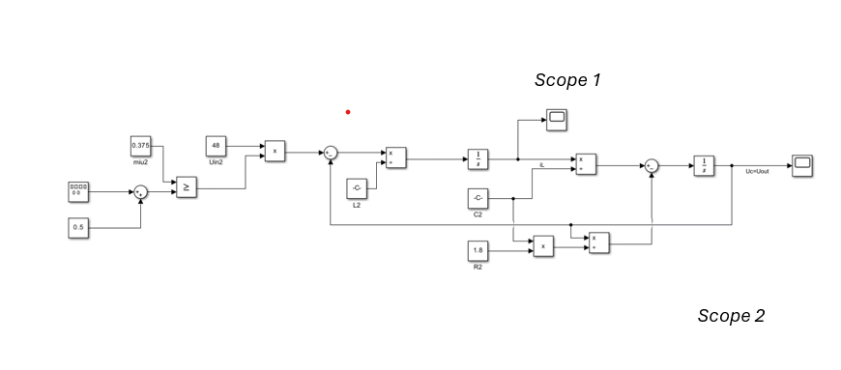Made with the values from the calculated part :

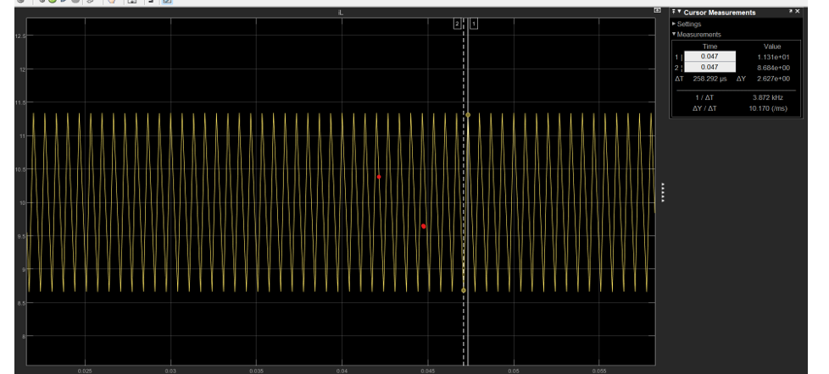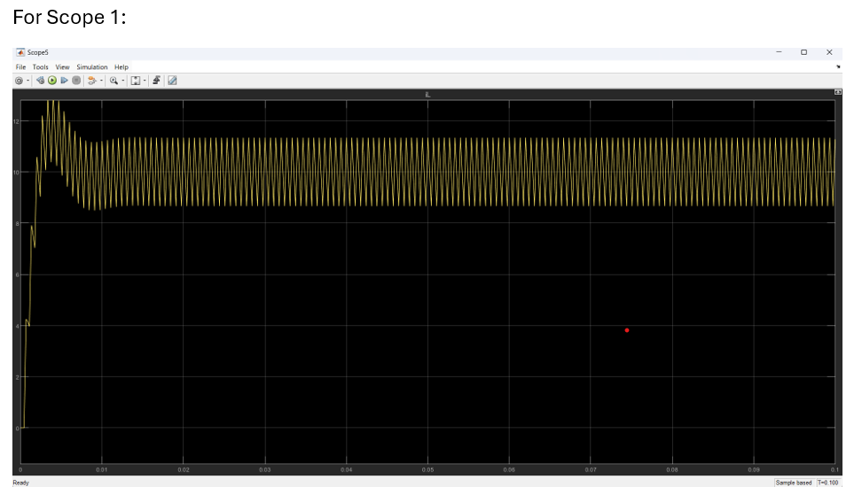

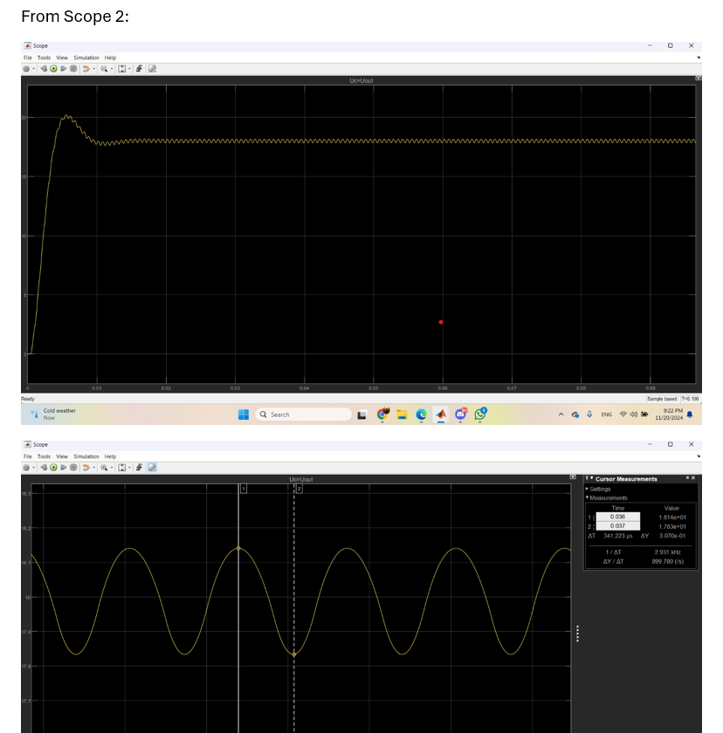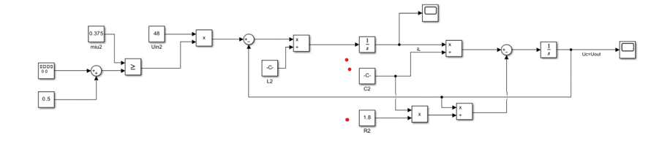Made with the values from the chosen components :

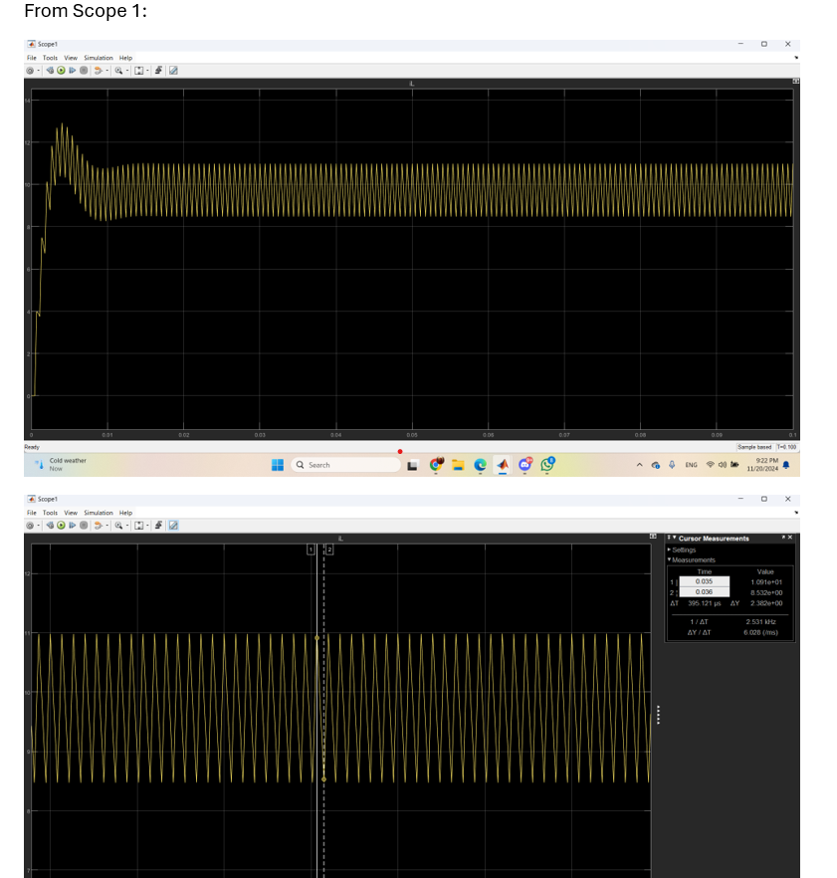

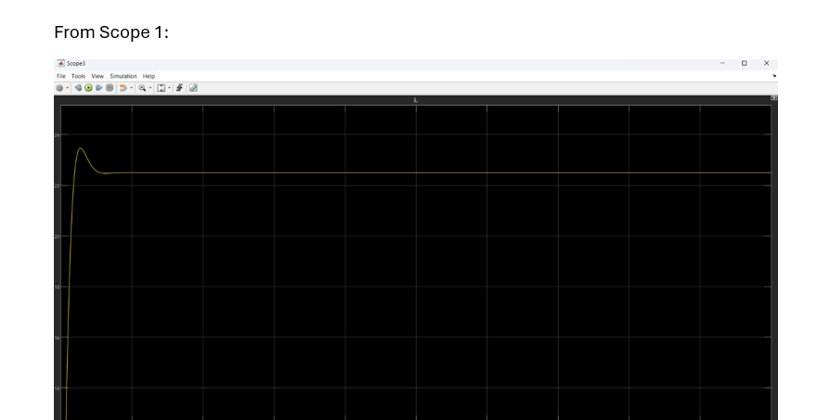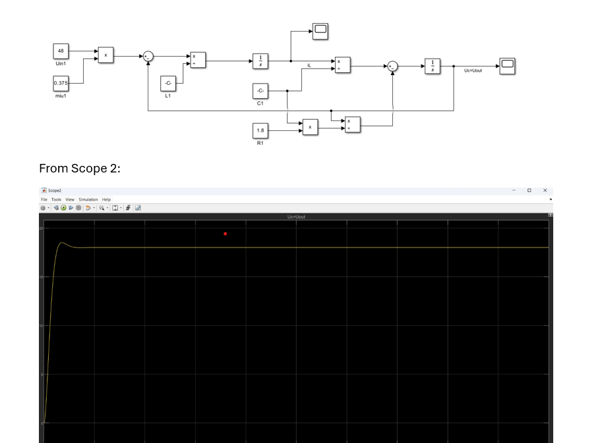µ (miu)

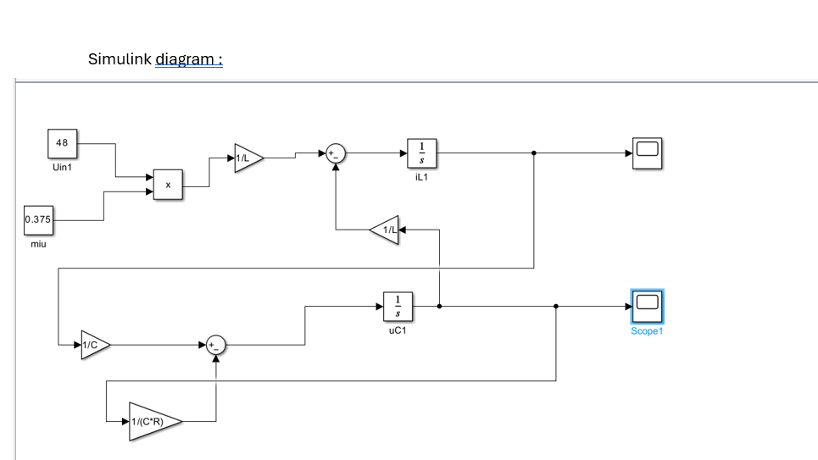

Overshoot and

Settling time

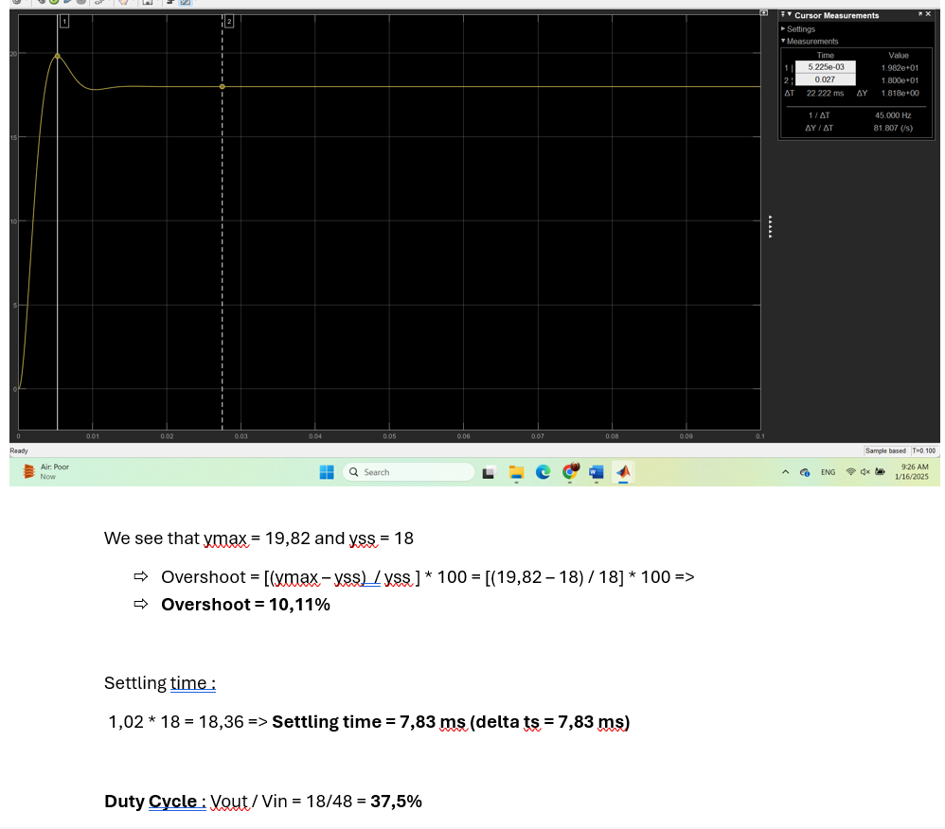

**Part three : Control**

The main goal of modeling and simulation is to help the development of a control structure. In our application, we want to improve the response of the system by reducing/eliminating the overshoot and making the settling time as small as possible.

To determine the closed loop controller, we will use the Guillemin-Truxal method. To apply this method, our model of the system should be converted to a transfer function.

We must define our closed loop system performances: overshoot and settling time. From these, we can determine the transfer function of the closed loop system, using the following, well-known formulas:

Damping factor:

Second order time constant:

The form of the closed loop system:

The controller transfer function:

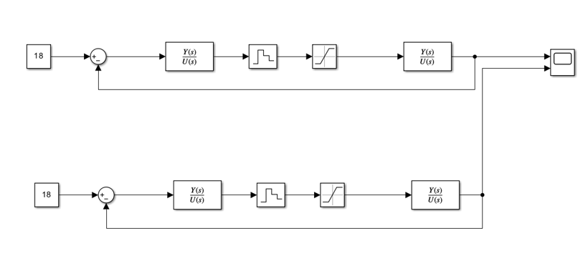The calculated controller is validated in closed loop simulation (the value of the control signal (duty cycle) should be between 0 and 1). Apply saturation block on the output of the controller. The output of the controller must be sampled with the multiple of the PWM signal period, for this we apply a Zero-Order Hold block on the control signal.

Next, the necessary calculations for the controller are made. Settinh “Zero-Order Hold” block period to the (PWM period)/10. Making closed loop simulation results in verifying the previously defined settling time and overshoot on the output voltage graph.

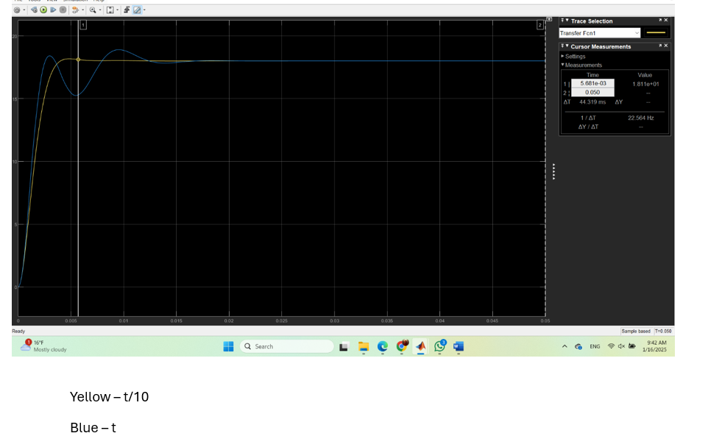

**Part four : Advanced model and simulation**

The previously discussed model is a simple representation of the real process. In this chapter we want to get closer to real behavior by using a specialized toolbox, Simscape, inside Simulink.

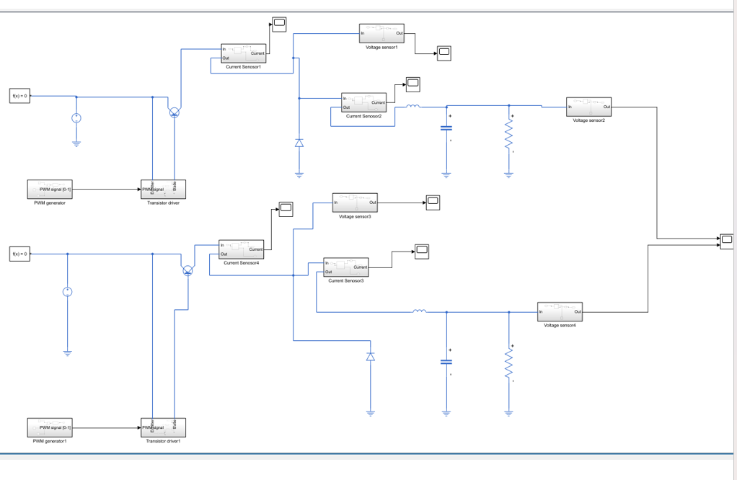The system topology remains the same, but we must add current and voltage sensors, and a special transistor driver.

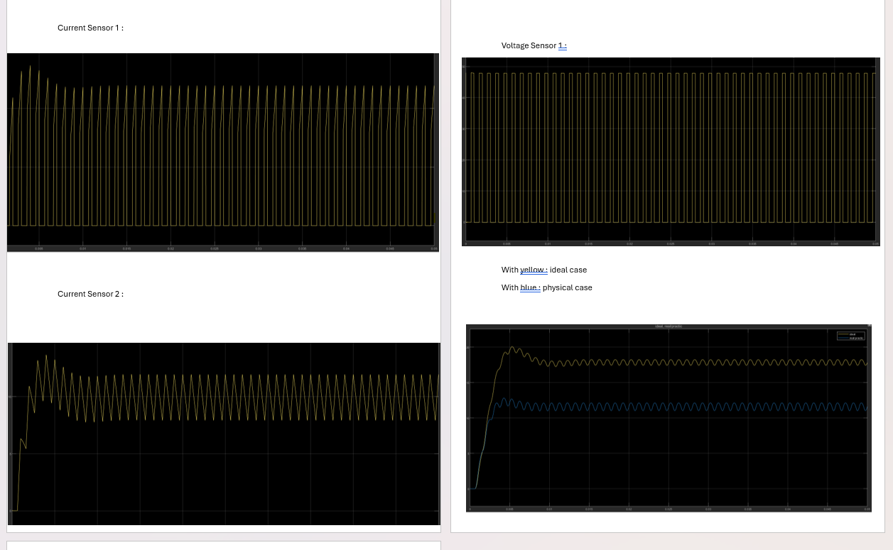

**Part five : Validation of control algorithm with advanced model**

The residual parameters of the physical components had caused the output voltage to drop below the desired value. A closed-loop controller should be able to compensate for these changes.

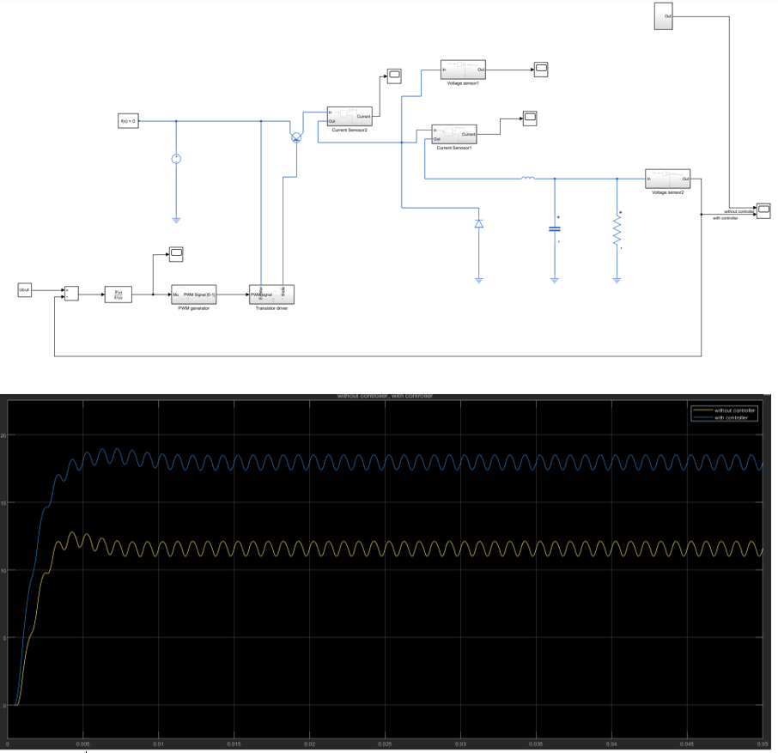Now we have to check if the controller determined in Part 3 is able to fix these changes of the output voltage. The Simscape simulation from Part 4 (with all the residual elements) with the closed loop controller (Where Hc is the controller determined in Part 3) should be completed.