TeamMatch Database Design

List of Entities
- User
- Instructor
- Student
- Course
- Team Formation Project
- Student Profile
- Skill
- Student Skill
- Availability
- Team
- Team Membership
- Matching Job
- Team Explanation / Result

2/3/4. Entities, Attributes, Primary Keys, and Foreign Keys
User
Attribute | Key | Description
user_id | PK | Unique ID for each user
first_name |  | User first name
last_name |  | User last name
email |  | User email used for login
password_hash |  | Encrypted password
role |  | Instructor or Student
created_at |  | Account creation date
Instructor
Attribute | Key | Description
instructor_id | PK | Unique instructor ID
user_id | FK | References User.user_id
department |  | Instructor department
Student
Attribute | Key | Description
student_id | PK | Unique student ID
user_id | FK | References User.user_id
major |  | Student major
academic_level |  | Freshman, sophomore, junior, senior, etc.
Course
Attribute | Key | Description
course_id | PK | Unique course ID
instructor_id | FK | References Instructor.instructor_id
course_name |  | Name of the course
course_code |  | Example: COMP 490
semester |  | Example: Spring 2026
Team Formation Project
Attribute | Key | Description
project_id | PK | Unique project ID
course_id | FK | References Course.course_id
project_name |  | Name of team formation activity
team_size_min |  | Minimum team size
team_size_max |  | Maximum team size
release_results |  | Whether students can view teams
created_at |  | Date created
Student Profile
Attribute | Key | Description
profile_id | PK | Unique profile ID
student_id | FK | References Student.student_id
project_id | FK | References TeamFormationProject.project_id
experience_level |  | Beginner, intermediate, advanced
preferred_role |  | Example: frontend, backend, leader
notes |  | Optional student notes
Attribute | Key | Description
membership_id | PK | Unique membership ID
team_id | FK | References Team.team_id
Skill
Attribute | Key | Description
skill_id | PK | Unique skill ID
skill_name |  | Example: Java, Python, UI design
category |  | Technical, communication, design, leadership
Student Skill
Attribute | Key | Description
student_skill_id | PK | Unique record ID
profile_id | FK | References StudentProfile.profile_id
skill_id | FK | References Skill.skill_id
proficiency_level |  | Skill rating or level
Availability
Attribute | Key | Description
availability_id | PK | Unique availability ID
profile_id | FK | References StudentProfile.profile_id
day_of_week |  | Example: Monday
start_time |  | Available start time
end_time |  | Available end time
Team
Attribute | Key | Description
team_id | PK | Unique team ID
project_id | FK | References TeamFormationProject.project_id
team_name |  | Example: Team 1
created_at |  | Date team was generated
Team Membership
student_id | FK | References Student.student_id
assigned_role |  | Role assigned in the team
Matching Job
Attribute | Key | Description
job_id | PK | Unique matching job ID
project_id | FK | References TeamFormationProject.project_id
status |  | Pending, running, completed, failed
started_at |  | Time job started
completed_at |  | Time job completed
algorithm_version |  | Version of matching algorithm used
Team Explanation / Result
Attribute | Key | Description
explanation_id | PK | Unique explanation ID
team_id | FK | References Team.team_id
job_id | FK | References MatchingJob.job_id
balance_score |  | Score showing team balance
skill_summary |  | Summary of team skill distribution
explanation_text |  | Natural language explanation

5.Relationships
Relationship | Type | Explanation
User -> Instructor | 1:1 | A user may be an instructor account.
User -> Student | 1:1 | A user may be a student account.
Instructor -> Course | 1:N | One instructor can manage many courses.
Course -> Team Formation Project | 1:N | One course can have many team formation projects.
Student -> Student Profile | 1:N | One student can submit profiles for different projects.
Team Formation Project -> Student Profile | 1:N | One project can collect many student profiles.
Student Profile -> Availability | 1:N | One student profile can have multiple availability times.
Student Profile -> Skill | M:N | Students can have many skills, and skills belong to many students. This is solved with Student Skill.
Team Formation Project -> Team | 1:N | One project can generate many teams.
Team -> Student | M:N | Teams contain many students, and students are connected through Team Membership.
Team Formation Project -> Matching Job | 1:N | A project can run multiple matching jobs.
Matching Job -> Team Explanation | 1:N | One matching job can produce explanations for multiple teams.
Team -> Team Explanation | 1:N | A team can have explanation records from job runs.

6.ER Diagram
This diagram shows the entities, primary keys, foreign keys, and relationship types used in TeamMatch.
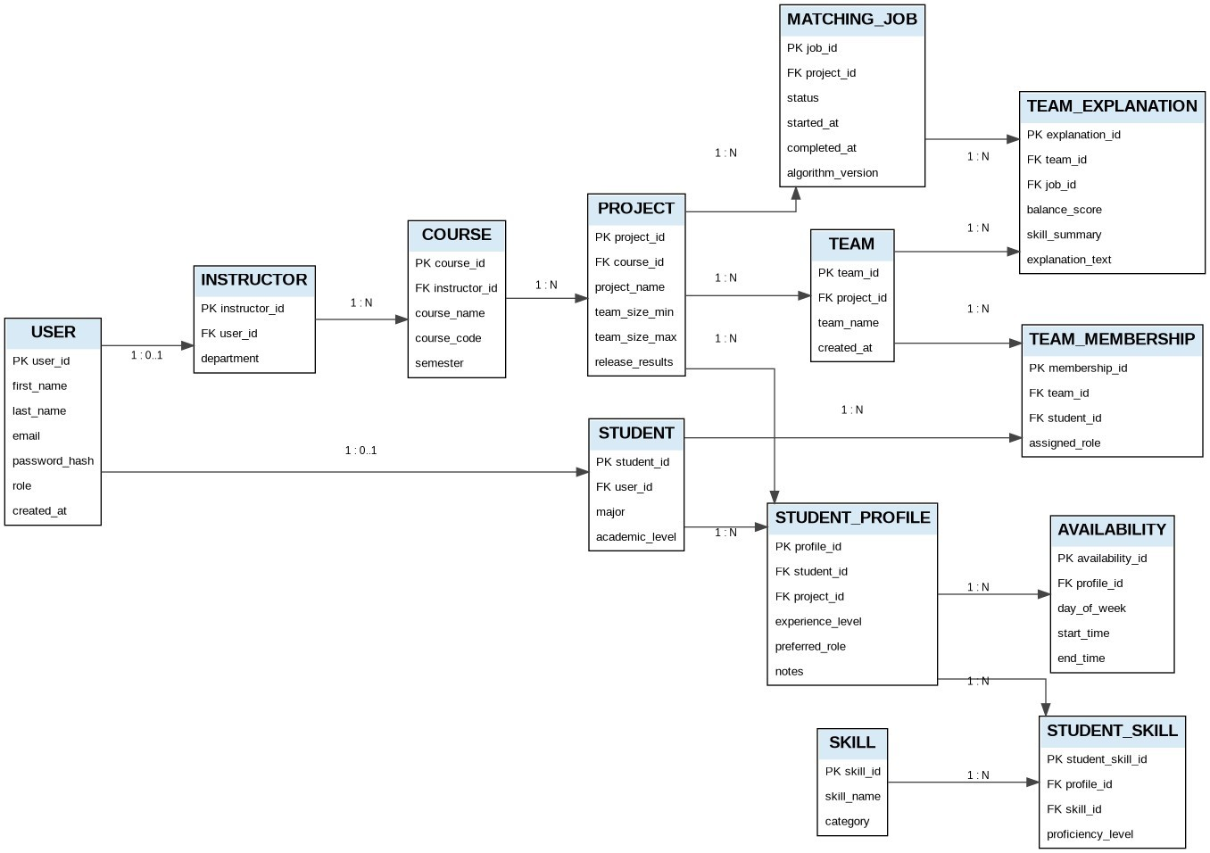

7.Short Explanation
The TeamMatch database is designed to support instructor-created team formation projects for computer science courses. Users are separated into instructor and student roles, allowing instructors to create courses and team formation projects while students submit profiles containing their skills, experience level, availability, and preferred roles. The database uses foreign keys to connect students, instructors, courses, projects, and teams in a clear structure.
The design avoids unnecessary duplication by using junction tables such as StudentSkill and TeamMembership to handle many to many relationships. This allows one student profile to contain many skills and one team to contain many students. The MatchingJob and TeamExplanation tables support the FRD requirement for deterministic, explainable team formation by storing the matching process, team balance scores, and natural language reasoning for each generated team.

