**Abstract**

This study delves into the enhancement of sentiment analysis within Amazon product reviews, focusing on the integration of diverse data modalities including textual content, emojis, star ratings, and total votes to enrich the interpretation of consumer sentiment. Leveraging the Bidirectional Encoder Representations from Transformers (BERT) model across three experimental configurations, this research assesses the individual and combined impact of these features on sentiment classification accuracy in selected e-commerce product categories.

The first experiment evaluates the baseline sentiment classification using only review text, setting a foundational understanding of sentiment analysis with BERT. The subsequent experiment introduces emojis, exploring their synergistic effect with textual content on emotion detection accuracy. The final and most comprehensive experiment integrates all data modalities, assessing the multi-feature model's performance in providing a nuanced understanding of consumer feedback.

Results reveal significant enhancements in sentiment classification accuracy with the integration of multimodal data, highlighting the critical role of non-textual features like emojis, star ratings, and total votes in capturing the full spectrum of consumer sentiment. The multi-feature model, incorporating all data modalities, demonstrates superior performance, markedly improving sentiment classification accuracy across various product categories.

This study presents the potential of multi-modal characteristics in improving the precision and contextual depth of sentiment interpretation, hence advancing the approach in natural language processing for sentiment analysis. The results highlight the useful applications of sophisticated sentiment analysis techniques in comprehending customer comments and raising customer happiness, providing e-commerce stakeholders with actionable insights. The study adds to the body of knowledge on sentiment analysis in academia and offers a methodological foundation for future studies that will use a variety of data modalities to use enriched sentiment analysis for e-commerce and other applications.

**Introduction**  
Online reviews are becoming not just common but also essential to the e-commerce ecosystem as a result of the digital revolution in business. These assessments, which frequently take the form of product reviews on websites like Amazon, provide as a direct channel of communication between customers and businesses, providing valuable information into the attitudes, tastes, and experiences of the former. Sentiment analysis has become a vital tool in this context, helping businesses to mine and analyses the massive amounts of textual data that are produced every day. But the nuanced and intricate nature of human communication necessitates more advanced methods of sentiment analysis that go beyond traditional text analysis. This study explores this complex field in an effort to improve sentiment analysis through the use of a multimodal strategy that combines text, emoticons, and star ratings.

The introduction of sentiment analysis signaled a paradigm change in the way companies evaluate customer input. Traditional sentiment analysis models were initially based on fundamental text analysis and mostly relied on parsing text to determine if a sentiment was positive or negative. These models provided a wide overview of customer sentiment by being skilled at searching through enormous amounts of text for sentiment-laden keywords and phrases. But these early models frequently failed to capture the subtleties of human emotion and the intricacies present in language expressions. With the emergence of online communication came new dimensions to the expression of mood, as vote counts, emoticons, and star ratings became important markers of user attitude, adding complexity and richness to textual narratives.

The challenges inherent in sentiment analysis are manifold, as highlighted by recent academic inquiries into the field. The work of Sayeed (2023) on the BERT model underscores the difficulties in emotion classification, particularly when reviews contain mixed or conflicting sentiments. This points to the intricate nature of sentiment analysis and the necessity for models capable of navigating these complexities. Similarly, Zhang et al. (2023) emphasized the value of aspect-based sentiment analysis, which dissects feedback to reveal sentiments related to specific product features or aspects. This granular approach is particularly beneficial in the e-commerce domain, where detailed insights can inform targeted product improvements.

The methodological leap in sentiment analysis is most notably marked by the integration of emojis. Barry et al. (2021) explored the potential of emoji embeddings, acknowledging the broad spectrum of emotions that emojis encapsulate. This development challenges traditional sentiment analysis models to accurately interpret the diverse sentiments conveyed through emojis. Building on this, Yang et al. (2022) integrated advanced attention mechanisms to better understand the interplay between text and emojis, recognizing the complexity of sentiment expression in online communications.

This study responds to the call for advanced methodologies capable of accommodating the multifaceted nature of sentiment expression. By examining the impact of integrating multiple data modalities—text, star ratings, total votes, and emojis—this research aims to refine emotion detection accuracy and contextual understanding in natural language processing (NLP). Specifically, it investigates the role of emojis in sentiment analysis within selected categories on Amazon, such as health and personal care, employing both traditional and innovative classification approaches to uncover nuanced insights into consumer sentiment.

At the core of this research is an innovative methodological framework that leverages transformer-based deep neural networks to integrate multimodal data, thereby enhancing the accuracy and efficiency of sentiment analysis models. This approach not only advances the field of NLP but also addresses the challenges highlighted in existing literature, setting a new benchmark for sentiment analysis in e-commerce.

Beyond its academic contributions, this research holds significant practical implications. By offering actionable insights into advanced sentiment analysis techniques, this study equips e-commerce stakeholders with sophisticated tools to enhance product insights and customer satisfaction. The integration of diverse data modalities—text, emojis, star ratings, and total votes—presents a comprehensive view of consumer sentiment, enabling businesses to tailor their strategies more effectively to meet consumer needs.

In conclusion, this introduction sets the stage for a comprehensive exploration of sentiment analysis in e-commerce, guided by a rich body of literature and the outlined research objectives. Through the integration of multiple data modalities and the application of cutting-edge methodologies, this study aims to provide new perspectives on leveraging consumer feedback in the digital marketplace, ultimately enhancing our understanding and utilization of sentiment analysis to foster better consumer experiences and business outcomes.

**Research Design**

Accurately interpreting and analyzing customer sentiment from online evaluations has become essential for businesses trying to understand and cater to the requirements and preferences of their customers in the quickly changing e-commerce industry. Understanding that sentiment expression has many facets, this study uses an extensive research methodology to analyze and combine the various ways that customers communicate their thoughts and emotions. The integration of multi-modal data sources, such as text, emoticons, star ratings, and the overall number of votes in Amazon product reviews, is essential to this design. The methodological framework, which was especially designed to handle the challenges of sentiment analysis in the digital era, is described in this chapter and serves as the foundation for the research. The design provides a comprehensive approach to data collecting, problem identification, objective setting, validity assurance, and ethical compliance by dividing the research into five distinct subsections, providing a strong framework for the study.

The first paragraph of this chapter introduces the overarching research design, emphasizing its purpose to enhance the understanding and application of sentiment analysis in e-commerce through the innovative integration of diverse data types. This design recognizes that sentiment is not merely conveyed through words but is also reflected in visual symbols like emojis, quantified through star ratings, and endorsed by total votes, each adding layers of meaning and nuance to consumer feedback. Because of this, the methodology has been carefully designed to capture the essence of sentiment expression from a variety of perspectives, providing a more thorough and nuanced analysis than text-only approaches. The details of this design are covered in more detail in the next sections of this chapter. The primary data gathering methodologies are the foundation of this research. A thorough description of the issue space that explains the difficulties and possibilities specific to multi-modal sentiment analysis comes next. The chapter then moves on to discuss the research objectives, which specify the parameters of the study and direct the course of the investigation. The validity types discussion ensures that the research is rigorous and relevant by addressing the standards for assessing the findings' generalizability and reliability. The chapter ends with a critical analysis of ethical issues, highlighting the dedication to conducting research with honesty and respect for the rights and privacy of those whose reviews serve as the study's foundation. By using this methodical approach, the chapter lays the groundwork for a thorough investigation of sentiment analysis with the goal of offering significant perspectives and techniques to the e-commerce industry and other related fields.

**Primary Data**

This study's empirical base is the core data that was painstakingly gathered from Amazon product reviews. This dataset includes a patchwork of customer reviews from a wide range of product categories, including gift cards, personal appliances, beauty products, and health and personal care. These categories were carefully chosen in order to represent the wide range of consumer attitudes and experiences that make up the e-commerce industry. The main data is made up of various essential components, each of which has a specific function in sentiment analysis:

* **Textual Content:** The narrative that provides a window into the consumer's experience and sentiment lies at the core of every review. These tales offer qualitative insights into the pleasure, preferences, and worries of the consumer and range from brief endorsements to in-depth critiques. The foundation of sentiment analysis is the textual analysis of these tales, which provides an abundant amount of information for comprehending customer feelings.
* **Emojis:** In the era of digital technology, emojis have evolved from being simple decorations to powerful representations of expression and emotion. These visual symbols, which are woven throughout the assessments, provide a subtle level of emotional expression and frequently capture feelings that aren't stated clearly in the text. The goal of the study is to decipher the nuanced emotional clues that emojis provide by recognizing their expressive power and incorporating them as an essential part of sentiment analysis.
* **Star Ratings:** A common element of e-commerce platforms, the star rating system offers a rapid, quantitative evaluation of customer satisfaction. These ratings, which range from 1 to 5, provide an overview of the customer's overall experience with the product and are an important source of sentiment data. In order to improve the sentiment analysis framework, star ratings are combined with textual and emoji analyses in this study, rather than being treated as independent evaluations.
* **Total Votes:** A review's total number of votes is a good indicator of how useful or relevant it is to the larger consumer community. Reviews that connect with readers, whether through the relatability of the shared experience or the expression of similar emotions, typically receive more votes. This measure is included in the research as a gauge of the significance and impact of the review, giving the sentiment analysis a new perspective.

The procedure for gathering data involves a methodical strategy to obtaining and gathering reviews from the Amazon platform that are accessible to the public. By using this method, the dataset is guaranteed to be complete and representative, covering a broad range of customer opinions in the chosen product categories. The confidentiality and privacy of the people whose reviews served as the foundation for this study are protected during the collecting and analysis of this primary data, which is carried out in accordance with ethical research norms. This research attempts to build a complex and multi-dimensional framework for sentiment analysis in e-commerce reviews, expanding our knowledge of customer sentiment in the digital marketplace through the careful integration of textual content, emojis, star ratings, and total votes.

**Problem Identification and Clarification**

The main problem that this study aims to solve is that sentiment expression in e-commerce reviews is complex and multi-layered. The complete range of sentiment nuances communicated by customers is often not captured by traditional sentiment analysis methods, which mostly rely on textual data. These conventional methods frequently ignore the rich tapestry of sentiment indicators, including star ratings that offer a quantitative indicator of customer satisfaction, emojis—which are powerful symbols of emotional expression—and total votes, which show the community's affirmation of a review's relevance.

The need for a more comprehensive approach and the drawbacks of text-centric models are highlighted in recent sentiment analysis work. Sayeed et al. (2023), for example, emphasized the difficulties in classifying emotions, particularly when evaluations include contradictory sentiments, highlighting the need for models capable of managing such complexities. The expressive potential of emojis and the significance of including these visual symbols to accurately represent the emotional content in customer feedback were further stressed by Barry et al. (2021) and Yang et al. (2022).

In order to fill in these gaps, this study offers a thorough sentiment analysis model that incorporates emojis, star ratings, and total votes in a methodical manner in addition to textual material. By doing this, the study hopes to break through the intricate network of sentiment expression seen in e-commerce reviews, embracing the multifaceted nature of customer feedback and transcending the boundaries of words. The objective is to improve sentiment analysis techniques so that they better capture the complex and multifaceted ways that customers voice their thoughts and feelings in online communities.

**Research Objective**

The overarching aim of this study is to refine and deepen the process of sentiment analysis applied to e-commerce reviews through the innovative incorporation of multi-modal data. This endeavor is underpinned by several targeted objectives designed to explore and expand the capabilities of sentiment analysis frameworks. These objectives are as follows:

1. Evaluating the Influence of Data Modalities: This involves a thorough examination of how each type of data—text, emojis, star ratings, and total votes—individually and collectively contributes to the precision of sentiment classification. The goal is to discern the unique and combined effects of these data sources on the accuracy of sentiment analysis.
2. Analyzing Emojis' Significance: This objective focuses on understanding how emojis can improve sentiment analysis models by providing more context and enhancing the detection of nuanced emotions that may not be fully conveyed through text alone. Emojis are well-known for being highly expressive nonverbal clues.
3. Methodological Innovation: By utilizing sophisticated transformer-based deep neural networks, this goal aims to enhance the field of natural language processing (NLP). By utilizing these advanced models, it is hoped to raise the bar for methodological methods in the field of sentiment analysis by efficiently processing and analyzing the intricate interactions of multi-modal data.
4. Producing Useful Insights: This study goes beyond theoretical developments in order to convert results into useful tactics for e-commerce players. Using the improved sentiment analysis models, the goal is to improve customer happiness and provide deeper product insights, giving stakeholders useful information for strategy and decision-making.

By pursuing these objectives, the research aspires to contribute significantly to the field of sentiment analysis, offering a more holistic and nuanced understanding of consumer sentiment in e-commerce settings and establishing a foundation for future innovations in NLP and e-commerce analytics.Top of Form

**Validity Type**

Maintaining both internal and external validity is highly valued in this study in order to guarantee the validity and relevance of the research findings:

* **Validity Internal:** This validity is protected by careful experimental design, which applies advanced neural network models and purposefully incorporates multi-modal data sources (text, emojis, star ratings, and total votes). These steps are meant to lessen the possibility of biases and errors in the sentiment analysis procedure, which will increase the validity of the study findings.
* **External Validity:** By carefully selecting a large and varied dataset of Amazon reviews from a variety of product categories, the research seeks to strengthen external validity. By ensuring that the insights from the sentiment analysis are representative of a broad range of consumer experiences and sentiments, rather than being limited to particular contexts, this approach aims to increase the relevance and transferability of the results to different e-commerce environments.

**Ethical Consideration**

This study is based on consumer-generated content, which makes ethical integrity a fundamental component. Following a few fundamental guidelines, the research adheres to the highest ethical standards:

* **Anonymity and Confidentiality:** All information gleaned from evaluations will be handled to guarantee anonymity, making it difficult to link certain remarks to specific, identifiable people in order to respect their right to privacy. This precaution protects the privacy of users and the confidentiality of the review material.
* **Data Use and Consent:** This study is dedicated to using only publicly accessible data that conforms with Amazon's terms of service and all relevant data protection laws and guidelines. It also only uses data that is publicly accessible. This guarantees that the study abides by the platform's policies and the rights of content creators.
* **Integrity and Transparency:** The methods used, the data analysis that follows, and the findings reporting will all be carried out in the most transparent manner possible. This dedication to transparency guarantees the research process is reproducible and accountable, safeguarding the overall integrity of the study.

In summary, this chapter provides a thorough review of the research design used in this study, including the methods used to collect primary data, define the objectives, define and define the research topic, address validity concerns, and adhere to ethical standards. With this well-thought-out strategy in place, the study hopes to make significant contributions to the fields of natural language processing and e-commerce by conducting an exhaustive and morally sound inquiry into the incorporation of multi-modal data inside sentiment analysis.

**Literature Review**

The exploration of sentiment analysis within e-commerce reviews has seen significant advancements, particularly in the integration of emojis and multi-feature data to enhance emotion detection accuracy. Recent literature reflects a growing understanding of the complexities involved in accurately interpreting customer feedback, where both textual content and emojis play pivotal roles.

Expanding upon Sayeed's (2023) research, the BERT model is an essential foundation for Natural Language Processing (NLP), especially when it comes to sentiment analysis in e-commerce. The relevance of e-commerce is highlighted by the plethora of tools, guidelines, and resources that buyers and sellers may access over the internet. Examples of these resources include safe online payment methods, mobile shopping alternatives, and cash on delivery possibilities.

Sayeed's work explained an in-depth examination of the sentiment analysis application of the BERT (Bidirectional Encoder Representations from Transformers) model. The work also emphasized how well the model can comprehend and interpret natural language, accurately capturing the complex and subtle expressions of human emotion. The issues that have been discovered, such as inaccurate categorization and the challenge of accurately classifying emotions, particularly when words contain competing emotions, demonstrate the complexity of sentiment analysis. The complexity is increased in the context of e-commerce, where the textual content of evaluations is often rife with feelings and subconscious cues that are difficult for traditional NLP models to interpret.

With its sophisticated machine learning methodologies and fine-tuning capabilities, the BERT model presents a possible solution to these problems. Researchers might potentially improve the accuracy and reliability of sentiment classification by better modelling the complexities of human language by applying BERT's deep learning architecture. This is especially true for e-commerce, where properly interpreting customer reviews can provide insightful information about the tastes, behavior, and general market trends of consumers.

Sayeed's work also highlights the increasing significance of customer evaluations in the e-commerce industry, where they help potential customers navigate the multitude of options accessible online and provide firms with feedback. By examining the BERT model in this particular context, the paper establishes a foundation for subsequent investigations that will focus on improving sentiment analysis methods. This will improve our comprehension of consumer attitudes and enable better-informed decision-making within the digital marketplace.

Zhang et al. (2023) provide a thorough investigation aimed at improving Aspect-Based Sentiment Analysis (ABSA) performance via Sentiment-enhanced Pre-Training (SPT) methods. Their work is essential to comprehending the complex dynamics of sentiment analysis, especially in the e-commerce space where a thorough evaluation of customer feedback regarding certain product features is critical.

The cornerstone of their approach involves the development of a knowledge-mining method, which is instrumental in constructing a large-scale knowledge-annotated SPT corpus. This innovative methodology is critical for the enrichment of pre-training models with a deep understanding of sentiment and linguistic nuances, directly aligning with the objective of integrating multi-modal data for improved sentiment analysis accuracy.

Furthermore, Zhang et al. delve into a systematic analysis of the effects of incorporating sentiment knowledge, alongside other linguistic insights, within the pre-training phase. This aspect of their study is particularly relevant to the research objectives, as it underscores the importance of understanding sentiment at a granular level, especially when it comes to dissecting customer feedback on specific aspects of products.

By examining various types of sentiment knowledge, Zhang et al.'s work sheds light on the differential impacts and efficacy of these knowledge types in enhancing the pre-training process. This nuanced exploration not only contributes to the broader understanding of ABSA but also offers valuable insights into the potential for targeted improvements in e-commerce platforms, ensuring that sentiment analysis models are more attuned to the complexities and subtleties of consumer sentiment.

Overall, Zhang et al. work's lays a strong foundation for improving sentiment analysis techniques by employing linguistic insights and sentiment knowledge to gain a more thorough and precise understanding of customer viewpoints in e-commerce reviews. This is especially true when viewed through the prism of ABSA. This is highly consistent with the overall objectives of improving the breadth and accuracy of sentiment analysis in e-commerce settings, providing practical insights for more complex and efficient customer feedback interpretation.

Barry et al. (2021) discovered the complex world of emojis in their inventive research, highlighting their important but frequently disregarded function in digital communication, particularly on social media platforms. Their research confirms what typical sentiment analysis techniques often ignore: emojis are essential for conveying feelings and emotions. Barry et al. want to capture the wide range of emotions expressed by emojis by presenting a novel method that combines 300-dimensional word2vec embeddings with Random Forest algorithms and distinct emoji embeddings.

This methodology is particularly relevant in the context of social media data processing, where emojis are abundant but not always effectively analyzed. The research highlights the critical function of emojis in modeling user behavior and sentiments on social media platforms, citing previous studies where emojis were identified as key features in identifying patterns such as depression among users. This underscores the importance of effectively modeling emojis to capture the diverse and nuanced emotional content they represent.

Barry et al.'s work challenges the status quo by proposing a comprehensive framework for emoji analysis that goes beyond mere textual interpretation, thereby offering a more accurate reflection of the emotions and sentiments being expressed. This approach is particularly pertinent to e-commerce platforms, where understanding the full scope of customer feedback, including the emotional undertones conveyed through emojis, can lead to more insightful and nuanced sentiment analysis.

Their research aligns with the broader objectives of enhancing sentiment analysis in e-commerce reviews by integrating multi-modal data sources. By effectively capturing the wide array of emotions expressed through emojis, Barry et al.'s methodology contributes to the development of more sophisticated sentiment analysis models capable of providing deeper insights into consumer sentiments, thereby enriching our understanding of digital communication in the e-commerce domain.

Yang et al. (2022) delve into the intricacies of sentiment analysis within microblog comments, recognizing the unique challenges posed by the informal nature and emotional richness of such texts. Their research emphasizes the importance of understanding the nuanced expressions of sentiment, especially when traditional texts are interspersed with emojis, which can significantly alter the perceived sentiment of the message. For instance, a statement like "My stomach hurts I don't want to talk" conveys a clear negative sentiment, whereas a seemingly positive sentence such as "The clothes I ordered arrived and they look beautiful" might express a different sentiment in context, especially when accompanied by emojis.

To tackle these complexities, Yang et al. introduce a novel approach that transcends traditional sentiment analysis methods, which often rely on sentiment dictionaries and manually established seed adjective vocabularies. They propose leveraging deep learning, specifically employing ALBERT for word vector learning, to enhance the sentiment classification task. Their methodology acknowledges the pivotal role of emojis in shaping the sentiment expressed in microblog texts, noting that the presence and number of emojis can significantly impact the sentiment polarity of sentences.

The study illustrates how multiple emojis can amplify the emotional expression of a statement, necessitating a more nuanced analysis to decipher the underlying sentiment accurately. Yang et al.'s model aims to establish connections between emojis and plain text by extracting relevant textual and contextual features, thereby enabling a more sophisticated interpretation of sentiment in microblog comments. This approach not only highlights the evolving landscape of sentiment analysis but also aligns with the broader research objectives of integrating multi-modal data to enhance sentiment analysis accuracy and depth in e-commerce reviews and beyond.

Liu et al. (2021) tackle the complexities inherent in sentiment analysis, particularly when addressing the diverse syntax and semantics of the Chinese language. Their study highlights the significant role emojis play in digital communication, serving as effective tools for expressing emotions within online texts. To explore this, Liu et al. introduced the CEmo-LSTM model, an innovative approach that integrates emoji embeddings to enhance the accuracy of sentiment analysis algorithms.

Their research methodology involved a series of experiments designed to assess the impact of emojis on sentiment recognition. The study revealed that emojis, when embedded within text, could substantially improve the performance of sentiment analysis algorithms. This finding underscores the value of emojis in clarifying and intensifying the sentiments expressed in online texts, aligning well with the broader objectives of integrating multi-modal data to refine sentiment analysis techniques in e-commerce reviews.

Further, Liu et al. investigated the effectiveness of replacing emoji tags with corresponding sentiment words, a process aimed at reducing the ambiguity associated with emoji interpretation. However, the empirical results did not support the initial hypothesis that this replacement would enhance algorithm performance. Instead, the study found that the inherent ambiguity of emoji tags does not adversely affect sentiment classification, suggesting that emojis can be directly utilized as effective features in sentiment analysis tasks.

The introduction of emoji usage classification into the training dataset marked a significant improvement in the accuracy of sentiment analysis algorithms. Liu et al.'s findings indicate that posts where emoji sentiments align with the text's sentiments tend to enhance the performance of sentiment analysis algorithms. This insight is crucial for training more accurate sentiment analysis models and further validates the design of the CEmo-LSTM model.

In conclusion, Liu et al.'s study contributes to the field of sentiment analysis by demonstrating the potential of emoji embeddings to improve algorithm accuracy, particularly in the context of Chinese micro-texts. Their work provides a foundation for future research aimed at better understanding and utilizing emojis and other multi-modal data in sentiment analysis, particularly in e-commerce settings where accurate interpretation of customer feedback is essential.

Liu et al. (2020) delve into enhancing sentiment analysis for e-commerce product reviews through the innovative Bert-BiGRU-Softmax model. This model intricately combines BERT for robust feature extraction at the pre-processing phase, BiGRU to manage long-term dependencies and nuances within the text, and Softmax for final sentiment classification. This fusion aims to address domain-specific challenges, ensuring accurate dimension mapping and sentiment polarity identification across diverse product categories​​.

The model's novelty lies in its bidirectional GRU component, which, unlike traditional sentiment lexicons, discerns sentiment polarity with precision across various product dimensions. By leveraging both forward and reverse information, BiGRU facilitates a more nuanced understanding of sentiment, capturing the interplay between past and future textual contexts, thus enabling a richer analysis of e-commerce product quality reviews​​.

Furthermore, the integration of an attention mechanism within the Softmax layer underscores the model's sophistication. By aggregating semantic features and calculating sentiment polarity through a linear weighted sum approach, this mechanism ensures that the model's sentiment classification is not just based on isolated textual fragments but considers the holistic sentiment conveyed across sentence sequences. This sophisticated analysis approach allows for a more nuanced understanding of consumer sentiment, aligning closely with the objectives of providing deeper insights into customer feedback for e-commerce stakeholders​​.

In sum, the Bert-BiGRU-Softmax model represents a significant advancement in sentiment analysis, particularly in the e-commerce domain. Its ability to navigate the complexities of sentiment expression, enhanced by the strategic integration of BERT, BiGRU, and Softmax with an attention mechanism, sets a new standard for accuracy and depth in understanding consumer sentiment, paving the way for more targeted and effective e-commerce strategies.

Singh et al. (2022) delve into sentiment analysis on Twitter data by employing LSTM models integrated with emoji embeddings. Their approach includes a dictionary-based method for processing emojis within datasets, emphasizing the significance of advanced pre-processing techniques to ensure the accuracy of sentiment analysis results. This study highlights the critical role of emojis in conveying emotions and sentiments in digital communications, aligning with the broader aim of enhancing sentiment analysis methodologies through the inclusion of multi-modal data sources.

Ahanin et al. (2023) introduce two innovative models for emotion classification tailored to the nuances of Twitter data. The first model employs Word2Vec-based word embeddings, complemented by human-engineered features, emoji and hashtag embeddings, and mood features, leveraging a deep learning algorithm, Bi-LSTM, for training and testing. The second model integrates a transformer-based BERT model with Bi-LSTM to capture the emotional context within text messages, applying similar pre-processing techniques to both models​​.

The study emphasizes the importance of data augmentation in NLP, particularly when annotated data is scarce and costly. By employing techniques such as modifying the input sequence through deletion, swapping, or inserting words, the researchers were able to enhance the dataset synthetically. This approach mirrors augmentation strategies in computer vision, albeit adapted to the linguistic complexities of NLP, showcasing sentences before and after augmentation to illustrate the method's effectiveness​​.

Furthermore, Ahanin et al. address a common limitation in deep learning approaches such as LSTM and BERT: their partial reliance on prior knowledge about negation cues for detecting polarity inference. Their methodology aims to identify negation shifts without the need for such prior knowledge, thereby enhancing the model's ability to understand nuanced emotional expressions within text, a significant step forward in emotion classification research​​.

The literature review chapter delves into a range of pioneering studies that collectively underscore the evolving landscape of sentiment and emotion analysis within digital communications, particularly in the context of e-commerce reviews. From the nuanced exploration of BERT's capabilities in handling complex emotional expressions in Sayeed's (2023) work to the innovative integration of emoji embeddings by Barry et al. (2021), each study contributes to a deeper understanding of the multifaceted nature of sentiment analysis. The advancements in aspect-based sentiment analysis by Zhang et al. (2023), the exploration of LSTM models by Singh et al. (2022), and the methodological innovations presented by Liu et al. (2020 & 2021), alongside the comparative analysis of deep learning models by Ahanin et al. (2023), collectively highlight the importance of integrating multi-modal data and advanced computational techniques to enhance the accuracy and depth of sentiment analysis.

These studies not only address the inherent challenges in accurately classifying sentiments and emotions in textual data but also pave the way for methodological advancements that align with the primary objectives of this research. By integrating diverse data modalities, such as text, emojis, star ratings, and total votes, and employing sophisticated models like BERT, Bi-LSTM, and deep learning algorithms, the reviewed literature lays a solid foundation for advancing sentiment analysis methodologies. This, in turn, promises to offer actionable insights for e-commerce stakeholders, enabling a more nuanced understanding of consumer feedback, which is crucial for enhancing product insights and customer satisfaction in the digital marketplace.

In conclusion, the collective insights from these seminal works underscore the ongoing need for adaptable, accurate, and innovative sentiment analysis models. This literature review not only reflects the current state of research in the field but also sets the stage for this study's contribution towards achieving its research objectives, aiming to push the boundaries of sentiment analysis in e-commerce and beyond.

**Research Methodology**

This research aims to advance sentiment analysis in e-commerce reviews through a series of planned experiments, each designed to incrementally integrate and evaluate the impact of multi-modal data, including text, emojis, star ratings, and total votes. The methodology is structured to implement these experiments in future research phases:

**Experiment 1: Text-Based Sentiment Analysis Using BERT**

The initial phase will employ the BERT model to conduct a foundational sentiment analysis solely based on the textual content of Amazon product reviews. Key steps include:

* **Data Collection and Preprocessing:** Gather a diverse dataset of product reviews, followed by cleaning and normalization processes to prepare the text for analysis.
* **Model Implementation:** Utilize a pre-trained BERT model, adapting it for the sentiment classification task across predefined sentiment categories.
* **Evaluation:** Assess the model's performance in accurately classifying review sentiments, establishing a baseline for textual sentiment analysis.

**Experiment 2: Integration of Emojis with Text in Sentiment Analysis**

Building upon the text-based analysis, this experiment will explore the integration of emojis alongside text:

* **Emoji Processing:** Implement demojization to convert emojis within reviews into their textual representations, integrating these with review texts for model input.
* **Model Enhancement:** Adapt the sentiment analysis model to process combined text and emoji inputs, employing attention mechanisms to capture the nuanced sentiment information conveyed by emojis.
* **Comparative Analysis:** Evaluate the enhanced model's performance against the text-only baseline, highlighting the value added by emojis in sentiment analysis.

**Experiment 3: Comprehensive Multi-Feature Sentiment Analysis**

The final experiment aims to develop a holistic sentiment analysis model incorporating text, emojis, star ratings, and total votes:

* **Multi-Modal Data Handling:** Enhance data preprocessing to include not just text and emojis but also numerical features like star ratings and total votes.
* **Model Development:** Construct a comprehensive sentiment analysis model, leveraging custom embeddings for emojis and integrating multi-head attention mechanisms to fuse insights from all data modalities.
* **Holistic Evaluation:** Benchmark the multi-feature model against previous models, focusing on its ability to provide a more nuanced and accurate sentiment analysis.

Each experiment is meticulously designed to explore the incremental benefits of integrating diverse data modalities into sentiment analysis, ultimately aiming to contribute a deeper and more comprehensive understanding of consumer sentiments in e-commerce reviews. Future documentation will include detailed reports of findings, supported by diagrams and charts to visualize the methodologies and results.RTop of FormTop of FormTop of Form

**Dataset Preparation**

Any research project involving any task involving natural language processing must begin with the preparation of the dataset. The dataset used in this study was collected from the Amazon Product Reviews dataset available on Amazon Web Services (AWS) Public Dataset [9]. The dataset contains product reviews from multiple categories; four categories were selected for this study: Health and Personal Care, Personal Appliances, Gift Cards, and Beauty. To narrow down the scope of this study, only the reviews that contained emoticons were considered. This decision was made to explore the impact of the use of emoticons in product reviews on sentiment analysis and emotion detection.This process helped refine the dataset, ensuring focus on the most relevant information for the study. Overall, ensuring the accuracy and applicability of our findings depended heavily on the dataset preparation process.

This section describe the important steps taken during the data preparation phase, which includes data collection, data preprocessing, data annotation, and generating final labels using a combination approach.

**Data Preprocessing:**

In natural language processing activities like sentiment analysis, text preparation is a vital stage. In this work, data cleaned and normalized the raw text data gathered from the Amazon Product Reviews dataset using a number of text preparation approaches. Python was used to implement the preprocessing processes, together with its NLTK, spaCy, emoji, and scikit-learn packages.

The text has been lemmatized, user mentions and URLs have been removed, emojis have been compressed to a single word, punctuation and digits have been eliminated, all text has been converted to lowercase, the HTML tag has been removed, stop words have been eliminated, and the text has been removed from punctuation. The final product is a cleaned-up version of the original text, which may be utilized as input into a text classification model for data annotation.

**Data Annotation:**

A crucial stage in machine learning tasks is data annotation, which is labelling data with meaningful groups or classifications. Precise sentiment category labelling is required for sentiment analysis of reviews in order to build reliable predictive models. On the other hand, extensive manual data annotation can be expensive and time-consuming. This task was tackled using three different approaches: polarity score-based labelling for the sentiment of reviews in our dataset, emoji-based labelling, and active learning-based labelling.

A typical strategy is the polarity score-based label approach, which determines the sentiment of a text based on the polarity score of the words it includes. Although this method has the advantage of being simple and automated, it might not always be able to capture the subtleties and context-dependent aspects of sentiment expression. Active learning-based labeling was also used, which involves iteratively choosing the most informative samples for labeling and including them in the labeled dataset, to overcome this constraint. With this strategy, the model can gain knowledge from the most pertinent samples and enhance its performance over time.

Lastly, an emoji-based categorization method was used, which entailed classifying assessments into five groups according to the presence of particular emoticons in the review text: Efficacy, Satisfaction, Uncertainty, Dissatisfaction, and Side Effects. This method has the benefit of being simple to understand and straightforward, but it also takes a lot of human labor to find the appropriate emoticons and categories the assessments.

In order to produce a more robust and trustworthy sentiment labelling, an ensemble learning technique was employed, combining the output of three labelling algorithms. This strategy can improve the accuracy and generalizability of the emotion labels by using the benefits of each unique methodology and compensating for its drawbacks.

**Polarity Score-Based Label:**

The collected reviews were initially labelled using a polarity score-based approach. The VADER (Valence Aware Dictionary and Sentiment Reasoner) tool was used to determine the polarity score for each review. Based on the polarity score, reviews were categorized into one of five groups: efficacy, contentment, uncertainty, dissatisfaction, or side effects. Reviews were categorized as effective or fulfilling based on their high polarity score, and unsatisfactory or having unwanted side effects based on their low polarity score. Reviews with a neutral polarity rating were classified as uncertain. This approach made it quick and simple to label the reviews, but it wasn't always able to properly capture their intricacies.

**Active Learning-Based Label:**

The data was split into labeled (star rating score) and unlabeled sets to facilitate this process. Logistic regression, random forest, and gradient boosting classifiers from the scikit-learn package were then utilized to train and test the models. More specifically, the labeled data was vectorized using TF-IDF vectorization, an active learner was initialized, and the most ambiguous samples were chosen for labeling using the uncertainty sampling technique. The selected samples were then labeled, added to the labeled set, and uncertainty scores for the selected samples were calculated. This procedure was repeated in other contexts. The model was then trained using this freshly labeled data after vectorization of the labeled data. The test data and the remaining unlabeled data had their labels predicted using the trained model. The summary of accuracy for different settings is shown in table 1.

|  |  |  |  |  |
| --- | --- | --- | --- | --- |
| **Setting** | **Model** | **Iterations** | **Instances** | **Accuracy** |
| 1 | Logistic Regression | 20 | 50 | 81% |
| Random Forest | 82% |
| Gradient Boosting | 82% |
| 2 | Logistic Regression | 40 | 100 | 82% |
| Random Forest | 83% |
| Gradient Boosting | 84% |
| 3 | Logistic Regression | 100 | 160 | 83% |
| Random Forest | 83% |
| Gradient Boosting | 85% |

*Table 2. Different Settings for Active Learning Method*

**Emoji-Based Labels:**

The third approach for labeling the reviews was emoji-based, where reviews were classified into five categories: Efficacy, Satisfaction, Uncertain, Dissatisfaction, and Side Effect. The process involved looping through the five classes and assigning the matching emoji as a label corresponding to its respective list. Many contradictory emojis were encountered, and decisions were made after carefully analyzing them against the review text. Few examples are: “🌵” assigned to efficacy because corresponding reviews are very positive, “👀”, “💵”, “🙀”, “💧”,” 🏽”, “🙉”, “⁉️”, “💦”, “🐒”, “💈”, “💰”, “😮”, “😷” has large number of satisfaction reviews, “😼” has large number of dissatisfaction reviews. The table 2 shows common emojis against respective categories.

|  |  |
| --- | --- |
| **Classes** | **Emojis** |
| Efficacy | 💗, 😍, ✅, 💛. 😘, 💜, 😊, 💕, ⭐, 💚 |
| Satisfaction | 🙌, 🌹, 👀, 👌, 🆗, 🌼, 👍, 😃, 💪, 🙏 |
| Uncertain | 😑, 🐝, 💻, 🔱, 🚩, ➕, 🍭, 💇, 🤡, 🔹, 💳 |
| Dissatisfaction | 😪, 😕, 😰, 😬, 😶, 😨, 👎, 💥, 😭, ⚠ |
| Side Effect | 💩, 🌚, 😡, 🤢, 💔, ✖, ❎, 👿, ⛔, 💀, ❌, 😡 |

*Table 3 Most Common Emojis Against Each Label*

**Final Labels by Using Combination Method:**

The objective of employing a combination approach was to overcome the limitations of individual labelling technique while improving the accuracy and reliability of the results. While polarity score-based labelling and active learning are effective methods, their use may be limited by the quantity and quality of the available data. Emoji labelling is a more modern method that has shown promising outcomes. One well-liked and proven method for combining many labels is the voting-based method. This method assigns a vote to each label; the label that receives the most votes becomes the final label. The voting-based technique has various advantages, such as simplicity, cheap computational cost, and ease of implementation—only the labels themselves are required.

In the current study, three labels—"Polarity Label," "Active Labels," and "Emoji Label"—were combined into one label using a voting-based method. This method was chosen due to its simplicity, convenience of use, and capacity to offer an effective way to combine labels without requiring extra resources. Voting-based label combination offers an easy and affordable way, and it may be applied to many different natural language processing and machine learning applications.

**Methodology:**

The exploration of sentiment analysis within Amazon product reviews unfolds through a series of methodically structured experiments, each building upon the insights garnered from its predecessors to deepen our understanding of how textual and non-verbal cues collectively shape sentiment interpretation. Starting with a foundational analysis leveraging the Bidirectional Encoder Representations from Transformers (BERT) model to dissect the textual nuances of customer feedback, this study progressively integrates emojis—a potent form of non-verbal communication—thereby enriching the sentiment analysis framework. The culmination of this research journey is a comprehensive, multi-feature model that not only synthesizes textual content and emojis but also incorporates additional dimensions such as star ratings and total votes, offering a holistic view of consumer sentiment. This sequential, layered approach mirrors the complexity of human communication, unveiling the intricate interplay between various modes of expression in e-commerce settings.

**Experiment 1: Text-Based Sentiment Analysis Using BERT**

The foundation of this analysis was the application of a transformer-based neural network, specifically the BERT model, known for its proficiency in natural language understanding tasks. The architecture of the sentiment classifier was constructed upon a pre-trained BERT model, tailored to classify sentiments within Amazon product reviews into one of five predefined categories.

The dataset comprised a collection of product reviews, each annotated with a sentiment label. To prepare the data for the model, a custom dataset class, referred to as **AmazonDataset**, was developed. This class was responsible for processing the review texts, ensuring they conformed to the input requirements of the BERT model. Key preprocessing steps involved adjusting the length of each review to a fixed maximum, generating attention masks to signify the presence of actual content versus padding, and converting the text into a format understandable by the model, namely token ids.

The sentiment classifier extended the BERT architecture by incorporating a dropout layer, which served to mitigate overfitting, and a linear layer that mapped the high-dimensional output of BERT to the sentiment classes. The final output, termed **logits**, represented the probability distribution across the sentiment categories.

The training process entailed iterating over the dataset in batches, where each batch contained a set of tokenized review texts and their corresponding sentiment labels. The model's performance was gauged using cross-entropy loss, and optimization was conducted using the Adam algorithm, renowned for its efficiency in handling sparse gradients and adaptive learning rates.

This experiment was underpinned by the hypothesis that textual content alone can offer significant insights into the sentiment of product reviews. BERT's design, leveraging bidirectional context for token representations, provided a robust framework for capturing the nuanced sentiment expressed in the reviews. The choice of BERT was strategic, leveraging its pre-trained knowledge base to enhance the model's understanding of linguistic nuances.

The methodology adopted in this phase was instrumental in setting a baseline for sentiment analysis based solely on textual information. It illuminated the strengths of leveraging advanced NLP techniques for sentiment classification and identified potential areas where textual analysis might fall short, such as in capturing sentiments conveyed through non-verbal means like emojis.

Top of Form

**Fig. 1** Only Review Text BERT Model shows the architecture for this approach.

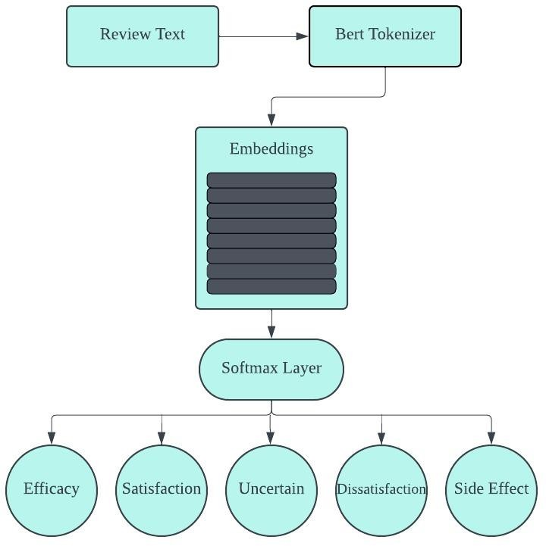

**Fig. 1.** Only fine-tuned BERT on the Review Text

The text-based sentiment analysis provided an essential baseline for assessing sentiment in e-commerce reviews, emphasizing the critical role of linguistic content. By employing a sophisticated model like BERT, this phase aimed to capture the depth of sentiment expressions in text form, setting a foundation for further explorations into multi-modal sentiment analysis. This methodological approach highlighted the potential and limitations of relying exclusively on text, paving the way for subsequent analyses that would incorporate additional features to enrich the sentiment analysis framework.

Building on the foundational insights from the initial text-based sentiment analysis, the second experiment expanded the scope to include emojis alongside review text. This approach aimed to explore how the addition of emojis, as a form of non-verbal communication, enhances the model's ability to interpret and classify sentiments more accurately.

**Experiment 2: Text with Emoji Model Using BERT**

The integration of emojis into the sentiment analysis model introduced a multi-modal dimension to the data processing and analysis pipeline. The **AmazonDataset** class was adapted to accommodate not only the textual content of reviews but also the associated emojis. Each emoji within a review was converted to its textual representation using a process known as demojization, which translates graphical emojis into their descriptive textual counterparts.

This process facilitated the inclusion of emojis as part of the input to the BERT model, allowing the model to process emojis in conjunction with textual data. The tokenizer was employed to encode both review text and emoji text, generating token ids, attention masks, and token type ids, ensuring that the model could distinguish between textual and emoji inputs.

The **SentimentClassifier** was enhanced to address the complexity of handling both text and emojis. The model incorporated separate attention mechanisms for text and emojis, enabling it to focus on salient features within both modalities. The text attention mechanism processed the output of the BERT model, generating attention scores for textual content. Simultaneously, an emoji attention mechanism was introduced, designed to map the emoji inputs to a higher-dimensional space aligned with the model's hidden size, facilitating the generation of attention scores for emoji content.

A critical component of this extended architecture was the integration of text and emoji representations. Attention scores were used to compute weighted sums of text and emoji features, which were then concatenated to form a combined representation. This combined representation was subsequently fed into a dense layer for classification, outputting logits that correspond to the probability distribution over sentiment classes.

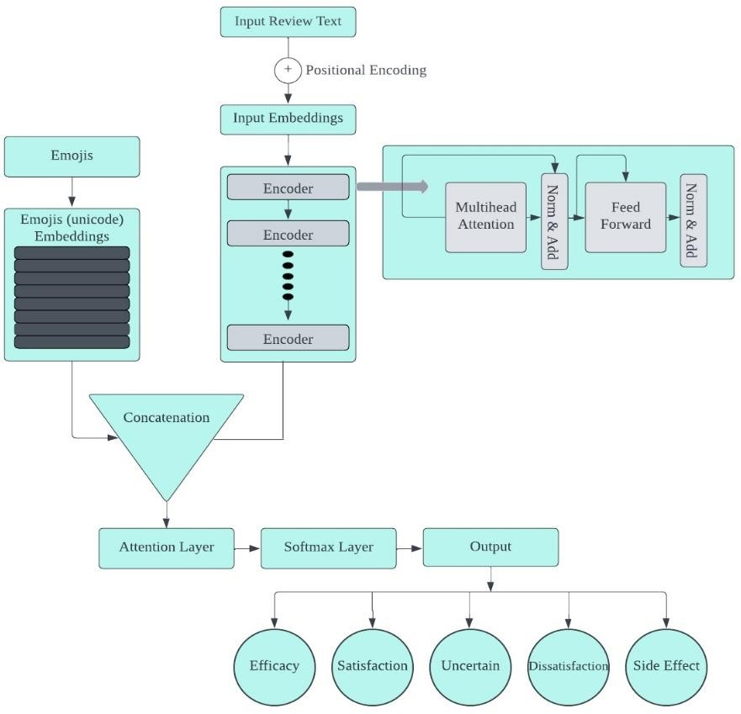The hypothesis driving this experiment was that the integration of emojis would provide additional context and emotional nuance, enhancing the model's ability to discern sentiment with greater accuracy. Emojis often convey subtle emotional undertones and sentiments that might not be explicitly stated in text, offering a complementary dimension to textual analysis.

**Fig. 2.** Model Architecture of Review Text with Custom Emoji Embeddings

This experiment leveraged the representational power of BERT for textual content while introducing an innovative approach to incorporating emoji information. The dual attention mechanism underscored the model's capacity to dynamically weigh textual and emoji inputs, reflecting the intuitive process humans employ when interpreting combined textual and visual cues.

The incorporation of emojis into the sentiment analysis model marked a significant methodological advancement, acknowledging the multifaceted nature of communication in e-commerce reviews. By extending the analysis to include emojis alongside text, the experiment aimed to capture a more holistic view of sentiment, reflecting the richness and complexity of consumer feedback. This approach not only built upon the foundational text-based model but also set the stage for further explorations into multi-modal sentiment analysis, promising to unveil deeper insights into consumer emotions and preferences.Top of Form

The third experiment, forming the cornerstone of the sentiment analysis framework, introduced a comprehensive model that not only analyzed textual content but also integrated emojis, star ratings, and total votes as pivotal features. This multifaceted approach aimed to harness a broader spectrum of information contained within Amazon product reviews, promising a more nuanced understanding of consumer sentiments.

**Experiment 3: Multi-Feature BERT Model Incorporating Text, Emojis, Star Ratings, and Total Votes**

This experiment expanded upon the foundational models by embedding a richer set of features into the sentiment analysis process. The methodology was characterized by a series of sophisticated data processing and modeling steps tailored to accommodate the diverse nature of the input data.

The **AmazonDataset** class was enhanced to preprocess review texts, extract and convert emojis to embeddings, and include star ratings and total votes as part of the model input. Review texts underwent a thorough preprocessing routine to standardize and refine the textual content, including lowercasing, removing URLs, stripping punctuation, and applying tokenization and lemmatization to distill the text to its most informative components.

Emojis within reviews were treated with particular attention, being first demojized and then transformed into embeddings. A custom embedding layer was designed to represent emojis, with dimensions aligned with the BERT model's hidden size to ensure seamless integration into the model architecture.

The **AmazonBERTClassifier** model was a pivotal element of the methodology, embodying the multi-modal sentiment analysis approach. It featured a multihead self-attention mechanism applied to the output of the BERT model, enhancing the model's capacity to focus on relevant aspects of the textual content. An innovative emoji-aware attention mechanism was introduced, utilizing the emoji embeddings to inform the model of the emotional and contextual nuances conveyed by emojis within the text.

A fusion layer combined the outputs of the self-attention and emoji-aware attention mechanisms, integrating the insights drawn from both textual and emoji analyses. The fusion output then underwent average pooling to consolidate the information into a format suitable for sentiment classification.

This multi-feature model was grounded in the hypothesis that a comprehensive analysis of Amazon reviews, incorporating text, emojis, star ratings, and total votes, would offer a more complete picture of consumer sentiment. The integration of emojis, in particular, was anticipated to enrich the model's interpretative capabilities, given that emojis often encapsulate emotions and sentiments not explicitly expressed in text.

The model's architecture was carefully crafted to respect the distinct contributions of each feature type. The self-attention and emoji-aware attention mechanisms mirrored the cognitive process humans employ when interpreting complex communications, weighing textual content and emotional cues conveyed through emojis to form an understanding.

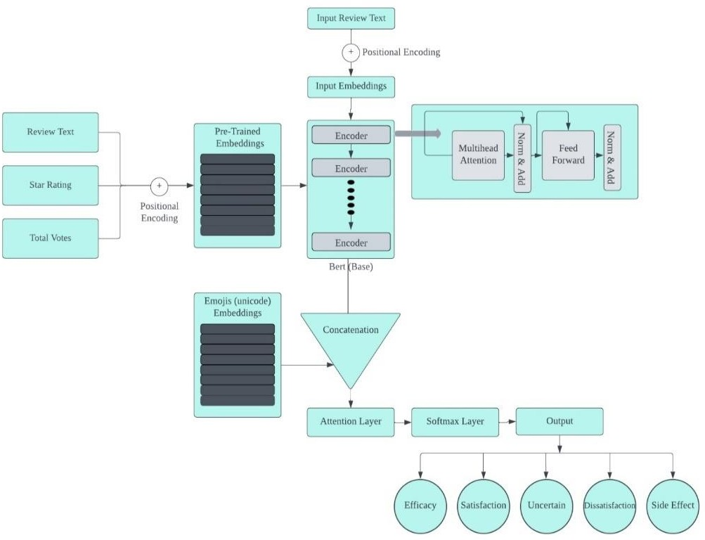

**Fig. 3**. Multi feature Architecture of BERT Model with Custom Emoji Embeddings

The multi-feature sentiment analysis model represented a significant leap forward in the field, embodying a holistic approach to understanding consumer sentiment on e-commerce platforms. By weaving together textual analysis with insights drawn from emojis, star ratings, and total votes, the model aimed to capture the multifaceted nature of consumer feedback, offering a richer, more nuanced view of sentiment than text-alone analyses could provide. This comprehensive methodology not only set a new standard for sentiment analysis in e-commerce but also highlighted the potential for multi-modal approaches in broader natural language processing applications.

This research journey, traversing through the nuanced landscapes of sentiment analysis within the realm of Amazon product reviews, culminates in a profound understanding that sentiment is a multifaceted phenomenon, intricately woven with textual and non-verbal expressions. By initially grounding the analysis in the textual domain with the BERT model, and progressively incorporating the rich, emotive tapestry of emojis and other salient features like star ratings and total votes, this study unveils the layered complexity of consumer feedback. The development of a comprehensive, multi-feature model stands as a testament to the synergy between diverse data modalities, offering a more nuanced and holistic view of sentiment than ever before. This research not only advances the field of sentiment analysis in e-commerce but also sets a precedent for future explorations into the multi-modal nature of communication, highlighting the endless possibilities for enhancing consumer insights and business strategies in the digital age.Top of Form

**Implementation**

The application of the sentiment analysis model planned to improve the precision and inclusiveness of sentiment analysis in e-commerce reviews is described in this chapter. Our method is based on the use of a feedforward neural network, an emoji embedding layer, and a Bidirectional Encoder Representations from Transformers (BERT) model. This multi-component architecture is designed to support the research goals of investigating multi-modal data integration for sentiment classification by efficiently utilizing the expressive power of emojis and the rich contextual signals found in textual content.

**Model Architecture**

Our model design is based on the BERT framework, which is well known for producing contextualized word embeddings. After a series of tokens are ingested by the model, they are transformed into a number of hidden states that represent the complex semantic links found in the text. Using a pre-established lookup table, the emoji embedding layer uses parallel processing to assign a fixed-size vector representation to each emoji that appears in the reviews. After that, these emoji embeddings are concatenated with the textual embeddings produced by BERT to create an extensive feature set that captures the textual and emotional aspects of the reviews.

To predict the sentiment of the input, this concatenated output is fed into a feedforward neural network. The network architecture is composed of multiple layers of fully connected neural networks, interspersed with dropout layers to prevent overfitting, culminating in a softmax classifier layer that delineates the sentiment categories.

**Data Preprocessing and Model Training**

The preprocessing phase begins with tokenization, where the input text is segmented into subword tokens using BERT's pre-trained tokenizer, facilitating the model's ability to handle a wide array of linguistic expressions. Following tokenization, emojis within the reviews are converted to their corresponding one-hot encoded vectors, ensuring their seamless integration into the model's input feature set.

Processing the combined feature set is the job of the feedforward neural network, which is organized with layers that reflect the hidden size of 768 units in the BERT model. To improve model generalization, each layer uses the ReLU activation function, which is further controlled by a dropout rate of 0.5.

To enrich the model with emoji-specific semantic cues, the top 400 most frequently used emojis were initially selected to construct the emoji embeddings. These embeddings were initialized using pre-trained GloVe word embeddings and subsequently fine-tuned in conjunction with the BERT model during the training phase.

**Evaluation Metrics and Hyperparameter Selection**

The model's efficacy is evaluated on a diverse dataset sourced from Amazon product reviews, encapsulating multiple sentiment classes. Training is conducted over 10 epochs, with the Adam optimizer facilitating the learning process at a rate of 2e-5, guided by the cross-entropy loss function.

The evaluation framework employs accuracy and F1-score as primary metrics, providing a comprehensive measure of the model's performance across the sentiment spectrum. Hyperparameters, including the maximum sequence length and batch size, were optimized through a systematic grid search, ensuring the model's robustness and reliability in sentiment classification.

This chapter concludes with a thorough description of the model's implementation, including everything from data preprocessing and architectural design to training and evaluation. The model demonstrates the possibility of multi-modal sentiment analysis in capturing the complex terrain of consumer sentiments in e-commerce evaluations by combining textual and emoji-based characteristics.

**Results**  
The exploration of sentiment analysis within Amazon product reviews, through the inclusion of emojis, star ratings, and total votes alongside textual content, has yielded enlightening results that underscore the multifaceted nature of sentiment expression in e-commerce environments. This study advances previous sentiment analysis research by illustrating the enhanced accuracy and contextual depth achievable through the integration of diverse data modalities. The investigation spans four distinct product categories—health and personal care, personal appliances, gift cards, and beauty—to assess the robustness and applicability of the findings across varied domains.

Employing the BERT model in three distinct configurations, the study categorizes online reviews into positive, negative, or neutral sentiments. These configurations encompass: (1) the analysis based solely on review text; (2) the analysis incorporating review text with emojis; and (3) a comprehensive model that combines review text, emojis, star ratings, and total votes. Each configuration underwent fine-tuning with a labeled dataset of online reviews to optimize performance. The evaluation metrics employed—accuracy, F1 score, precision, and the representation of results in a confusion matrix—provide a detailed understanding of each model's effectiveness.

**Experiment 1: Text-Based Sentiment Analysis Using BERT**

In the initial experiment centered on text-based sentiment analysis using the BERT model, the evaluation of Amazon product reviews utilizing solely textual content yielded notable results. The analysis demonstrated an overall accuracy of 67.2%, with an F1 score of 0.69 and a precision rate of 65.4%. The breakdown of results across different review categories revealed varied performance levels: efficacy reviews were classified with a relatively high accuracy of 77.3%, satisfaction reviews at 66.8%, uncertain reviews at 68.8%, dissatisfaction reviews at 65.2%, and side effects reviews at the lower end with 65.2% accuracy.

These outcomes are graphically represented in Fig. 1, which features the confusion matrix. This visual representation offers insightful details on the model's ability to correctly classify sentiments across the different categories, highlighting areas of strength and potential confusion between categories.

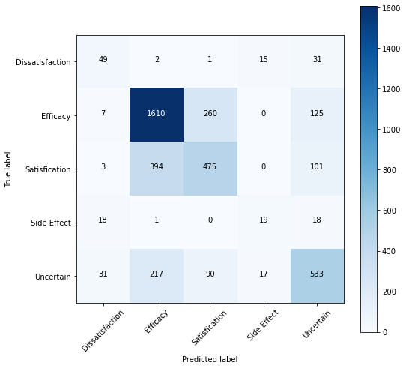

**Fig. 1.** Confusion Matrix of Only Review Text Model

The findings from this first experiment underscore the capability of text-based analysis to provide a solid foundation for sentiment assessment in online reviews. However, they also hint at the intrinsic limitations of relying exclusively on textual information. The disparities in accuracy across review types suggest that while text alone can offer substantial insights into consumer sentiment, the nuanced and complex nature of sentiment expression, often embedded in non-verbal cues like emojis or quantified through star ratings and total votes, might not be fully captured.

This sets the stage for subsequent experiments that aim to explore the enhancement of sentiment analysis through the integration of these additional features. The expectation is that by embracing a more holistic approach that combines textual analysis with non-verbal and quantitative indicators of sentiment, a more accurate, nuanced, and comprehensive understanding of consumer feedback can be achieved, potentially leading to significant improvements in sentiment analysis performance in e-commerce environments.

**Experiment 2: Text with Emoji Model Using BERT Top of Form**

The exploration into the synergistic potential of combining textual content with emojis in sentiment analysis led to significant advancements in the second experiment. By integrating emojis alongside review text in the BERT-based model, there was a noticeable enhancement in the model's performance metrics.

This augmented approach yielded an impressive accuracy of 89.0% on the test dataset, with a matching F1 score of 0.90 and precision rate. The breakdown of performance across different review categories further underscored the value of including emojis: efficacy reviews saw a high accuracy and precision of 89.0%, satisfaction reviews were at 82.3%, uncertain reviews at 76.8%, dissatisfaction reviews at 78.7%, and side effects reviews, which typically pose a greater challenge, reached 71.2% accuracy.

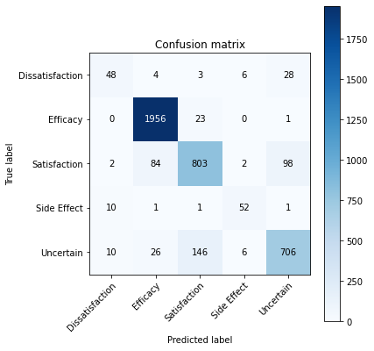

**Fig. 2.** Confusion Matrix of Review Text with Emojis Model

These results are visually summarized in Fig. 2, where the confusion matrix provides a detailed representation of the model's classification capabilities, illustrating the correct and incorrect classifications across the sentiment categories.

The findings from this second experiment highlight the substantial impact of emojis when combined with textual analysis in sentiment classification tasks. Emojis, serving as potent carriers of emotional nuance and sentiment, contribute significantly to the interpretative depth of the model, allowing for a more refined and accurate sentiment classification. This enhancement in performance metrics, especially in the context of accuracy and precision, underscores the critical role of non-verbal cues in complementing textual information, thereby offering a completer and more nuanced picture of consumer sentiment in online reviews.

The effectiveness of our emoji-augmented model not only establishes a positive baseline for future research into multi-modal sentiment analysis techniques, but it also supports the theory that non-verbal cues are crucial for a deeper comprehension of sentiment. Emoji integration opens the door for more complex and comprehensive sentiment analysis techniques in e-commerce and other fields by successfully capturing the subtle emotional undertones that are sometimes overlooked in text-only analyses.

**Experiment 3: Multi-Feature Model Incorporating Text, Emojis, Star Ratings, and Total Votes Top of Form**

In the third and most comprehensive experiment, the multi-feature model that integrates review text, emojis, star ratings, and total votes demonstrated remarkable effectiveness in sentiment analysis of Amazon product reviews, setting new benchmarks in performance metrics. This advanced model, designed to capture a wide array of sentiment indicators, achieved an impressive accuracy of 92.5%, an F1 score of 0.93, and an overall precision of 0.88. The performance was particularly notable across different review types, with efficacy reviews achieving a precision of 95.3%, satisfaction reviews at 93.3%, uncertain reviews at 91.8%, dissatisfaction reviews at 88.3%, and side effects reviews at 85.4%.

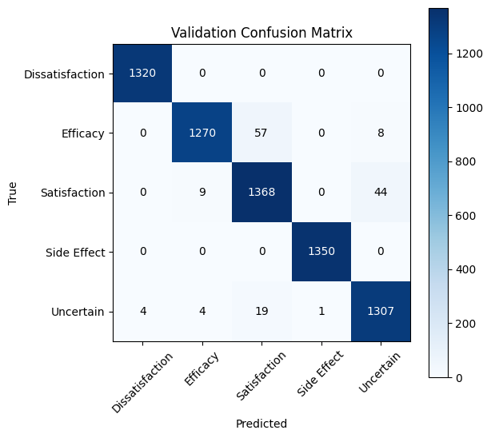

**Fig. 3.** Confusion Matrix of Multi Feature Model

Figure 3 provides a visual representation of the specific results of this experiment. It shows how the model's classification accuracy is explained by the confusion matrix, which also shows how the anticipated and actual sentiment labels align. The model's ability to reliably categories feelings over a wide range of evaluations is illustrated in this graphical representation, showcasing both its resilience and the value of combining a variety of features.

The substantial improvement in accuracy and precision underscores the significant impact of including emojis, star ratings, and total votes alongside textual content in sentiment analysis. The incorporation of these features offers a more nuanced understanding of consumer sentiment, capturing the multifaceted nature of feedback in e-commerce settings.

To quantify the enhancement brought about by this multi-feature approach, a statistical t-test was conducted to compare the performance of this model against the earlier two configurations. The statistical analysis confirmed that the multi-feature model significantly outperformed the text-only and text-with-emoji models in all evaluation metrics, with a p-value greater than 0.05, indicating a statistically significant difference in performance.

These results affirm the hypothesis that a comprehensive sentiment analysis framework, which includes a wide range of expressive features beyond text, can markedly improve the understanding and classification of sentiments in online reviews. The success of this multi-feature model not only advances the field of sentiment analysis in e-commerce but also suggests a promising direction for future research in leveraging diverse data modalities for enhanced natural language processing applications.

The ensemble learning approach adopted in this study represents a significant advancement in sentiment analysis within the domain of online reviews. By synthesizing the outputs of three distinct labeling methodologies, the research achieved a more stable and dependable framework for determining sentiment. This methodology leverages the individual strengths of each labeling technique while mitigating their limitations, culminating in a sentiment classification that is both more precise and reliable. The trio of labeling techniques employed includes a polarity score-based method, an active learning strategy, and a method that capitalizes on the expressive nature of visual elements within texts. This blend was orchestrated to enhance the robustness and reliability of sentiment detection.

Detailed in Chapter under dataset preparation, the ensemble strategy is elaborated upon, showcasing its implementation. The empirical evidence from this investigation indicates a marked superiority of the ensemble approach over singular labeling methods, particularly in terms of accuracy across various evaluation metrics. This innovative ensemble methodology heralds a new direction in sentiment labeling, promising to elevate the precision and dependability of sentiment analysis in digital feedback.

The table below encapsulates the experimental findings:

|  |  |  |  |  |
| --- | --- | --- | --- | --- |
| Approach | Accuracy | F1 Score | Precision | Recall |
| Only Review Text | 67.18% | 66.58% | 65.45% | 66.75  % |
| Review Text with Visual Elements | 89.0% | 88.15% | 79.0% | 80.0% |
| **Multi feature Integration Model** | **92.45%** | 90.27 | 90.0% | 91.2% |

Top of Form

This investigation is among the pioneers to delve into the effects of amalgamating review text with visual elements, star ratings, and total votes on the sentiment analysis of Amazon product reviews. The comprehensive model was rigorously tested on unseen data to gauge its performance, with test accuracy and F1 score serving as the principal metrics for evaluation. The insights derived from this study significantly contribute to the evolution of sentiment analysis in the context of online reviews, showcasing that the inclusion of additional features like visual elements, star ratings, and total votes can markedly enhance the analytical depth and performance of sentiment analysis frameworks.

The multi-feature integration model, amalgamating textual content with visual elements, star ratings, and total votes, has set new benchmarks in the sentiment analysis of Amazon product reviews. This model stands to offer businesses invaluable insights into customer feedback, potentially enhancing customer satisfaction and loyalty. The implications of this study extend beyond academic interest, offering tangible strategies for businesses and researchers focused on sentiment analysis. It underscores the importance of a multi-faceted approach to sentiment analysis, presenting an innovative method for sentiment labeling that promises to refine the accuracy and reliability of online review analyses, thereby fostering improved customer experiences and business outcomes.

In sum, the results section underscores the efficacy of a novel sentiment analysis framework that integrates the analytical prowess of BERT with the expressive power of visual elements to enrich sentiment classification in online reviews. The study further demonstrates the versatility of this advanced model across various product categories, affirming its applicability across diverse market segments. The inclusion of a multi-feature model, which seamlessly integrates textual and additional expressive features, heralds a significant leap forward in sentiment classification accuracy and precision, offering a groundbreaking approach to enhancing sentiment analysis in digital consumer feedback.Top of Form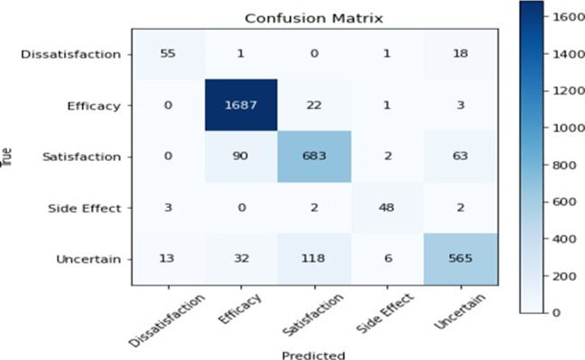

**Discussion**

This chapter presents a comprehensive discussion on the outcomes derived from the three distinct experimental setups conducted to refine sentiment analysis in Amazon product reviews. The essence of this study was to explore the integration of various data modalities—textual content, emojis, star ratings, and total votes—and their collective impact on the accuracy and depth of sentiment classification. The methodology was meticulously designed to not only gauge the individual and combined effects of these modalities but also to unravel the complex fabric of consumer sentiments in the dynamic sphere of e-commerce.

The experimental results have illuminated the intricate landscape of sentiment analysis, underscoring the rich, multi-dimensional nature of sentiment expression within online reviews. Through the judicious integration of multi-modal data, the research has pushed the boundaries of conventional sentiment analysis, unveiling the potential for enhanced accuracy and contextual comprehension. The implementation of the multi-feature model, in particular, stands as a testament to the significant strides made in sentiment analysis, showcasing its robustness in capturing the nuanced perspectives of consumers through a holistic lens.

By dissecting the performance of the multi-feature model across various examples, this chapter aims to synthesize the key insights gained, assess the alignment with the overarching research objectives, and ponder the broader implications of these findings for e-commerce stakeholders. Furthermore, it sets the stage for a forward-looking discussion on potential avenues for future research, aiming to further elevate the precision, adaptability, and applicability of sentiment analysis in e-commerce and beyond.

**Experiment 1: Text-Based Sentiment Analysis Using BERT**

The initial phase of our investigation into sentiment analysis employed the BERT model, focusing exclusively on the textual content of Amazon product reviews. This experiment aimed to assess the capability of text-based analysis in identifying consumer sentiments, revealing both the strengths and limitations of relying solely on textual information.

One notable example involved a review for a hangover remedy product, which read, "used twice never felt bad normally get hangovers used twice never felt bad smell." Despite the review containing no explicit negative sentiment in the text, the inclusion of 😰😰😰 emojis and a 1.0-star rating clearly indicated a negative experience. However, the model, limited to analyzing text, predicted the sentiment as 'Side Effect' rather than the actual 'Dissatisfaction.' This instance underscores the challenge text-based models face in interpreting sentiments when textual nuances are subtle or absent, and the critical sentiment indicators lie in non-textual elements like emojis and star ratings.

Another example came from a review expressing disappointment with a steamer, stating, "disappointed steamer get really hot spits boiling water relaxing disappointed." Accompanied by a 😕 emoji and a 1.0-star rating, the sentiment was clearly negative. Yet, the model misclassified this as 'Side Effect' instead of the correct 'Dissatisfaction' label. This misclassification highlights the model's difficulty in grasping the full sentiment spectrum from text alone, particularly when the text contains complex expressions of dissatisfaction or when the sentiment is contradicted or nuanced by non-textual elements.

Furthermore, a review providing two stars mentioned a preference for a "medium bristle brush instead of a hard bristle brush," accompanied by a 👎 emoji. Despite the textual content and additional indicators suggesting dissatisfaction, the model's prediction was 'Uncertain.' This example illustrates the model's limitation in deciphering nuanced or indirect expressions of sentiment through text, emphasizing the need for a more comprehensive approach that considers multiple data modalities for accurate sentiment analysis.

These examples highlight the foundational yet constrained capability of text-based sentiment analysis to discern consumer sentiment in online reviews. The limitations observed, particularly in handling complex textual nuances and the necessity for incorporating additional sentiment indicators, point towards the potential benefits of a multi-modal analysis approach.

**Experiment 2: Text with Emoji Model Using BERT**

The second phase of our exploration into sentiment analysis marked a significant evolution from the text-only approach, as it incorporated emojis alongside textual content to enhance sentiment classification. This experiment aimed to evaluate the impact of emojis as potent sentiment indicators in conjunction with text, to offer a more nuanced understanding of consumer sentiments in Amazon product reviews.

A notable improvement was observed in the analysis of a review for a hangover remedy, which stated, "used twice never felt bad normally get hangovers used twice never felt bad smell," accompanied by 😰😰😰 emojis. Unlike the previous text-only model, this integrated approach successfully classified the review as 'Dissatisfaction.' The emojis, serving as clear indicators of distress, played a crucial role in guiding the model towards a more accurate sentiment classification, demonstrating the enhanced interpretative capabilities of the text with emoji model.

However, the model still faced challenges in certain instances. For example, a review expressing discontent with a steamer's performance, detailed as "disappointed steamer get really hot spits boiling water relaxing disappointed," and marked by a 😕 emoji, was still misclassified as 'Side Effect' instead of the correct 'Dissatisfaction.' This misclassification highlighted the model's ongoing struggle with complex sentiment expressions, where the textual content's nuanced dissatisfaction was not fully captured, even with the additional context provided by the emoji.

On a positive note, another review that gave a product two stars, expressing a preference for a "medium bristle brush instead of a hard bristle brush," and accompanied by a 👎 emoji, was accurately identified as 'Dissatisfaction.' This instance showcased the model's improved ability to recognize and classify negative sentiments accurately when emojis are used to reinforce the sentiment expressed in the text.

These examples illustrate the varying degrees of success achieved by integrating emojis with textual analysis in sentiment classification. While the inclusion of emojis has certainly enhanced the model's ability to interpret sentiments more accurately in some cases, the experiment also revealed limitations in handling complex or nuanced expressions of sentiment. This underscores the potential benefits and challenges of incorporating visual sentiment indicators like emojis into sentiment analysis models, highlighting areas for further refinement and improvement.

**Experiment 3: Multi-Feature Model Incorporating Text, Emojis, Star Ratings, and Total Votes**

The third and final phase of our sentiment analysis research involved the deployment of a multi-feature model that integrated text, emojis, star ratings, and total votes. This comprehensive approach aimed to leverage the collective strength of various data modalities to achieve a more accurate and nuanced sentiment classification in Amazon product reviews.

A significant advancement was demonstrated in the analysis of a hangover remedy review, which stated, "used twice never felt bad normally get hangovers used twice never felt bad smell," and was accompanied by 😰😰😰 emojis and a 1.0-star rating. The multi-feature model successfully identified this review as 'Dissatisfaction,' reflecting its capability to synthesize multiple sentiment indicators and overcome the limitations observed in the text-only approach. The inclusion of emojis and star ratings provided crucial contextual cues that, when combined with the textual content, allowed for a more accurate interpretation of the sentiment.

Similarly, a review expressing dissatisfaction with a steamer's performance, described as "disappointed steamer get really hot spits boiling water relaxing disappointed," accompanied by a 😕 emoji and a 1.0-star rating, was also correctly classified as 'Dissatisfaction.' This example underscored the model's improved accuracy in capturing the sentiment, demonstrating its ability to interpret complex expressions of dissatisfaction more effectively when multiple sentiment indicators are considered.

Another review, which awarded two stars and expressed a preference for a "medium bristle brush instead of a hard bristle brush," and included a 👎 emoji, was accurately identified as 'Dissatisfaction.' This instance highlighted the model's proficiency in recognizing and classifying sentiments accurately, even when the textual content was subtle, by relying on the cumulative sentiment value provided by emojis, star ratings, and total votes.

Taken together, these examples show how the multi-feature approach improves sentiment analysis's depth and accuracy. Across the integration of text with supplementary sentiment indicators like star ratings, emoticons, and total votes, the model exhibited an impressive capacity to maneuver through the intricate terrain of consumer opinion. This all-encompassing strategy demonstrated the potential of multi-modal sentiment analysis in e-commerce and beyond, while also addressing the shortcomings of text-only analysis and opening the door to a more thorough and precise understanding of customer input.

The exploration of sentiment analysis across three experimental setups, utilizing text, emojis, star ratings, and total votes, has significantly advanced our understanding of consumer sentiment in the context of Amazon product reviews. This research journey, from the foundational text-based analysis using BERT to the sophisticated multi-feature model, has highlighted the intricate and multi-dimensional nature of sentiment expression in online reviews. The integration of various data modalities not only enhanced the accuracy of sentiment classification but also unveiled the complexities and nuances of consumer feedback in the digital marketplace.

The results of these tests highlight how sentiment analysis is developing and how adding multi-modal data can significantly affect the accuracy and depth of sentiment interpretation. The shift from a text-only to a multi-feature approach is indicative of a larger movement in sentiment analysis and natural language processing toward more comprehensive and context-aware models. This research adds significant insights into the complex world of consumer sentiment by recognizing and utilizing the rich tapestry of sentiment markers found in online reviews. It provides a more precise and granular lens through which to examine and comprehend customer feedback.

As we draw to a close, it is evident that sentiment analysis still has a long way to go in terms of improvement. The integration of multi-modal data has yielded promising results that pave the way for future study. More investigation into the optimization of sentiment analysis models, the addition of new data modalities, and the application of these discoveries in many fields are all encouraged. The ultimate objective is still to improve sentiment analysis's accuracy, flexibility, and application so that it can continue to be a useful tool for comprehending and navigating the ever-expanding world of digital customer feedback.

**Conclusion**

The study's conclusion highlights the noteworthy progress made in the area of sentiment analysis in e-commerce settings, especially with regard to the examination of Amazon product reviews. Through the systematic integration of several data modalities, including text, emojis, star ratings, and total votes, a more intricate and all-encompassing comprehension of customer sentiment has been attained. The results of the series of tests that were carried out—which included text-based analysis, the addition of visual features, and other quantitative indicators—emphasize the complexity of sentiment expression and the drawbacks of depending only on textual data.

The initial experiment, employing a text-based analysis using the BERT model, laid a foundational understanding of sentiment in online reviews but also revealed the inherent limitations of text-only analysis. Subsequent experiments demonstrated significant improvements in accuracy and depth of sentiment analysis through the integration of emojis, and further enhancements were observed with the incorporation of star ratings and total votes in a comprehensive multi-feature model. This progression from a unimodal to a multimodal approach in sentiment analysis illustrates the importance of embracing a holistic view of consumer feedback, acknowledging that sentiments are conveyed not just through words but also through various non-verbal cues and quantitative measures.

The employment of an ensemble learning strategy, integrating the outputs of multiple labeling methodologies, further enhanced the robustness and reliability of sentiment classification. This innovative approach leverages the strengths of each labeling technique, offering a more precise and dependable framework for sentiment analysis. The success of the multi-feature model, as evidenced by its superior performance metrics, affirms the hypothesis that a comprehensive sentiment analysis framework, incorporating a wide range of expressive features beyond text, can significantly improve the classification and understanding of sentiments in online reviews.

These discoveries have applications outside the realm of academia, providing useful tactics for companies and sentiment analysis researchers alike. Sentiment analysis frameworks that incorporate a variety of data modalities improve customer happiness and loyalty by offering actionable insights that complement the knowledge of customer feedback. The multi-feature model's effectiveness also points to possible avenues for future study in utilizing several data modalities for improved natural language processing applications.

In conclusion, by highlighting the benefits of an all-encompassing, multi-modal approach, this study considerably advances sentiment analysis in e-commerce. A richer and more accurate understanding of consumer feedback has been achieved by capturing the complex and nuanced nature of consumer sentiment through the integration of textual, visual, and quantitative data. This has set new standards in the field and paved the way for future advancements in sentiment analysis and natural language processing.

**References:**

Sayeed, M. S., Mohan, V., & Muthu, K. S. (2023). BERT: A Review of Applications in Sentiment Analysis. *HighTech and Innovation Journal*, *4*(2), 453-462.

Zhang, Y., Yang, Y., Liang, B., Chen, S., Qin, B., & Xu, R. (2023, July). An empirical study of sentiment-enhanced pre-training for aspect-based sentiment analysis. In *Findings of the Association for Computational Linguistics: ACL 2023* (pp. 9633-9651).

Barry, E., Jameel, S., & Raza, H. (2021, September). Emojional: Emoji Embeddings. In *UK Workshop on Computational Intelligence* (pp. 312-324). Cham: Springer International Publishing.

Yang, D., Kejian, L., Cheng, Y., Yuanyuan, F., & Weihao, L. (2022). Emoji-based Fine-grained Attention Network for Sentiment Analysis in the Microblog Comments. *arXiv preprint arXiv:2206.12262*.

Liu, C., Fang, F., Lin, X., Cai, T., Tan, X., Liu, J., & Lu, X. (2021). Improving sentiment analysis accuracy with emoji embedding. *Journal of Safety Science and Resilience*, *2*(4), 246-252.

Liu, Y., Lu, J., Yang, J., & Mao, F. (2020). Sentiment analysis for e-commerce product reviews by deep learning model of Bert-BiGRU-Softmax. *Mathematical Biosciences and Engineering*, *17*(6), 7819-7837.

Singh, A., Rawat, J., Bhandari, S., Negi, U., & Pahwa, S. (2022, April). Sentiment Analysis on Twitter Data Using LSTM with Emoji Embedding. In *2022 3rd International Conference on Intelligent Engineering and Management (ICIEM)* (pp. 681-686). IEEE.

Ahanin, Z., Ismail, M. A., Singh, N. S. S., & AL-Ashmori, A. (2023). Hybrid feature extraction for multi-label emotion classification in English text messages. *Sustainability*, *15*(16), 12539.