**Abstract**

This study delves into the enhancement of sentiment analysis within Amazon product reviews, focusing on the integration of diverse data modalities including textual content, emojis, star ratings, and total votes to enrich the interpretation of consumer sentiment. Leveraging the Bidirectional Encoder Representations from Transformers (BERT) model across three experimental configurations, this research assesses the individual and combined impact of these features on sentiment classification accuracy in selected e-commerce product categories.

The first experiment evaluates the baseline sentiment classification using only review text, setting a foundational understanding of sentiment analysis with BERT. The subsequent experiment introduces emojis, exploring their synergistic effect with textual content on emotion detection accuracy. The final and most comprehensive experiment integrates all data modalities, assessing the multi-feature model's performance in providing a nuanced understanding of consumer feedback.

Results reveal significant enhancements in sentiment classification accuracy with the integration of multimodal data, highlighting the critical role of non-textual features like emojis, star ratings, and total votes in capturing the full spectrum of consumer sentiment. The multi-feature model, incorporating all data modalities, demonstrates superior performance, markedly improving sentiment classification accuracy across various product categories.

This study presents the potential of multi-modal characteristics in improving the precision and contextual depth of sentiment interpretation, hence advancing the approach in natural language processing for sentiment analysis. The results highlight the useful applications of sophisticated sentiment analysis techniques in comprehending customer comments and raising customer happiness, providing e-commerce stakeholders with actionable insights. The study adds to the body of knowledge on sentiment analysis in academia and offers a methodological foundation for future studies that will use a variety of data modalities to use enriched sentiment analysis for e-commerce and other applications.

**Introduction**  
The rise of online evaluations in the digital age has changed the face of e-commerce and is a valuable source of customer sentiment that companies should try to comprehend and take use of. Sentiment analysis, the computational process of recognizing and classifying opinions in text, has emerged as a vital instrument for interpreting the massive volume of user comments produced on websites such as Amazon.com. This introduction describes the study's journey through the complex field of sentiment analysis, emphasizing how several data modalities, such as text, emojis, star ratings, and total votes, are integrated to improve the precision and nuance of sentiment interpretation.

The emergence of sentiment analysis signified a significant change in the way companies comprehend the preferences and experiences of their customers. This field, which has its roots in text analysis, has struggled to understand the nuances of human emotion and the intricacies of language. In order to determine customer sentiment, early sentiment analysis models concentrated on obtaining sentiment from text by parsing phrases and keywords. But as online communication developed, it became clear that text could never adequately capture the richness of human emotion. Star ratings, the total number of votes, and emojis all showed up as important sentiment markers that deepened and nuanced our understanding of customer feedback.

The difficulties that come with sentiment analysis are highlighted in recent research. Sayeed's (2023) investigation of the BERT model brought to light the challenges associated with emotion classification, especially in the case of reviews with conflicting feelings. This emphasizes how difficult sentiment analysis is and how important it is to have models that can handle these nuances. Similarly, Zhang et al. (2023) stressed the significance of aspect-based sentiment analysis, which provides insights into particular product features or aspects by breaking down attitudes at a fine level. This strategy is very helpful in e-commerce, as specific product modifications may be guided by comprehensive feedback.

The integration of emojis in sentiment analysis represents a significant methodological advancement. Barry et al. (2021) explored the use of emoji embeddings, acknowledging the wide emotional spectrum that emojis convey. This challenges traditional models to accurately capture the diversity of sentiments expressed through these visual symbols. Yang et al. (2022) furthered this exploration by integrating fine-grained attention mechanisms to capture the interplay between text and emojis, recognizing the complexity of sentiment expression in online communication.

The need for advanced methodologies that accommodate the multifaceted nature of sentiment expression is evident. This study aims to bridge this gap by assessing the impact of multi-feature integration on sentiment classification. By evaluating the influence of text, star ratings, total votes, and emojis, this research seeks to enhance emotion detection accuracy and contextual understanding in natural language processing. Specifically, the study explores the role of emojis in sentiment analysis within the health and personal care category on Amazon, employing both traditional and innovative classification approaches.

Innovative methodology is the foundation of this study. This work improves the field of natural language processing by using transformer-based deep neural networks to incorporate multi-modal information that increase the accuracy and efficiency of sentiment analysis models. This method raises the bar for sentiment analysis in e-commerce while simultaneously addressing the issues raised in the literature.

Beyond scholarly curiosity, this research has practical ramifications. Through the provision of practical insights into sophisticated sentiment analysis methodologies, this research gives e-commerce stakeholders significant approaches to augment customer satisfaction and product insights. A full picture of customer emotion is shown by the integration of text, emojis, star ratings, and total votes. This helps businesses better customize their tactics to match the demands of their customers.

To sum up, this introduction lays the groundwork for a thorough investigation of sentiment analysis in e-commerce, which will be informed by the wealth of literature in this area and directed by the goals specified. This study advances sentiment analysis by integrating multiple data modalities and employing innovative methods. It provides fresh insights into comprehending and utilizing customer input in the digital marketplace.

**Literature Review**

The exploration of sentiment analysis within e-commerce reviews has seen significant advancements, particularly in the integration of emojis and multi-feature data to enhance emotion detection accuracy. Recent literature reflects a growing understanding of the complexities involved in accurately interpreting customer feedback, where both textual content and emojis play pivotal roles.

Sayeed's (2023) analysis of the BERT Model framework underscores the inherent challenges in sentiment analysis, such as misclassifications due to incorrect labeling and the difficulty in accurately categorizing emotions, especially when contradictory emotions are present within sentences. This highlights the nuanced nature of sentiment analysis and the need for advanced models capable of handling such complexities.

Zhang et al. (2023) delve into aspect-based sentiment analysis (ABSA), emphasizing the importance of dissecting sentiments at the aspect level and integrating sentiment knowledge for a deeper understanding of customer perspectives. This approach is crucial for e-commerce platforms, where understanding specific aspects of products can lead to more targeted improvements.

Barry et al. (2021) introduces an innovative use of 300-dimensional word2vec embeddings, combined with Random Forests and unique emoji embeddings, to track the evolving emotional content expressed through emojis. Their methodology reflects the wide emotional spectrum emojis can convey, challenging traditional sentiment analysis models to capture this diversity accurately.

Yang et al. (2022) propose a model that employs a fine-grained attention mechanism to capture the intricate interactions between emojis and text. By using ALBERT for word vector learning and integrating emoji2vec for emoji embeddings, their approach acknowledges the complexity of sentiment expression in microblog comments, a feature equally relevant in e-commerce reviews.

Liu et al. (2021) address the challenges posed by the diverse syntax and semantics in sentiment analysis, particularly in Chinese. Their findings on the effectiveness of emojis in enhancing sentiment analysis algorithm accuracy underscore the potential of emojis as a valuable feature in understanding customer emotions.

In a similar vein, Liu et al. (2020) introduce the Bert-BiGRU-Softmax model, designed to tackle sentiment word disambiguation and polarity issues. Their work, though tested on a large-scale dataset, calls for further research to extend the model's applicability, underlining the ongoing need for adaptable and accurate sentiment analysis models.

Singh et al. (2022) explore the use of LSTM for text and emoji analysis, demonstrating the model's capability in handling crucial information for classification tasks. Their dictionary approach for managing emojis within datasets points to the necessity of sophisticated pre-processing techniques to ensure the accuracy of sentiment analysis.

Lastly, Ahanin et al. (2023) compare deep learning-based methods for emotion classification, illustrating the enhanced prediction capabilities when hybrid features are integrated with models like Bi-LSTM and BERT. This comparison not only showcases the potential of deep learning in sentiment analysis but also the importance of methodological innovation to capture the full range of human emotions in digital communications.

When taken as a whole, above works lay the groundwork for improving sentiment analysis techniques, especially when it comes to e-commerce reviews. This body of work lays the groundwork for more precise, effective, and context-aware sentiment analysis models by tackling the difficulties in integrating multi-modal input, such as text and emojis, and the requirement for nuanced emotion identification. These studies' findings have the potential to greatly advance our comprehension of customer input, which will improve product insights and customer satisfaction on e-commerce platforms.

**Research Methodology**

This research aims to advance sentiment analysis in e-commerce reviews through a series of planned experiments, each designed to incrementally integrate and evaluate the impact of multi-modal data, including text, emojis, star ratings, and total votes. The methodology is structured to implement these experiments in future research phases:

**Experiment 1: Text-Based Sentiment Analysis Using BERT**

The initial phase will employ the BERT model to conduct a foundational sentiment analysis solely based on the textual content of Amazon product reviews. Key steps include:

* **Data Collection and Preprocessing:** Gather a diverse dataset of product reviews, followed by cleaning and normalization processes to prepare the text for analysis.
* **Model Implementation:** Utilize a pre-trained BERT model, adapting it for the sentiment classification task across predefined sentiment categories.
* **Evaluation:** Assess the model's performance in accurately classifying review sentiments, establishing a baseline for textual sentiment analysis.

**Experiment 2: Integration of Emojis with Text in Sentiment Analysis**

Building upon the text-based analysis, this experiment will explore the integration of emojis alongside text:

* **Emoji Processing:** Implement demojization to convert emojis within reviews into their textual representations, integrating these with review texts for model input.
* **Model Enhancement:** Adapt the sentiment analysis model to process combined text and emoji inputs, employing attention mechanisms to capture the nuanced sentiment information conveyed by emojis.
* **Comparative Analysis:** Evaluate the enhanced model's performance against the text-only baseline, highlighting the value added by emojis in sentiment analysis.

**Experiment 3: Comprehensive Multi-Feature Sentiment Analysis**

The final experiment aims to develop a holistic sentiment analysis model incorporating text, emojis, star ratings, and total votes:

* **Multi-Modal Data Handling:** Enhance data preprocessing to include not just text and emojis but also numerical features like star ratings and total votes.
* **Model Development:** Construct a comprehensive sentiment analysis model, leveraging custom embeddings for emojis and integrating multi-head attention mechanisms to fuse insights from all data modalities.
* **Holistic Evaluation:** Benchmark the multi-feature model against previous models, focusing on its ability to provide a more nuanced and accurate sentiment analysis.

Each experiment is meticulously designed to explore the incremental benefits of integrating diverse data modalities into sentiment analysis, ultimately aiming to contribute a deeper and more comprehensive understanding of consumer sentiments in e-commerce reviews. Future documentation will include detailed reports of findings, supported by diagrams and charts to visualize the methodologies and results.RTop of FormTop of FormTop of Form

**Dataset Preparation**

Any research project involving any task involving natural language processing must begin with the preparation of the dataset. The dataset used in this study was collected from the Amazon Product Reviews dataset available on Amazon Web Services (AWS) Public Dataset [9]. The dataset contains product reviews from multiple categories; four categories were selected for this study: Health and Personal Care, Personal Appliances, Gift Cards, and Beauty. To narrow down the scope of this study, only the reviews that contained emoticons were considered. This decision was made to explore the impact of the use of emoticons in product reviews on sentiment analysis and emotion detection.This process helped refine the dataset, ensuring focus on the most relevant information for the study. Overall, ensuring the accuracy and applicability of our findings depended heavily on the dataset preparation process.

This section describe the important steps taken during the data preparation phase, which includes data collection, data preprocessing, data annotation, and generating final labels using a combination approach.

**Data Preprocessing:**

In natural language processing activities like sentiment analysis, text preparation is a vital stage. In this work, data cleaned and normalized the raw text data gathered from the Amazon Product Reviews dataset using a number of text preparation approaches. Python was used to implement the preprocessing processes, together with its NLTK, spaCy, emoji, and scikit-learn packages.

The text has been lemmatized, user mentions and URLs have been removed, emojis have been compressed to a single word, punctuation and digits have been eliminated, all text has been converted to lowercase, the HTML tag has been removed, stop words have been eliminated, and the text has been removed from punctuation. The final product is a cleaned-up version of the original text, which may be utilized as input into a text classification model for data annotation.

**Data Annotation:**

A crucial stage in machine learning tasks is data annotation, which is labelling data with meaningful groups or classifications. Precise sentiment category labelling is required for sentiment analysis of reviews in order to build reliable predictive models. On the other hand, extensive manual data annotation can be expensive and time-consuming. This task was tackled using three different approaches: polarity score-based labelling for the sentiment of reviews in our dataset, emoji-based labelling, and active learning-based labelling.

A typical strategy is the polarity score-based label approach, which determines the sentiment of a text based on the polarity score of the words it includes. Although this method has the advantage of being simple and automated, it might not always be able to capture the subtleties and context-dependent aspects of sentiment expression. Active learning-based labeling was also used, which involves iteratively choosing the most informative samples for labeling and including them in the labeled dataset, to overcome this constraint. With this strategy, the model can gain knowledge from the most pertinent samples and enhance its performance over time.

Lastly, an emoji-based categorization method was used, which entailed classifying assessments into five groups according to the presence of particular emoticons in the review text: Efficacy, Satisfaction, Uncertainty, Dissatisfaction, and Side Effects. This method has the benefit of being simple to understand and straightforward, but it also takes a lot of human labor to find the appropriate emoticons and categories the assessments.

In order to produce a more robust and trustworthy sentiment labelling, an ensemble learning technique was employed, combining the output of three labelling algorithms. This strategy can improve the accuracy and generalizability of the emotion labels by using the benefits of each unique methodology and compensating for its drawbacks.

**Polarity Score-Based Label:**

The collected reviews were initially labelled using a polarity score-based approach. The VADER (Valence Aware Dictionary and Sentiment Reasoner) tool was used to determine the polarity score for each review. Based on the polarity score, reviews were categorized into one of five groups: efficacy, contentment, uncertainty, dissatisfaction, or side effects. Reviews were categorized as effective or fulfilling based on their high polarity score, and unsatisfactory or having unwanted side effects based on their low polarity score. Reviews with a neutral polarity rating were classified as uncertain. This approach made it quick and simple to label the reviews, but it wasn't always able to properly capture their intricacies.

**Active Learning-Based Label:**

The data was split into labeled (star rating score) and unlabeled sets to facilitate this process. Logistic regression, random forest, and gradient boosting classifiers from the scikit-learn package were then utilized to train and test the models. More specifically, the labeled data was vectorized using TF-IDF vectorization, an active learner was initialized, and the most ambiguous samples were chosen for labeling using the uncertainty sampling technique. The selected samples were then labeled, added to the labeled set, and uncertainty scores for the selected samples were calculated. This procedure was repeated in other contexts. The model was then trained using this freshly labeled data after vectorization of the labeled data. The test data and the remaining unlabeled data had their labels predicted using the trained model. The summary of accuracy for different settings is shown in table 1.

|  |  |  |  |  |
| --- | --- | --- | --- | --- |
| **Setting** | **Model** | **Iterations** | **Instances** | **Accuracy** |
| 1 | Logistic Regression | 20 | 50 | 81% |
| Random Forest | 82% |
| Gradient Boosting | 82% |
| 2 | Logistic Regression | 40 | 100 | 82% |
| Random Forest | 83% |
| Gradient Boosting | 84% |
| 3 | Logistic Regression | 100 | 160 | 83% |
| Random Forest | 83% |
| Gradient Boosting | 85% |

*Table 2. Different Settings for Active Learning Method*

**Emoji-Based Labels:**

The third approach for labeling the reviews was emoji-based, where reviews were classified into five categories: Efficacy, Satisfaction, Uncertain, Dissatisfaction, and Side Effect. The process involved looping through the five classes and assigning the matching emoji as a label corresponding to its respective list. Many contradictory emojis were encountered, and decisions were made after carefully analyzing them against the review text. Few examples are: “🌵” assigned to efficacy because corresponding reviews are very positive, “👀”, “💵”, “🙀”, “💧”,” 🏽”, “🙉”, “⁉️”, “💦”, “🐒”, “💈”, “💰”, “😮”, “😷” has large number of satisfaction reviews, “😼” has large number of dissatisfaction reviews. The table 2 shows common emojis against respective categories.

|  |  |
| --- | --- |
| **Classes** | **Emojis** |
| Efficacy | 💗, 😍, ✅, 💛. 😘, 💜, 😊, 💕, ⭐, 💚 |
| Satisfaction | 🙌, 🌹, 👀, 👌, 🆗, 🌼, 👍, 😃, 💪, 🙏 |
| Uncertain | 😑, 🐝, 💻, 🔱, 🚩, ➕, 🍭, 💇, 🤡, 🔹, 💳 |
| Dissatisfaction | 😪, 😕, 😰, 😬, 😶, 😨, 👎, 💥, 😭, ⚠ |
| Side Effect | 💩, 🌚, 😡, 🤢, 💔, ✖, ❎, 👿, ⛔, 💀, ❌, 😡 |

*Table 3 Most Common Emojis Against Each Label*

**Final Labels by Using Combination Method:**

The objective of employing a combination approach was to overcome the limitations of individual labelling technique while improving the accuracy and reliability of the results. While polarity score-based labelling and active learning are effective methods, their use may be limited by the quantity and quality of the available data. Emoji labelling is a more modern method that has shown promising outcomes. One well-liked and proven method for combining many labels is the voting-based method. This method assigns a vote to each label; the label that receives the most votes becomes the final label. The voting-based technique has various advantages, such as simplicity, cheap computational cost, and ease of implementation—only the labels themselves are required.

In the current study, three labels—"Polarity Label," "Active Labels," and "Emoji Label"—were combined into one label using a voting-based method. This method was chosen due to its simplicity, convenience of use, and capacity to offer an effective way to combine labels without requiring extra resources. Voting-based label combination offers an easy and affordable way, and it may be applied to many different natural language processing and machine learning applications.

**Methodology:**

The exploration of sentiment analysis within Amazon product reviews unfolds through a series of methodically structured experiments, each building upon the insights garnered from its predecessors to deepen our understanding of how textual and non-verbal cues collectively shape sentiment interpretation. Starting with a foundational analysis leveraging the Bidirectional Encoder Representations from Transformers (BERT) model to dissect the textual nuances of customer feedback, this study progressively integrates emojis—a potent form of non-verbal communication—thereby enriching the sentiment analysis framework. The culmination of this research journey is a comprehensive, multi-feature model that not only synthesizes textual content and emojis but also incorporates additional dimensions such as star ratings and total votes, offering a holistic view of consumer sentiment. This sequential, layered approach mirrors the complexity of human communication, unveiling the intricate interplay between various modes of expression in e-commerce settings.

**Experiment 1: Text-Based Sentiment Analysis Using BERT**

The foundation of this analysis was the application of a transformer-based neural network, specifically the BERT model, known for its proficiency in natural language understanding tasks. The architecture of the sentiment classifier was constructed upon a pre-trained BERT model, tailored to classify sentiments within Amazon product reviews into one of five predefined categories.

The dataset comprised a collection of product reviews, each annotated with a sentiment label. To prepare the data for the model, a custom dataset class, referred to as **AmazonDataset**, was developed. This class was responsible for processing the review texts, ensuring they conformed to the input requirements of the BERT model. Key preprocessing steps involved adjusting the length of each review to a fixed maximum, generating attention masks to signify the presence of actual content versus padding, and converting the text into a format understandable by the model, namely token ids.

The sentiment classifier extended the BERT architecture by incorporating a dropout layer, which served to mitigate overfitting, and a linear layer that mapped the high-dimensional output of BERT to the sentiment classes. The final output, termed **logits**, represented the probability distribution across the sentiment categories.

The training process entailed iterating over the dataset in batches, where each batch contained a set of tokenized review texts and their corresponding sentiment labels. The model's performance was gauged using cross-entropy loss, and optimization was conducted using the Adam algorithm, renowned for its efficiency in handling sparse gradients and adaptive learning rates.

This experiment was underpinned by the hypothesis that textual content alone can offer significant insights into the sentiment of product reviews. BERT's design, leveraging bidirectional context for token representations, provided a robust framework for capturing the nuanced sentiment expressed in the reviews. The choice of BERT was strategic, leveraging its pre-trained knowledge base to enhance the model's understanding of linguistic nuances.

The methodology adopted in this phase was instrumental in setting a baseline for sentiment analysis based solely on textual information. It illuminated the strengths of leveraging advanced NLP techniques for sentiment classification and identified potential areas where textual analysis might fall short, such as in capturing sentiments conveyed through non-verbal means like emojis.

Top of Form

**Fig. 1** Only Review Text BERT Model shows the architecture for this approach.

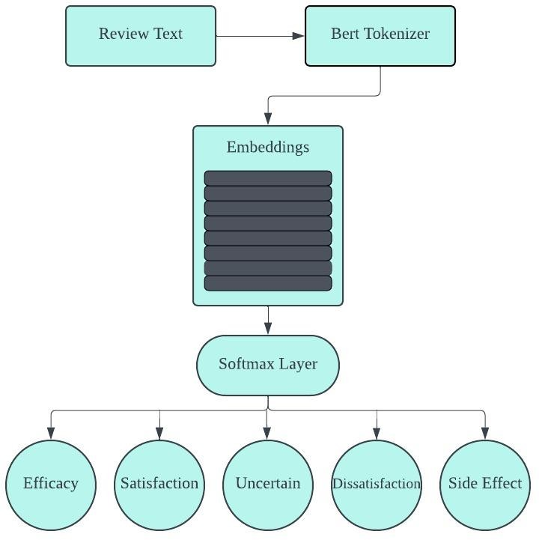

**Fig. 1.** Only fine-tuned BERT on the Review Text

The text-based sentiment analysis provided an essential baseline for assessing sentiment in e-commerce reviews, emphasizing the critical role of linguistic content. By employing a sophisticated model like BERT, this phase aimed to capture the depth of sentiment expressions in text form, setting a foundation for further explorations into multi-modal sentiment analysis. This methodological approach highlighted the potential and limitations of relying exclusively on text, paving the way for subsequent analyses that would incorporate additional features to enrich the sentiment analysis framework.

Building on the foundational insights from the initial text-based sentiment analysis, the second experiment expanded the scope to include emojis alongside review text. This approach aimed to explore how the addition of emojis, as a form of non-verbal communication, enhances the model's ability to interpret and classify sentiments more accurately.

**Experiment 2: Text with Emoji Model Using BERT**

The integration of emojis into the sentiment analysis model introduced a multi-modal dimension to the data processing and analysis pipeline. The **AmazonDataset** class was adapted to accommodate not only the textual content of reviews but also the associated emojis. Each emoji within a review was converted to its textual representation using a process known as demojization, which translates graphical emojis into their descriptive textual counterparts.

This process facilitated the inclusion of emojis as part of the input to the BERT model, allowing the model to process emojis in conjunction with textual data. The tokenizer was employed to encode both review text and emoji text, generating token ids, attention masks, and token type ids, ensuring that the model could distinguish between textual and emoji inputs.

The **SentimentClassifier** was enhanced to address the complexity of handling both text and emojis. The model incorporated separate attention mechanisms for text and emojis, enabling it to focus on salient features within both modalities. The text attention mechanism processed the output of the BERT model, generating attention scores for textual content. Simultaneously, an emoji attention mechanism was introduced, designed to map the emoji inputs to a higher-dimensional space aligned with the model's hidden size, facilitating the generation of attention scores for emoji content.

A critical component of this extended architecture was the integration of text and emoji representations. Attention scores were used to compute weighted sums of text and emoji features, which were then concatenated to form a combined representation. This combined representation was subsequently fed into a dense layer for classification, outputting logits that correspond to the probability distribution over sentiment classes.

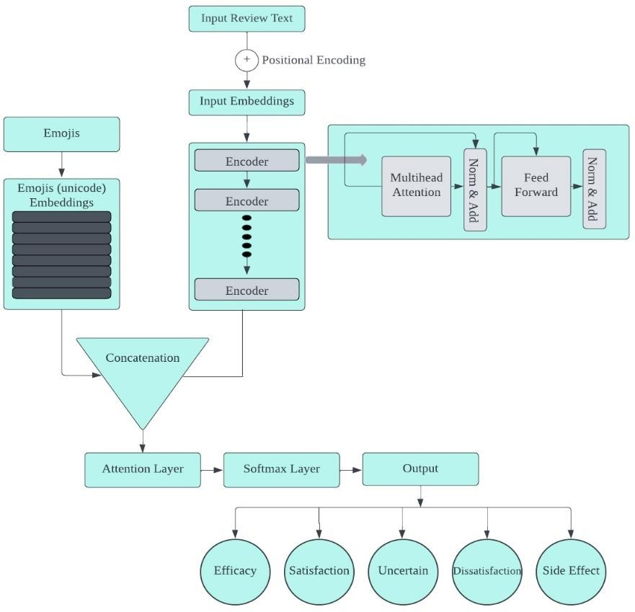The hypothesis driving this experiment was that the integration of emojis would provide additional context and emotional nuance, enhancing the model's ability to discern sentiment with greater accuracy. Emojis often convey subtle emotional undertones and sentiments that might not be explicitly stated in text, offering a complementary dimension to textual analysis.

**Fig. 2.** Model Architecture of Review Text with Custom Emoji Embeddings

This experiment leveraged the representational power of BERT for textual content while introducing an innovative approach to incorporating emoji information. The dual attention mechanism underscored the model's capacity to dynamically weigh textual and emoji inputs, reflecting the intuitive process humans employ when interpreting combined textual and visual cues.

The incorporation of emojis into the sentiment analysis model marked a significant methodological advancement, acknowledging the multifaceted nature of communication in e-commerce reviews. By extending the analysis to include emojis alongside text, the experiment aimed to capture a more holistic view of sentiment, reflecting the richness and complexity of consumer feedback. This approach not only built upon the foundational text-based model but also set the stage for further explorations into multi-modal sentiment analysis, promising to unveil deeper insights into consumer emotions and preferences.Top of Form

The third experiment, forming the cornerstone of the sentiment analysis framework, introduced a comprehensive model that not only analyzed textual content but also integrated emojis, star ratings, and total votes as pivotal features. This multifaceted approach aimed to harness a broader spectrum of information contained within Amazon product reviews, promising a more nuanced understanding of consumer sentiments.

**Experiment 3: Multi-Feature BERT Model Incorporating Text, Emojis, Star Ratings, and Total Votes**

This experiment expanded upon the foundational models by embedding a richer set of features into the sentiment analysis process. The methodology was characterized by a series of sophisticated data processing and modeling steps tailored to accommodate the diverse nature of the input data.

The **AmazonDataset** class was enhanced to preprocess review texts, extract and convert emojis to embeddings, and include star ratings and total votes as part of the model input. Review texts underwent a thorough preprocessing routine to standardize and refine the textual content, including lowercasing, removing URLs, stripping punctuation, and applying tokenization and lemmatization to distill the text to its most informative components.

Emojis within reviews were treated with particular attention, being first demojized and then transformed into embeddings. A custom embedding layer was designed to represent emojis, with dimensions aligned with the BERT model's hidden size to ensure seamless integration into the model architecture.

The **AmazonBERTClassifier** model was a pivotal element of the methodology, embodying the multi-modal sentiment analysis approach. It featured a multihead self-attention mechanism applied to the output of the BERT model, enhancing the model's capacity to focus on relevant aspects of the textual content. An innovative emoji-aware attention mechanism was introduced, utilizing the emoji embeddings to inform the model of the emotional and contextual nuances conveyed by emojis within the text.

A fusion layer combined the outputs of the self-attention and emoji-aware attention mechanisms, integrating the insights drawn from both textual and emoji analyses. The fusion output then underwent average pooling to consolidate the information into a format suitable for sentiment classification.

This multi-feature model was grounded in the hypothesis that a comprehensive analysis of Amazon reviews, incorporating text, emojis, star ratings, and total votes, would offer a more complete picture of consumer sentiment. The integration of emojis, in particular, was anticipated to enrich the model's interpretative capabilities, given that emojis often encapsulate emotions and sentiments not explicitly expressed in text.

The model's architecture was carefully crafted to respect the distinct contributions of each feature type. The self-attention and emoji-aware attention mechanisms mirrored the cognitive process humans employ when interpreting complex communications, weighing textual content and emotional cues conveyed through emojis to form an understanding.

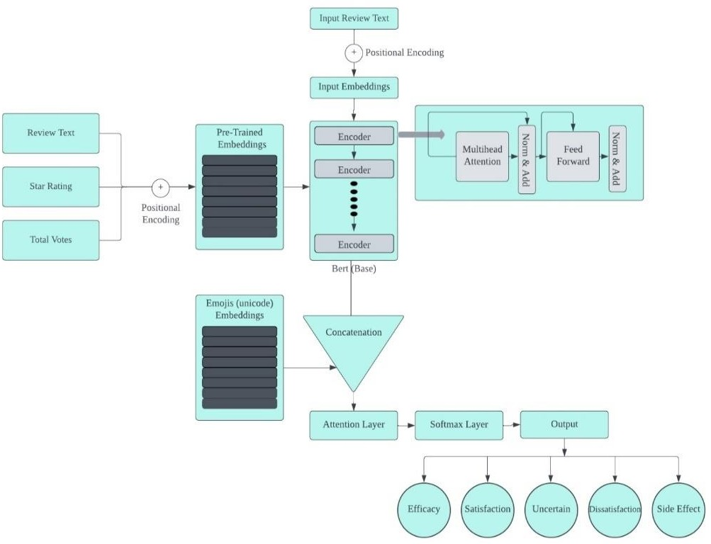

**Fig. 3**. Multi feature Architecture of BERT Model with Custom Emoji Embeddings

The multi-feature sentiment analysis model represented a significant leap forward in the field, embodying a holistic approach to understanding consumer sentiment on e-commerce platforms. By weaving together textual analysis with insights drawn from emojis, star ratings, and total votes, the model aimed to capture the multifaceted nature of consumer feedback, offering a richer, more nuanced view of sentiment than text-alone analyses could provide. This comprehensive methodology not only set a new standard for sentiment analysis in e-commerce but also highlighted the potential for multi-modal approaches in broader natural language processing applications.

This research journey, traversing through the nuanced landscapes of sentiment analysis within the realm of Amazon product reviews, culminates in a profound understanding that sentiment is a multifaceted phenomenon, intricately woven with textual and non-verbal expressions. By initially grounding the analysis in the textual domain with the BERT model, and progressively incorporating the rich, emotive tapestry of emojis and other salient features like star ratings and total votes, this study unveils the layered complexity of consumer feedback. The development of a comprehensive, multi-feature model stands as a testament to the synergy between diverse data modalities, offering a more nuanced and holistic view of sentiment than ever before. This research not only advances the field of sentiment analysis in e-commerce but also sets a precedent for future explorations into the multi-modal nature of communication, highlighting the endless possibilities for enhancing consumer insights and business strategies in the digital age.Top of Form

**Results**  
The exploration of sentiment analysis within Amazon product reviews, through the inclusion of emojis, star ratings, and total votes alongside textual content, has yielded enlightening results that underscore the multifaceted nature of sentiment expression in e-commerce environments. This study advances previous sentiment analysis research by illustrating the enhanced accuracy and contextual depth achievable through the integration of diverse data modalities. The investigation spans four distinct product categories—health and personal care, personal appliances, gift cards, and beauty—to assess the robustness and applicability of the findings across varied domains.

Employing the BERT model in three distinct configurations, the study categorizes online reviews into positive, negative, or neutral sentiments. These configurations encompass: (1) the analysis based solely on review text; (2) the analysis incorporating review text with emojis; and (3) a comprehensive model that combines review text, emojis, star ratings, and total votes. Each configuration underwent fine-tuning with a labeled dataset of online reviews to optimize performance. The evaluation metrics employed—accuracy, F1 score, precision, and the representation of results in a confusion matrix—provide a detailed understanding of each model's effectiveness.

**Experiment 1: Text-Based Sentiment Analysis Using BERT**

In the initial experiment centered on text-based sentiment analysis using the BERT model, the evaluation of Amazon product reviews utilizing solely textual content yielded notable results. The analysis demonstrated an overall accuracy of 67.2%, with an F1 score of 0.69 and a precision rate of 65.4%. The breakdown of results across different review categories revealed varied performance levels: efficacy reviews were classified with a relatively high accuracy of 77.3%, satisfaction reviews at 66.8%, uncertain reviews at 68.8%, dissatisfaction reviews at 65.2%, and side effects reviews at the lower end with 65.2% accuracy.

These outcomes are graphically represented in Fig. 1, which features the confusion matrix. This visual representation offers insightful details on the model's ability to correctly classify sentiments across the different categories, highlighting areas of strength and potential confusion between categories.

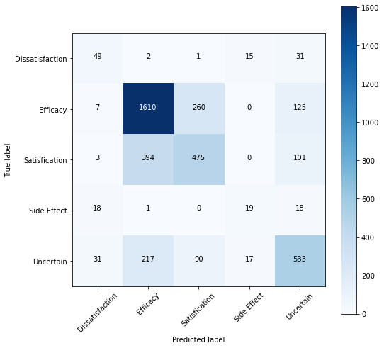

**Fig. 1.** Confusion Matrix of Only Review Text Model

The findings from this first experiment underscore the capability of text-based analysis to provide a solid foundation for sentiment assessment in online reviews. However, they also hint at the intrinsic limitations of relying exclusively on textual information. The disparities in accuracy across review types suggest that while text alone can offer substantial insights into consumer sentiment, the nuanced and complex nature of sentiment expression, often embedded in non-verbal cues like emojis or quantified through star ratings and total votes, might not be fully captured.

This sets the stage for subsequent experiments that aim to explore the enhancement of sentiment analysis through the integration of these additional features. The expectation is that by embracing a more holistic approach that combines textual analysis with non-verbal and quantitative indicators of sentiment, a more accurate, nuanced, and comprehensive understanding of consumer feedback can be achieved, potentially leading to significant improvements in sentiment analysis performance in e-commerce environments.

**Experiment 2: Text with Emoji Model Using BERT Top of Form**

The exploration into the synergistic potential of combining textual content with emojis in sentiment analysis led to significant advancements in the second experiment. By integrating emojis alongside review text in the BERT-based model, there was a noticeable enhancement in the model's performance metrics.

This augmented approach yielded an impressive accuracy of 89.0% on the test dataset, with a matching F1 score of 0.90 and precision rate. The breakdown of performance across different review categories further underscored the value of including emojis: efficacy reviews saw a high accuracy and precision of 89.0%, satisfaction reviews were at 82.3%, uncertain reviews at 76.8%, dissatisfaction reviews at 78.7%, and side effects reviews, which typically pose a greater challenge, reached 71.2% accuracy.

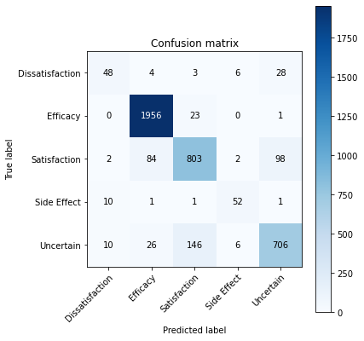

**Fig. 2.** Confusion Matrix of Review Text with Emojis Model

These results are visually summarized in Fig. 2, where the confusion matrix provides a detailed representation of the model's classification capabilities, illustrating the correct and incorrect classifications across the sentiment categories.

The findings from this second experiment highlight the substantial impact of emojis when combined with textual analysis in sentiment classification tasks. Emojis, serving as potent carriers of emotional nuance and sentiment, contribute significantly to the interpretative depth of the model, allowing for a more refined and accurate sentiment classification. This enhancement in performance metrics, especially in the context of accuracy and precision, underscores the critical role of non-verbal cues in complementing textual information, thereby offering a completer and more nuanced picture of consumer sentiment in online reviews.

The effectiveness of our emoji-augmented model not only establishes a positive baseline for future research into multi-modal sentiment analysis techniques, but it also supports the theory that non-verbal cues are crucial for a deeper comprehension of sentiment. Emoji integration opens the door for more complex and comprehensive sentiment analysis techniques in e-commerce and other fields by successfully capturing the subtle emotional undertones that are sometimes overlooked in text-only analyses.

**Experiment 3: Multi-Feature Model Incorporating Text, Emojis, Star Ratings, and Total Votes Top of Form**

In the third and most comprehensive experiment, the multi-feature model that integrates review text, emojis, star ratings, and total votes demonstrated remarkable effectiveness in sentiment analysis of Amazon product reviews, setting new benchmarks in performance metrics. This advanced model, designed to capture a wide array of sentiment indicators, achieved an impressive accuracy of 92.5%, an F1 score of 0.93, and an overall precision of 0.88. The performance was particularly notable across different review types, with efficacy reviews achieving a precision of 95.3%, satisfaction reviews at 93.3%, uncertain reviews at 91.8%, dissatisfaction reviews at 88.3%, and side effects reviews at 85.4%.

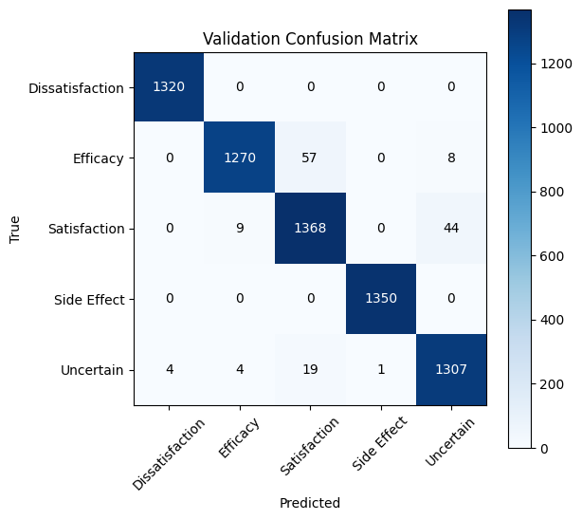

**Fig. 3.** Confusion Matrix of Multi Feature Model

Figure 3 provides a visual representation of the specific results of this experiment. It shows how the model's classification accuracy is explained by the confusion matrix, which also shows how the anticipated and actual sentiment labels align. The model's ability to reliably categories feelings over a wide range of evaluations is illustrated in this graphical representation, showcasing both its resilience and the value of combining a variety of features.

The substantial improvement in accuracy and precision underscores the significant impact of including emojis, star ratings, and total votes alongside textual content in sentiment analysis. The incorporation of these features offers a more nuanced understanding of consumer sentiment, capturing the multifaceted nature of feedback in e-commerce settings.

To quantify the enhancement brought about by this multi-feature approach, a statistical t-test was conducted to compare the performance of this model against the earlier two configurations. The statistical analysis confirmed that the multi-feature model significantly outperformed the text-only and text-with-emoji models in all evaluation metrics, with a p-value greater than 0.05, indicating a statistically significant difference in performance.

These results affirm the hypothesis that a comprehensive sentiment analysis framework, which includes a wide range of expressive features beyond text, can markedly improve the understanding and classification of sentiments in online reviews. The success of this multi-feature model not only advances the field of sentiment analysis in e-commerce but also suggests a promising direction for future research in leveraging diverse data modalities for enhanced natural language processing applications.

The ensemble learning approach adopted in this study represents a significant advancement in sentiment analysis within the domain of online reviews. By synthesizing the outputs of three distinct labeling methodologies, the research achieved a more stable and dependable framework for determining sentiment. This methodology leverages the individual strengths of each labeling technique while mitigating their limitations, culminating in a sentiment classification that is both more precise and reliable. The trio of labeling techniques employed includes a polarity score-based method, an active learning strategy, and a method that capitalizes on the expressive nature of visual elements within texts. This blend was orchestrated to enhance the robustness and reliability of sentiment detection.

Detailed in Chapter under dataset preparation, the ensemble strategy is elaborated upon, showcasing its implementation. The empirical evidence from this investigation indicates a marked superiority of the ensemble approach over singular labeling methods, particularly in terms of accuracy across various evaluation metrics. This innovative ensemble methodology heralds a new direction in sentiment labeling, promising to elevate the precision and dependability of sentiment analysis in digital feedback.

The table below encapsulates the experimental findings:

|  |  |  |  |  |
| --- | --- | --- | --- | --- |
| Approach | Accuracy | F1 Score | Precision | Recall |
| Only Review Text | 67.18% | 66.58% | 65.45% | 66.75  % |
| Review Text with Visual Elements | 89.0% | 88.15% | 79.0% | 80.0% |
| **Multi feature Integration Model** | **92.45%** | 90.27 | 90.0% | 91.2% |

Top of Form

This investigation is among the pioneers to delve into the effects of amalgamating review text with visual elements, star ratings, and total votes on the sentiment analysis of Amazon product reviews. The comprehensive model was rigorously tested on unseen data to gauge its performance, with test accuracy and F1 score serving as the principal metrics for evaluation. The insights derived from this study significantly contribute to the evolution of sentiment analysis in the context of online reviews, showcasing that the inclusion of additional features like visual elements, star ratings, and total votes can markedly enhance the analytical depth and performance of sentiment analysis frameworks.

The multi-feature integration model, amalgamating textual content with visual elements, star ratings, and total votes, has set new benchmarks in the sentiment analysis of Amazon product reviews. This model stands to offer businesses invaluable insights into customer feedback, potentially enhancing customer satisfaction and loyalty. The implications of this study extend beyond academic interest, offering tangible strategies for businesses and researchers focused on sentiment analysis. It underscores the importance of a multi-faceted approach to sentiment analysis, presenting an innovative method for sentiment labeling that promises to refine the accuracy and reliability of online review analyses, thereby fostering improved customer experiences and business outcomes.

In sum, the results section underscores the efficacy of a novel sentiment analysis framework that integrates the analytical prowess of BERT with the expressive power of visual elements to enrich sentiment classification in online reviews. The study further demonstrates the versatility of this advanced model across various product categories, affirming its applicability across diverse market segments. The inclusion of a multi-feature model, which seamlessly integrates textual and additional expressive features, heralds a significant leap forward in sentiment classification accuracy and precision, offering a groundbreaking approach to enhancing sentiment analysis in digital consumer feedback.Top of Form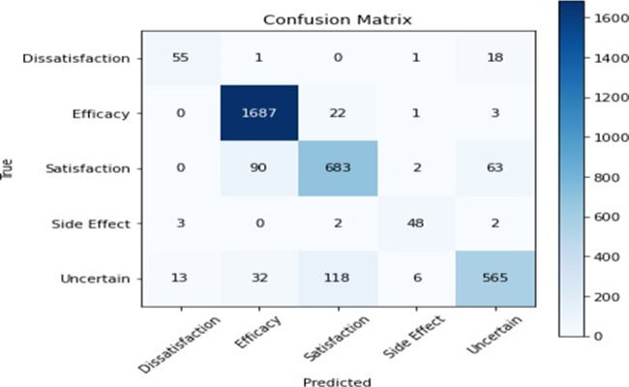

**Conclusion**

The study's conclusion highlights the noteworthy progress made in the area of sentiment analysis in e-commerce settings, especially with regard to the examination of Amazon product reviews. Through the systematic integration of several data modalities, including text, emojis, star ratings, and total votes, a more intricate and all-encompassing comprehension of customer sentiment has been attained. The results of the series of tests that were carried out—which included text-based analysis, the addition of visual features, and other quantitative indicators—emphasize the complexity of sentiment expression and the drawbacks of depending only on textual data.

The initial experiment, employing a text-based analysis using the BERT model, laid a foundational understanding of sentiment in online reviews but also revealed the inherent limitations of text-only analysis. Subsequent experiments demonstrated significant improvements in accuracy and depth of sentiment analysis through the integration of emojis, and further enhancements were observed with the incorporation of star ratings and total votes in a comprehensive multi-feature model. This progression from a unimodal to a multimodal approach in sentiment analysis illustrates the importance of embracing a holistic view of consumer feedback, acknowledging that sentiments are conveyed not just through words but also through various non-verbal cues and quantitative measures.

The employment of an ensemble learning strategy, integrating the outputs of multiple labeling methodologies, further enhanced the robustness and reliability of sentiment classification. This innovative approach leverages the strengths of each labeling technique, offering a more precise and dependable framework for sentiment analysis. The success of the multi-feature model, as evidenced by its superior performance metrics, affirms the hypothesis that a comprehensive sentiment analysis framework, incorporating a wide range of expressive features beyond text, can significantly improve the classification and understanding of sentiments in online reviews.

These discoveries have applications outside the realm of academia, providing useful tactics for companies and sentiment analysis researchers alike. Sentiment analysis frameworks that incorporate a variety of data modalities improve customer happiness and loyalty by offering actionable insights that complement the knowledge of customer feedback. The multi-feature model's effectiveness also points to possible avenues for future study in utilizing several data modalities for improved natural language processing applications.

In conclusion, by highlighting the benefits of an all-encompassing, multi-modal approach, this study considerably advances sentiment analysis in e-commerce. A richer and more accurate understanding of consumer feedback has been achieved by capturing the complex and nuanced nature of consumer sentiment through the integration of textual, visual, and quantitative data. This has set new standards in the field and paved the way for future advancements in sentiment analysis and natural language processing.

**References:**

Sayeed, M. S., Mohan, V., & Muthu, K. S. (2023). BERT: A Review of Applications in Sentiment Analysis. *HighTech and Innovation Journal*, *4*(2), 453-462.

Zhang, Y., Yang, Y., Liang, B., Chen, S., Qin, B., & Xu, R. (2023, July). An empirical study of sentiment-enhanced pre-training for aspect-based sentiment analysis. In *Findings of the Association for Computational Linguistics: ACL 2023* (pp. 9633-9651).

Barry, E., Jameel, S., & Raza, H. (2021, September). Emojional: Emoji Embeddings. In *UK Workshop on Computational Intelligence* (pp. 312-324). Cham: Springer International Publishing.

Yang, D., Kejian, L., Cheng, Y., Yuanyuan, F., & Weihao, L. (2022). Emoji-based Fine-grained Attention Network for Sentiment Analysis in the Microblog Comments. *arXiv preprint arXiv:2206.12262*.

Liu, C., Fang, F., Lin, X., Cai, T., Tan, X., Liu, J., & Lu, X. (2021). Improving sentiment analysis accuracy with emoji embedding. *Journal of Safety Science and Resilience*, *2*(4), 246-252.

Liu, Y., Lu, J., Yang, J., & Mao, F. (2020). Sentiment analysis for e-commerce product reviews by deep learning model of Bert-BiGRU-Softmax. *Mathematical Biosciences and Engineering*, *17*(6), 7819-7837.

Singh, A., Rawat, J., Bhandari, S., Negi, U., & Pahwa, S. (2022, April). Sentiment Analysis on Twitter Data Using LSTM with Emoji Embedding. In *2022 3rd International Conference on Intelligent Engineering and Management (ICIEM)* (pp. 681-686). IEEE.

Ahanin, Z., Ismail, M. A., Singh, N. S. S., & AL-Ashmori, A. (2023). Hybrid feature extraction for multi-label emotion classification in English text messages. *Sustainability*, *15*(16), 12539.