**Hypothesis 1**

To evaluate Hypothesis 1 ("Emoji Usage Differs by Product Category"), a detailed methodology would include:

**Phase 1: Data Collection and Preparation**

1. **Data Sourcing**:
   * Collect a comprehensive dataset of online product reviews from various e-commerce platforms.
   * Categories to focus on: Toys, Apparel, Electronics.
2. **Data Cleaning**:
   * Remove irrelevant text and non-textual elements from reviews.
   * Normalize text for consistency (e.g., converting to lowercase).
3. **Data Segmentation**:
   * Categorize the data based on product types.
   * Ensure a balanced representation of each category.

**Phase 2: Emoji Analysis**

1. **Frequency Analysis**:
   * Use text analytics tools to count the frequency of each emoji in the dataset.
   * Categorize emojis based on their type and emotional connotation.
2. **Pattern Recognition**:
   * Implement algorithms to identify common patterns in emoji usage within each product category.
   * Detect associations between specific emojis and product types.

**Phase 3: Comparative Analysis and Visualization**

1. **Comparative Study**:
   * Analyze differences in emoji usage across product categories.
   * Examine if certain emojis are predominantly used in specific categories.
2. **Data Visualization**:
   * Use bar charts to show the frequency of top emojis in each category.
   * Develop heat maps or cluster diagrams to illustrate emoji patterns.

**Phase 4: Interpretation and Conclusion**

1. **Data Interpretation**:
   * Examine the emotional undertones conveyed by emojis in different categories.
   * Interpret how emoji usage reflects customer sentiment and engagement.
2. **Conclusion**:
   * Determine if there are significant differences in emoji usage across product categories.
   * Assess the extent to which emojis contribute to the emotional depth in reviews.

**Phase 5: Reporting**

* **Document Findings**: Compile a comprehensive report detailing the methodology, analysis, findings, and conclusions.

**Diagrams and Charts**

* **Process Flowchart**: To illustrate the sequence of steps in the methodology.
* **Emoji Frequency Bar Charts**: For each category, showing the most commonly used emojis.
* **Pattern Recognition Heat Maps**: Visualizing clusters of emoji usage in different product categories.

This methodology aims to provide a thorough analysis of emoji usage across product categories, aligning with the hypothesis that emojis play a varied role in different e-commerce contexts.

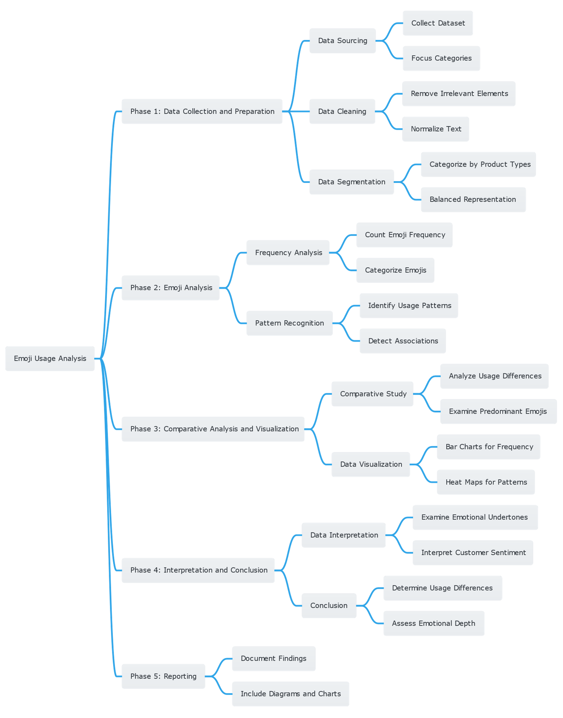

**Hypothesis 02**

To test Hypothesis 2 ("Reviews with and without emojis show a markedly different sentiment"), the following detailed methodology is proposed:

**Phase 1: Data Collection**

1. **Gathering Reviews**:
   * Collect a large dataset of online product reviews, ensuring a mix of reviews with and without emojis across various product categories (toys, apparel, electronics).
2. **Data Segregation**:
   * Segregate the reviews into two distinct groups: those containing emojis and those without.

**Phase 2: Sentiment Analysis**

1. **Processing Reviews**:
   * Apply natural language processing (NLP) techniques to clean and preprocess the text data.
2. **Sentiment Analysis**:
   * Use sentiment analysis tools to evaluate the sentiment of reviews in both groups.
   * Measure the intensity and polarity of sentiments (positive, negative, neutral).

**Phase 3: Comparative Study**

1. **Comparative Analysis**:
   * Compare the sentiment scores between reviews with and without emojis.
   * Analyze the emotional depth and nuance conveyed in each group.
2. **Statistical Analysis**:
   * Employ statistical methods to determine if the differences in sentiment between the two groups are significant.

**Phase 4: Visualization and Interpretation**

1. **Visualization**:
   * Create visual representations (like graphs or heat maps) to depict sentiment variations between the two groups.
2. **Interpretation**:
   * Analyze how the presence or absence of emojis affects the overall sentiment of the reviews.
   * Determine if emojis contribute additional emotional complexity to the reviews.

**Phase 5: Documentation and Reporting**

* **Reporting**: Document the entire process, findings, and interpretations in a detailed report.

**Supporting Diagrams:**

* **Process Flowchart**: Illustrate the step-by-step methodology.
* **Sentiment Comparison Graphs**: Show differences in sentiment scores between reviews with and without emojis.

This methodology aims to robustly test whether the inclusion of emojis in product reviews leads to a significant difference in sentiment expression, aligning with the hypothesis that emojis enhance the emotional depth in digital communication.

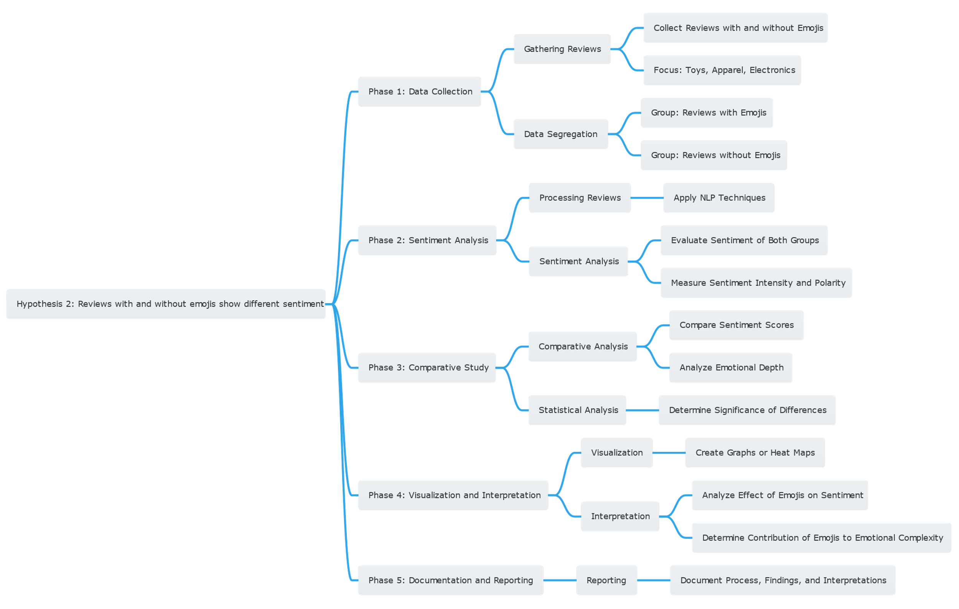

**Hypothesis 03**

To evaluate Hypothesis 3 ("Emoji-infused sentiment analysis models will produce more accurate and thorough sentiment evaluations than text-only models"), the following methodology can be adopted:

**Phase 1: Model Development and Data Preparation**

1. **Model Design**:
   * Develop a sentiment analysis model integrating emoji sentiment with traditional text analysis.
   * Utilize machine learning techniques suitable for processing both textual and emoji data.
2. **Data Collection**:
   * Gather a comprehensive dataset of e-commerce reviews containing both text and emojis.
3. **Data Preprocessing**:
   * Clean and preprocess the data, ensuring it's suitable for the model.

**Phase 2: Model Training and Evaluation**

1. **Training**:
   * Train the model using the prepared dataset.
   * Fine-tune parameters to optimize performance.
2. **Benchmarking**:
   * Compare the emoji-infused model against standard text-only sentiment analysis models.
   * Use similar datasets for fair comparison.

**Phase 3: Performance Metrics Evaluation**

1. **Testing**:
   * Evaluate the models using a separate test dataset.
   * Focus on metrics like accuracy, precision, recall, and F1-score.
2. **Analysis**:
   * Analyze how effectively the emoji-infused model interprets sentiment compared to text-only models.

**Phase 4: Interpretation and Documentation**

1. **Interpretation**:
   * Draw conclusions based on the comparative performance of the models.
   * Assess the added value of emojis in sentiment analysis.
2. **Reporting**:
   * Document the methodology, process, findings, and interpretations in a detailed report.

**Supporting Diagrams and Visuals:**

* **Model Architecture Diagram**: Illustrate the structure of the emoji-infused sentiment analysis model.
* **Performance Comparison Charts**: Graphically represent the performance metrics of both models.

This methodology is designed to rigorously test the hypothesis that incorporating emojis into sentiment analysis models leads to more accurate and comprehensive sentiment evaluations, particularly in e-commerce reviews.

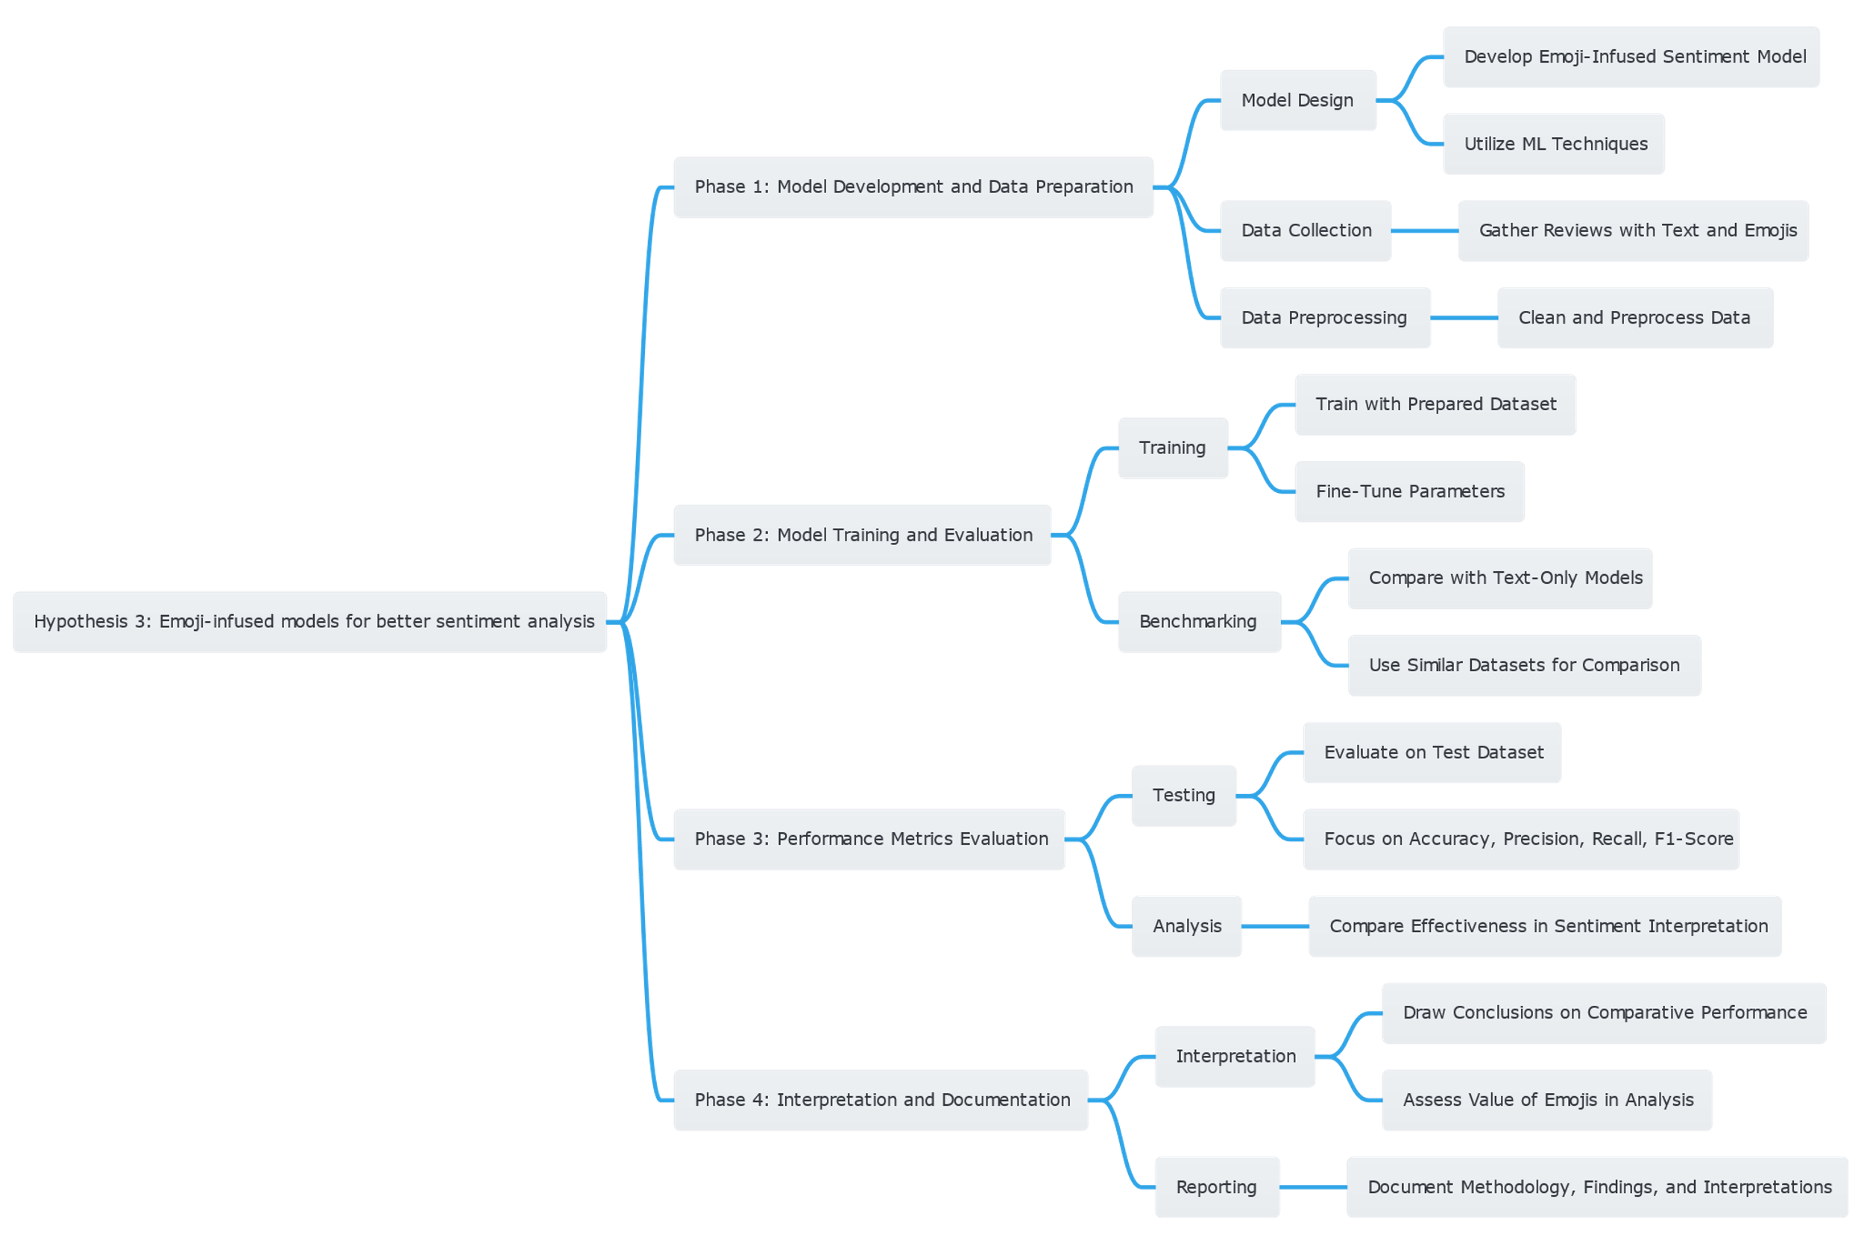Top of Form