Государственный Университет Молдовы

Факультет Математики и Информатики

Департамент Информатики

Лабораторная работа №3

Выполнила:   
студентка группы IA2003  
Шошова Таисия

composer require logger

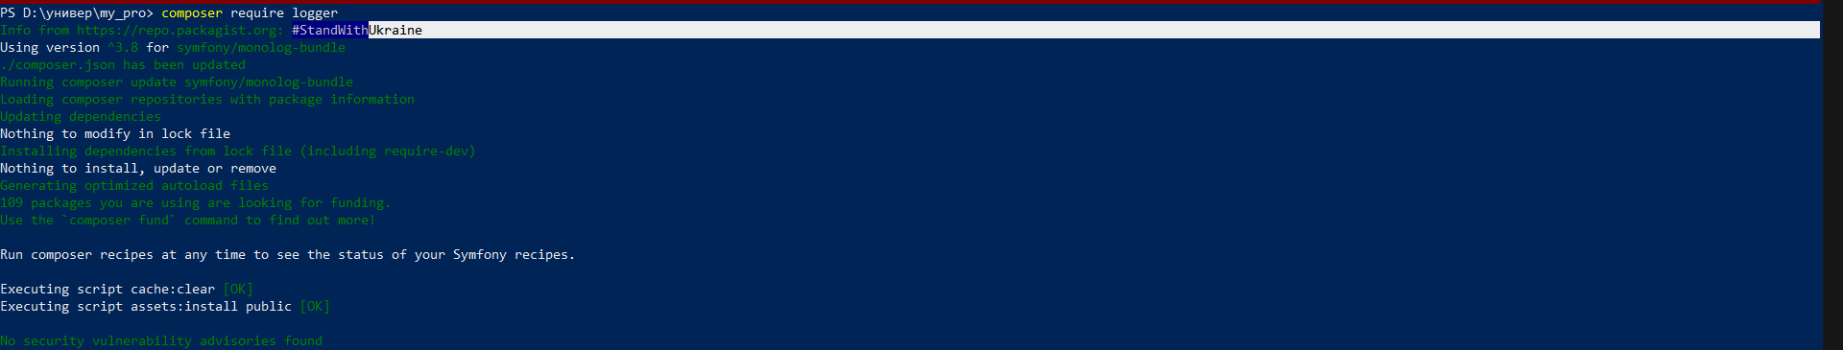

Composer require monolog/monolog

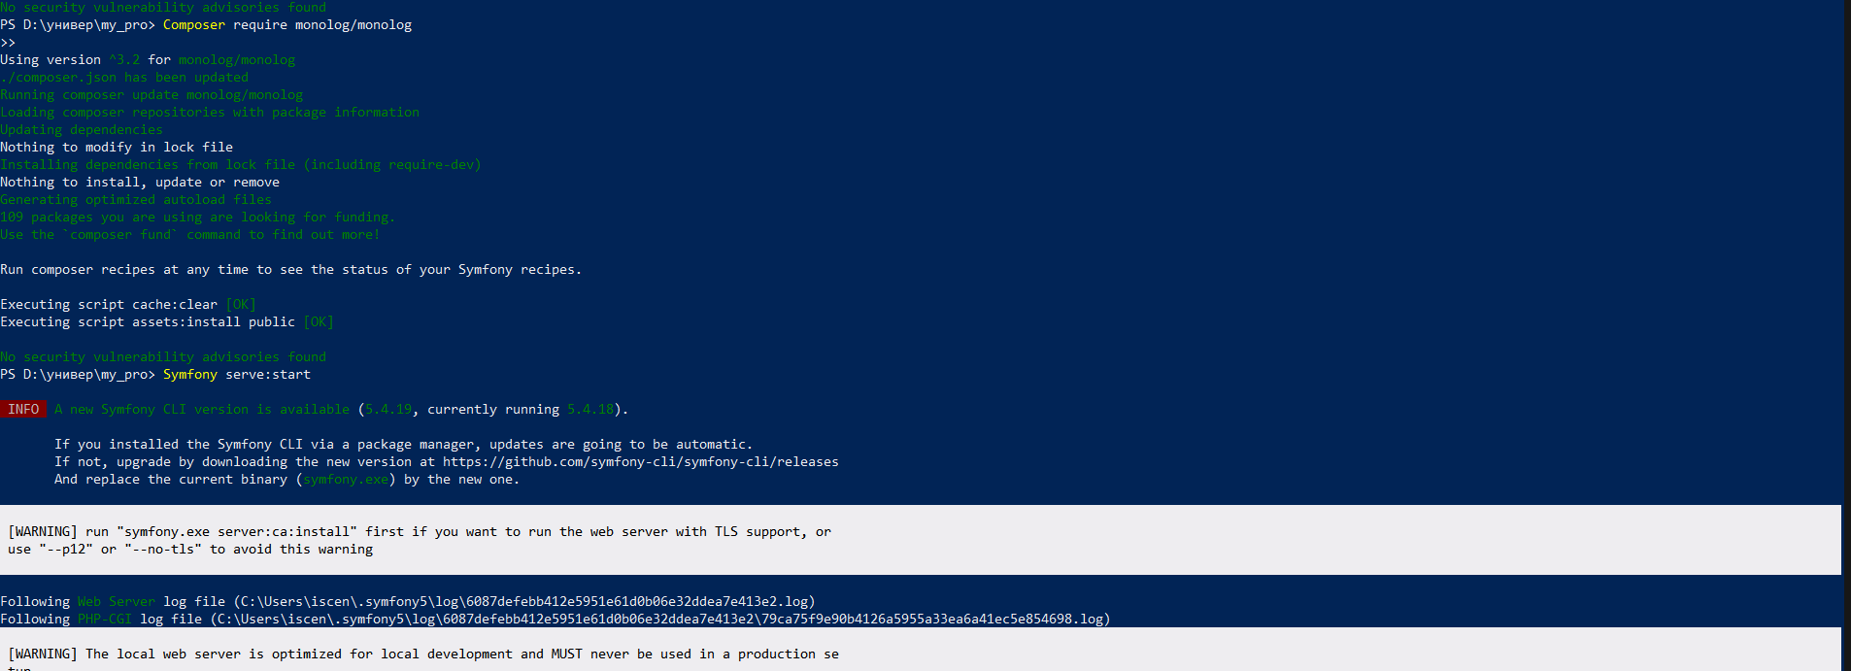

<?php

// src/GreetingGenerator.php

namespace App;

class GreetingGenerator

{

public function getRandomGreeting(): string

{

$greetings = ['Hey', 'Yo', 'Aloha'];

$greeting = $greetings[array_rand($greetings)];

return $greeting;

}

}

<?php

namespace App\Controller;

use Symfony\Bundle\FrameworkBundle\Controller\AbstractController;

use Symfony\Component\HttpFoundation\Response;

use Symfony\Component\Routing\Annotation\Route;

use Psr\Log\LoggerInterface;

use App\GreetingGenerator;

class MainController extends AbstractController

{

/**

* @Route("/main/{name}")

*/

public function index($name, LoggerInterface $logger, GreetingGenerator $generator)

{

$greeting = $generator->getRandomGreeting();

$logger->info("Saying hello to $name!");

return $this->render('main/index.html.twig', [

'name' => $name,

]);

}

}

<?php

// src/Twig/GreetExtension.php

namespace App\Twig;

use App\GreetingGenerator;

use Twig\Extension\AbstractExtension;

use Twig\TwigFilter;

class GreetExtension extends AbstractExtension

{

public function __construct(private readonly GreetingGenerator $greetingGenerator)

{

}

public function getFilters()

{

return [

new TwigFilter('greet', [$this, 'greetUser']),

];

}

public function greetUser(string $name): string

{

$greeting = $this->greetingGenerator->getRandomGreeting();

return "$greeting $name!";

}

}