Credential
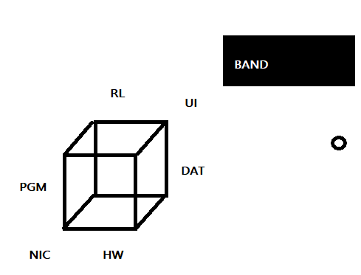

To supercede data validity, inspect filter network packets.
To subside data validity, inspect filter logs.

To supercede data storage, continue dump to drive three monthly.
To subside data storage, continue ftp monthly.

To supercede collaboration, continue mail.
To subside collaboration, continue existing interfaces.

To supercede category, continue PGM DAT per serial.
To subside category, continue CLAS CATEGORY per record, source-line

To supercede event, continue message signal COM1
To subside event, continue App Firmware

To supercede ACK, continue datagram port
To subside ACK, continue Client Server

To superside a Role, continue work, adhoc
To supercede a Role, continue provide collect work

—-----------------------------------------------------------------------------------------------------------------------
Session vs Cache
—-----------------------------------------------------------------------------------------------------------------------

While both Session and Cache objects are used to temporarily store data in memory on the server, they serve fundamentally different purposes regarding who the data belongs to and how long it stays around.

Core Distinction
- Session Object: Tied to a single, specific user. It stores user-state across multiple HTTP requests (e.g., shopping cart items, logged-in user state, temporary wizard progress).
- Cache Object: Shared across all users (or global application scope). It stores expensive-to-compute or frequently fetched data to reduce backend load and improve response speed (e.g., product catalogs, site settings, database query results).

Key Comparisons
Feature | Session Object | Cache Object
Scope | Per-User / Per-Session  (Isolated to individual browser connection) | Application-Wide / Shared  (Accessible by all concurrent users)
Primary Purpose | State management (tracking who the user is and what they are doing) | Performance optimization (reducing database/API overhead)
Typical Lifetime | Short-term: Expires when the user logs out, closes the browser, or idle time limits out (e.g., 20 mins) | Variable/Flexible: Expires based on absolute time, sliding scale, or explicitly when data changes
Memory Management | Cleared upon session abandonment or explicit logout | Cleared dynamically via eviction policies (e.g., LRU - Least Recently Used) when memory is tight
Storage Scale | Small (typically kilobytes per active user) | Medium to Large (can hold thousands of aggregated records)

Key Differences in Detail

1. Data Isolation & Security
- Session: Highly sensitive to isolation. User A must never see User B’s session object. It relies on a unique Session ID stored in a browser cookie or token to map requests back to that user’s server-side memory block.
- Cache: Not tied to individual identities. If 1,000 users visit the home page, the app serves the exact same cached navigation tree or featured product list to everyone.

2. Expiration & Eviction
- Session: Expiration is usually activity-driven (sliding expiration). Every time the user makes a request, their session timeout resets. If idle for too long, the session is invalidated.
- Cache: Uses explicit expiration strategies:
  - Absolute Expiration: Item expires at a set time (e.g., "evict every 10 minutes").
  - Sliding Expiration: Item expires if not requested for a set period.
  - Cache Invalidation: Item is explicitly purged or updated when underlying source data changes.

3. Scaling Considerations
- Session: In distributed systems (multiple web servers), session state requires either sticky sessions (routing a user to the same server) or an external distributed store like Redis/Memcached to share session states across nodes.
- Cache: Often multi-tiered (e.g., in-memory local L1 cache + centralized distributed L2 cache like Redis). Loss of a cache object is never fatal—the application simply falls back to querying the database and repopulating the cache.

Summary Rule of Thumb
Store data in a Session if it answers: "Who is this user, and what are they doing right now?"
Store data in a Cache if it answers: "What expensive data do multiple users (or requests) need over and over again?"

