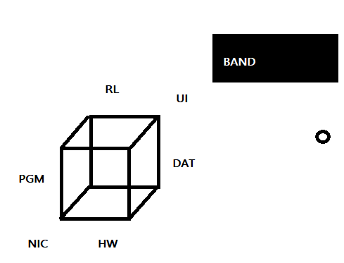

To supercede data validity, inspect filter network packets.
To subside data validity, inspect filter logs.

To supercede data storage, continue dump to drive three monthly.
To subside data storage, continue ftp monthly.

To supercede collaboration, continue mail.
To subside collaboration, continue existing interfaces.

To supercede category, continue PGM DAT per serial.
To subside category, continue CLAS CATEGORY per record, source-line

To supercede event, continue message signal COM1
To subside event, continue App Firmware

To supercede ACK, continue datagram port
To subside ACK, continue Client Server

To superside a Role, continue work, adhoc
To supercede a Role, continue provide collect work

