Portfolio 1 | Database Design and Modelling
  - Theoscyba Security Services • Cybersecurity Incident and Vulnerability Management System
MIT 8103 — Advanced Database Systems | M.Sc. Information Technology | 2026/2027 academic session
Technical implementation report • PostgreSQL 18 • pgAdmin 4

Abstract
This report presents the design, implementation and verification of an eight-table PostgreSQL database for a simulated multi-client cybersecurity services organization. The model records client organizations, monitored assets, analysts, incidents, vulnerabilities, remediation activities, audit events and incident-assignment history. Its logical design uses primary keys, ten foreign-key constraints, controlled vocabularies, time-ordering checks and a partial unique index. A vulnerability-update trigger stores before-and-after record snapshots in JSONB. The completed demonstration dataset and a controlled analyst handover were verified in a separate rebuild database. The report provides the relational schema, data-dependency rationale, normalization discussion, implementation evidence, limitations and technical reflection.

1. Organization, users and requirements
Theoscyba Security Services is a simulated cybersecurity services provider managing security operations for multiple client organizations. Its demonstration dataset includes fintech, healthcare, commerce, system integration, travel consulting and fashion clients. All incident and vulnerability details in this portfolio are fictional and intended for training, not representations of actual customer security findings.
Primary users are security analysts, vulnerability analysts, security engineers, security managers, system administrators and auditors. The system supports client/asset registration; incident detection and assignment; vulnerability scoring and lifecycle tracking; remediation planning and completion; assignment handover with history; and audited vulnerability modifications. Weekly/monthly reporting is a planned operational requirement, not a completed database reporting feature in this portfolio.

2. Database architecture and ER diagram
The implementation uses a relational core of eight public-schema tables. clients own assets; assets anchor both incidents and vulnerabilities; vulnerabilities link to remediation actions; and analysts are referenced by investigations, remediation, audit attribution and assignment records. incidents.assigned_analyst_id captures current ownership, while incident_assignments records the time-bounded history of ownership. The ERD was generated from the existing database in pgAdmin and visually checked against ten verified foreign keys (Evidence E01–E02).
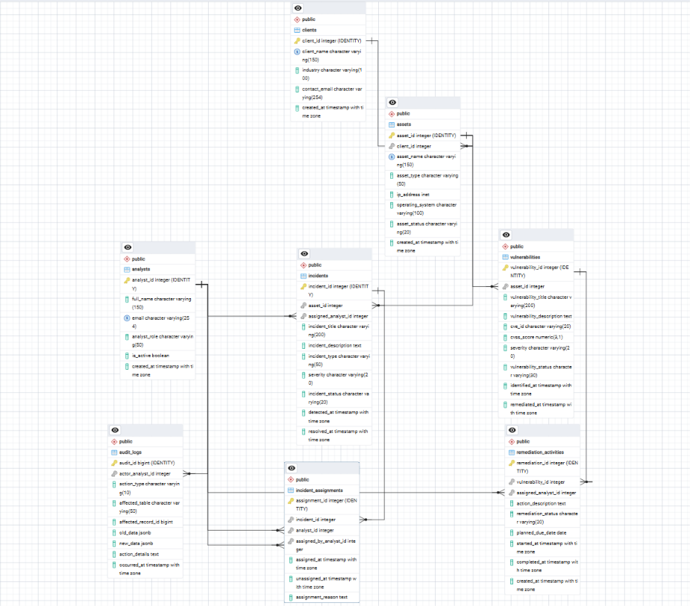
Figure 1. Theoscyba eight-table ERD as exported from pgAdmin 4 (E01). Open the original PNG for readable field-level detail.

3. Relational schema
Notation: PK = primary key; FK = foreign key; UQ = unique constraint. Fields shown without NOT NULL may accept NULL unless another constraint prohibits it. Timestamp defaults and data types correspond to the reviewed CREATE TABLE scripts.

3.1 clients
CLIENTS(
client_id INTEGER [PK, identity];
client_name VARCHAR(150) [NOT NULL, UQ];
industry VARCHAR(100);
contact_email VARCHAR(254);
created_at TIMESTAMPTZ [NOT NULL, default CURRENT_TIMESTAMP].
)
Client organisations, represented once regardless of the number of assets.

3.2 assets
ASSETS(
asset_id INTEGER [PK, identity];
client_id INTEGER [FK → CLIENTS.client_id, NOT NULL];
asset_name VARCHAR(150) [NOT NULL];
asset_type VARCHAR(50) [NOT NULL];
ip_address INET;
operating_system VARCHAR(100);
asset_status VARCHAR(20) [NOT NULL, default Active];
created_at TIMESTAMPTZ [NOT NULL, default CURRENT_TIMESTAMP].
)
UQ(client_id, asset_name); status restricted to Active, Inactive or Retired.

3.3 analysts
ANALYSTS(
analyst_id INTEGER [PK, identity];
full_name VARCHAR(150) [NOT NULL];
email VARCHAR(254) [NOT NULL, UQ];
analyst_role VARCHAR(50) [NOT NULL];
is_active BOOLEAN [NOT NULL, default TRUE];
created_at TIMESTAMPTZ [NOT NULL, default CURRENT_TIMESTAMP].
)
Role CHECK allows Security Analyst, Vulnerability Analyst, Security Manager, InfoSec Engineer and Security Engineer.

3.4 incidents
INCIDENTS(
incident_id INTEGER [PK, identity];
asset_id INTEGER [FK → ASSETS.asset_id, NOT NULL];
assigned_analyst_id INTEGER [FK → ANALYSTS.analyst_id, nullable];
incident_title VARCHAR(200) [NOT NULL];
incident_description TEXT;
incident_type VARCHAR(50) [NOT NULL];
severity VARCHAR(20) [NOT NULL];
incident_status VARCHAR(20) [NOT NULL, default Open];
detected_at TIMESTAMPTZ [NOT NULL, default CURRENT_TIMESTAMP];
resolved_at TIMESTAMPTZ.
)
Checks limit severity/status and reject resolved_at earlier than detected_at.

3.5 vulnerabilities
VULNERABILITIES(
vulnerability_id INTEGER [PK, identity];
asset_id INTEGER [FK → ASSETS.asset_id, NOT NULL];
vulnerability_title VARCHAR(200) [NOT NULL];
vulnerability_description TEXT;
cve_id VARCHAR(20);
cvss_score NUMERIC(3,1);
severity VARCHAR(20) [NOT NULL];
vulnerability_status VARCHAR(30) [NOT NULL, default Open];
identified_at TIMESTAMPTZ [NOT NULL, default CURRENT_TIMESTAMP];
remediated_at TIMESTAMPTZ.
)
Checks limit CVSS (if present) to 0.0–10.0, severity/status and timestamp order.

3.6 remediation_activities
REMEDIATION_ACTIVITIES(
remediation_id INTEGER [PK, identity];
vulnerability_id INTEGER [FK → VULNERABILITIES.vulnerability_id, NOT NULL];
assigned_analyst_id INTEGER [FK → ANALYSTS.analyst_id];
action_description TEXT [NOT NULL];
remediation_status VARCHAR(20) [NOT NULL, default Planned];
planned_due_date DATE;
started_at TIMESTAMPTZ;
completed_at TIMESTAMPTZ;
created_at TIMESTAMPTZ [NOT NULL, default CURRENT_TIMESTAMP].
)
Completion timestamp required exactly when status is Completed; date ordering checked if both dates present.

3.7 audit_logs
AUDIT_LOGS(
audit_id BIGINT [PK, identity];
actor_analyst_id INTEGER [FK → ANALYSTS.analyst_id, nullable];
action_type VARCHAR(10) [NOT NULL];
affected_table VARCHAR(50) [NOT NULL];
affected_record_id BIGINT [NOT NULL];
old_data JSONB;
new_data JSONB;
action_details TEXT;
occurred_at TIMESTAMPTZ [NOT NULL, default CURRENT_TIMESTAMP].
)
Checks limit action/table and require positive affected_record_id; record reference is polymorphic, not an FK.

3.8 incident_assignments
INCIDENT_ASSIGNMENTS(
assignment_id INTEGER [PK, identity];
incident_id INTEGER [FK → INCIDENTS.incident_id, NOT NULL];
analyst_id INTEGER [FK → ANALYSTS.analyst_id, NOT NULL];
assigned_by_analyst_id INTEGER [FK → ANALYSTS.analyst_id, nullable];
assigned_at TIMESTAMPTZ [NOT NULL, default CURRENT_TIMESTAMP];
unassigned_at TIMESTAMPTZ;
assignment_reason TEXT.
)
CHECK unassigned_at >= assigned_at when present; partial UQ index on incident_id WHERE unassigned_at IS NULL.

4. Foreign-key relationships
Referencing column | Referenced key | Meaning
assets.client_id | clients.client_id | Client → multiple assets
incidents.asset_id | assets.asset_id | Asset → multiple incidents
incidents.assigned_analyst_id | analysts.analyst_id | Current analyst; optional
vulnerabilities.asset_id | assets.asset_id | Asset → multiple vulnerabilities
remediation_activities.vulnerability_id | vulnerabilities.vulnerability_id | Vulnerability → multiple activities
remediation_activities.assigned_analyst_id | analysts.analyst_id | Remediation assignee; optional
audit_logs.actor_analyst_id | analysts.analyst_id | Audit actor; optional
incident_assignments.incident_id | incidents.incident_id | Incident → historical assignments
incident_assignments.analyst_id | analysts.analyst_id | Assigned analyst
incident_assignments.assigned_by_analyst_id | analysts.analyst_id | Assignment author; optional
These ten constraints were counted in the populated theoscyba_rebuild_test database (E02). audit_logs.affected_record_id is deliberately absent from this table: it is not a foreign key, since the target relation varies according to affected_table.

5. Integrity controls and implementation features
Control | Implementation and significance
Identity and uniqueness | Identity PKs on all eight tables; client name, analyst email and (client_id, asset_name) are additionally unique.
Foreign keys | Ten references prevent invalid client, asset, analyst, incident, vulnerability and assignment links.
Domains | CHECK clauses enforce allowed incident/vulnerability severities, statuses, analyst roles and remediation statuses.
Temporal checks | Incident, vulnerability, remediation and assignment dates cannot violate the specific chronological constraints encoded in SQL.
CVSS representation | NUMERIC(3,1) with CHECK 0.0–10.0 for non-NULL scores; severity is stored separately and not derived automatically.
JSONB audit trigger | AFTER UPDATE on vulnerabilities; stores to_jsonb(OLD) and to_jsonb(NEW) when a row actually changes.
Partial unique index | uq_active_incident_assignment enforces at most one active history assignment per incident.
Handover consistency | Guarded atomic DO procedure ends previous assignment, inserts replacement and updates incidents current owner.
The audit table permits metadata for INSERT/UPDATE/DELETE events, but the implemented trigger is limited to UPDATE of vulnerabilities. actor_analyst_id is not populated automatically by that trigger; action_details records the database session username, which does not prove the individual business user. The partial index ensures uniqueness within assignment history, but equality between current incident owner and its active history record is maintained by the controlled workflow and verification queries, not by a declarative FK.

6. Normalisation analysis
The relational design was evaluated against 1NF, 2NF and 3NF under the stated business dependencies. A formal normal-form claim depends on all functional dependencies and candidate keys; SQL constraints alone cannot establish every business dependency. The observations below are therefore design justifications, not a mechanical proof of all possible dependencies.
Normal form | Application to Theoscyba
1NF | Clients, assets, incidents, vulnerabilities, analysts and remediation actions are represented in separate rows with non-repeating scalar attributes; separate assignment records replace repeating analyst columns.
2NF | Each table has a single-column identity PK, so partial dependence on a composite primary key is avoided. Additional candidate keys (e.g., analysts.email and clients.client_name) must still be considered.
3NF | Client metadata is not copied into assets; asset metadata is not copied into incidents or vulnerabilities; analyst identity is not duplicated in incident/remediation/assignment rows. Non-key data is held with its corresponding business entity.
The audit_logs relation intentionally uses JSONB snapshots to retain previous and new states of whole vulnerability rows. This is controlled historical duplication for traceability rather than a strict relational decomposition of each stored JSON property. Likewise, the current-owner field in incidents and the active assignment-history row deliberately represent related operational facts; both are retained for convenience and historical functionality, with application/procedure-level consistency checks.

7. Rebuild, tests and observed results
The database was implemented incrementally using 26 SQL files. The populated demonstration database is theoscyba_rebuild_test; the original theoscyba_security_db was protected from rebuild demonstrations. The script dependency order is documented in README_REBUILD.md. Some scripts are one-time state-changing demonstrations; separate deliberately failing constraint tests are excluded from the normal rebuild sequence.
Verified metric | Observed result
Schema | 8 public base tables; 10 foreign-key constraints
Clients / assets / analysts | 6 / 12 / 5
Incidents / vulnerabilities | 4 / 8
Remediation activities | 7: 4 Planned; 2 In Progress; 1 Completed
Audit records | 1; enabled vulnerability UPDATE trigger
Assignment history | 4 records: 3 active; 1 ended
Ownership validation | All four incidents MATCH between current owner and active history
Duplicate active assignments | Zero detected

7.1 Audit test
A guarded change to the fictional FOLM Nigeria Ltd “Missing Server Security Patches” vulnerability appended “Remediation validation has been scheduled.” to the description. The AFTER UPDATE trigger created one audit record. JSONB extraction showed distinct old/new descriptions; the verified severity, CVSS score and vulnerability status remained unchanged (E05–E06).

7.2 Incident handover
The PaySecure “Suspicious VPN Sign-in” incident was transferred from Chineze Okafor to Amina Yusuf. A guarded PL/pgSQL DO block locked the incident row, verified original ownership, ended Chineze’s active history row, inserted Amina’s replacement row, and updated incidents.assigned_analyst_id within one statement. Final checks established four historical records, three active and one ended; the other incident assignments were unchanged (E07–E08).

7.3 Evidence and reproducibility qualification
The completion claims in this report reflect my recorded pgAdmin execution results and screenshots, not a new live database connection made to create this report. The saved script set was reviewed and used incrementally, but the final complete set has not been independently replayed from start to finish against a further fresh empty database. The README explicitly documents this remaining reproducibility check.

8. Design evaluation, limitations and future work
- Controlled status–date consistency: Incidents may be marked Resolved or Closed without requiring resolved_at; remediations may be Completed with started_at NULL. Additional lifecycle rules could be designed and tested.
- CVSS semantics: Score range is checked, but severity is not computed or cross-validated against a chosen CVSS version; cve_id is optional.
- Audit scope and attribution: Only vulnerability UPDATE is automatically audited. A broader audit framework and authenticated application-user context would improve coverage and attribution.
- Polymorphic audit references: affected_table plus affected_record_id does not provide database-enforced referential integrity to the target row. Application-level validation and retention policies would be needed.
- Operational access controls: Analyst inactivity does not automatically block assignment; privileges, row-level policies and a dedicated role model require separate implementation and testing.
- Reporting and scale: Weekly/monthly reports, performance profiling, indexes for analytical queries, concurrent transaction testing, NoSQL and cloud distribution remain later portfolio or future phases, not demonstrated Portfolio 1 features.

9. Individual technical reflection
While implementing this database, I learnt that a credible database submission requires more than creating tables: relationships, constraints, repeatable scripts and observable test evidence must agree. The rebuild process exposed practical dependency problems, notably the need to insert additional assets before their vulnerabilities and to create the audit function before attaching its trigger. Revising the sample assets to retain assigned IP addresses also taught me to reconcile data requirements with schema rules. The controlled vulnerability update and incident handover showed why transactions, historical records and verification queries matter in security operations. Before submission, I will ensure I can explain the differences between current incident ownership, assignment history and audit snapshots without relying on generated text.

10. Academic integrity and AI-use declaration
AI tool used: OpenAI ChatGPT. Use: step-by-step SQL explanations, draft script review, troubleshooting guidance, relational-modelling discussion and preparation of technical documentation. Verification: I reviewed the suggested SQL, executed and checked database operations in pgAdmin, retained and modified some of the scripts and screenshots, and corrected scripts when dependencies or intended sample data changed. All example client, incident and vulnerability data used for this portfolio are simulated. I remain responsible for understanding, validating and explaining my submission.

References and source materials
[1] Miva Open University, School of Postgraduate Studies. (2026/2027). MIT 8103 Advanced Database Systems: First Semester Continuous Assessment — Individual Practical Database Portfolio. Course assessment brief, pp. 1–8.
[2] Theoscyba Security Services demonstration project. SQL source scripts 01–20, including 13a audit function, 14 audit demonstration, 18 handover procedure and 20 final verification (student-authored working scripts).
[3] Theoscyba Security Services. README_REBUILD.md and EVIDENCE_INDEX.md (project-local documentation).

Appendix A — Evidence catalogue
Ref | Suggested filename | Evidence subject
E01 | E01_Final_ERD.png | Eight-table pgAdmin ERD
E02 | E02_Schema_Foreign_Keys.png | Tables and ten foreign keys
E03 | E03_Final_Database_Counts.png | Populated dataset
E04 | E04_Remediation_Status.png | Remediation lifecycle counts
E05 | E05_Audit_Trigger.png | Enabled vulnerability audit trigger
E06 | E06_JSONB_Audit_History.png | Old/new JSONB snapshots
E07 | E07_Incident_Handover.png | Chineze-to-Amina handover
E08 | E08_Final_Integrity_Check.png | Assignment integrity and ownership
Evidence index paths and filenames are expected to match the student’s screenshots/Portfolio_1_Final_Evidence folder. The approved ERD source remains separately available as Theoscyba_Final_ERD.pgerd.

Appendix B — Submission boundary
This document supports Portfolio 1 only. The 2026/2027 course brief requires a private GitHub repository with progressive commits and a separate 2–3-page LMS summary covering all five portfolios, technical reflection, appropriate references and an AI-use declaration [1]. No GitHub URL is included here because none has yet been supplied or verified. The final LMS summary should be assembled after Portfolios 2–5 are completed.

