**Building a Chinese training corpus**

Contents

1. OBJ and OBJ2 2

2. TOP and PTOP 3

3. JCT , PREPO, POSTO 5

4. PRED 6

5. AUX 7

6. DET, QUANT, CLASS , MOD 7

7. CONJ , COORD , ENUM 9

8. LP 10

9. COMP and COBJ 10

10. CSUBJ, CPRED 12

11. CJCT 13

12. CMOD 14

13. LINK 15

14. BEG, BEGP, END, ENDP 15

15. SRL, VR, VD 17

16. APP 18

17. INCROOT, OM 19

18. SFP and ASP 20

Although there are many similarities between the GRs needed for Chinese and those for English, there still exists a few major differences. This chapter provides detailed illustrations that help you to obtain better understanding for different Grammatical Relations.

# OBJ and OBJ2

**OBJect** identifies the direct object or the first object of a verb, which is one of the most common GRs.

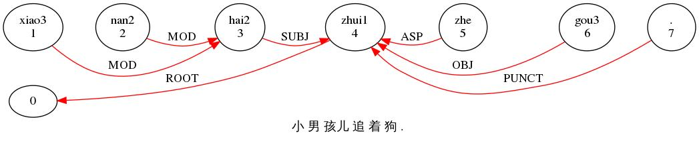

*CHI: 小 男 孩儿 追 着 狗 .

%mor: adj|xiao3=small adj|nan2=male n|hai2-DIA=child v|zhui1=pursue

asp|zhe n|gou3=dog .

%gra: 1|3|MOD 2|3|MOD 3|4|SUBJ 4|0|ROOT 5|4|ASP 6|4|OBJ 7|4|PUNCT

**OBJect2** identifies the indirect object in a sentence, which is the noun closer to the verb and thus is also called the “close object” in the double objects sentences. The head of OBJ2 is the verb for which it’s acting as an indirect object. Here is an example with both OBJ and OBJ2:

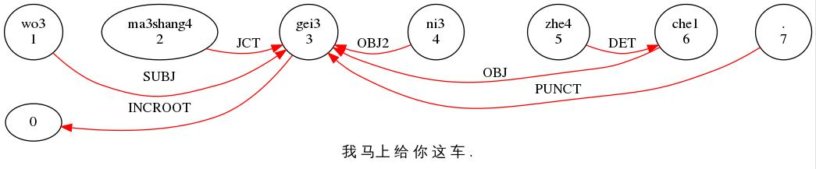

*IN2: 我 马上 给 你 这 车 .

%mor: pro|wo3=I adv|ma3shang4=immediately v|gei3=give pro|ni3=you

pro|zhe4=this n|che1=vehicle .

%gra: 1|3|SUBJ 2|3|JCT 3|0|INCROOT 4|3|OBJ2 5|6|DET 6|3|OBJ 7|3|PUNCT

The verb 给(gei3) takes five arguments here. Three of them are JCT, the OBJ is 车(che1) and the OBJ2 is 你(ni3). Similar to what it is like in English, when the order of the two objects changes because the beneficiary is included in a prepositional phrase, as in 讲完了马上就把这车给你, “把这车” is treated as an adjunct to the verb and 把 is linked to 给 as a JCT. However, 这车is tied to 把 as PREPO while 你is attached to the ROOT verb 给as the OBJ which can be seen in the following graph:

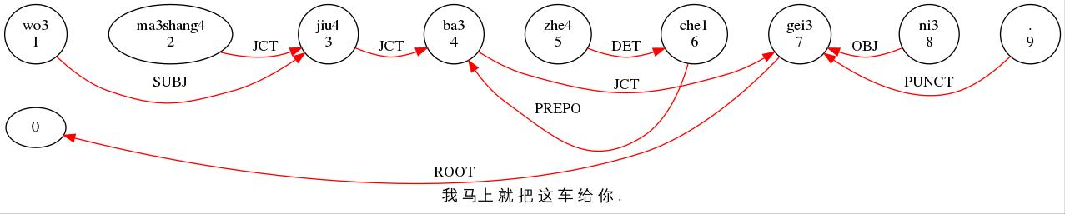

*IN2: 我 马上 就 把 这 车 给 你 .

%mor: pro|wo3=I adv|ma3shang4=immediately adv|jiu4=just

prep|ba3=object_marker pro|zhe4=this n|che1=vehicle v|gei3=give

pro|ni3=you .

%gra: 1|3|SUBJ 2|3|JCT 3|4|JCT 4|7|JCT 5|6|DET 6|4|PREPO 7|0|ROOT

8|7|OBJ 9|7|PUNCT

# TOP and PTOP

**TOPic** identifies the noun or noun phrases in the very beginning of the sentence which is not the subject but is the topic of the sentence. The head of TOP is the ROOT or the INCROOT of the sentence. Topic-comment construction does not exist in English, which has made this one of the major differences between English and Chinese. Although there are many different theories on the coexistence of topic and subject, it is generally believed that both topic and subject exist in Chinese as separate grammatical notions and the two can exist in the same sentence. Topic is always related to a position inside th ecomment but does not have its own syntactic function.

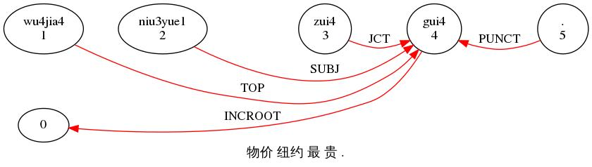

*PAR: 物价 纽约 最 贵 .

%mor: n|wu4jia4=commodity_prices n:geo|niu3yue1=New_York adv|zui4=most adj|gui4=expensive .

%gra: 1|4|TOP 2|4|SUBJ 3|4|JCT 4|0|INCROOT 5|4|PUNCT

Notice there are two nouns in the sentence which are both in front of the adjectival predicate. Both of them are competing to be the subject of the sentence, but the predicate 贵can only take one argument which is closer to it, so 物价should be the topic and 纽约the subject.

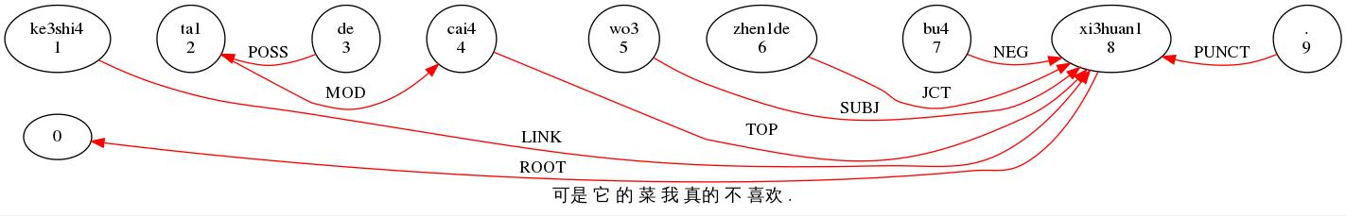

*CHI: 可是 它 的 菜 我 真的 不 喜欢 .

%trn: conj|ke3shi4=but pro|ta1=it poss|de n|cai4=food pro|wo3=I

adv|zhen1de=really neg|bu4=not v|xi3huan1=like .

%grt: 1|8|LINK 2|4|MOD 3|2|POSS 4|8|TOP 5|8|SUBJ 6|8|JCT 7|8|NEG 8|0|ROOT

9|8|PUNCT

Unlike the preceding sentence, this one looks like an inverted sentence, as you can reform it by moving它的菜to the end and the meaning stays the same. However, this is actually a topic-comment sentence, with 它的菜being what the sentence is about.

**PosTOPic=PTOP** identifies the topic words being at the end of the sentence, such as the following example. There are two nouns in the sentence, the second of which is located after the INCROOT, indicating that it is not an object but a topic of the sentence but unlike TOP, PTOP is in the end of a sentence. The head of PTOP is also the ROOT or INCROOT of the sentence.

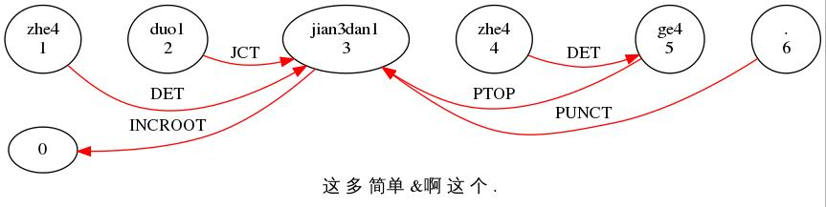

*HA2: 这 多 简单 &啊 这 个 .

%mor: pro|zhe4=this adv|duo1=far_more adj|jian3dan1=terse pro|zhe4=this cl|ge4 .

%gra: 1|3|DET 2|3|JCT 3|0|INCROOT 4|5|DET 5|3|PTOP 6|3|PUNCT

# JCT , PREPO, POSTO

**adJunCt=JCT** identifies an adjunct that modifies a verb, an adjective, or an adverb but not a noun. The head of JCT is the verb, adjective or adverb it modifies. The JCT relation in Chinese itself is relatively similar to the one in English. (see section 11.2) Here is an example:

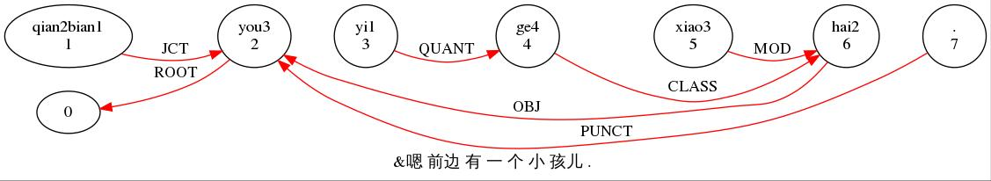

*CHI: &嗯 前边 有 一 个 小 孩儿 .

%mor: post|qian2bian1=in_front v|you3=have num|yi1=one cl|ge4

adj|xiao3=small n|hai2-DIA=child .

%gra: 1|2|JCT 2|0|ROOT 3|4|QUANT 4|6|CLASS 5|6|MOD 6|2|OBJ 7|2|PUNCT

**PREPOsitional object = PREPO** identifies the non-clausal nominal object dependent on a preposition, in which the preposition is the head. The PREPO relation usually goes with another JCT relation as showed in the following example:

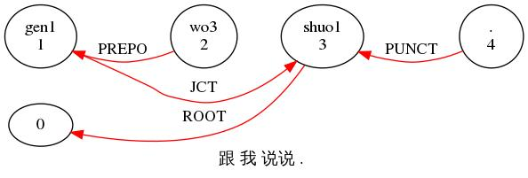

*IN1: 跟 我 说说 .

%mor: prep|gen1=with pro|wo3=I v|shuo1&DIM=say .

%gra: 1|3|JCT 2|1|PREPO 3|0|ROOT 4|3|PUNCT

The PREPO relation with the head and predicate, as a whole, usually acts as an adjunct that modifies a verb or an adverb.

**POSTpositional Object = POSTO** identifies the non-clausal nominal object dependent on a postposition, which is the head of the noun. Same as the PREPO relation, the POSTO relation also goes with another JCT relation.

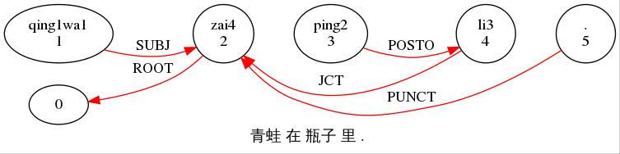

*CHI: 青蛙 在 瓶子 里 .

%mor: n|qing1wa1=frog v|zai4=lie_in n|ping2-NOM=bottle post|li3=inside .

%gra: 1|2|SUBJ 2|0|ROOT 3|4|POSTO 4|2|JCT 5|2|PUNCT

# PRED

**PREDicate** identifies a nominal or adjectival predicate. This is an argument of the verb 是 and the head of PRED is the verb of which it is an argument.

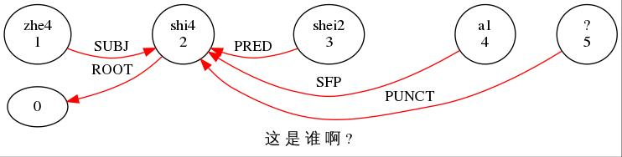

*INV: 这 是 谁 啊 ?

%trn: pro|zhe4=this v:cop|shi4=is pro:wh|shei2=who sfp|a1 ?

%grt: 1|2|SUBJ 2|0|ROOT 3|2|PRED 4|2|SFP 5|2|PUNCT

# AUX

**AUXiliary** identifies an auxiliary or modal of a main verb, such as 会 and 可以. The head of the AUX is the verb that it precedes.

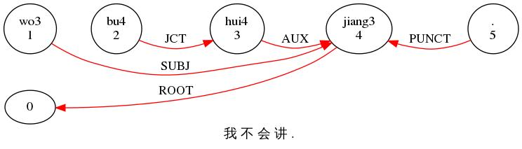

*CHI: 我 不 会 讲 .

%mor: pro|wo3=I neg|bu4=not v:aux|hui4=will v|jiang3=speak .

%gra: 1|4|SUBJ 2|3|JCT 3|4|AUX 4|0|ROOT 5|4|PUNCT

# DET, QUANT, CLASS , MOD

**DETerminer** identifies a determinor which is linked to its head noun. Determiners in Chinese include 这, 那 and 哪. When there is a noun or noun phrase following the determiner, the head is always the noun and the dependent is the determiner; however, if there is no nouns or noun phrases following, the determiner will be treated as a noun.

**CLASSifier** identifies a measure word that is inserted before a noun. In Chinese, when a noun is preceded by a quantifier or a determinator, a classifier or a measure word is needed in between to connect them. One example is given here:

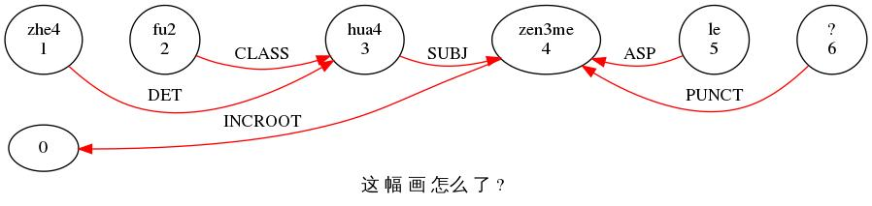

*HA1: 这 幅 画 怎么 了 ?

%mor: pro|zhe4=this cl|fu2 n|hua4=painting adv:wh|zen3me=how asp|le ?

%gra: 1|3|DET 2|3|CLASS 3|4|SUBJ 4|0|INCROOT 5|4|ASP 6|4|PUNCT

**MODifier** identifies a nominal modifier. In the following case, 大点itself is no doubt a modifier, but they are not treated as one word and 点

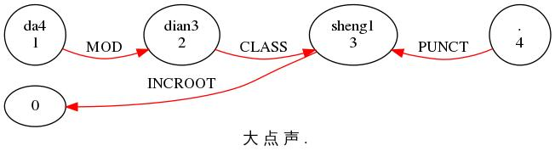

*HAN: 大 点 声 .

%trn: adj|da4=great cl|dian3 n|sheng1=sound .

%grt: 1|2|MOD 2|3|CLASS 3|0|INCROOT 4|3|PUNCT

**QUANTifier** identifies a nominal quantifier, including the numbers and other nouns that are used to denote numerical meaning. Typically, the head is the classifier or the noun when the classifier is omitted, and the dependent is a quantifier. In cases where quantifier has no head, there is no QUANT relation. In Chinese, the QUANT, DET, CLASS, and MOD relations have mostly the same syntax: DET + QUANT + CLASS + MOD + noun.

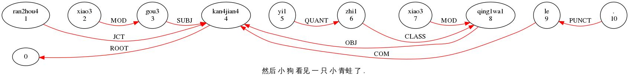

*CHI: 然后 小 狗 看见 一 只 小 青蛙 了 .

%trn: adv|ran2hou4=thereupon adj|xiao3=small n|gou3=dog v|kan4jian4=see num|yi1=one cl|zhi1 adj|xiao3=small n|qing1wa1=frog asp|le .

%grt: 1|4|JCT 2|3|MOD 3|4|SUBJ 4|0|ROOT 5|6|QUANT 6|8|CLASS 7|8|MOD 8|4|OBJ 9|4|COM 10|9|PUNCT

# CONJ , COORD , ENUM

**CONJunction** identifies the coordinating conjunction which is linked to the preceding items. There are more of those conjunctions in Chinese than those in English, including 和, 跟, 或, 或者, 与, 及, 以及. When the conjunction is involved in the relation with a cluster of conjoined items that has been combined with ENUM relation, the conjunction is linked to the first word or phrase in the cluster.

**COORDination** identifies the attached element to the preceding conjunction.

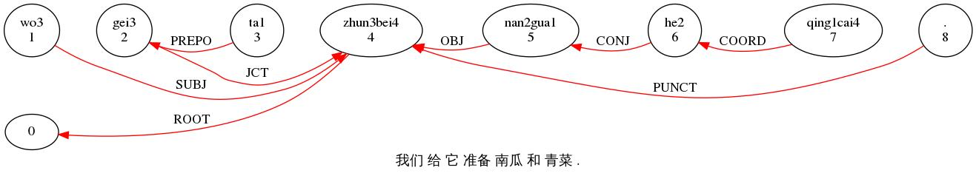

*CHI: 我们 给 它 准备 南瓜 和 青菜 .

%mor: pro|wo3-PL=I prep|gei3=for pro|ta1=it v|zhun3bei4=prepare n|nan2gua1=pumpkin conj|he2=and n|qing1cai4=chinese_cabbage .

%gra: 1|4|SUBJ 2|4|JCT 3|2|PREPO 4|0|ROOT 5|4|OBJ 6|5|CONJ 7|6|COORD 8|4|PUNCT

**ENUMeration** joins a series of elements that are linked through CONJ and COORD. The elements that are connected are all linked to the first item in the series which serves as the head. The series could have any length. Here is an example of a children listing the characters that appeared in a story:

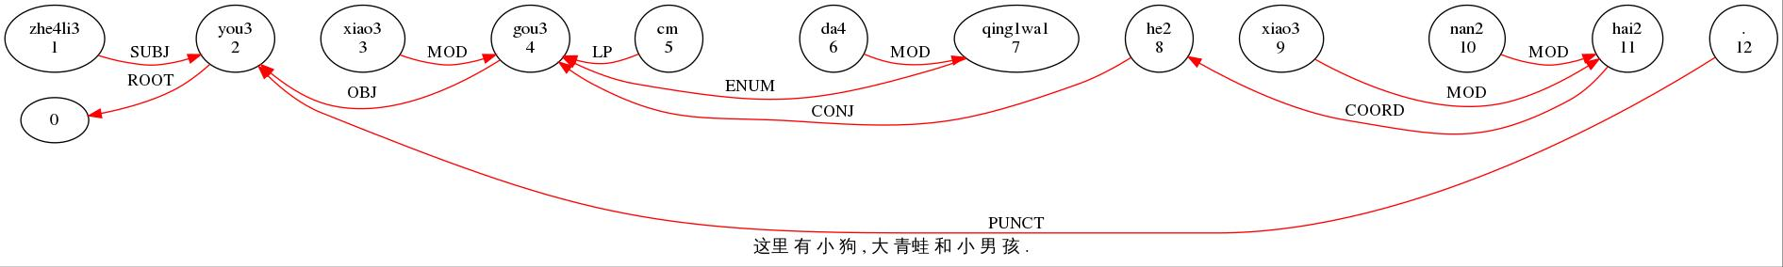

*CHI: 这里 有 小 狗 , 大 青蛙 和 小 男 孩 .

%mor: post|zhe4li3=here v|you3=have adj|xiao3=small n|gou3=dog cm|cm adj|da4=great n|qing1wa1=frog conj|he2=and adj|xiao3=small adj|nan2=male n|hai2=child .

%gra: 1|2|JCT 2|0|ROOT 3|4|MOD 4|2|OBJ 5|4|LP 6|7|MOD 7|4|ENUM 8|4|CONJ 9|11|MOD 10|11|MOD 11|8|COORD 12|2|PUNCT

# LP

**Local Punctuation = LP** identifies the relation between comas and the overall structure. Each coma in an ENUM series should be linked to the previous word and the comas that are used to delimit clauses should be linked to the ROOT.

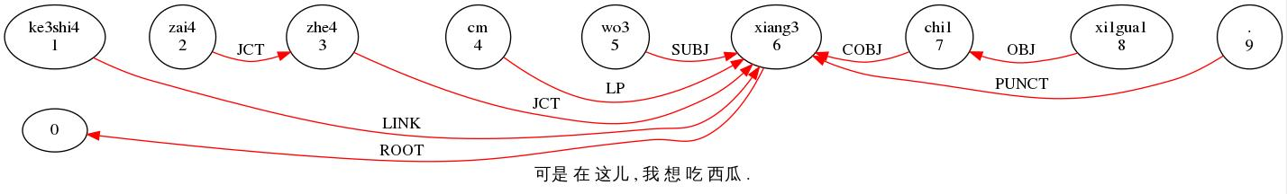

CHI: 可是 在 这儿 , 我 想 吃 西瓜 .

%mor: conj|ke3shi4=but adv|zai4=currently post|zhe4&DIA=here cm|cm

pro|wo3=I v|xiang3=think v|chi1=eat n|xi1gua1=watermelon .

%gra: 1|6|LINK 2|3|JCT 3|6|JCT 4|6|LP 5|6|SUBJ 6|0|ROOT 7|6|COBJ 8|7|OBJ

9|6|PUNCT

# COMP and COBJ

**COMPlement** identifies a clausal complement of a verb. The head is the main verb of the matrix clause and the dependent is the main verb of the clausal complement. The noun after the main verb of the matrix clause is linked to the following verb, the main verb of the clausal complement, by SUBJ relation, but it should sound gramatically correct if it acts as the object of the preceding verb.

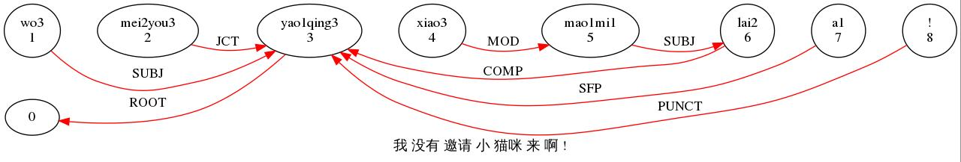

*CHI: 我 没有 邀请 小 猫咪 来 啊 !

%mor: pro|wo3=I neg|mei2you3=not_have v|yao1qing3=invite adj|xiao3=small n|mao1mi1=kitty v:dirc|lai2=come sfp|a1 !

%gra: 1|3|SUBJ 2|3|JCT 3|0|ROOT 4|5|MOD 5|6|SUBJ 6|3|COMP 7|3|SFP 8|3|PUNCT

小猫咪(the small kitty) is linked to the following verb 来(come) as the subject of the clausal complement, but if it is the object of the preceding verb 邀请(invite), the sentence, which is 邀请小猫咪 (invite the small kitty), is not grammatically incorrect.

Another example is given here:

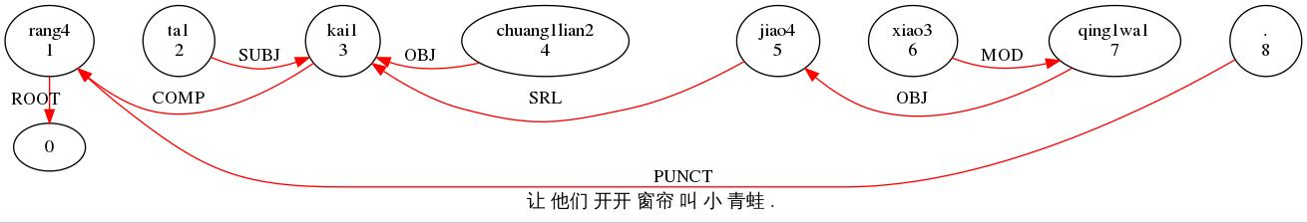

*CHI: 让 他们 开开 窗帘 叫 小 青蛙 .

%mor: v|rang4=allow pro|ta1-PL=he v:resc|kai1&DIM=open n|chuang1lian2=curtain v|jiao4=call adj|xiao3=small n|qing1wa1=frog .

%gra: 1|0|ROOT 2|3|SUBJ 3|1|COMP 4|3|OBJ 5|3|SRL 6|7|MOD 7|5|OBJ 8|1|PUNCT

**Clausal OBJect = COBJ** identifies a full clause which serves as an object. The verb of the object clause, which is the dependent. attaches to the main verb which is the head.

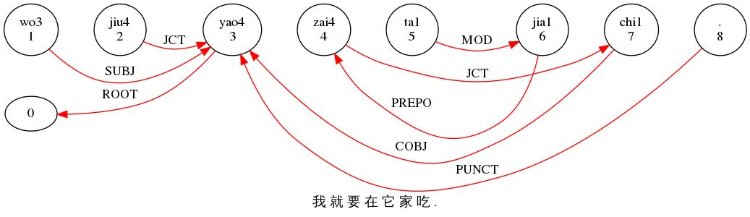

*CHI: 我 就 要 在 它 家 吃 .

%trn: pro|wo3=I adv|jiu4=just v|yao4=want prep|zai4=at pro|ta1=it n|jia1=family v|chi1=eat .

%grt: 1|3|SUBJ 2|3|JCT 3|0|ROOT 4|7|JCT 5|6|MOD 6|4|PREPO 7|3|COBJ 8|3|PUNCT

When we omit the adjunct 在它家, this sentence can be simplified to be 我就要吃 (I just want to eat). 要(want), the main verb of the sentence, should be the ROOT of the sentence, and what follows it should be its object. But the following word is also a verb 吃(eat), which acts as an object clause connecting to 要 by COBJ relation.

COBJ and COMP can coexist in one sentence. An example is given here:

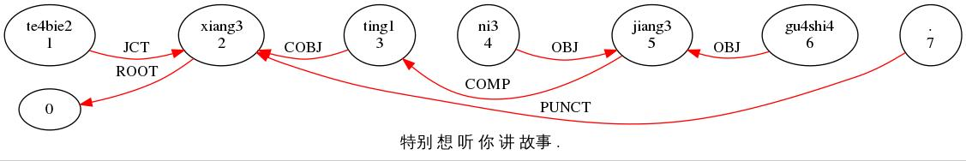

*IN1: 特别 想 听 你 讲 故事 .

%mor: adv|te4bie2=especially v|xiang3=think v|ting1=listen pro|ni3=you v|jiang3=speak n|gu4shi4=story .

%gra: 1|2|JCT 2|0|ROOT 3|2|COBJ 4|5|SUBJ 5|3|COMP 6|5|OBJ 7|2|PUNCT

# CSUBJ, CPRED

**Clausal SUBJect = CSUBJ** identifies the finite clausal subject of the another clause. The head is the main verb and the dependent is the main verb of clausal subject.

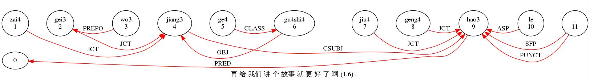

*IN1: 再 给 我们 讲 个 故事 就 更 好 了 啊 (1.6) .

%trn: adv|zai4=again prep|gei3=for pro|wo3-PL=I v|jiang3=speak cl|ge4

n|gu4shi4=story adv|jiu4=just adv|geng4=more adj|hao3=good asp|le

sfp|a1 .

%grt: 1|4|JCT 2|4|JCT 3|2|PREPO 4|9|CSUBJ 5|6|CLASS 6|4|OBJ 7|9|JCT 8|9|JCT

9|0|PRED 10|9|ASP 11|9|SFP 11|9|PUNCT

**Clausal PREDicate = CPRED** identifies a full clause that serves as the predicate after the verb 是. An example is given here:

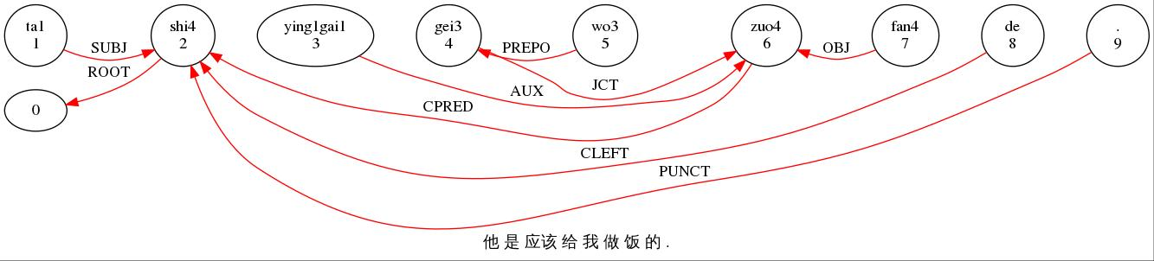

*CHI: 他 是 应该 给 我 做 饭 的 .

%mor: pro|ta1=he v:cop|shi4=is v:aux|ying1gai1=should prep|gei3=for

pro|wo3=I v|zuo4=make n|fan4=food nom|de .

%gra: 1|2|SUBJ 2|0|ROOT 3|6|AUX 4|6|JCT 5|4|PREPO 6|2|CPRED 7|6|OBJ

8|2|CLEFT 9|2|PUNCT

# CJCT

**Clausal adJunCT = CJCT** identifies a finite clause that adjoins to a veb, adjective, or a verb and acts as an adjunct in the sentence. The head is the root verb of the whole sentence and the dependent is the main verb of the subordinate clause.

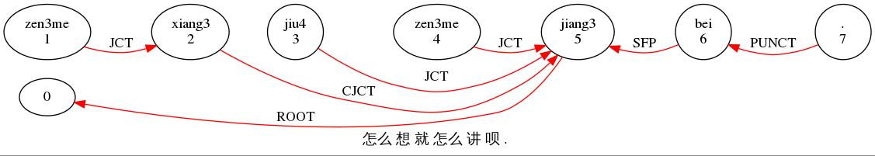

*HA1: 怎么 想 就 怎么 讲 呗 .

%mor: adv:wh|zen3me=how v|xiang3=think adv|jiu4=just adv:wh|zen3me=how v|jiang3=speak adv|bei=just .

%gra: 1|2|JCT 2|5|CJCT 3|5|JCT 4|5|JCT 5|0|ROOT 6|5|SFP 7|6|PUNCT

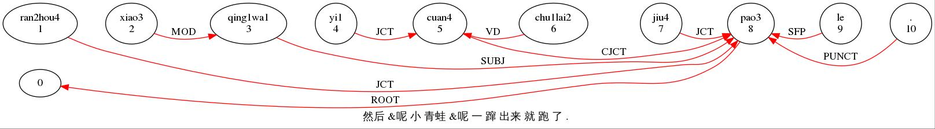

*CHI: 然后 &呢 小 青蛙 &呢 一 蹿 出来 就 跑 了 .

%trn: adv|ran2hou4=thereupon adj|xiao3=small n|qing1wa1=frog adv|yi1=just_as v|cuan4=leap_up v|chu1lai2=go_out adv|jiu4=just v|pao3=run asp|le .

%grt: 1|8|JCT 2|3|MOD 3|8|SUBJ 4|5|JCT 5|8|CJCT 6|5|VD 7|8|JCT 8|0|ROOT 9|8|SFP 10|8|PUNCT

# CMOD

**Clausal MODifier = CMOD** identifies the relative clause that modifies the noun after it. The head is the noun and the dependent is the verb inside the clause. Unlike those in English, the verb in the relative clause in Chinese is typically followed by 的 which is the dependent linked to the verb through the LINK relation.

In the following example, 小青蛙is modified by the relative clause preceding it: 他养的. And the verb 养inside the clause is the dependent of the head 青蛙 through the CMOD relation while 他is without doubt the subject of the clause and 的 is linked to 养.

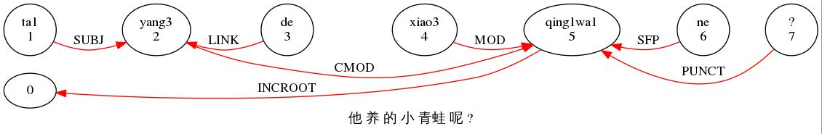

*INV: 他 养 的 小 青蛙 呢 ?

%mor: pro|ta1=he v|yang3=raise att|de adj|xiao3=small n|qing1wa1=frog sfp|ne ?

%gra: 1|2|SUBJ 2|5|CMOD 3|2|LINK 4|5|MOD 5|0|INCROOT 6|5|SFP 7|5|PUNCT

# LINK

**LINK** identifies the sentential connectives in complex sentences. The head is usually the verb of the following clause or sentence and the dependent is the conjunction such as 然后(then) and 所以(so).

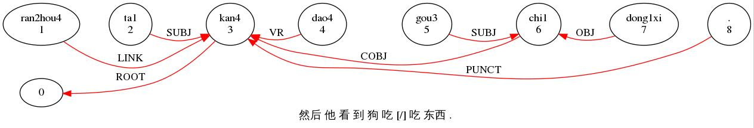

*CHI: 然后 他 看 到 狗 吃 [/] 吃 东西 .

%mor: adv|ran2hou4=thereupon pro|ta1=he v|kan4=look v:resc|dao4=arrive n|gou3=dog v|chi1=eat n|dong1xi=thing .

%gra: 1|3|LINK 2|3|SUBJ 3|0|ROOT 4|3|VR 5|6|SUBJ 6|3|COBJ 7|6|OBJ 8|3|PUNCT

# BEG, BEGP, END, ENDP

**BEGinning** identifies an initial clause-external element, such as a vocative and a commincater. The head of BEG is 0. BEG is marked in the main line with a following ‡ mark (typing F2 and then V to get this mark) that is coded on the %mor tier as beg|begp.

**BEGinning Punctuation = BEGP** is the relation between the double dagger ‡ and the BEG element so that the clause-external element could be partitioned off from the rest of the sentence.

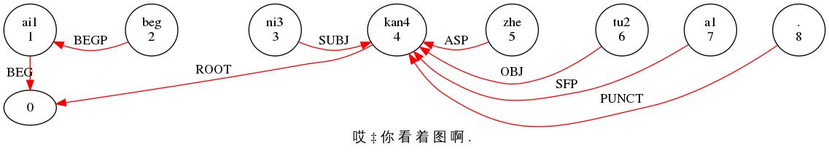

*HA2: 哎 ‡ 你 看 着 图 啊 .

%mor: co|ai1=ugh beg|beg pro|ni3=you v|kan4=look asp|zhe n|tu2=picture sfp|a1 .

%gra: 1|0|BEG 2|1|BEGP 3|4|SUBJ 4|0|ROOT 5|4|ASP 6|4|OBJ 7|4|SFP 8|4|PUNCT

**END** identifies a final clause-externl postposed element, such as a tag question or word and a vocative. Unlike BEG, END is linked to the root of the sentence through the relation END. END is marked in the main line with a prececding „ mark (typing F2 and then T to get this mark)that is coded on the %mor tier as end|endp.

**END Punctuation = ENDP** identifies the relation between END and the preceding double coma „ so that the clause-external element could be partitioned off from the main sentence.

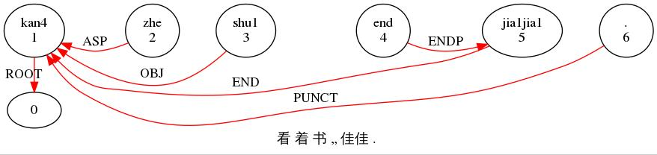

*IN1: 看 着 书 „ 佳佳 .

%trn: v|kan4=look asp|zhe n|shu1=book end|end n:name|jia1jia1 .

%grt: 1|0|ROOT 2|1|ASP 3|1|OBJ 4|5|ENDP 5|1|END 6|1|PUNCT

**TAG** identifies the tag questions in the sentence-final position. The head is the root of the whole sentence and the dependent is the tag question. Unlike in English, there are three tag forms in Chinese including Verb-不-Verb, Verb-particle, and Negative-Verb-particle and are in most cases treated as a whole word.

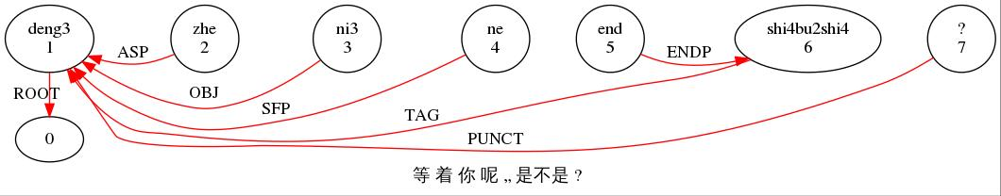

等 着 你 呢 „ 是不是 ?

%trn: v|deng3=wait asp|zhe pro|ni3=you sfp|ne end|end tag|shi4bu2shi4=right ?

%grt: 1|0|ROOT 2|1|ASP 3|1|OBJ 4|1|SFP 5|6|ENDP 6|1|TAG 7|1|PUNCT

# SRL, VR, VD

**SeRial** identifies serial verbs in one sentence. The head is the first verb that appears in the series of verbs and the following verbs are linked to the head as dependents through the SRL relation.

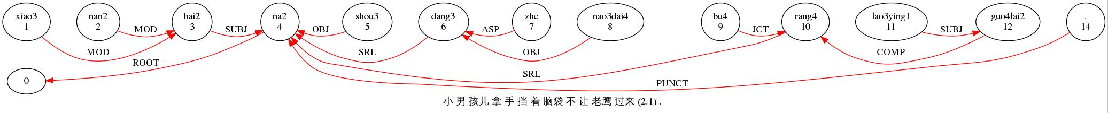

*CHI: 小 男 孩儿 拿 手 挡 着 脑袋 不 让 老鹰 过来 (2.1) .

%trn: adj|xiao3=small adj|nan2=male n|hai2-DIA=child v|na2=hold n|shou3=hand v|dang3=ward_off asp|zhe n|nao3dai4=head neg|bu4=not v|rang4=allow n|lao3ying1=hawk v|guo4lai2=come_over .

%grt: 1|3|MOD 2|3|MOD 3|4|SUBJ 4|0|ROOT 5|4|OBJ 6|4|SRL 7|6|ASP 8|6|OBJ 9|10|JCT 10|4|SRL 11|12|SUBJ 12|10|COMP 14|4|PUNCT

There are three verbs in this sentences existing this serial verb construction: 拿, 挡, 让. In this case, the first verb拿is treated as the root of the sentence as well as the head of the SRL relations and the following two verbs are both linked to the root through SRL relation.

**Resultative Verb = VR** identifies the resultative verb after the initial verb. Used together with the initial verb indicating an action, the resultative verb indicates the result of the action. The head is the initial verb and the resultative verb is the dependent.

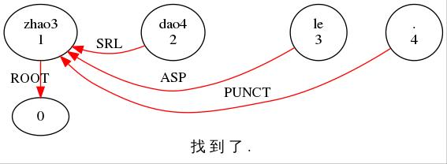

*CHI: 找 到 了 .

%trn: v|zhao3=search v:resc|dao4=arrive asp|le .

%grt: 1|0|ROOT 2|1|VR 3|1|ASP 4|1|PUNCT

**Directonal Verb = VD** identifies the directional verb after the initial to indicate the direction of an act or behavior. The head is the initial verb which indicates the action and the dependent is the directional verb.

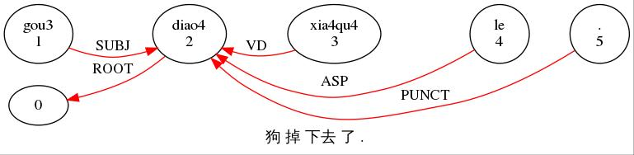

*CHI: 狗 掉 下去 了 .

%mor: n|gou3=dog v|diao4=drop v:dirc|xia4qu4=downwards asp|le .

%gra: 1|2|SUBJ 2|0|ROOT 3|2|VD 4|2|ASP 5|2|PUNCT

# APP

**APPosition** identifies the appositive noun or phrase, as in 我们五个人. The head of APP is the noun it corresponds to. Unlike in English, the head of the APP in Chinese is always the first apposed term while the dependent is the second. But the essential quality of APP is the same in both languages: both nouns or phrases denote the same entity.

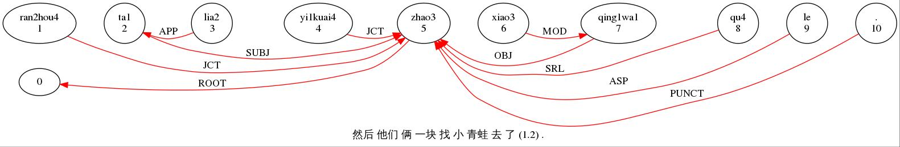

*CHI: 然后 他们 俩 一块 找 小 青蛙 去 了 (1.2) .

%mor: adv|ran2hou4=thereupon pro|ta1-PL=he n|lia2=two adv|yi1kuai4=together v|zhao3=search adj|xiao3=small n|qing1wa1=frog v:dirc|qu4=go asp|le .

%gra: 1|5|JCT 2|5|SUBJ 3|2|APP 4|5|JCT 5|0|ROOT 6|7|MOD 7|5|OBJ 8|5|SRL 9|5|ASP 10|5|PUNCT

# INCROOT, OM

**INComplete ROOT = INCROOT** identifies the word that can serve as the root of the sentence when the usual root, a verb, is missing. It covers a range of parts of speech, such as an adverb, a communicator, a noun and an adjective. The following sentence, or phrase, has the adjective 好as its INCROOT.

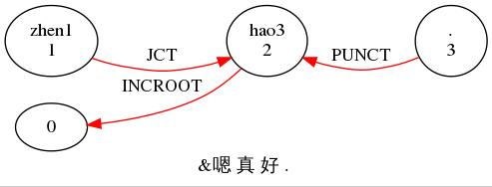

*INV: &嗯 真 好 .

%trn: adv|zhen1=really adj|hao3=good .

%grt: 1|2|JCT 2|0|INCROOT 3|2|PUNCT

**OMission** identifies the ellipsis or omission which leaves a determiner or other modifiers without a head. In these cases, the omissions should be attached the most local predicate using the OM relation.

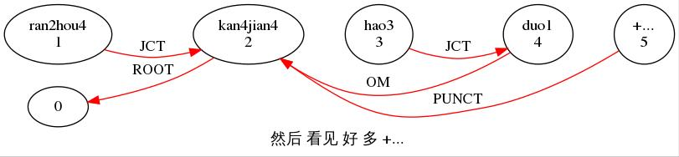

*CHI: 然后 看见 好 多 +...

%trn: adv|ran2hou4=thereupon v|kan4jian4=see adv|hao3=very adj|duo1=lots +...

%grt: 1|2|JCT 2|0|ROOT 3|4|JCT 4|2|OM 5|2|PUNCT

# SFP and ASP

**Sentence Final Particle = SFP** identifies the phonologically small elements, most frequently monosyllabic, which mostly occur in sentence-final position for some semantic and pragmatic use.

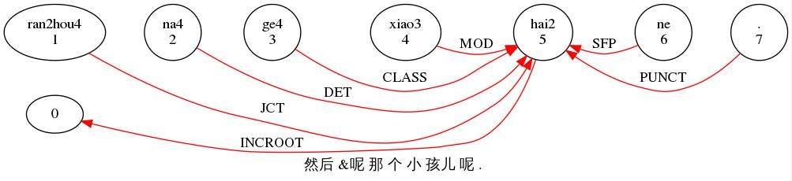

*CHI: 然后 &呢 那 个 小 孩儿 呢 .

%trn: adv|ran2hou4=thereupon pro|na4=that cl|ge4 adj|xiao3=small n|hai2-DIA=child sfp|ne .

%grt: 1|5|JCT 2|5|DET 3|5|CLASS 4|5|MOD 5|0|INCROOT 6|5|SFP 7|5|PUNCT

**ASPect marker = ASP** identifies a few particles which add a particular aspectual value to the verb to which they are attached. In Chinese, there are four of them: 了, 过, 在 and 着. These aspect markers are linked to the verb they are attached to through ASP relation and in most instances, they are in the sentence-final positions like it is in the following example.

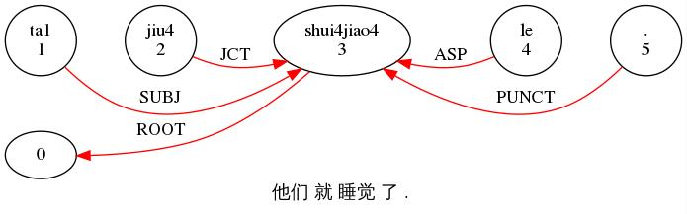

*CHI: 他们 就 睡觉 了 .

%trn: pro|ta1-PL=he adv|jiu4=just v|shui4jiao4=sleep asp|le .

%grt: 1|3|SUBJ 2|3|JCT 3|0|ROOT 4|3|ASP 5|3|PUNCT

But sometimes aspect markers can be inserted in the middle of the sentence, closer to the verb.

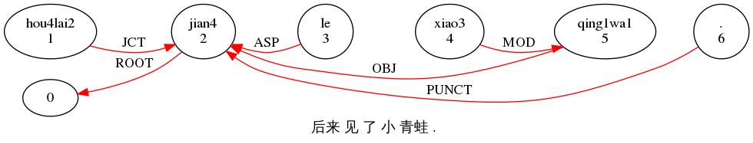

*CHI: 后来 见 了 小 青蛙 .

%trn: adv|hou4lai2=later v|jian4=see asp|le adj|xiao3=small n|qing1wa1=frog .

%grt: 1|2|JCT 2|0|ROOT 3|2|ASP 4|5|MOD 5|2|OBJ 6|2|PUNCT