

Education

Mathematics & Statistics

Political Science

Bachelor of Arts

Applied Mathematics

Master of Science

**Damian A. von Schoenborn**

612.321.8249 • vonSchoenborn@gmail.com

Data professional with 5+ years’ experience in machine learning, data visualization, and crafting data stories



**2006 2007 2008 2009 2010 2011 2012 2013 2014 2015 2016**

Employment

Data Analytics & Reporting Supervisor

Senior Data Scientist

Projects

Certificates

Leadership

* Tableau Desktop 8 Qualified (Tableau)
* AWS Technical Essentails (Amazon)
* Hadoop Data Analyst Training (Cloudera)
* Developer Training for Spark (Cloudera)
* Data Science Boot Camp (Metis)
* Scalable Machine Learning (edX)
* Head of Engineering Data-as-Product Team
* Head of Data Integrity Team
* Co-lead of Tableau Task Force
* Led transition to new database platform
* Managed deployment of new Business Intelligence software
* Oversaw report development and delivery
* Model to predict customer attrition
* Customer Segmentation models
* Develop reports consumed by 1000+
* Built process to validate customer email addresses
* Automatic natural disaster identification system



Tool Proficiency

Recommended for:

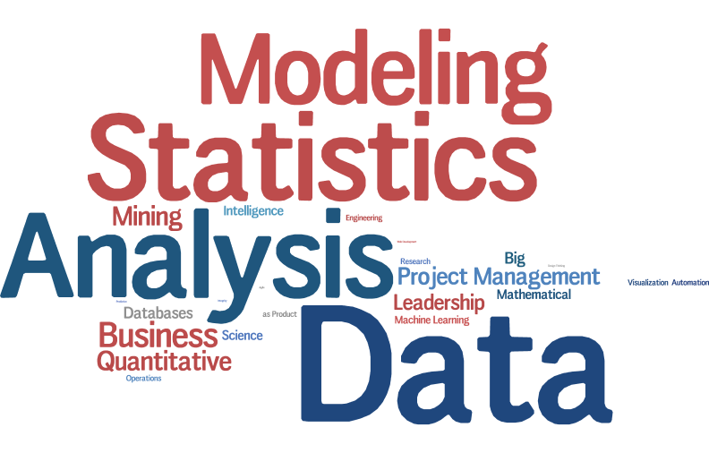





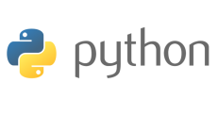



http://www.cloudera.com/content/dam/cloudera/support/ungated/icons/teradata2_351464.png







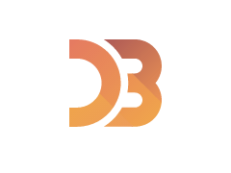





Passions