

Education

Mathematics & Statistics

Political Science

Bachelor of Arts

Applied Mathematics

Master of Science

**Damian A. von Schoenborn**

612.321.8249 • vonSchoenborn@gmail.com

Data professional with 5+ years’ experience in machine learning, data visualization, and crafting data stories



**2006 2007 2008 2009 2010 2011 2012 2013 2014 2015 2016**



Employment

Data Analytics & Reporting Supervisor

Co-founder

Senior Data Scientist

Projects

Certificates

Leadership

* Tableau Desktop 8 Qualified (Tableau)
* AWS Technical Essentials (Amazon)
* Hadoop Data Analyst Training (Cloudera)
* Developer Training for Spark (Cloudera)
* Data Science Boot Camp (Metis)
* Scalable Machine Learning (edX)
* Head of Engineering Data-as-Product Team
* Head of Data Integrity Team
* Co-lead of Tableau Task Force
* Led transition to new database platform
* Managed deployment of new Business Intelligence software
* Oversaw report development and delivery
* Model to predict customer attrition
* Customer Segmentation models
* Develop reports consumed by 1000+
* Built process to validate customer email addresses
* Automatic natural disaster identification system
* County-level pricing model
* Automated order-to-processor assignment process



Tool Proficiency

Recommended for:

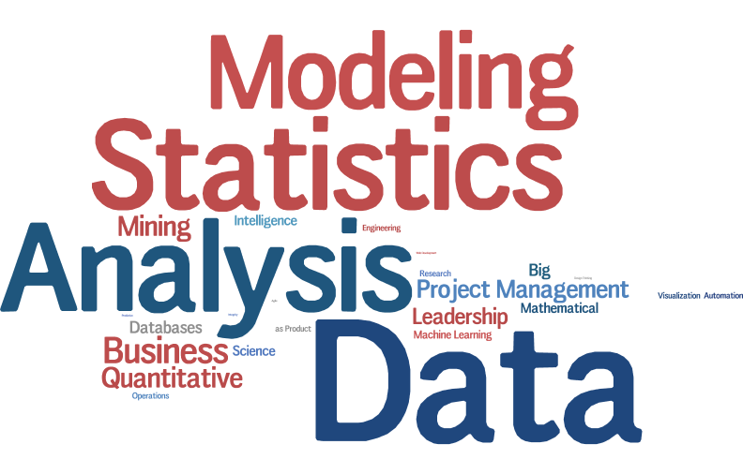









http://www.cloudera.com/content/dam/cloudera/support/ungated/icons/teradata2_351464.png









Damian Andreas Hoye Graf von Schoenborn, MSc

Senior Data Scientist at Capital One

vonschoenborn@gmail.com

Summary

• Data professional with 5+ years experience in database design, machine learning, advanced analytics, and data visualization • Excels at converting complex data and analyses into actionable insights and meaningful stories • Passionate about implementing cutting-edge techniques

Skills & Expertise

Data Science Big Data Python Apache Spark Hadoop

D3.js Tableau Data-as-Product Hive Data Visualization Machine Learning R Agile Development Data Engineering Artificial Neural Networks Data Mining SQL Unix Statistical Modeling SAS Data Analysis Quantitative Analytics Statistics Mathematical Modeling Business Analysis Databases Mathematical Automated System Construction Business Intelligence Operations Research RapidMiner Leadership

Predictive Analytics Project Management Teradata ETL

Microstrategy MIS Data Modeling Decision Support Systems MATLAB

Applied Mathematics Decision Sciences Data Integrity Problem Solving MapReduce

Web Development Apache Pig APIs Design Thinking

Certifications

Tableau Desktop 8 Qualified Associate | Tableau Software September 2014

Interests

Data Analyst Training: Using Pig, Hive, and Impala with Hadoop | Cloudera June 2015

edX Verified Certificate for Introduction to Big Data with Apache Spark | edX July 2015

edX Verified Certificate for Scalable Machine Learning | edX August 2015

Big Data XSeries | edX August 2015

AWS Technical Essentials | Amazon Web Services August 2015

Cloudera Developer Training for Apache Spark | Cloudera August 2015

Data Science Boot Camp | Metis September 2015

Experience

Senior Data Scientist at Capital One

April 2013 - Present (2 years 7 months) Leadership: * Formed and lead eDAPT: Engineering Data-as-Product Team (6 members) * Formed and lead

a cross-functional Data Integrity Team (5 members) * Co-founded the Bank Tableau Help Desk * Tableau

Server Site Admin * Founding member of the Tableau Task Force, expanding Tableau adoption throughout the enterprise Accomplishments: * Developed data visualization and reporting tool consumed by 750+ associates up to EVP level * Head Subject Matter Expert (SME) on Customer Life Cycle; SME on Mobile Data * Developed automated data querying, transferring, and reporting solutions * Graduated from year-

long Analyst Development Program * Optimize queries on massive data * Generated reports for CEO and Board of Directors * Created Hadoop+Python process for validating customers' email addresses Machine Learning Models Built: * Predicting customer attrition (SAS) * Customer Segmentation (SAS) * Paths customers take to developing Primary Banking Relationships (Python) * Merchants that have customers' card details stored (Python) Business Teams supported: * Horizontal Analytics * Marketing & Acquisitions

* Customer Management * Overdraft Strategy

Data Analytics and Reporting Supervisor at U.S. Bank

August 2012 - April 2013 (9 months) *Led transition to new database platform, including ETL design, data modeling and database design

*Managed deployment of new Business Intelligence software *Data, workflow, and troubleshooting documentation *Gathered functional requirements and translated to technical requirements *Managed work request demand and various other project management tasks *Performed user acceptance testing *Validated data integrity and troubleshot issues *Oversaw report development and delivery covering: -- ~$1.6B/month in real estate collateral -- 11K loan applications per month -- 15 business line partners getting weekly and monthly reports -- 130 employees' performances -- Ad hoc and scheduled reports and dashboards -- 4000 appraisers and vendor management companies

Data Analyst at U.S. Bank

September 2010 - August 2012 (2 years) *Sole data analyst for USB Lending Support Services (now Red Sky Risk Services), a subsidiary of US Bank

(under Consumer Banking Risk Management), that fulfills the bank's appraisal orders for real estate based lending. *Designed and maintained databases *Analyzed appraisal data to: -- identify opportunities for operating efficiency improvement -- utilize the appraisers producing the highest quality work for reasonable costs and turn-times *Created automated process for assigning orders to processors *Developed automated system for identifying natural disaster incidents that may have damaged real estate *Designed county-level pricing model for various appraisal products *Produced reports for CEO, COO, and various division and business line heads. *Defined and performed systems analysis and development tasks to improve workflow and operating efficiency. *Prepared cost/benefit analyses *Designed company intranet site *Software design/

testing *Analyzed vendor contracts

Grade 7 Referee at United States Soccer Federation

February 1999 - June 2011 (12 years 5 months)

Training in the US Olympic Development Program Refereed several games for the U15 and U17 U.S. National Teams

Director of Operations and Accounting at Schoch Hycoo Web Ventures, LLC

July 2007 - May 2011 (3 years 11 months) Personally managed financial accounts, transactions, and tax matters; Designed and constructed websites for

diverse applications

Student Government Cabinet Member at Grinnell College

May 2008 - May 2010 (2 years 1 month) Led a team of over 50 students, leading to an attendance increase of over 80% Appointed to serve on Cabinet

by two administrations; Served as Chairman of the SGA Films Committee; Personally managed a budget of ~$27,000 per semester; Scheduled films and negotiated with distributors to purchase rights; Created and oversaw campus events;

Education

University of Washington

Master of Science (MSc), Applied Mathematics, 2012 - 2015

Grinnell College

B.A., Political Science, Mathematics & Statistics, 2006 - 2010 Activities and Societies: Judicial Council, Student Government Association, Student Endowment Investment

Group, SGA Films Committee, International Soccer Club

University of Peradeniya

ethnic conflict, politics, religion, 2008 - 2009