## Sentiment Analysis Application

—----------------------------------------------------------------------------------------------------------------------------

### **Libraries**

* **Streamlit**: Provides a simple way to create web applications with Python. It allows you to create interactive web apps with minimal code.
* **TextBlob**: A library used for processing textual data. It provides a straightforward API for sentiment analysis among other natural language processing tasks.

### **Functions**

#### **analyze_sentiment(text)**

* **Input**: A string text representing the user's input text.
* **Output**: A float sentiment representing the sentiment polarity of the text.
  + The polarity ranges from -1.0 to 1.0:
    - 1.0 indicates a very positive sentiment.
    - -1.0 indicates a very negative sentiment.
    - 0 indicates a neutral sentiment.

#### **main()**

* **Setup**:
  + The st.title("Sentiment Analysis Application") sets the title of the web application.
  + The st.text_area("Enter your text here:") creates a text area widget where users can input their text.
  + The st.button("Analyze") creates a button that triggers sentiment analysis when clicked.
* **Sentiment Analysis**:
  + When the "Analyze" button is clicked, the analyze_sentiment() function is called with the user's input text.
  + Based on the sentiment score returned by analyze_sentiment(), the application classifies the sentiment as Positive, Negative, or Neutral.
  + The result is displayed to the user using st.write().

### **Running the Application**

To run the application:

1. Save the code to a file, e.g., app.py.
2. Open your terminal and navigate to the directory containing app.py.
3. Run the Streamlit app with the following command:  
   sh  
   Copy code  
   streamlit run app.py
4. A new browser window should open displaying the web application. If it doesn’t open automatically, you can access it by navigating to http://localhost:8501 in your web browser.

## **User Interface**

* **Title**: "Sentiment Analysis Application"
* **Text Area**: Allows users to enter the text they want to analyze.
* **Analyze Button**: Submits the entered text for sentiment analysis.
* **Sentiment Result**: Displays whether the sentiment of the text is Positive, Negative, or Neutral based on the analysis.
* App link : <https://huggingface.co/spaces/talktorhutika/sentimental-analysis-app>
* Have uploaded some snaps to refer.

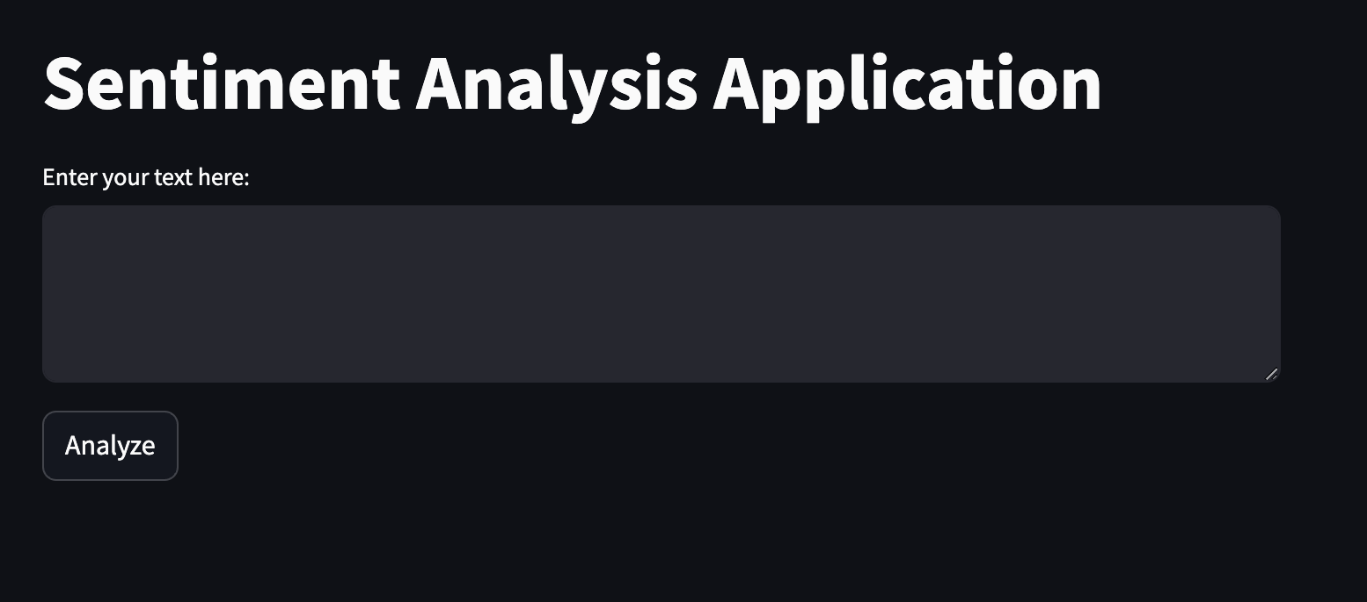

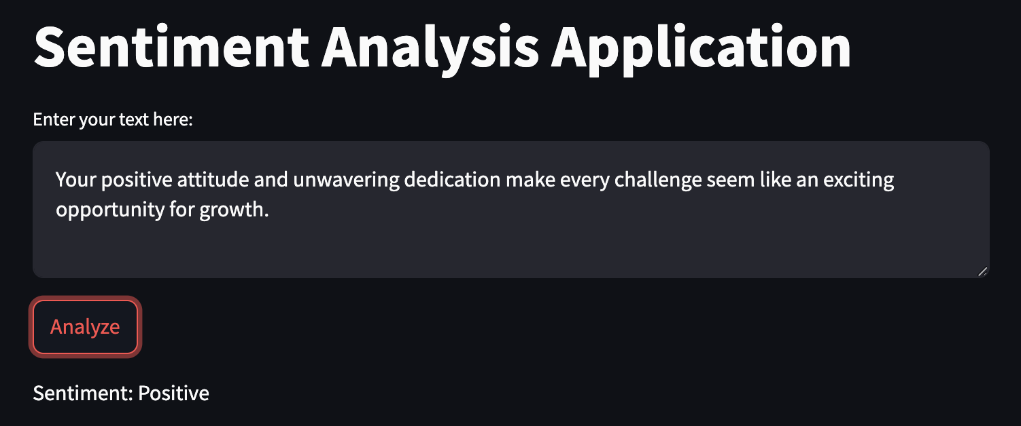

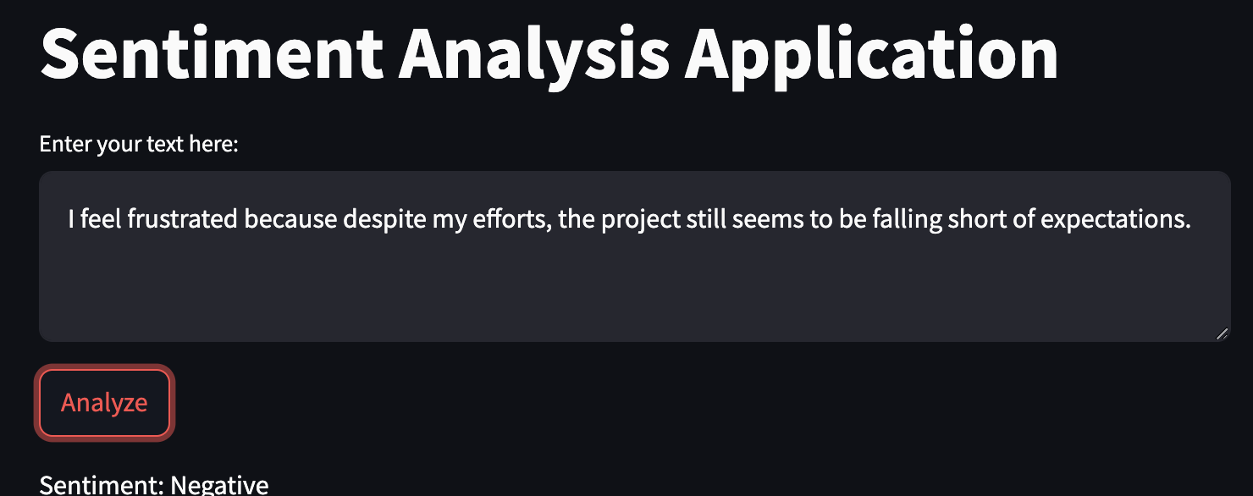

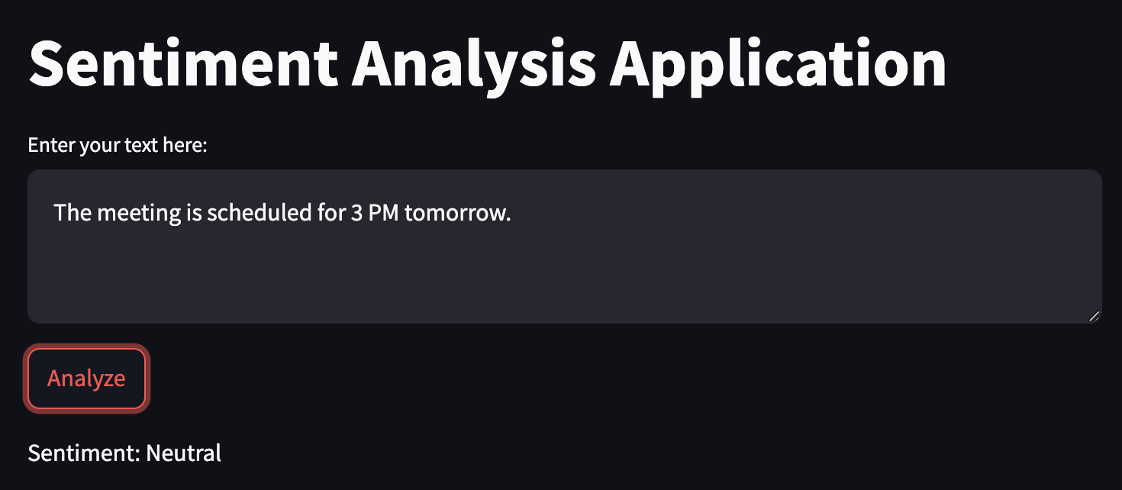

## **Troubleshooting**

* **No Results Displayed**: Ensure that Streamlit and TextBlob are installed correctly. You may need to restart the Streamlit server if it was running during the installation.
* **Error Messages**: Check that there are no syntax errors in the code and that all dependencies are correctly installed.

## **Conclusion**

This sentiment analysis application provides a simple and interactive way to analyze text sentiment using Streamlit and TextBlob. It is a great starting point for building more complex natural language processing applications and can be further extended with additional features or more advanced sentiment analysis techniques.