Colten Davis

CS 402 Fall 2020

Homework 2

1st Idea – Encryption/Decryption App

1. A tabbed app that would encrypt or decrypt plaintext, using 2 or 3 different types of encryption. Such as a tab for a Caesar cipher, and a tab for a rail cipher.

2. Feature list: 2-3 tabs, each with own encryption type. Swift code for the encryption/decryption. I would say each tab would take me 3 hours to implement and get the design looking correct. An app like this would not use any technology feature other than the computational power of the device since it’s all math based.

3. 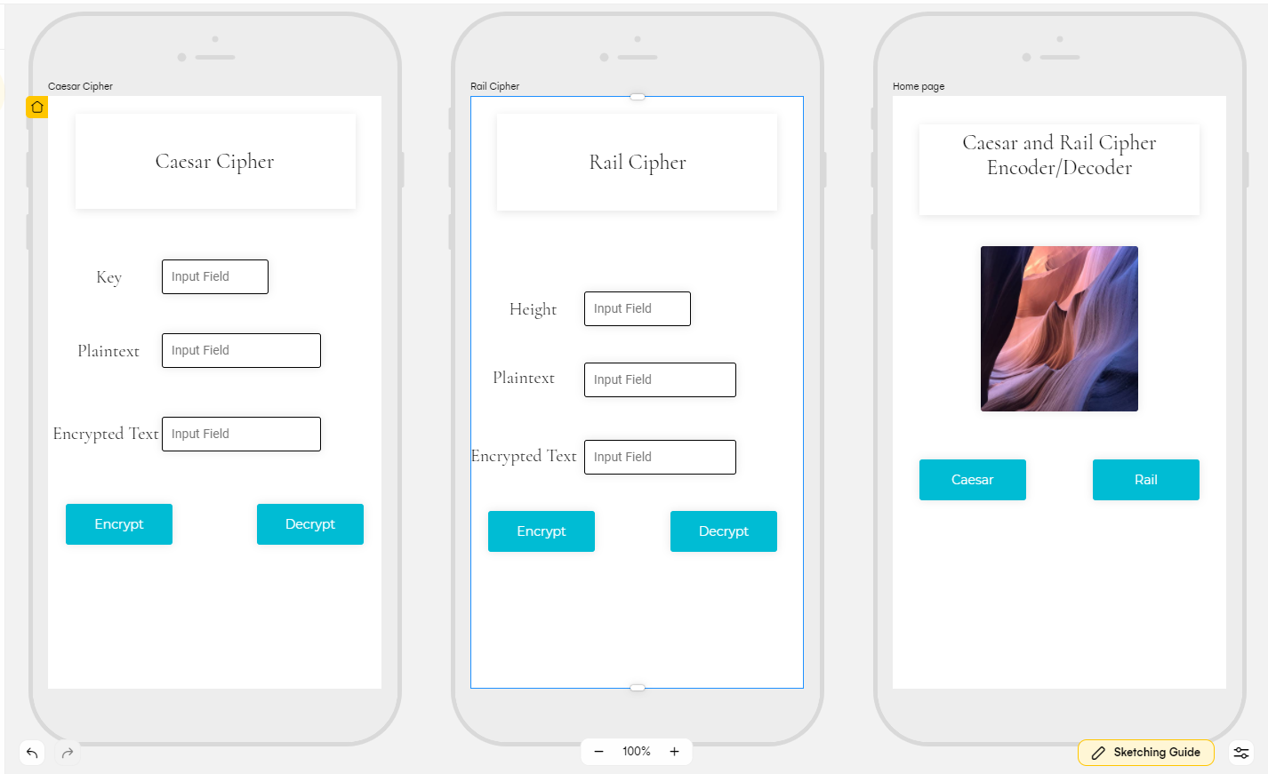

4. The only app I could find is called “Cipher Sender”, and it is a messaging app, not an encoding/decoding app. So as far as I can tell, mine would be a unique app on the store.

5. Intended audience would probably be students or entry level workers dealing with cryptographic analysis.

6. I’d honestly make this app free, it’s an app I wish I had. Otherwise, if I had to charge, 99cents with an option to remove adds for $5.

2nd Idea – Dash Cam iPhone App

1. App that would let you use your iPhone as a dash cam. Recording videos, uploading them to the cloud or perhaps an attachment sold separately, like an SSD via the lightning cable.

2. App would utilize the camera for vision, perhaps the accelerometer to determine current speed and GPS to track location. Each feature would probably take me a full month.

4. There are many dash cam apps on the store. I would set mine apart by integrating it with Apple CarPlay, so you can handle the settings from your cars screen instead of constantly adjusting it from the phone.

5. Audience would be anyone wanting a dash cam but doesn’t want to go out and buy another camera. An iPhone has everything you need.

6. I’d charge $5 for it. Then perhaps in the app, storage options for cloud storage instead of local storage, to free up space on the phone.

3rd Idea – AR Photo App

1. This app would utilize AR and the camera. This app would be opened, it would turn on the camera and show it like a photo. However, instead of taking a photo, a small text box would pop up on the screen detailing what you are looking at.

2. The app would have to have access to a type of visual recognition API as well as be able to use GPS to indicate where you are, as well as the accelerometer in conjunction to indicate what direction you are pointing. This app would probably take me several months, as I’ve never made an app.

3. 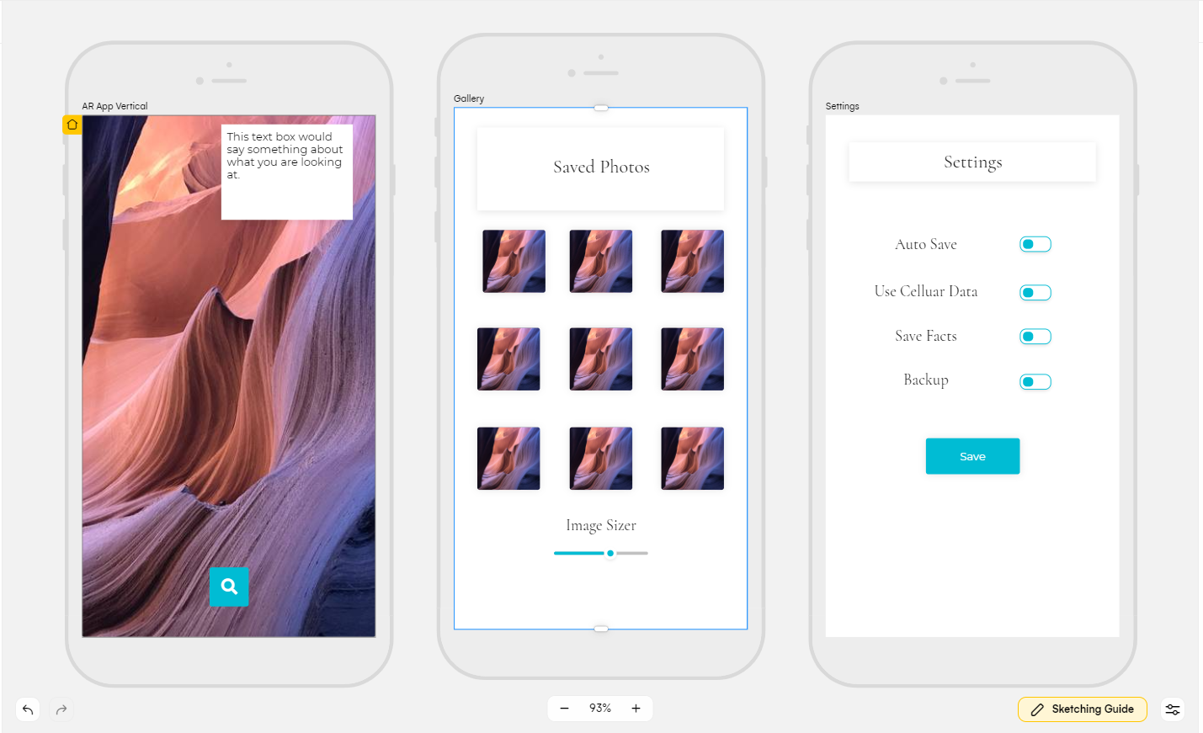

4. I was not able to find any app that does what this app would do.

5. Intended audience would be everyone. It would be a great way to learn about your environment while still engaging with your audience.

6. Being that this app would be large and complicated, I think charging at least $1.99 for it would be reasonable, or free and companies could load adds into the AR when looking at specific things.