Colten Davis

CS 402

Homework 3

1. App Title – Quick Cipher

2. App Subtitle – Encrypt and decrypt with common ciphers.

3. App Description – Need to solve a Caesar cipher? Want to encrypt with a rail cipher? With several different cipher options, encoding or decoding with common ciphers has never been easier. Currently featuring the Caesar Cipher, Atbash Cipher, Vigenere Cipher and the

4. App Wireframes

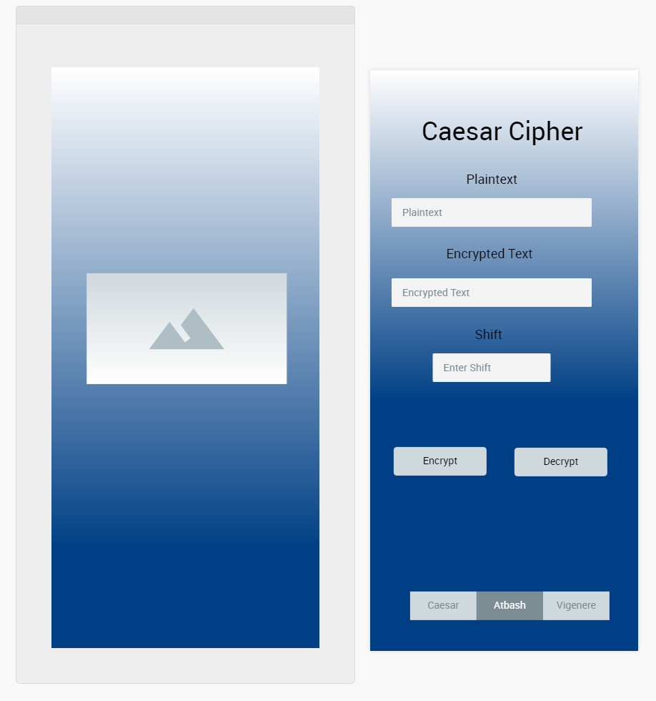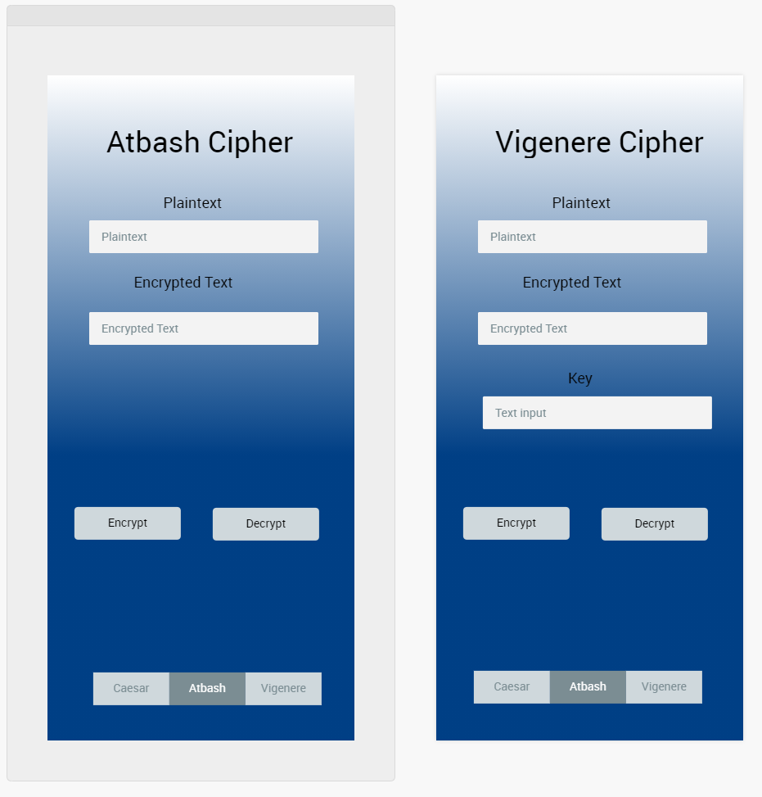

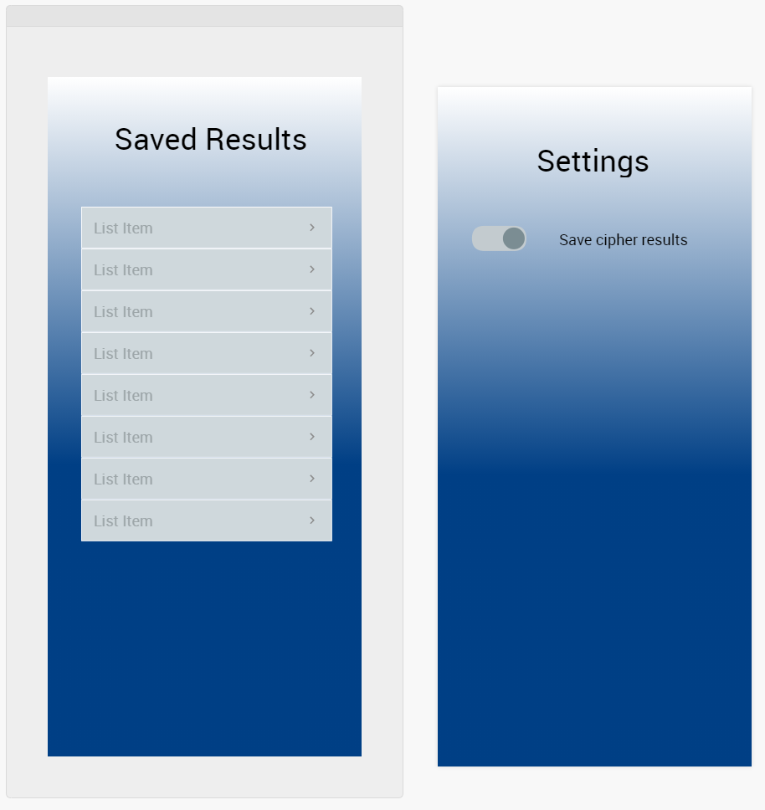

5. Logo



6. App Category - Utilities

7. Keywords – cipher,encrypt,decrypt,encode,decode,cryptogram,solver,secret message,text encrypt,text decrypt