Real-Time Voxelization for complex polygonal models
Team 21
Lakshay Bansal

Deliverables:

In the mid project as stated in the previous report I was to deliver the rasterization and texelization part of the algorithm.

STAGE 1
RATERIZATION

In the first stage I filtered all the triangles into separate buckets according to their major principal axis. In the paper they suggested to reduce the number of iteration we could perform the sorting by CPU itself.

Challenge1

So, I first uploaded all the vertices from the obj file, then filtered these triangles (3 concurrent verticies) on the basis of axis along which they project maximum area.

BucketX -> For all the verticies having major axis a X
BucketY -> For all the verticies having major axis a Y
BucketZ -> For all the verticies having major axis a Z

then I transfered them to their GL_float buffers using appropriate measures.

After the filtering stage I needed a way ro store the result of my computaion of shaders in texture

For that I made a function by the name of Rasterize which takes in few paramemetes some of them being direction, the vertex vao and vertex attrib.

Then For each axis I determined number of slices I would need which were
Voxel_dim_axis / # voxels_perslice

Then I did an orthographic projection of the model with varying far and near place depending upon the slice orienaion and position.

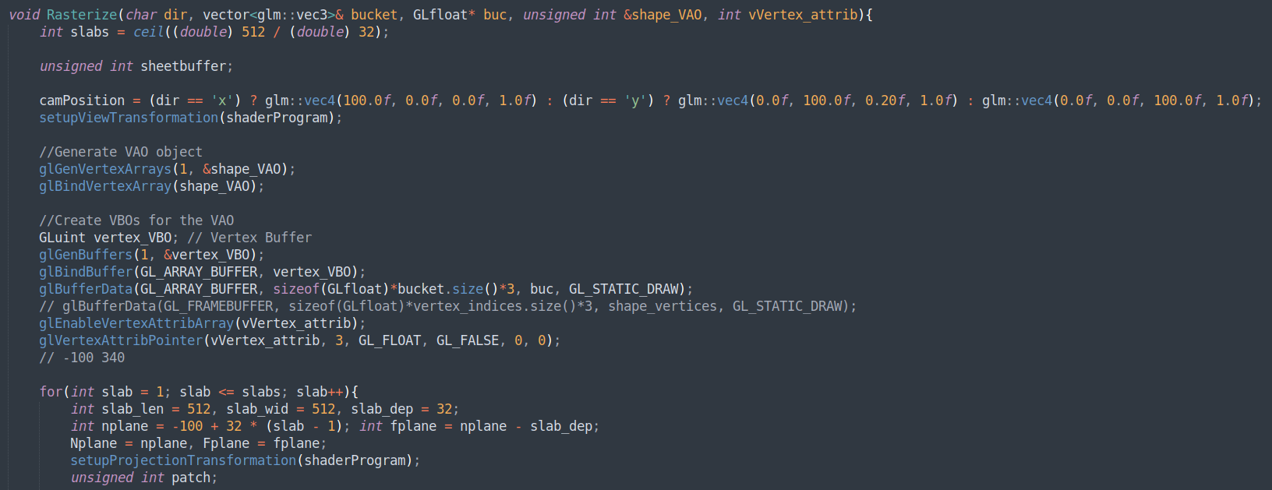
Fig1 : Rasterize fuction (calculating number of slices and setting up parameters for each slice)
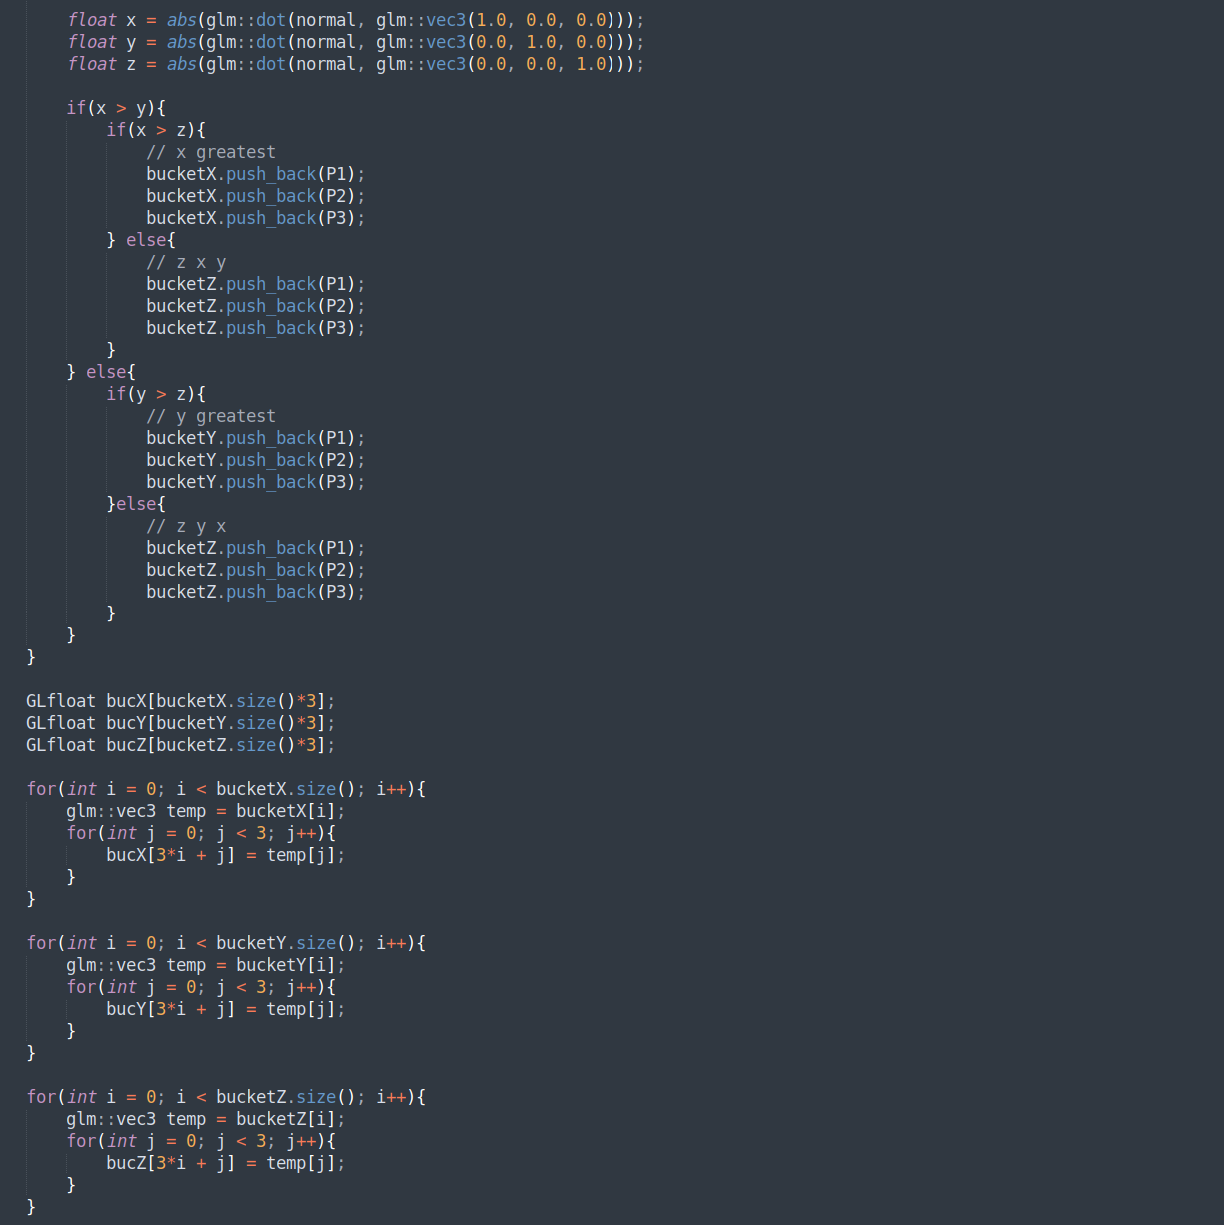
Fig2: Filtering triangles on the basis of direction of maximum projection

Challenge 2:

Now I needed a way to store all computaion results in some textures instead of default frame buffer.

I loaded ‘stb’ to perform texture manipulations and all the results were casted to textures and stored in ./texture/ where named np here n represent slice number along direction p.

I defined textures to have a rgba formato for future texelization procedure. Each texture have a dimension of 512 * 512 therby incorporating each voxel occupancy.
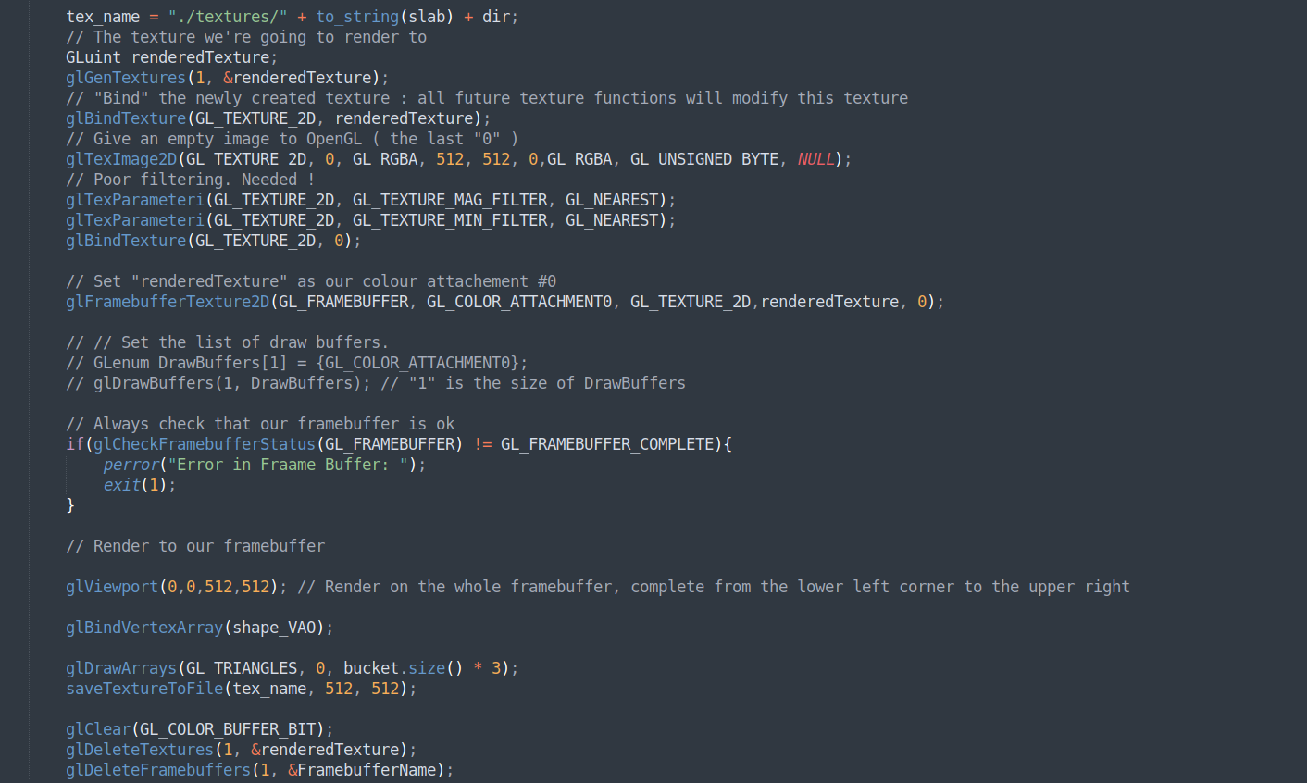
STAGE2
TEXELIZATION:

Texeliztion stage included processing all the preprocessed triangles. For each triangle bound to be rasterized along a directon. First its AABB is computed and then all the voxels which intersect this AABB are tested for triangle voxel intersection.

Vertex Shader:

Vetex shader does not do anythin special it just passes the values to geometry shader for further computaions.

Geomerty Shader:

Next big challenge was of determing who geometry shader worked. After going through several tutorails I determined that taking in triangle (3 verticies / primitive) and outputting a triangle_strip of 4 verticeis denoting AABBs of the triangle would be enough for my implementation:

layout (triangles) in;
layout (triangle_strip, max_vertices = 4) out;

In the geometry shader for exact voxelization triangle verticies are transformed using MVP (orthgraphic projection) and the AABB is calculated by displacing each vertex half a pixel away in x and y direction and voxel dimension displacement in z direction.

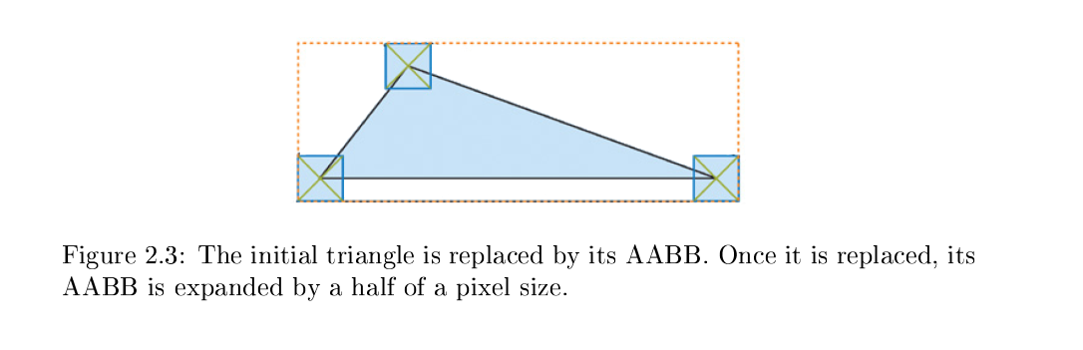

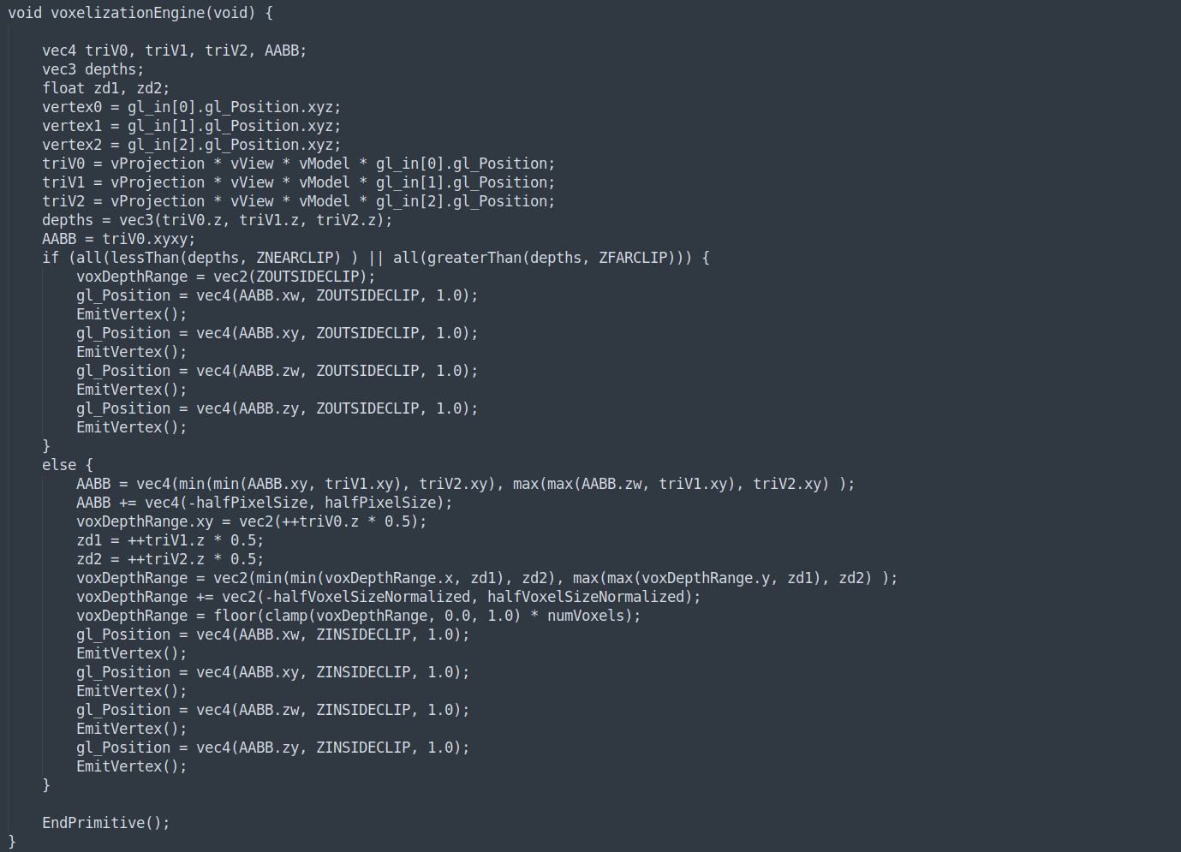
The exact implementation was taken from paper im attaching hereby

Then these newly computed AABB were passed to Fragment shader.

Challenge 3

The fragment shader part needed to find all the voxels which intersected with the AABBs.

The triangle_box_overlap and plane_box_overalp are the most frequently used algortihms for detecting collision which is based on the following theorem:

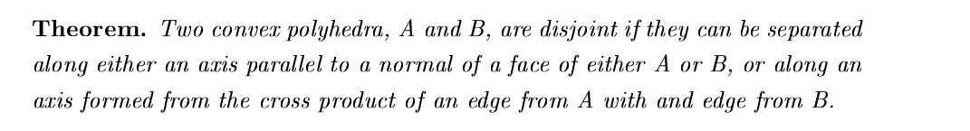
In my code triBoxOverlap function with the help of planeBoxOverlap determine the interesting voxels. All the computed results are then passed to out buffer which was intentionally set to texture in previous stage.

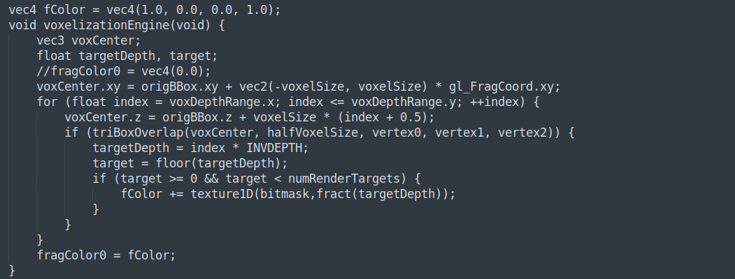
During the entire process a 1D frame buffer was also binded to use it as a bitmask for representing voxels and as a lookup buffer. Althugh results of whom are to be verfied in Endterm submissions.

Future Work

In future I will be updating my 1d buffer to incorprate depth data in various buffers. Also the most amazing part of synthesing results from this immediate buffers need to be accumulated.

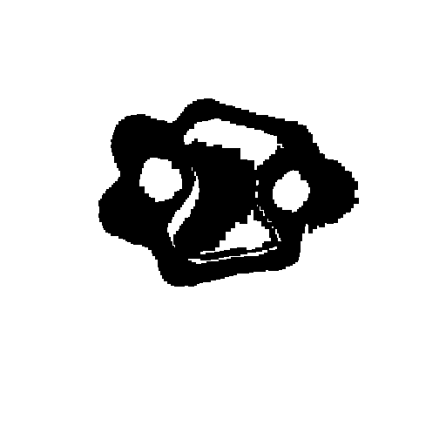
A Z slice of our 3d model

Deliverables:

Voxelized Model genrated from textures genrated in mid submission

STAGE3
Voxelization

In the final stage I made use of all the previously computed textured along different axis to get final voxelized model.

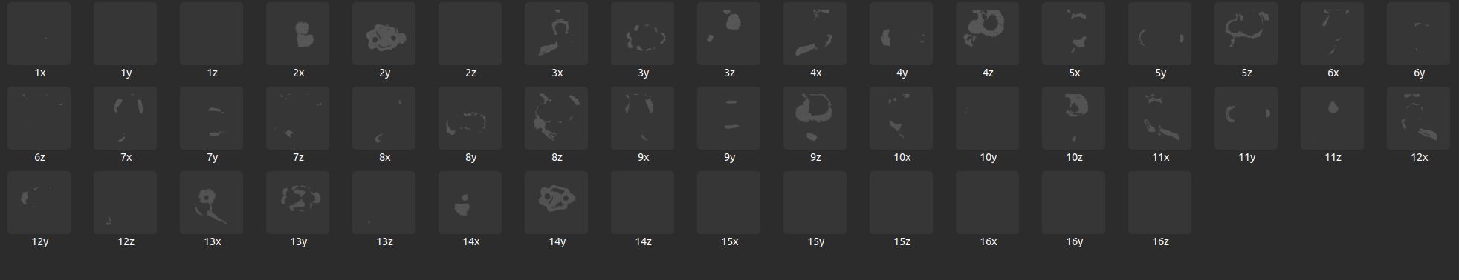

Challenge1

Read the textures
I first needed a way to read all the textures I stored previously for which i used stb library again with inverted flag set to true since all the textures were stored flipped.

Then I got value of a texel at correponding position by use of bit shift operator (<<) if the value was 1 this meant voxel was occupied.

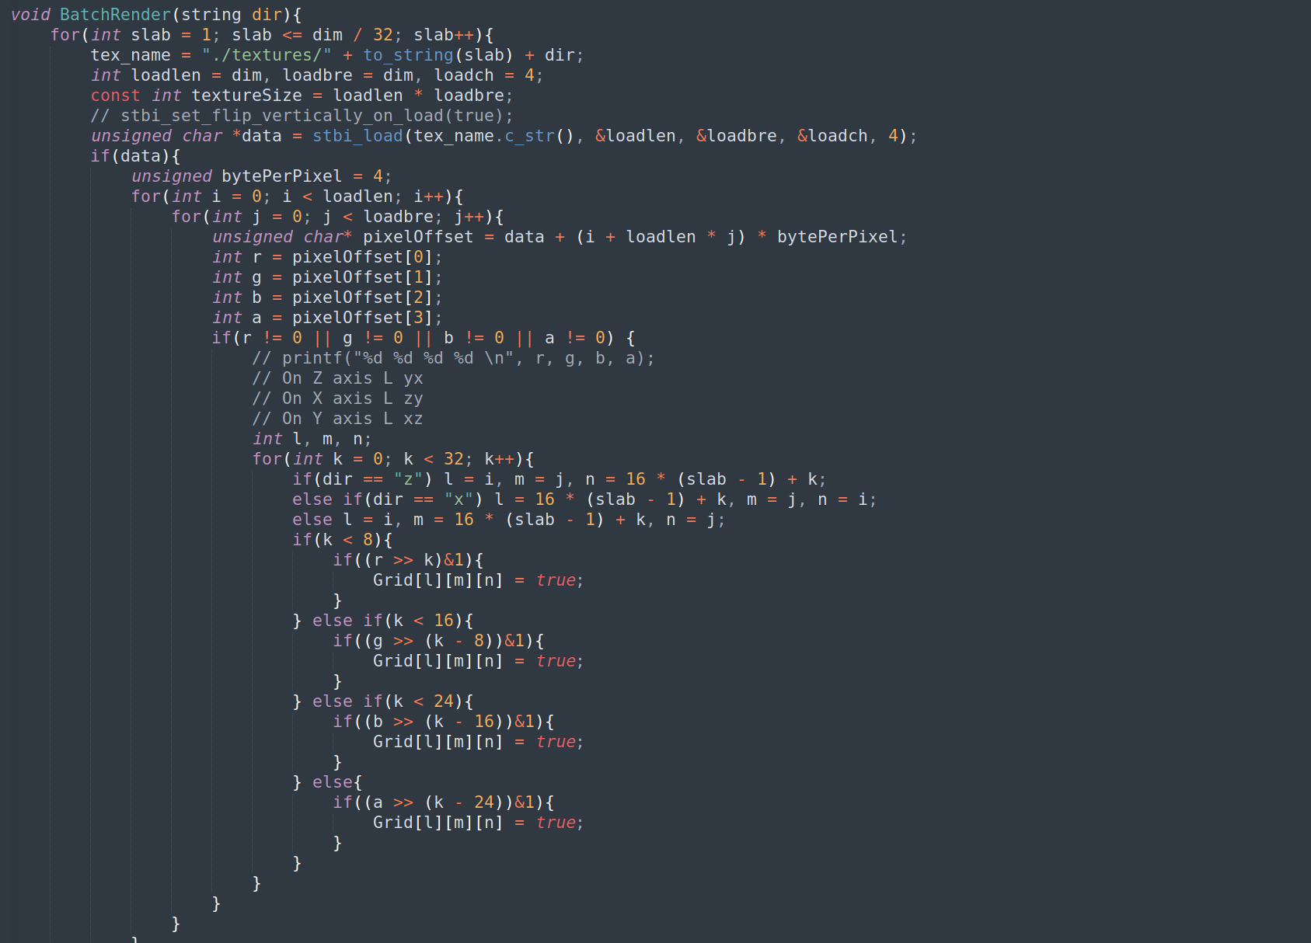

Challenge2

Make Voxels
Now I had to decide how shall I represent Voxels after careful thought I concluded a 3D vector would be suffice. So I declared the vector named Grid and set it to false initiallly.

Challenge3

Interpret Textures

Since the textures are all along different axis next step was to make sure that I read correct texel and map them correctly to voxels in Grid. I think it took me most of the time as i was not able to come up with correct soultion till end.

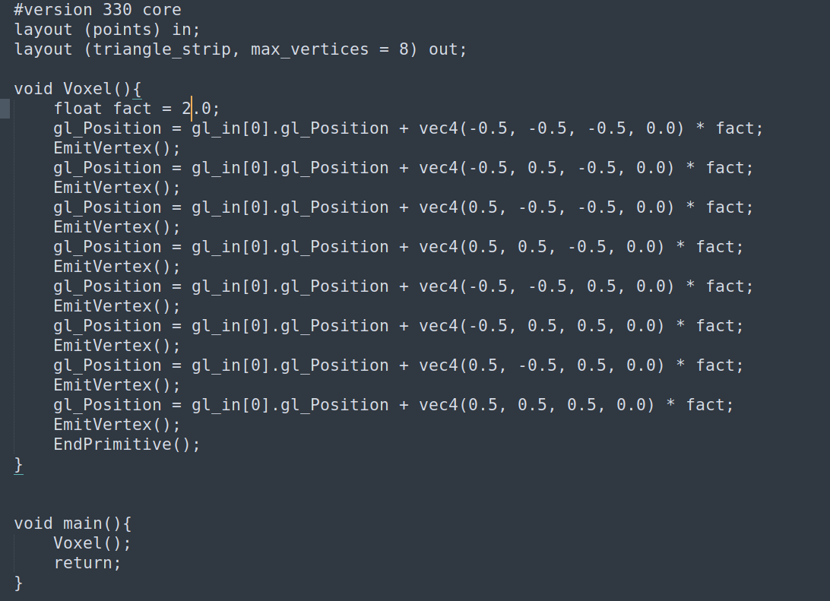

Finally after setting up the buffer I rendered it using points and expanded it into 3 dimension in geometryshader with voxel size represented as fact.

Later on I added some finish up code for different modes namely render passes along different axes.

Final Results

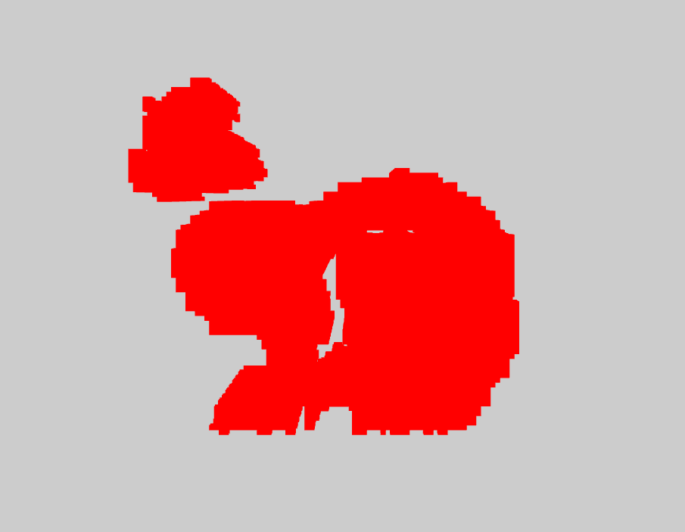

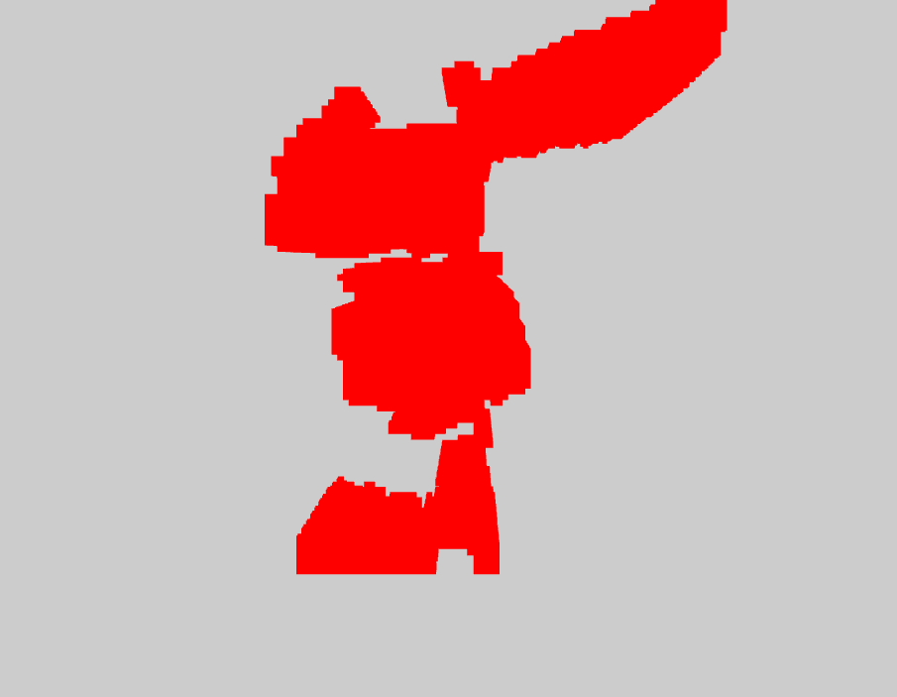

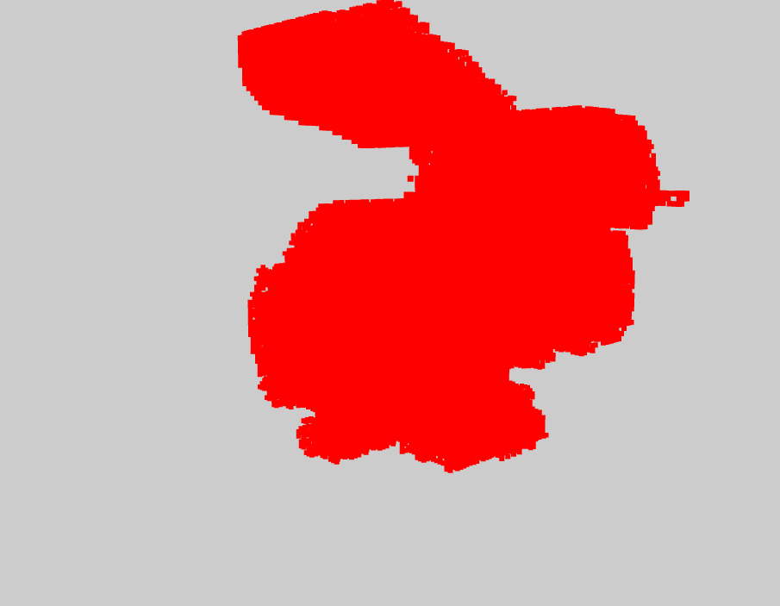
I did not implement any kind of shading for the model as it was not mentioned in the paper also I ditched the plan of conservative restiriztation because I realized the paper did not state of conservative resterization also.

Note: As i didnot implement conservative resterization some voxels are wrongly occupied which is a common problem and expected as stated in Nvidia paper here. https://developer.nvidia.com/content/basics-gpu-voxelization
