Report

Approach:

I used Kaggle for this assignment

For this assignment we were asked to finetune gpt2 model on Amazon Fine Food review dataset.
The Csv file had two columns of our interest:
1) Text: This column has the review written by the consumer
2) Summary: This had summary of the Text

Q1) For this part I imported the Review.csv file and gpt2 model from Hugging Face and cleaned the Text and summary using re, nltk and beautiful soap libraries. I also appended ‘\nTL;DR:\n’ at hte end of each text to instruct gpt2 model to genereate summaries.
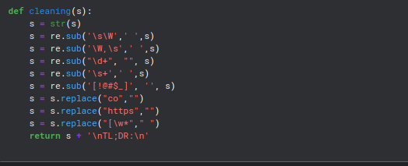
Q2) I imported gpt2 and reviews.csv from Hugging face and finetuned the model because the dataset was very large I finetuned the model on a subset of 30000 entries instead of entire corpus. I experimented with different parameters and came to conclusion that these were the best.
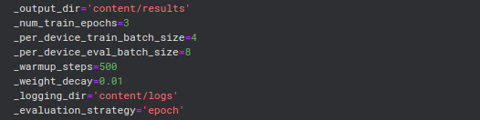

Results:

Here are the results for few on few of the test dataset enteries.

Methodology: I followed the link provided in the document to get better insigts of how finetuning works.
Assumption: Here I assumed that gpt2 model was able to give somewhat relevant summaries of text on which i further performed finetuning.
Challenges: It was my first finetuning model expeirence I initally trained a model for 8 hrs using wrong parameters later when i realise i reduced by dataset and generted all results on a much smaller dataset to know if everything was working fine then ony I increased the databse which finally resulted in good results.

