Report

Approach:

I used Kaggle for this assignment

For this assignment we were asked to manipulate amazon review dataset to extract relevant information.
We had two files:
1) Metadata: Had metadata of the products
2) 5-core: reviews file which had reviews of user stored of different products

Q1) For this part I read the dataframe of 5-core in one go but because the dataset of metadata was to large I had to read it in chunks. For which I constructed multiple dataframes each having around 100000 enteries and then i concatenated them and saved them on the disc to free up memory.
I imported the dataframes in the Kaggle by creating a new dataset and attaching it to the notebook.

Q2) I had user put in input of the product. (For the report I will be using headphones as the input)
Q3) For computing number of rows I searched the ‘title’ column of the metadata for headphone and fetched all the asin value corresponding to that particular entry (with no case matching and dropping duplicate entries). Then I searched in my review dataset for all the precomputed asin values (and filtered results on the basis of 4 parameter which are asin, reviewerID, unixtime and reviewtime the reason being it is quiet possible that a user may have multiple reviews to same product on different times).
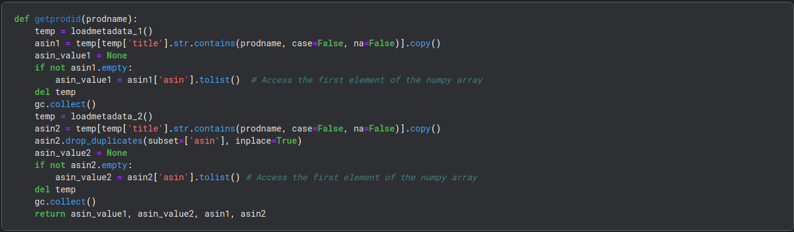

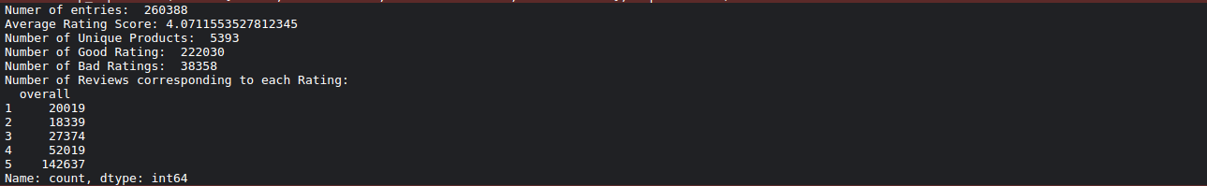
Q4) For this part I made a new dataset by the name of revs on which I performed various operation like computing mean. Fetching enteries satisfying a certain property and count of review corresponding to each rating value.

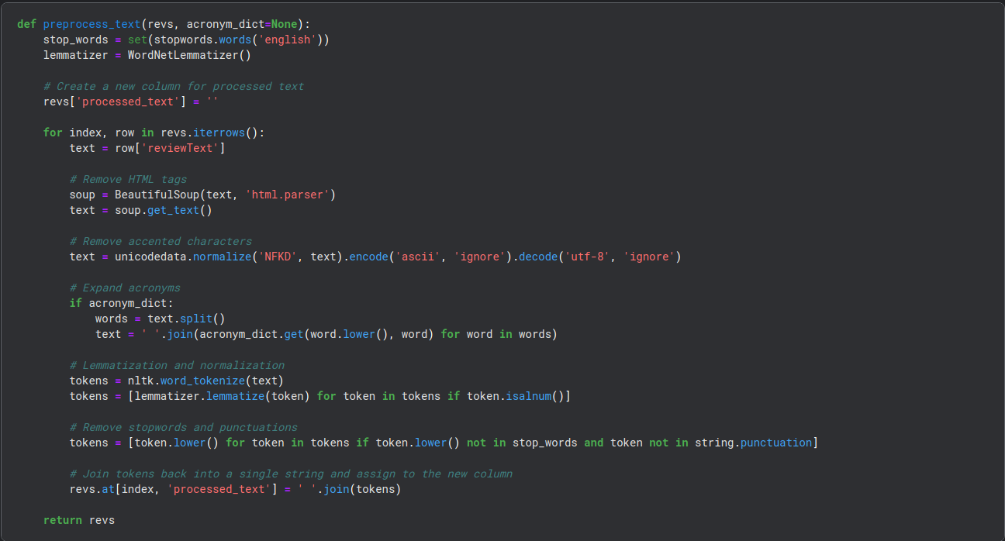
Q5) Step 5 asked us to preprocess the text I used BeautifulSoap library to remove html tags and tokenization and lemmitization was done with the help of assignment2 code. The results were returned as space separated words instead of list for the purpose of tfidftokenizer in later parts.
Q6) In this part we were asked to extract relevant statistics, related to the products fetched in the previous parts
For extracting top 20 companies with most reviews I counted number of reviews of each of them and similar task was done to extract bottom 20.
For finding most positively reviewed headphone I did a scoring scheme where I increased the count by 1 (in case the rating was good/average) and decreased by 1 (in case it was bad) then i extracted the one with most positive score.

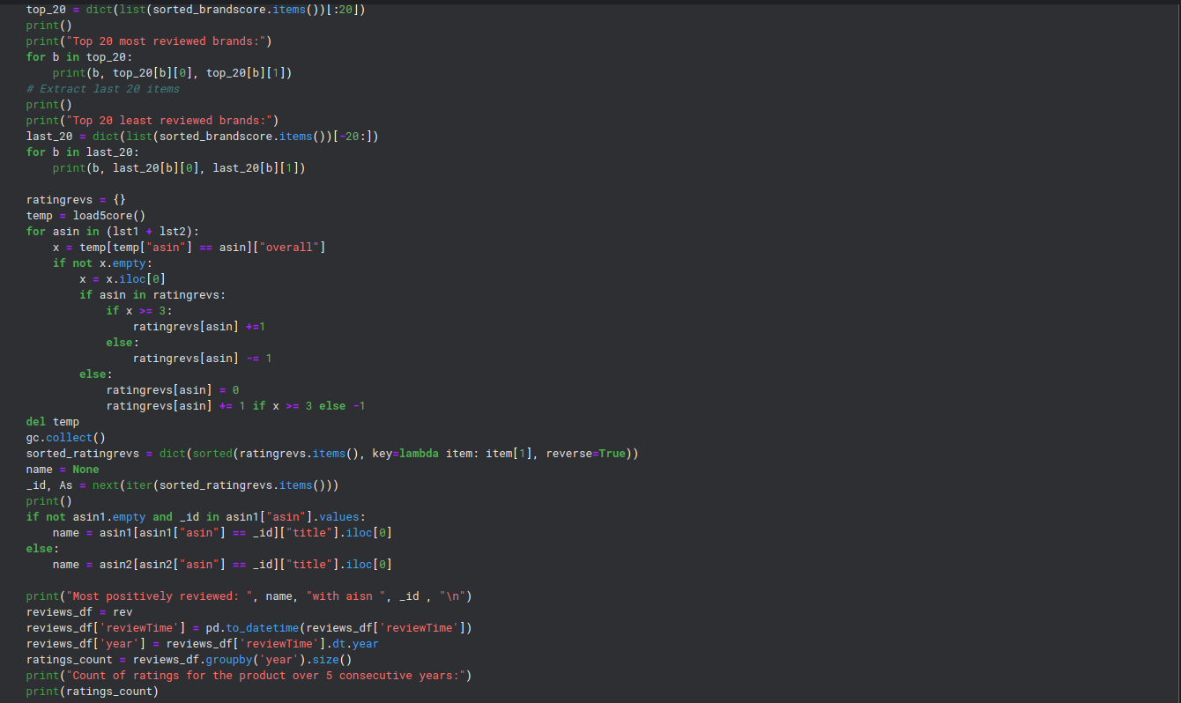
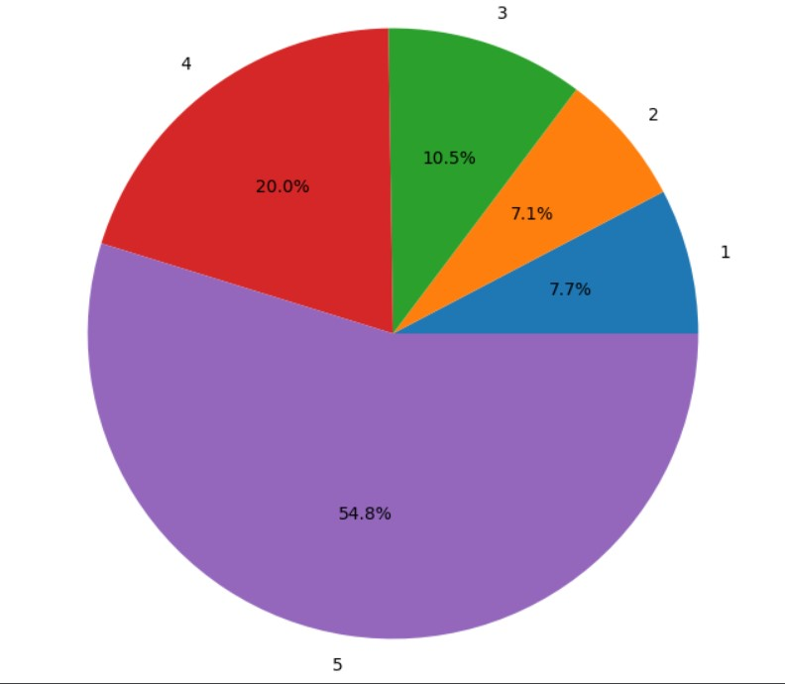
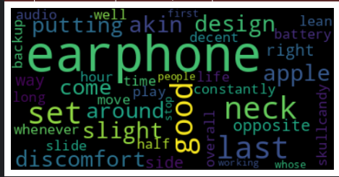
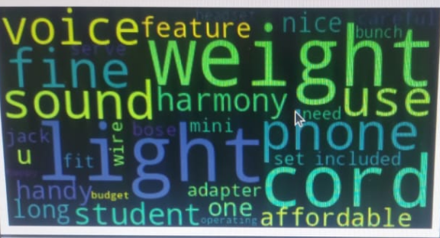

Q7) For this part I used TF-IDF, as I am well versed with this. I preprocessed the text and computed tf-idf of the review text which was used in later parts.

Q10) I took the reviews data and partitioned the data into 75:25 and passed it to 5 ML models. The 5 models that I used are:
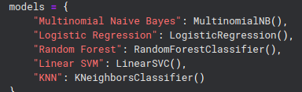

whose results are below:

Q11) For the Collaborative Filtering:
First I created a new dataset with Reviewer ID as the 1st column and Asin of different products as subsequent colums. Then I added normalized values of rating to each of the column a user had rated for using max – min statistic (In case a user has only voted for 1 item the value was changed to 0.5) Now for different values of N which are [10, 20, 30, 40, 50] I computed nearest N user using cosine similarity.

