AI-Powered Conference Recommendation System

**Abstract--The dissemination of research findings through conference presentations is a cornerstone of academic progress. However, the traditional process of identifying suitable conferences is often a laborious and inefficient undertaking. Researchers must sift through numerous calls for papers (CFPs), each with its own specific deadlines, subject matter focus, and level of prestige. This manual search process can consume valuable time and effort that could be better spent on research itself. This paper proposes an AI-Powered Conference Recommender, a system designed to alleviate this burden by leveraging the power of Natural Language Processing (NLP), web scraping, and machine learning. This system aims to provide researchers with personalized conference recommendations based on their specific research interests, thereby streamlining the conference selection process and maximizing the impact of their work. By intelligently analyzing research topics and matching them with relevant conferences, the system empowers researchers to make informed decisions about where to submit their valuable work, ultimately contributing to the advancement of knowledge across disciplines.**

**INTRODUCTION**

The academic landscape thrives on the continuous exchange of ideas and research findings. Conferences serve as vital hubs for this exchange, providing researchers with invaluable opportunities to present their work, receive feedback from peers, network with experts in their field, and stay abreast of thelatest advancements in their respective disciplines. Participating in conferences is not merely about disseminating research; it is also about engaging in a dynamic dialogue that fosters collaboration, sparks new research directions, and accelerates the pace of innovation.

However, the sheer volume of conferences held globally presents a significant challenge for researchers. Navigating this vast landscape to identify the most appropriate venues for their work can be a daunting task. Researchers must consider a multitude of factors, including:

Relevance: Does the conference's focus align with the specific subject matter of their research?

Reputation: Is the conference known for its rigorous review process and high-quality publications?

Deadlines: Does the conference's submission timeline align with the researcher's current project schedule?

Location: Is the conference location feasible in terms of travel and logistical arrangements?

Costs: Are the conference registration fees and associated travel expenses within the researcher's budget?

Traditionally, researchers have relied on a combination of manual searches, keyword alerts, and personal networks to identify potential conferences. This approach is often time-consuming, prone to oversights, and can lead to researchers missing out on potentially valuable opportunities. The rise of online conference listing platforms like WikiCFP has somewhat simplified this process, but these platforms typically offer basic search and filtering functionalities, lacking the intelligence needed to provide truly personalized recommendations.

The advent of Artificial Intelligence (AI) and, in particular, Natural Language Processing (NLP), offers a promising solution to this challenge. AI-powered systems can be designed to automate the conference discovery process, intelligently matching research topics with relevant conferences based on a variety of criteria. Such systems can significantly reduce the time and effort researchers spend searching for conferences, allowing them to focus on what matters most: conducting impactful research.

**RELATED WORKS**

The concept of automated recommendation systems has been explored in various domains, including e-commerce, entertainment, and information retrieval. However, the application of AI to the specific problem of conference recommendation is a relatively nascent field. While some existing tools and platforms offer limited functionalities in this area, a truly intelligent and comprehensive solution remains an open area of research.

**WikiCFP and Conference Portals:** Platforms like WikiCFP serve as valuable repositories of conference information, providing structured lists of upcoming events. However, these platforms primarily rely on keyword-based searches and lack the ability to perform semantic analysis of research topics. As a result, researchers must still manually review numerous conference descriptions to determine their relevance.

**Google Scholar and ORCID**: Google Scholar and ORCID are essential tools for researchers to track their publications and maintain their academic profiles. While these platforms provide information about where researchers have published in the past, they do not proactively suggest relevant conferences for future submissions.

**Machine Learning for Recommendations**: Machine learning techniques, such as collaborative filtering and content-based recommendation, have been applied to various recommendation tasks, including journal recommendations. However, the application of these techniques to conference recommendations presents unique challenges due to the diverse nature of conferences and the limited availability of structured data.

**NLP for Research Topic Matching**: NLP techniques, such as TF-IDF and word embeddings, have been used to analyze research papers and identify semantically similar documents. More recently, transformer-based models like BERT have demonstrated remarkable performance in capturing the nuances of human language. These NLP techniques can be leveraged to analyze research abstracts and match them with the topics covered by different conferences.

This work aims to build upon these existing efforts by developing a more sophisticated and comprehensive AI-powered conference recommender. The proposed system will integrate NLP-based topic matching, advanced ranking algorithms, and real-time data retrieval to provide researchers with personalized conference recommendations that are both relevant and timely.

**PROPOSED METHODOLOGY**

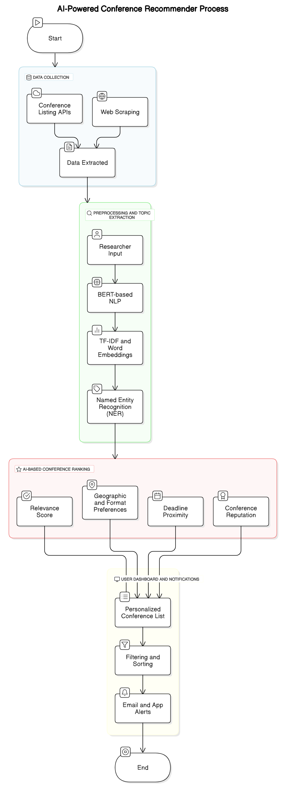

The AI-Powered Conference Recommender employs a multi-stage process to identify and recommend relevant conferences to researchers:1.

**(1)Data Collection**: The system gathers data from a variety of sources, including:

**Conference Listing APIs**: APIs provided by academic publishers like IEEE, Springer, and ACM are used to retrieve conference details.

**Web Scraping:** Web scraping techniques are employed to extract data from conference websites and platforms like WikiCFP when APIs are not available. Tools like BeautifulSoup and Selenium can be used for this purpose.

**Data Extracted:** The system extracts a range of information about each conference, including its name, acronym, dates, location, field of study, submission deadlines, past keynote speakers, and any available metrics related to impact or reputation.2.

**(2)Preprocessing and Topic Extraction:**Researchers input their research paper abstract or a set of keywords describing their research topic. The system then employs NLP techniques to analyze this input and extract key concepts and themes.

**BERT-based NLP**: BERT, or other similar transformer models, are used to generate contextualized word embeddings for the research input. These embeddings capture the semantic meaning of the text and allow for accurate comparison with conference topic descriptions.

**TF-IDF and Word Embeddings**: TF-IDF can be used to identify the most important terms in the research input, while word embeddings can capture semantic relationships between these terms.

**Named Entity Recognition (NER**): NER techniques are used to identify key phrases, research areas, and other relevant entities within the research abstract.3.

**(3)AI-Based Conference Ranking**: The system ranks conferences based on a combination of factors, including:

**Relevance Score**: A relevance score is calculated based on the semantic similarity between the researcher's topic and the conference'sscope. This score is typically determined using cosine similarity between the vector representations generated by BERT or other NLP models.

**Conference Reputation**: The system incorporates measures of conference reputation, such as the acceptance rate, the quality of past publications, or citations received by papers published at the conference. This information may be gathered from external databases or through web scraping.

**Deadline Proximity:** Conferences with upcoming deadlines are given higher priority to ensure that researchers have sufficient time to prepare their submissions.

**Geographic and Format Preferences**: Researchers can specify their preferences for conference location (e.g., specific countries or regions) and format (e.g., in-person, virtual, or hybrid). The system takes these preferences into account when ranking conferences.4.

**(4)User Dashboard and Notifications**: The system provides a user-friendly dashboard where researchers can view personalized conference recommendations.

**Personalized Conference List:** The recommended conferences are presented in a ranked list, with the most relevant conferences appearing at the top.

**Filtering and Sorting**: Researchers can filter and sort the recommendations based on various criteria, such as relevance, deadline, location, and conference reputation.

**Email and App Alerts:** The system can send email or app notifications to alert researchers about upcoming conference deadlines or new conferences that match their research interests.

**RESULTS AND DISCUSSION**

The development of an AI-powered conference recommender represents a significant step towards streamlining the research workflow and empowering researchers to make more informed decisions about conference submissions. While the described methodology provides a solid foundation for such a system, several avenues for future research and development remain:

**Integration with Existing Research Platforms**: Integrating the recommender with platforms like Google Scholar and ORCID would allow for automatic retrieval of research profiles and publication history, further personalizing the recommendations.

**Expanding to Journal Recommendations**: The principles underlying the conference recommender can be extended to develop a similar system for journal recommendations, providing researchers with a comprehensive solution for disseminating their research.

**User Feedback Loop**: Incorporating a user feedback mechanism would allow the system to learn from user interactions and continuously improve the accuracy of its recommendations. Researchers could provide explicit feedback on the relevance of recommended conferences, which could then be used to refine the ranking algorithms.

**Reinforcement Learning:** Reinforcement learning techniques could be employed to train the conference ranking model, allowing it to adapt to evolving research trends and user preferences.

**Handling Conference Quality and Reputation**: Developing robust methods for assessing conference quality and reputation is crucial. This could involve analyzing citation data, reviewing past program committees, or incorporating feedback from the research community.

**Addressing Bias in Conference Selection**: It is important to be mindful of potential biases in conference selection, such as geographic bias or bias towards certain research areas. The system should be designed to mitigate these biases and ensure that all researchers have equal access to relevant conference opportunities.

The future of AI in academia is bright, and systems like the AI-Powered Conference Recommender represent a crucial step towards a more efficient and equitable research ecosystem. By automating tedious tasks and providing intelligent assistance, AI can free up researchers' time and energy, allowing them to focus on pushing the boundaries of knowledge and making meaningful contributions to their fields. This, in turn, accelerates the pace of scientific discovery and fosters a more collaborative and interconnected research community.