
PUCIT
Punjab University College of Information Technology

Lahore Tour Guide

Table of Contents

Final Project Proposal Guide 3
1. Introduction 3
1.1 Project Title 3
1.2 Project Overview Statement 3
1.4 Project Goals & Objectives 4
1.5 High-level system components 5
1.6 List of optional functional units 5
1.7 Exclusions 5
1.8 Application Architecture 6
1.9 Gantt chart 6
1.10 Hardware and Software Specification 7
1.11 Tools and technologies used with reasoning 7

Final Project Proposal Guide

1. Introduction
Nowadays, 87% travelers and tourists use navigation apps and smartphones while traveling to new places. Cities across the globe are looking for new ways to offer useful information to tourists and people unfamiliar with the city for a pleasant and guided stay. Many cities have come up with their own apps for the guidance of such people. We aim to develop and design a similar app that will not only give travelers and tourists easy access to the Lahore city’s points of interest. But, also allow them to find and book the best place for their stay in the city.

1.1 Project Title
Lahore Tour Guide

1.2 Project Overview Statement
Our aim is to create a user-friendly application for guiding the tourists and paying guests to learn best about the Lahore city. Our application will define, describe and direct the users to specific locations. For this purpose, we are going to integrate google maps in our application. Moreover, our system will allow the renters to quickly contact hotels and landlords. The renters can select a certain area and see the list of rooms and hotels available, public reviews and feedbacks and then book a room easily via online payment or on-site payment. By default, the app will locate the current location of the user and show the nearby areas and points of interest. These locations will be divided in several categories to help user make custom search easier. The users can change the location and find the areas and places anywhere in the city. On the other hand, landlords and hotels can have their profiles and post advertisements for the availability of the rooms and apartments. The renters can either book rooms in hotels or can find a room to stay as paying guest.

Project Overview Statement Template
Project Title: Lahore Tour Guide
Group Leader: Bilal Mubarak
Project Members:
Name | Registration # | Email Address | Signature
Maham Mubashir | BSEF17M008 | bsef17m008@pucit.edu.pk
Anzala Mohsin | BSEF17M018 | bsef17m018@pucit.edu.pk
Mubarra Naz | BSEF17M031 | bsef17m031@pucit.edu.pk
Bilal Mubarak | BSEF17M056 | bsef17m056@pucit.edu.pk

Project Goal:
Develop a platform to guide tourists and travelers about every point of interest in the Lahore City and ease their stay in the city.

Objectives:
Sr.#
1 | Understanding the Idea; Researching the work done on the idea and understanding scope and all aspects of the idea.
2 | Understanding the Technology; Learning and understanding the required languages, frameworks, tools and technologies.
3 | Building the skeletal structure; understanding and building the detailed application architecture and workflow of the system.
4 | Design Selection; Interactive UI design creation and selection based upon the built structure of the app.
5 | Location Guide; integrating google maps for location defining and guidance, distributing locations in different categories.
6 | Stay guide; helping travelers and paying guests to find a place to stay in a certain area in a certain budget, in hotels as well as rental apartments.
7 | Increase revenue of hotels and landlords; Allowing different hotels and landlords to application increasing their demand audience. A step toward automating room allotments.
8 | Feedback and review; Allowing users to give feedback and reviews on locations, hotels and apartments.
9 | Quality assurance; testing the activities for proper functioning of the system
10 | Launch and maintenance; launching app and maintaining the working of the system

Project Success criteria:
A running application guiding users to move correctly, saving time, physical hard work and resources of users to find rooms. To provide an online website and an open source application for smartphones that can be freely installed and used.

Assumptions, Risks and Obstacles:
- Runtime requirements
- Lack of Resources
- Lack of time

Organization Address (if any):

Type of project: Research Development
Target End users:
Demand side: General public including Tourists, Travelers and Paying Guests
Supply Side: Hotel owners and landlords who want to rent their rooms and apartments.

Development Technology: Object Oriented Structured
Platform: Web based Distributed
Desktop based Setup Configurations
Other (android and iOS)
Suggested Project Supervisor: Ma’am Madiha Khalid
Approved By:
Date:

1.4 Project Goals & Objectives
- To create a network, connecting paying guests with hotels and landlords enhancing affective communication.
- To develop a website and a mobile application where users can book a room in minutes by just tapping a button.
- To provide a platform where travelers/tourists can find all nearest places, find all the possible routes to the nearest destinations and get authentic navigations.
- Real time availability and guidance of points of interest is must.
- Increase revenue for the hotels and landlords, increasing traffic to their destinations.
- Promote tourism by making tourism concise and easier to access.
- Become experts in the technologies being used in the development, design and planning of the system.

1.5 High-level system components
User management
- Registration
- Authentication
- Rights and access (general user/ hotel or landlord/ admin)
- History maintenance
City Guide
- Display points of interest (Map view and list view)
- Describe points of interest
- Categorize points of interest
- Customized search
- Location guidance
- Reviews and feedback
Stay Guide
- Hotels and landlords’ profiles
- Advertisement posting
- Customized/ filtered search
- Contact options
- Booking
- Reviews and feedback
- Complains management

1.6 List of optional functional units
- Promotion and discounts for hotels and rooms
- Direct chat with landlords
- Integrated blogs/articles/stories relevant to the places being searched
- Multiple payment options (credit card, PayPal, etc.)
- Auto suggest the highest rated options and places for both stay and visit
- Guest mode for naïve/new users

1.7 Exclusions
- Restaurant reservation feature
- Multiple tour and travel guides or agencies

1.8 Application Architecture
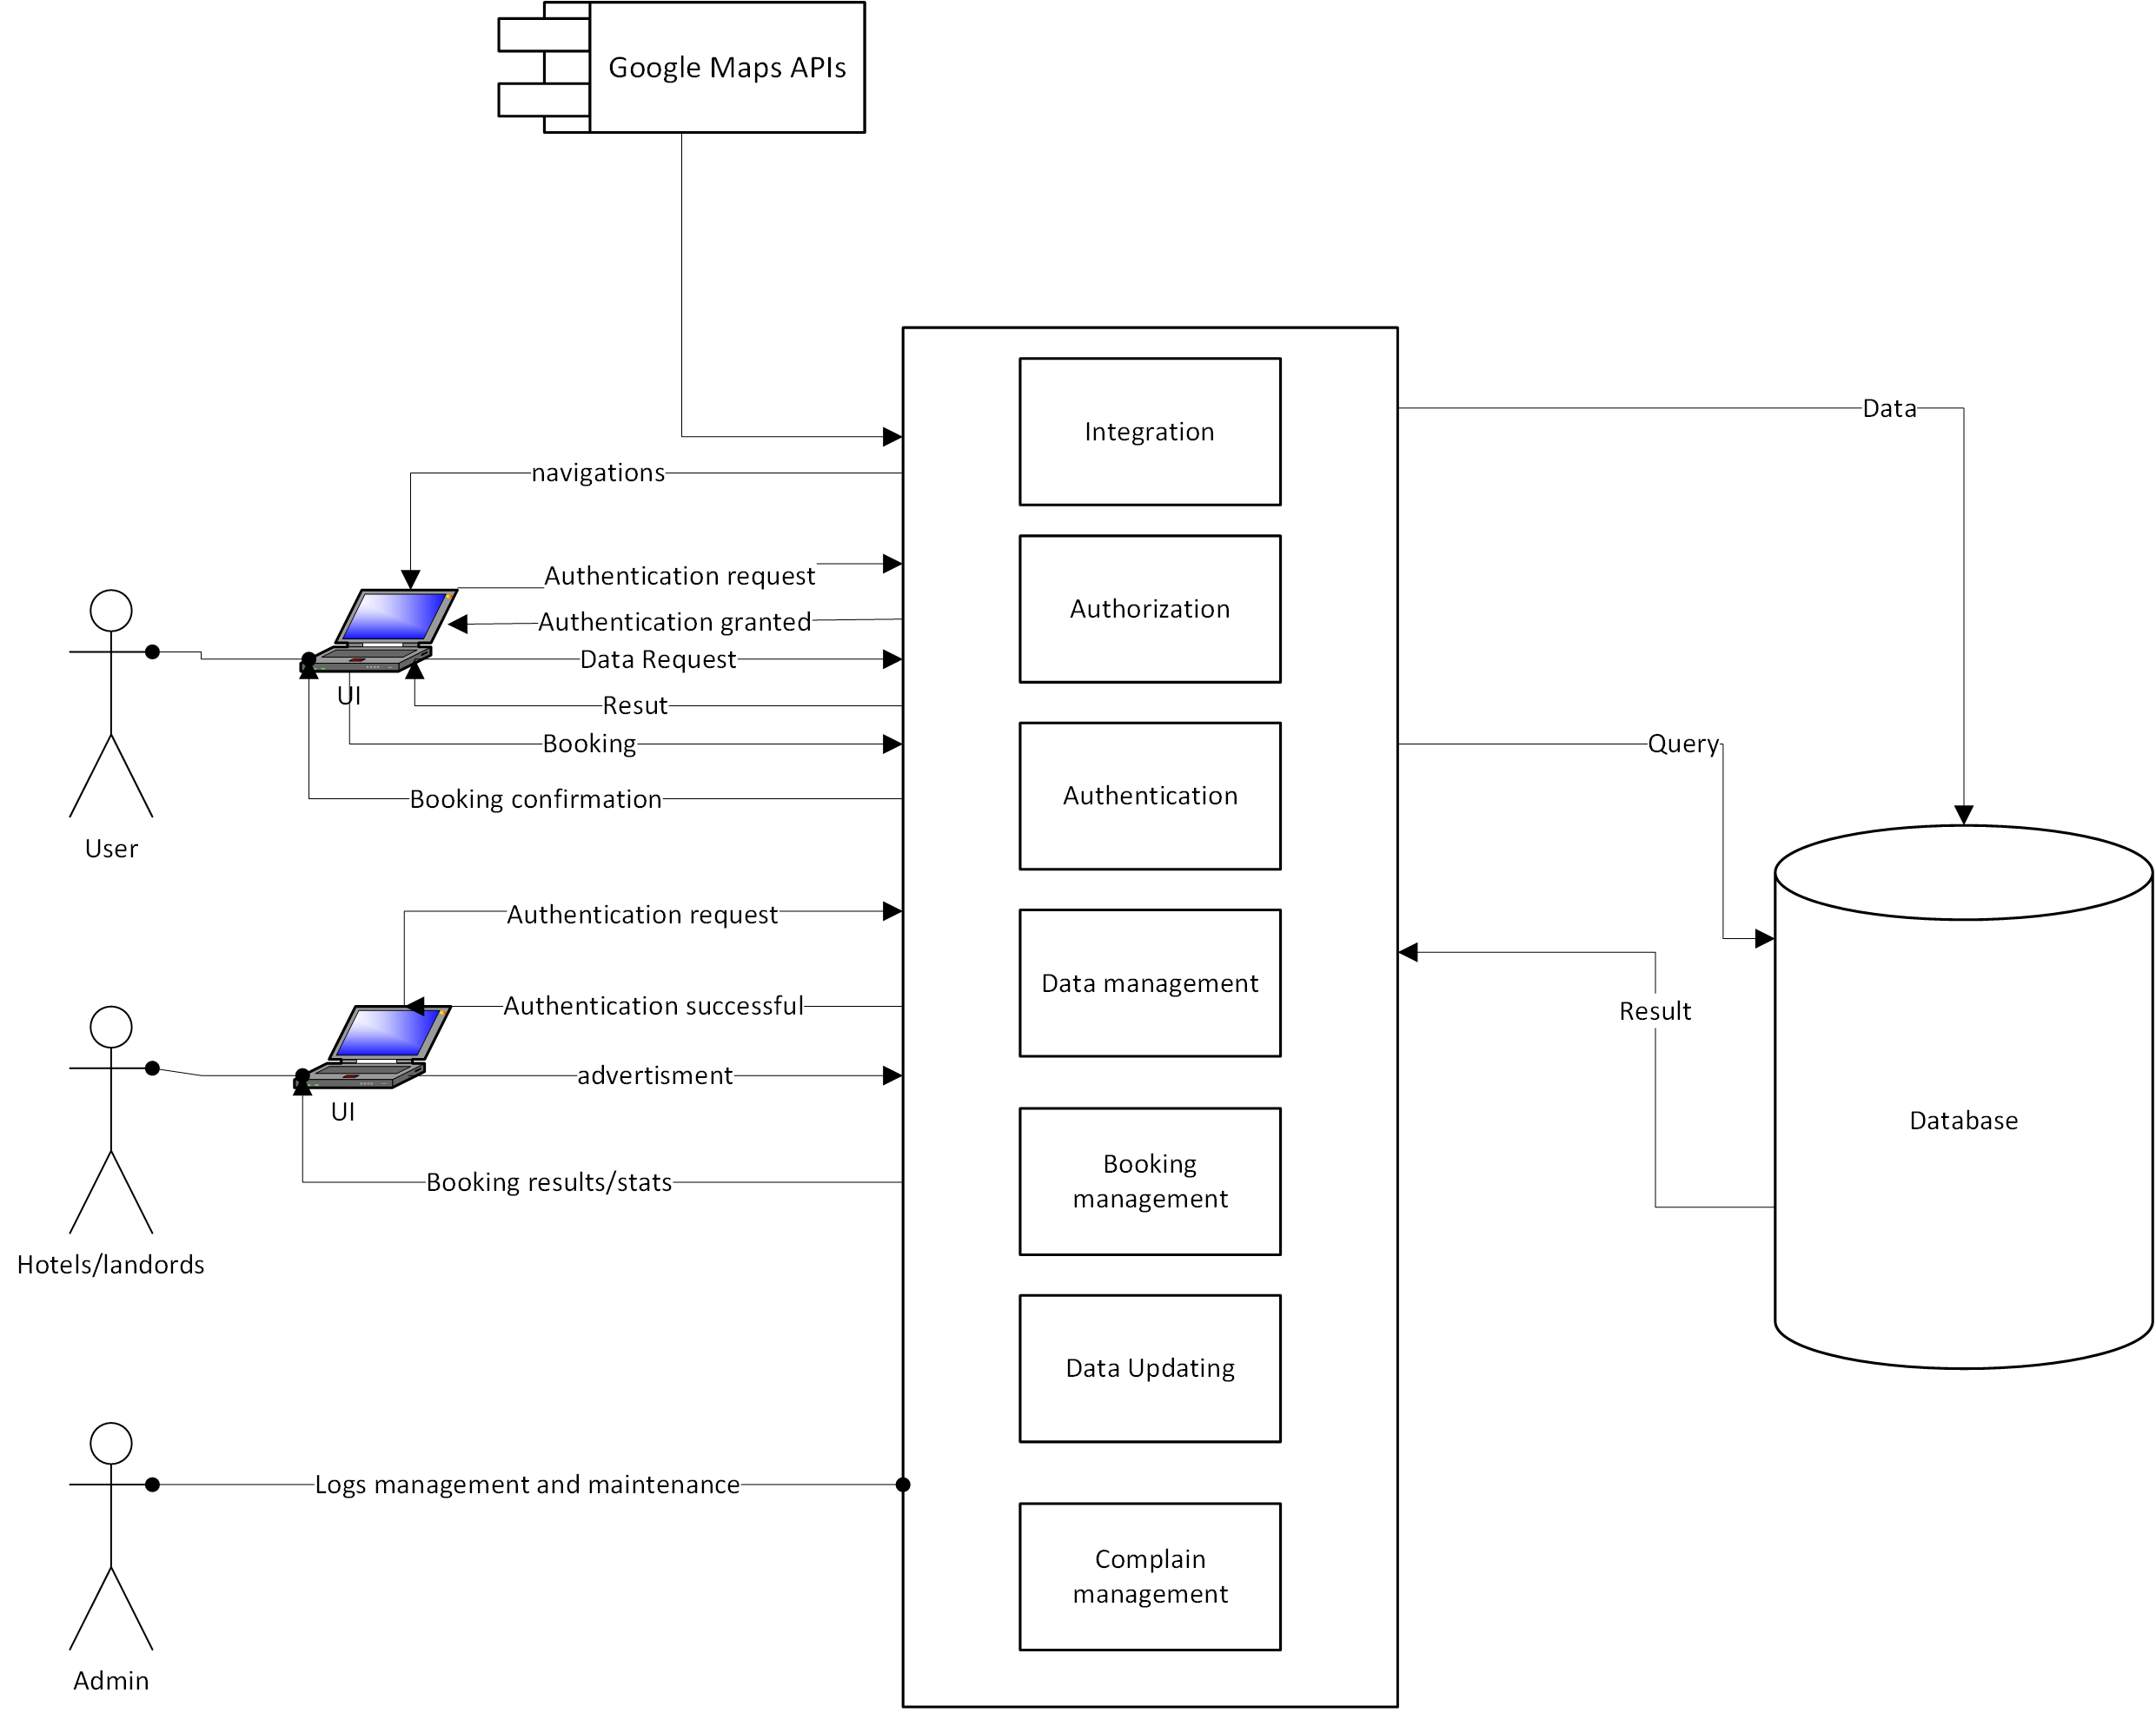

1.9 Gantt chart
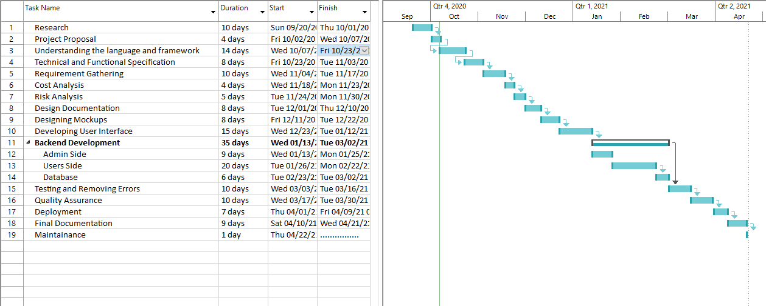

1.10 Hardware and Software Specification
RAM 4GB minimum
2GB minimum available disk Space
1280×800 minimum screen resolution
Processor 1.0 GHz or above
Internet
Microsoft Windows 8/10 (64-bit)
Browser (Google chrome V85/ IE8/ MS EdgeV44)

1.11 Tools and technologies used with reasoning
Tools and Technologies | Reasoning
MS word | For documentation. Extreme availability and easy to use.
MS Visio | For flowcharts and diagramming. It is easy to use with built-in templates.
MS Project | For Gantt Chart. It’s the best tool being used in the industry for project management plans.
React Native | For front End development. It is an open-source, cross platform framework. The core is JavaScript and is easy to learn and use.
Django REST framework | Using python as backend language for its powerful server-side development, latest technological advancement and acceptance, and simplest DB management.
SQL Lite | Database. It requires no maintenance or configuration. It is cross-platform, high on performance, reverse compatible, lightweight and portable.
Agile Development | Discovering requirements and developing solutions with collaborative effort of self-organizing, early and predictable delivery and transparency.

