FAST NATIONAL UNIVERSITY



SUBJECT: Artificial Intelligence

Project # 02

Chess using AI

Name:

🡺Talha Mustafa (18i-0573)

🡺Tayyab Ali (18i-0531)

Section: D

***Game Analysis***

**Total Number of Moves we performed:** 57

**Winner**: Black – chess.com

**Analysis:**

Our AI made a solid Queen Pawn’s opening giving us a better win percentage.

The online(expert) AI was making most of the moves at about 15-20 depth while our AI was thinking only 3 moves ahead.

Even with such depth difference our AI took the game to 57 moves and only made 1 blunder and 2 mistakes in the whole game and was almost even in pieces the whole game till the pawn promotions.

Following are a few screenshots from the chess.com game report.

**Opening: Mistakes/Blunders:**

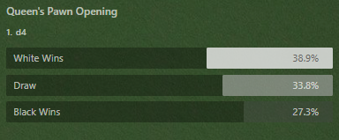

**Depth:**

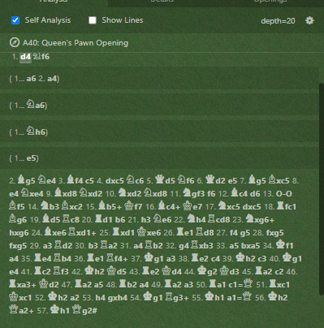

**Note: (Play the video on 2x since the AI does take some time thinking).**