FAST NATIONAL UNIVERSITY



**Software Design and Analysis**

**Final Project Report**

Name:

Tayyab Abbas (18i-0417)

Hanzala Ahmed Khan (18i-0518)

Talha Mustafa (18i-0573)

Section:

BCS – 5D

***Software Design and Analysis***

***Project***

***Vehicle Management System (VMS)***

# Introduction: -

The MIS (Management Information System) we had opted to design is Vehicle Management System, which will greatly attract the attention of variety of car companies to opt for, because of is well defined, easy to use and readily understandable features. This MIS will help automobiles company to save, maintain and update their daily, weekly, monthly and yearly tasks with great ease. The system is defined so that not only can automobile company’s employees have benefit from it, but also, it is really user friendly to their customers as well. This VMS MIS will help company to maintain and keep track of all their details and will help company in getting rid of lots and lots of documentation and paper work.

VMS MIS has three major segments defined below:

1. Presentation Layer (The UI)
2. Business Layer (All the backend work)
3. Data Layer (Database Management System for VMS)

# Project Scope: -

The system is designed for all vehicles falling under a company. We will have an interface which will provide users an ease to communication with software and help them in resolution of their different queries for example, the process of buying vehicles, test drives, sales, viewing details of different vehicles, maintaining data of employees, costumer and vehicles, and other related options. The customers will be able to access all the details about different cars in different company’s showrooms all across country. The Software will contain following information:

-Management of the Vehicles

-Vehicle Information

-Dealers Information

-Test Drive Vehicles

-Sales Data etc.

The software will have 3 different interfaces, one for Customer, one for Dealers and finally for Manager.

# Project Stakeholders: -

Our MIS Stakeholders majorly are mentioned below:

1. The manager of that Automobile Company Outlet.
2. The Employee working there, Dealers
3. The Costumer, who wants to buy vehicle form that Company.

# High Level Goal of Stakeholders: -

1. Manager can easily save, maintain and update information related to his outlet, helping him to manage the company well and for better development of company.
2. Dealers can easily interact to costumer even if costumer is not present at very moment. He can easily keep track and view detail of vehicles assigned to him.
3. Costumer and easily access different vehicle details, even if visiting company is issue for them.

# List of MIS Features: -

* Adding/Removing vehicle in DBMS for VMS
* Adding/Removing dealer in DBMS for VMS
* Storing detail of sales made by Company
* Storing information of Costumers
* Helping costumer to receive messages about asked service
* Form generation for different services provided by Company
* Helping costumer to easily find and contact appointed dealer
* Helping manager to assign dealer to different car type
* Helping dealer to easily make sale and approve test drive
* Helping costumer to easily find their choice of vehicle
* Blocking unauthorized access to data for privacy and other data breach concerns
* Providing interface to communicate with software with ease
* User Friendly
* Fast respond to queries

# Functional Requirements: -

* Keeping details of Employees
* Keeping data/information of Costumers.
* Searching through data for further processing for example searching Vehicle, Dealer, Outlet, Costumer etc.
* Keeping details of purchases and sales.
* Maintaining information related to vehicles and vehicle types.
* Providing platform for easy sale for dealer and purchase for costumer.
* It will help costumer for test drive registration.
* It will help manager to keep in touch with overall aspects of company for proper functioning.
* MIS will be 3-tier based.
* MIS will have a data base keeping track of different information.
* MIS will have data for all models, costumer related data, dealer information. (Referring to above point).

# Non-Functional Requirements: -

* Easy Interface.
* Shall run on different Machines/OS.
* Easy to understand by programmers for changes.
* Secures; specific data should be accessible by desire user.
* Fast to respond against generated query.

# High Level Use Cases: -

**1.**

|  |  |
| --- | --- |
| **Use Case Name** | Search Vehicle Details |
| **Actors** | Customer |
| **Type** | Primary |
| **Description** | Customer can go to website and search for cars. Customer can perform search providing specific details like model, name, type or perform a search on all available cars. He/She can also search for outlets near their location and vehicles available there. The customer can also search for different parts available for a vehicle, Warranty, Body Work or Paint and other upgrades available. |

**2.**

|  |  |
| --- | --- |
| **Use Case Name** | Register for Test Drive |
| **Actors** | Customer |
| **Type** | Primary |
| **Description** | The customer can register for a test drive of a vehicle. He/She can go to website, choose a vehicle he/she wants to test drive. Apply for test drive providing some information like Name, Email, Phone, DOB, Country, from which showroom he/she wants to do it from and preferred time for test drive. After submitting the request, he/she will have to wait for response. |

**3.**

|  |  |
| --- | --- |
| **Use Case Name** | Buy Vehicle |
| **Actors** | Customer, Dealer |
| **Type** | Primary |
| **Description** | After getting all the vehicle information, the customer goes to showroom and the dealer shows him/her around the car. He/She can also test drive it. Then the customer provides all the details, name, address, ID card, buying option (direct or installments), etc. After all the documentation, the vehicle is delivered to the customer. |

**4.**

|  |  |
| --- | --- |
| **Use Case Name** | Keep Employee Details |
| **Actors** | Manager |
| **Type** | Primary |
| **Description** | Manager will log in to the system to add or remove the employees working in the company or outlet. Manager uses the system to select criteria of salary of his employees. He can use system to keep track of workings of his employees, their daily attendance and more. |

**5.**

|  |  |
| --- | --- |
| **Use Case Name** | Add/Remove Vehicles |
| **Actors** | Manager |
| **Type** | Primary |
| **Description** | Manager can add certain vehicle type of vehicles within certain types to be displayed and sold from his showroom/outlet. For this he will add that vehicle type or vehicle in the database of his system so that it can be used by other stakeholders. Also, he can remove certain vehicles or vehicle type which they no longer deal with. |

**6.**

|  |  |
| --- | --- |
| **Use Case Name** | Add/Remove Dealer |
| **Actors** | Manager |
| **Type** | Primary |
| **Description** | The Manager uses the system to delete unwanted data of fired dealer or the one who had left their job. He logs into the system and select remove employee feature to delete all details of his employee except the date and day at which employee left. Similarly, he can add details for new dealer that he had hired for further processing. |

**7.**

|  |  |
| --- | --- |
| **Use Case Name** | Assigning Dealer Vehicle Type |
| **Actors** | Manager |
| **Type** | Primary |
| **Description** | The Manager uses system and select specific vehicle type. He then selects his wanted dealer to deals with costumer of certain vehicle type. It’s is to make sure that the selected dealer is looking after the sales of specific vehicle type. |

**8.**

|  |  |
| --- | --- |
| **Use Case Name** | Tracking Customer Details |
| **Actors** | Manager, Dealer |
| **Type** | Primary |
| **Description** | The Dealer use the system to track the Customer Details such as customer ID, Name, Number, the Vehicle sold to customer and the number of vehicles possessed by the customer. |

**9.**

|  |  |
| --- | --- |
| **Use Case Name** | Track Sales Information |
| **Actors** | Manager |
| **Type** | Primary |
| **Description** | Manager use the system to check company sales, total sales, how many sales are made by each dealer and to which customer. |

**10.**

|  |  |
| --- | --- |
| **Use Case Name** | Approving Test Drive Registration |
| **Actors** | Dealer |
| **Type** | Primary |
| **Description** | The Dealer can approve of Test drive if the customer meets the appropriate requirements such as having a license, providing info etc. The customer needs to go through an entire form before registering for test drive, and only if the Dealer approves of it, the customer may take the vehicle for test drive. |

**11.**

|  |  |
| --- | --- |
| **Use Case Name** | Making Sale |
| **Actors** | Dealer |
| **Type** | Primary |
| **Description** | The Dealer can make sale of the vehicle once the order and the payment method are confirmed by the customer and is approved by the manager. The Dealer will transfer all the rightful legal ownership of the vehicle to the Customer. The dealer will be in contact with the Vehicle Registration Company (third party) to finalize the deal. |

# Extended Use Cases: -

**1.**

**Use Case Name:** Search Vehicle Details

**Scope: Vehicle** Management System

**Level:** User

**Primary Actor:** Customer

**Stakeholders and Interests:**

Customer: Wants to search for a vehicle and its properties.

Dealer/Manager: Wants a customer to select a vehicle so they can make sales and profit.

**Pre-Conditions:** The website should be in running condition.

**Post-Conditions:** Customer has gotten all the information.

**Main Success Scenario:**

|  |  |
| --- | --- |
| **Actor Actions** | **System Response** |
| 1. **Customer accesses the website and is on home page.** |  |
|  | 1. **The server is waiting for customer to provide some details of information needed.** |
| 1. **Customer can either browse through all available vehicles or provide vehicle model, type or name for some specific searches.** |  |
|  | 1. **The server checks customer’s request and gives a list of available vehicles in response to search query.** |
| 1. **Customer can also browse for car parts, modifications, warranty, outlet or other related information.** |  |
|  | 1. **The server gives a list of parts or other information asked in query.** |
| 1. **Customer closes the website after getting all the information.** |  |

**Extensions:**

1. The website crashes. The IT team should fix the issue ASAP and customers have to be patient till it fixes.
2. There is no result of the user query. The server should inform the user that the vehicle or parts are not available and show them alternatives related to their search.

**Special Requirements:**

The website should have a good interface.

It should be easy to understand and go through.

The search responses should be fast.

**Technology and Data variations List:**

N/A

**Frequency of Occurrence:**

Depends on number of users accessing the website.

**Miscellaneous:**

N/A

**2.**

**Use Case Name:** Register for Test Drive

**Scope: Vehicle** Management System

**Level:** User

**Primary Actor:** Customer, Dealer

**Stakeholders and Interests:**

Customer: Wants to test drive a vehicle that he/she wants to purchase.

Dealer/Manager: Wants a customer to select a vehicle so they can make sales and profit.

**Pre-Conditions:**

The website should be in running condition.

The vehicle should be available for test drive.

**Post-Conditions:**

Customer has registered a request for test drive.

The test drive request should be approved.

**Main Success Scenario:**

|  |  |
| --- | --- |
| **Actor Actions** | **System Response** |
| 1. **The Customer accesses the website and goes to Test Drive registration page.** |  |
|  | 1. **The server shows a list of vehicles available for test drive.** |
| 1. **The customer clicks on the vehicle he/she wants to register for test drive.** |  |
|  | 1. **The server asks from what outlet the customer wants to test it and at what time.** |
| 1. **The customer provides city and showroom name and the time.** |  |
|  | 1. **The server asks for some personal information like Name, DOB, Email, Phone, etc.** |
| 1. **The customer provides all the required information.** |  |
|  | 1. **The server takes all the information and submits user’s application.** |
| 1. **The customer leaves and waits for a response on phone or email.** |  |
|  | 1. **The dealer reads the application and approves the test drive request.** |
| 1. **The customer gets a response of approval.** |  |

**Extensions:**

1. The website crashes. The IT team should fix the issue ASAP and customers have to be patient till it fixes.
2. The test drive request is denied. The customer should know the reason of rejection and should be provided different alternatives.

**Special Requirements:**

The website should have a good interface.

It should be easy to understand and go through.

The search responses should be fast.

**Technology and Data variations List:**

N/A

**Frequency of Occurrence:**

Depends on number of users wanting to register for a test drive.

**Miscellaneous:**

N/A

**3.**

**Use Case Name:** Apply for Booking

**Scope: Vehicle** Management System

**Level:** User

**Primary Actor:** Customer, Manager

**Stakeholders and Interests:**

Customer: Wants to buy a vehicle on installments.

Dealer/Manager: Wants a customer to select a vehicle so they can make sales and profit.

Bank: Wants to make profit through installments and make things easier for customer.

**Pre-Conditions:**

The manager should be available.

The customer should have all the documents.

**Post-Conditions:**

Installment request should be approved.

The vehicle has been delivered to customer on installments.

**Main Success Scenario:**

|  |  |
| --- | --- |
| **Actor Actions** | **System Response** |
| 1. **The customer goes to manager and asks for booking options.** |  |
|  | 1. **The manager asks him some details like name, age, address, income, ID card info, expenses, bank.** |
| 1. **The customer provides all the required information.** |  |
|  | 1. **Manager checks all the information and provides the customer some installment options he can use.** |
| 1. **The customer selects the option best suited to him/her.** |  |
|  | 1. **The car is delivered to customer.** |
| 1. **Customer has received the vehicle.** |  |
|  |  |

**Extensions:**

1. The booking is denied. The customer should know the reason of rejection and should be provided different alternatives.

**Special Requirements:**

The manager should be cooperative.

The process should be easily understandable.

**Technology and Data variations List:**

N/A

**Frequency of Occurrence:**

Depends on number of customers wanting to apply for booking.

**Miscellaneous:**

N/A

**4.**

**Use Case Name:** Approving Test Drive Registration

**Scope:** Vehicle Management System

**Level:** User

**Primary Actor:** Dealer

**Stakeholders and Interests:**

Dealer: Grants access of a car to the customer for test drive.

Customer: Is waiting for approval so that they can take the car for test drive.

**Pre-Conditions:**

The website should be in running condition.

The vehicle should be available for test drive.

The Dealer should be authenticated and verified.

**Post-Conditions:**

Dealer has successfully registered a customer for test drive.

**Main Success Scenario:**

|  |  |
| --- | --- |
| **Actor Actions** | **System Response** |
| 1. **Dealer accesses the website and sign in into their account as a Dealer.** |  |
|  | 1. **The server is waiting for Dealer checks their login id and password, after verifying that, Dealer is granted access to the website.** |
| 1. **The Dealer searches for the form submitted by the customer.** |  |
|  | 1. **The server fetches and display the form submitted by the customer.** |
| 1. **The Dealer then has to check for if the customer meets certain requirements or not.** |  |
| 1. **After confirming, The Dealer will accept the approve of the registration form and click Confirm.** |  |
|  | 1. **The Customer is notified that their registration is accepted.** |

**Extensions:**

1. The website crashes. The IT team should fix the issue ASAP and customers have to be patient till it fixes.
2. The test drive request is denied. The dealer should provide a reason for request rejection.

**Special Requirements:**

The website should have a good interface.

It should be easy to understand and go through.

The search responses should be fast.

**Technology and Data variations List:**

N/A

**Frequency of Occurrence:**

Depends on number of users wanting to register for a test drive.

**Miscellaneous:**

N/A

**5.**

**Use Case Name:** Making Sale

**Scope: Vehicle** Management System

**Level:** User

**Primary Actor:** Dealer  
**Secondary Actor:** Bank and Vehicle registration company

**Stakeholders and Interests:**

Customer: Wants to buy a vehicle on installments.

Dealer/Manager: Wants a customer to select a vehicle so they can make sales and profit.

Bank: Wants to make profit through installments and make things easier for customer.

**Pre-Conditions:**

The manager should be available.

The customer should have all the documents.

The website should be in working condition.

The Dealer should be authenticated and verified.

**Post-Conditions:**

Installment request should be approved if any.

The vehicle has been delivered to customer on installments.

The manager is informed of the transaction.

**Main Success Scenario:**

|  |  |
| --- | --- |
| **Actor Actions** | **System Response** |
| 1. **Dealer accesses the website and sign in into their account as a Dealer.** |  |
|  | 1. **The server is waiting for Dealer checks their login id and password, after verifying that, Dealer is granted access to the website.** |
| 1. **The Dealer checks for the customer filled purchase form.** |  |
|  | 1. **The system fetches it for the dealer and displays it on the screen.** |
| 1. **The dealer then sends the form to the manager for approval.** |  |
| 1. **After Approval from manager, the dealer confirms the purchase** |  |
|  | 1. **The system informs the bank about this purchase and generates 3 copies of an invoice, one for the bank, one for customer and one for the company to keep.** |
|  | 1. **The system delivers this invoice to respective viewers.** |
|  | 1. **After the invoice is generated, The system asks the Vehicle Registration company to legally transfer ownership to the Customer.** |
| 1. **The Dealer confirms the transfer of ownership to the customer.** |  |
|  | 1. **The Vehicle is successfully purchased and assigned to the customer.** |

**Extensions:**

1. The installment is denied. The dealer should provide reason of rejection.
2. The purchase is denied. The dealer should provide the reason of rejection.

**Special Requirements:**

The manager should be cooperative.

The process should be easily understandable.

**Technology and Data variations List: N/A**

**Frequency of Occurrence:**

Depends on number of customers wanting to purchase the vehicle.

**Miscellaneous: N/A**

# Domain Model: -

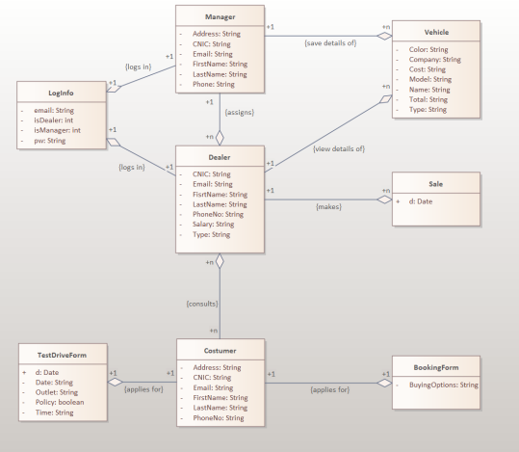

# System Sequence Diagrams: -

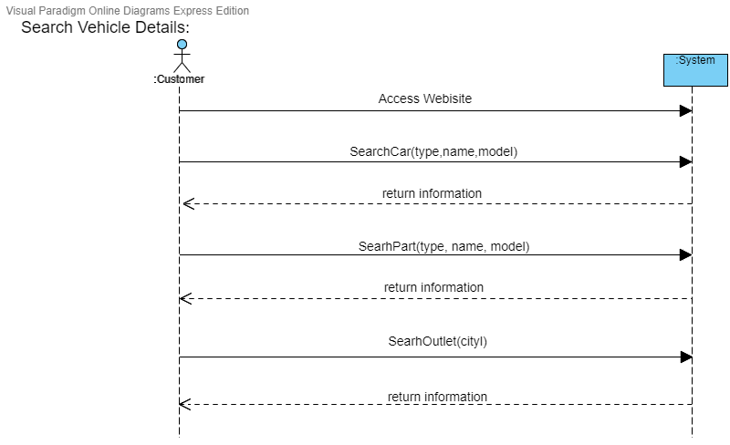

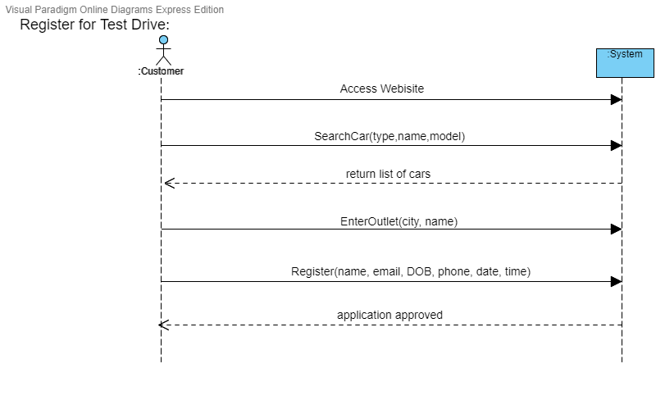

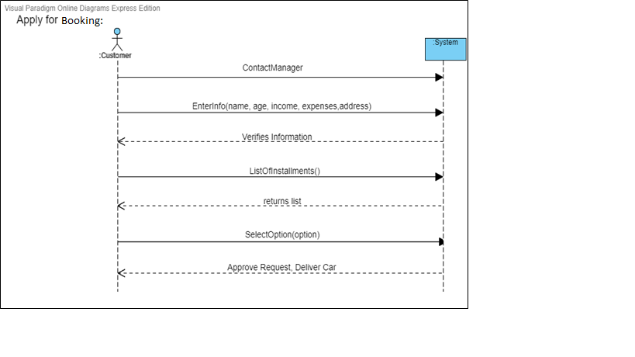

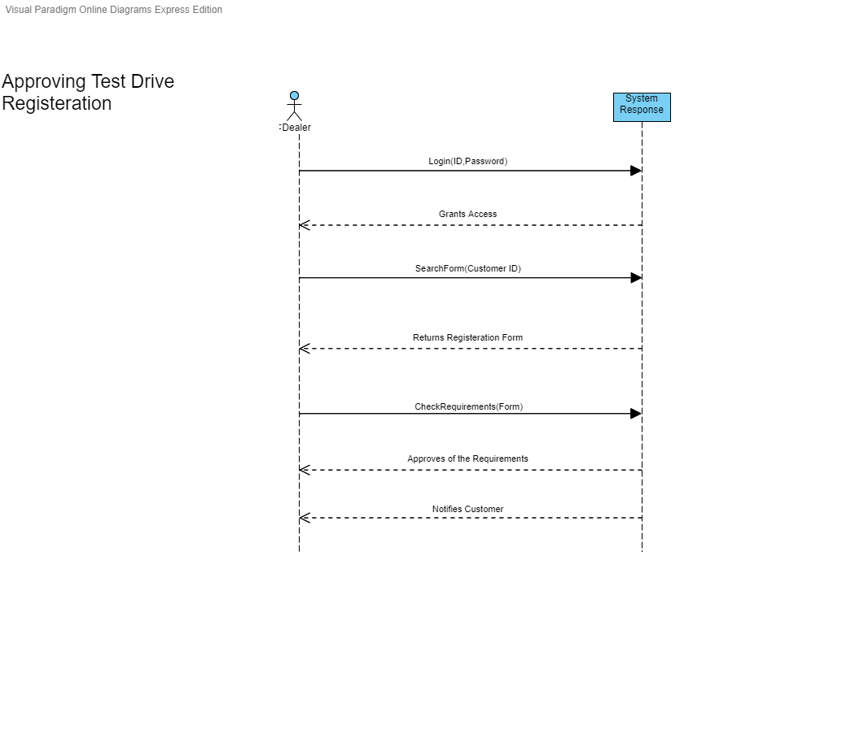

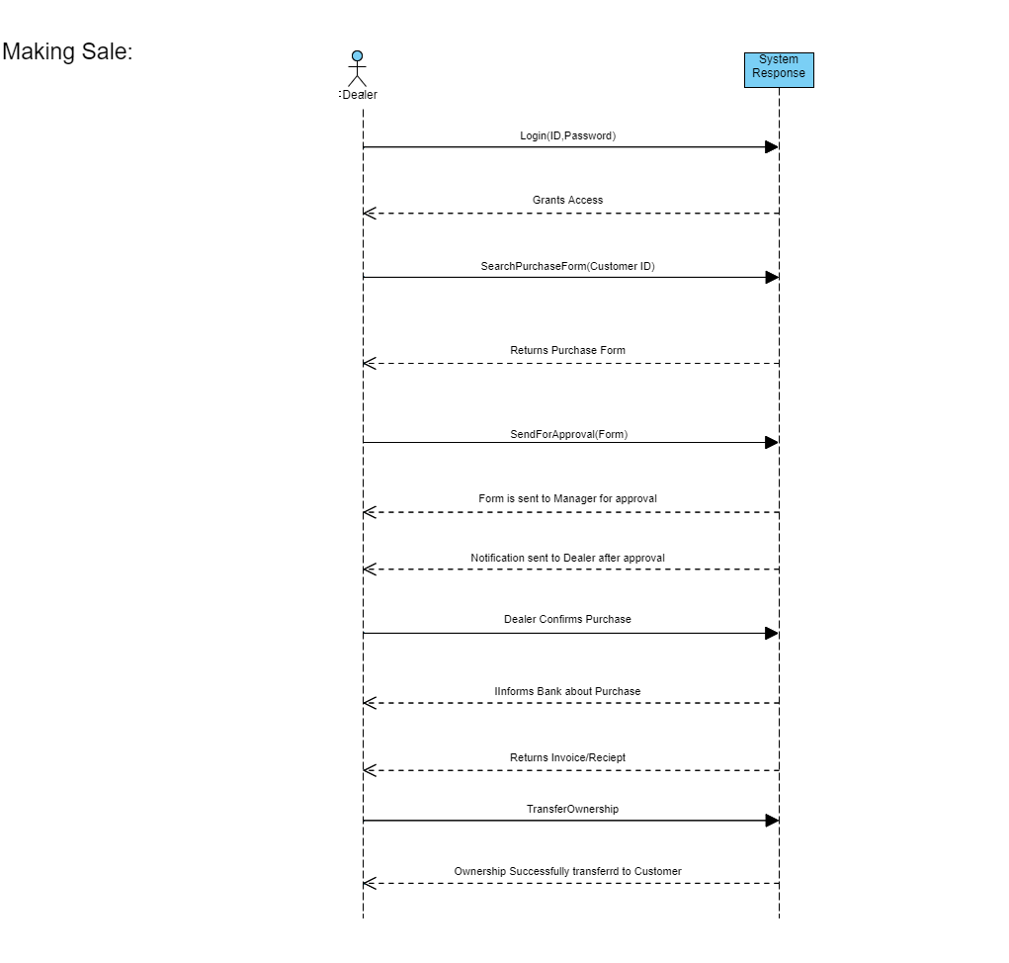

# System Sequence Diagrams: -

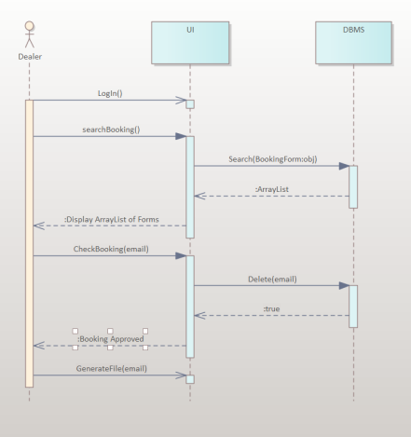

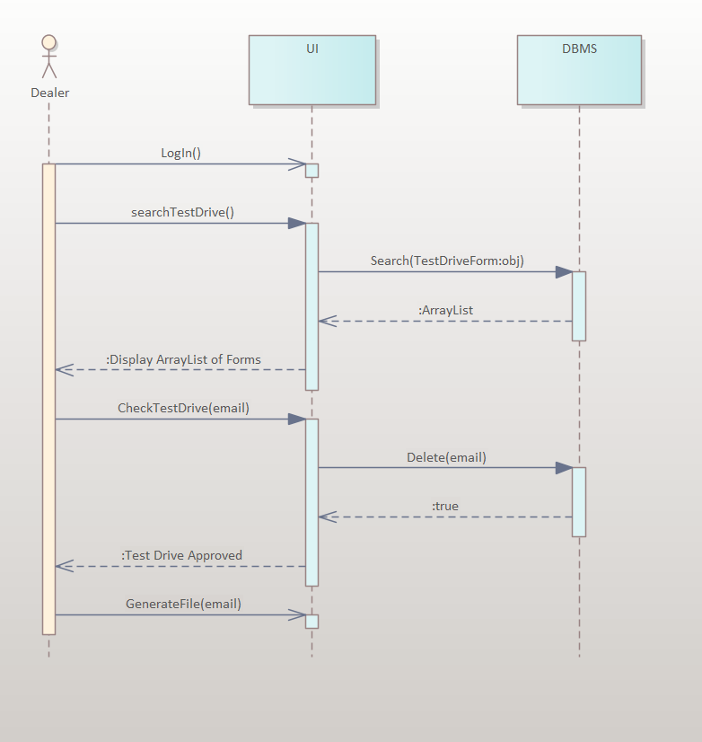

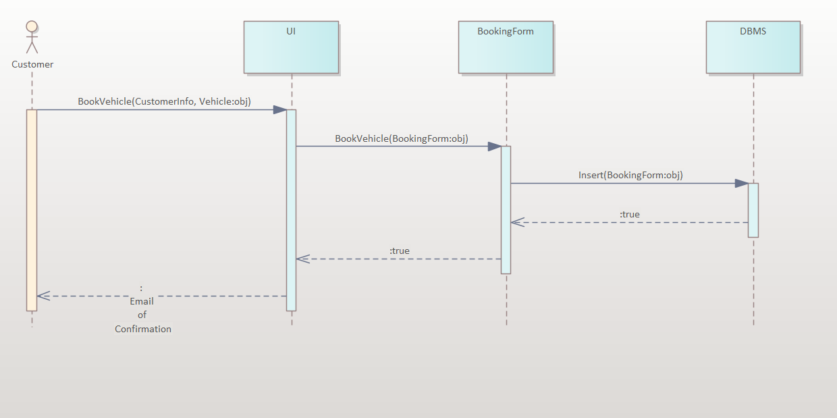

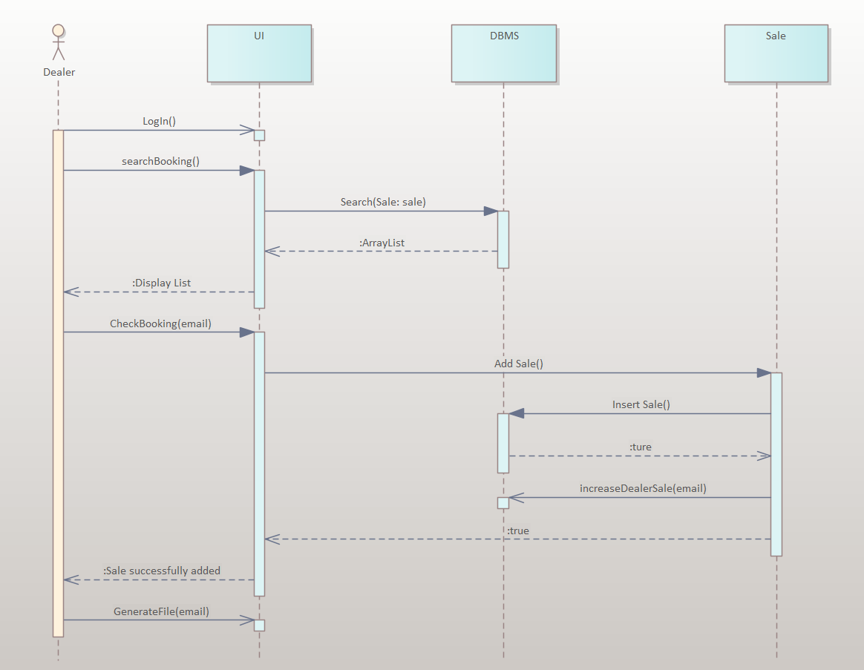

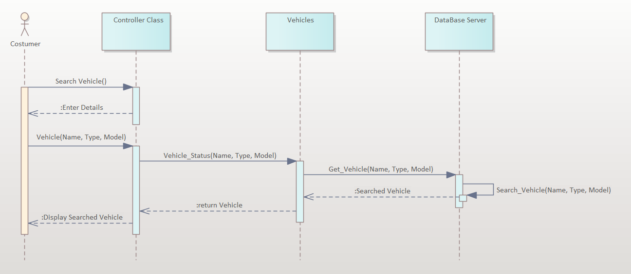

# Class Diagrams: -

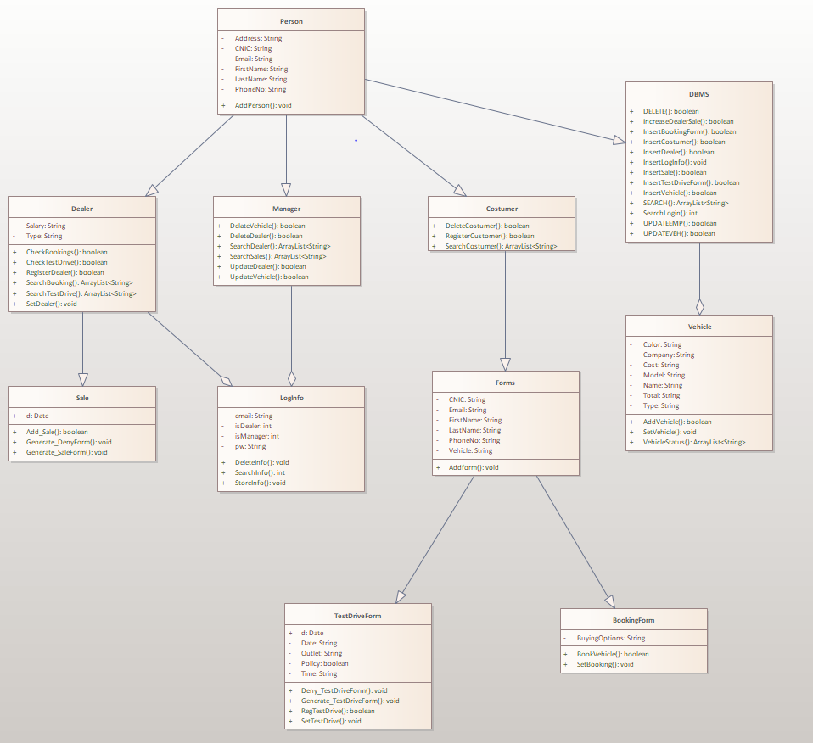

# Description of Data Base: -

We used SQL for our database.

**Tables/Columns:**

**Employee:** Stores Manager and Dealer Information.



**Vehicle:** Stores Vehicle Details.



**Customer:** Stores Customer Information.



**Booking:** Stores customers vehicle booking requests.



**TestDriveReg:** Stores test drive requests by customers.



**Sale:** Stores sales made by dealers.



**Login:** Stores Login Details.



**Feedback:** Stores customer feedback.



**Query Language is in DBMS.java file.**