Roverpede

Talon Pham Pollard

Victor Valley College

**Abstract**

As included in the name and with a design resembling a centipede, Roverpede’s goal is to be resilient and adaptive to its environments; more specifically, the harsh, terrestrial world of Mars. In previous generations of the Mars rovers, the designs had many challenges: wheels damage from sharp rocks’ puncture, risky sand travel which involved a lot of time and last-minute simulation tests by scientists back home, and power source unable to work properly due to dusty solar panels (Malik, 2017). Because the Martian terrain mainly comprises of rocky surfaces, one of Roverpede’s improvements in comparison to the previous models is its ability to traverse on any terrain, be it incline hills, rocky surface, or dunes. Using cameras, sensors, and the instrumental package Radar Imager for Mars' Subsurface Experiment (RIMFAX), Roverpede analyzes the terrain and changes forms accordingly to ensure safe traveling. Additionally, with regards to the cold atmospheric temperature and planet-wide dust storms that can critically damage and interfere with the rover’s hardware and impede its functions, Roverpede’s second objective is to be self-sufficient in time of harsh weather conditions. Roverpede maintains awareness of potentially hazardous climate changes by using the Mars Environmental Dynamics Analyzer (MEDA), this instrumental package’s main priority is to measure wind speed and direction, temperature and humidity, and the amount and size of dust particles near the rover. This awareness will help Roverpede react to its surroundings in times of emergency and transition into a more stable form. During an extremely low temperature, Roverpede’s stable form can maintain insulation, prevents hardware freeze, and continue operation. Finally, to combat Mar’s dust issues and prevent power shortage, Roverpede’s final objective is to utilize a dual-energy system, consisting of the solar panels and Multi-Mission Radioisotope Thermoelectric Generator (MMRTG) capsules. With the Electrodynamic Dust Shield (EDS) to handle dust clearance from its solar panels, sensors, and hardware, Roverpede can cumulate even more energy, possibly improving its mission’s duration and efficiency.

*\*Note: All dimension measurements are in millimeters (mm)*

**Specifications**

**Chassis**

*The chassis has a rectangular frame, capable of transforming into a ladder or a box.*

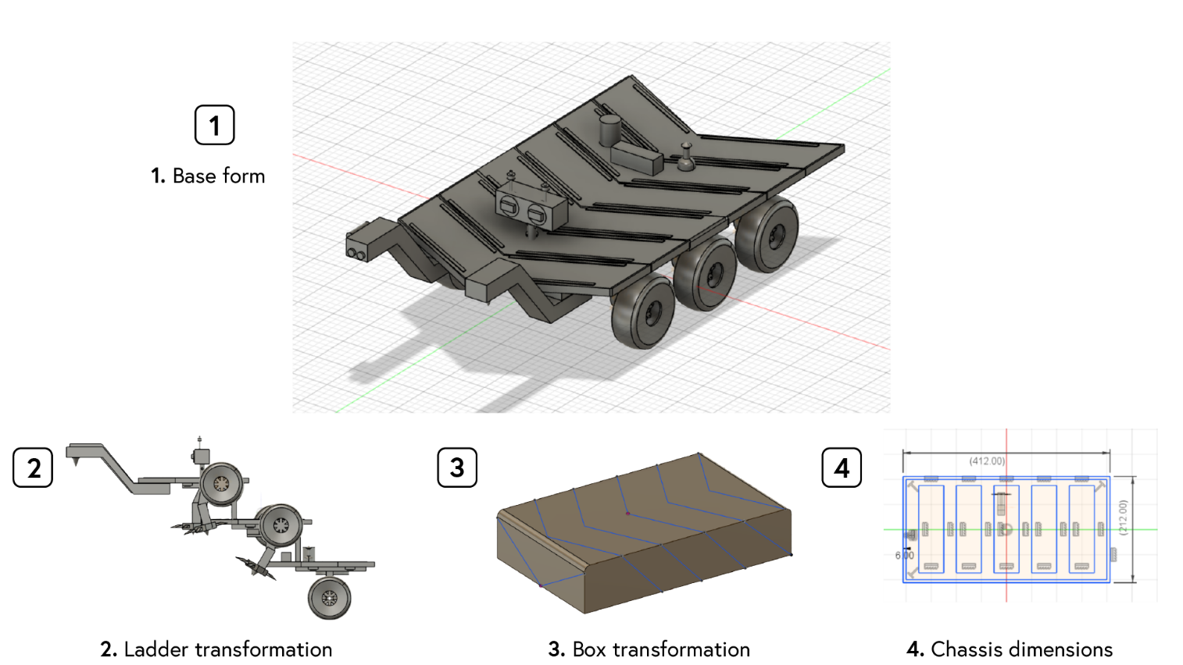

*Figure 1.* Overview of Roverpede’s forms and chassis.

**(1) *Terrain traversal improvement:*** The chassis is equipped with six hybrid limbs that switch between mechanical legs and wheels depending on the task/terrain*.* The ladder transformation design, as shown in Figure 1, allows Roverpede to reach difficult terrain directly rather than having to scout for alternative paths; this method of direct traveling will greatly save energy and minimize terrain mapping, calculation or other extraneous tasks.

*Figure 2.* Roverpede’s hybrid traversal system.

Roverpede’s wheels are built from a durable and flexible shape memory alloy made of nickel-titanium, possessing many benefits over previous generations of rover’s wheels (Kilkenny, 2017). Shape memory alloy wheels are lightweight yet capable of carrying heavier payloads; responsive to temperature — the wheels do not break when frozen like rubber, nor are they prone to puncturing damage like the Curiosity’s aluminum wheels; and capable of conforming to any shape and traveling on any surface: sharp/rocky ground, flat surface, or dunes. These characteristics help Roverpede resists against wheels deformation and damage over long-term travels; perfect for Mar’s unforgiving environment.

Roverpede’s mechanical legs are responsive and flexible, connected by rotatable joints which allow for full range motions when in search to find the best feet placement; the legs are further equipped with talons-like hooks and a mini drill under its palm to assist the rover with staying balanced on rough/incline surface. The hooks are responsible for latching onto rocks and resting points while the drill prevents slipping by digging under the surface.

***(2) Insulation and storm resistance:***Roverpede’s chassis can change into an enclosed, fiberglass box (Figure 2) which has important properties such as wind absorption, electrical insulation, and heat insulation (Savage, 2010). During high-velocity dust storms, the fiberglass absorbs wind and deflects dust, minimizing damage to the rover from the outside. Roverpede’s mechanical legs are also implanted tightly to the ground with their drills to hold Roverpede stationary. When the temperature drops below freezing on Mars, Roverpede’s box transformation can maintain internal insulation to keep its hardware operational and functional; insulation will also reduce the energy required to keep the power system warm. Finally, as mentioned previously with the shapeshifting wheels’ physical properties — deformation in cold and reformation in heat — if the surface temperature is deemed unfit for traveling and the wheels give out, Roverpede can simply transform into the insulated box and maintain just enough heat to revert the wheel’s shape.

**Power Source**

*The power system uses a dual energy system: MMRTG and solar panels.*

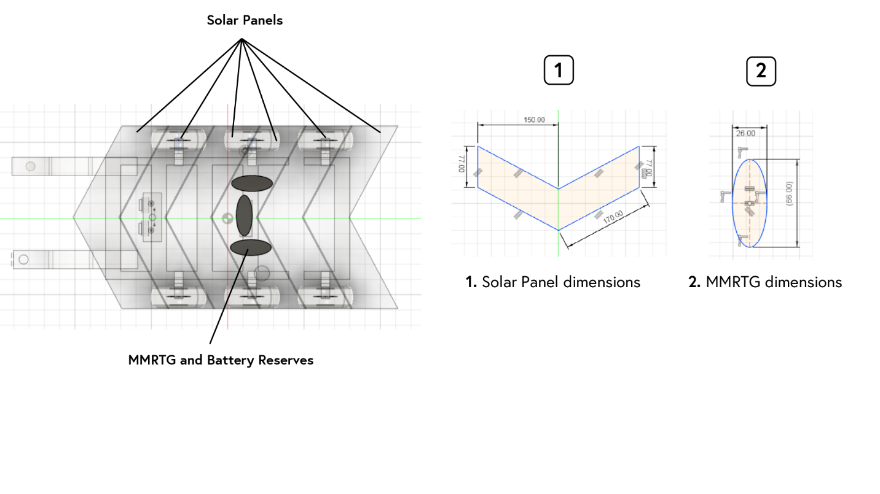*Figure 3.* Roverpede’s power sources.

**(1) Multi-Mission Radioisotope Thermoelectric Generator (MMRGT):** Like Mars 2020, Roverpede’s MMRTG converts thermal energy from the natural decay of plutonium dioxide into electrical power (Bechtel, 2013). The MMRTG and its battery reserves are placed beneath Roverpede’s body segment #3.

**(2) Solar panels:** In addition to the MMRTG, Roverpede is armored with plates of solar panels for an additional energy source. The plates are designed to be responsive to the Sun’s location and are capable of tilting at slight angles to ensure the most solar energy absorption.

Roverpede shares the same thermocouples that convert heat energy into electricity with the MMRTG; relying on solar energy and limiting its usage of MMRTG during the day; using up its solar energy reserve or turning off solar completely and relying on MMRTG during the night. With a dual power system, Roverpede has two sources to extract energy from, improving both physical and hardware performances; more power is always available to accomplish tasks throughout the day and night. Any excess energy is reserved for later usage or expended on additional tasks.

**Instrument Packages**

*Figure 4.* Roverpede’s instrument packages.

**(1) Radar Imager for Mars' Subsurface Experiment (RIMFAX):** Because different mineral compositions reflect, absorb, and scatter radar waves in distinct ways, RIMFAX is placed beside the mechanical arm (camera) to assist with traveling and sample analysis. Roverpede uses RIMFAX’s ground-penetration capability to probe for the terrain’s density, makeup, and structure before taking any actions (Hamran, n.d.). Using constructed image representation of the subsurface structure, Roverpede and the scientist team can decide whether it is safe to climb/travel on certain areas or whether certain samples are worth investigating. Through the ability to flexibly and adaptively travel on any terrain, Roverpede and RIMFAX can detect ice, water, or salty brine in more difficult-to-reach areas, further expanding the focus of research and learning opportunities on Mars.

**(2) Mars Environmental Dynamics Analyzer (MEDA):** MEDA is placed next to the navigation hardware, its priority is to measure wind speed and direction, atmospheric pressure and radiation, temperature and humidity, and the amount and size of dust particles that are currently circulating the area (Manfredi, n.d.). This instrument will notify Roverpede of any climate changes or incoming hazardous storms, allowing the rover to decide on its next course of action and transition into more appropriate, stable forms, ensuring safe operation. MEDA can also collect weather data for the scientists at home; helping researchers gain a better understanding of the dust cycles on Mars and its impact on the weather system.

**(3) Electrodynamic Dust Shield (EDS):** Dust circulates and accumulates on Roverpede at all times on Mars while traveling or performing any activity. As a result, dust is a huge hindrance to the solar panels when trying to absorb solar energy, cameras when trying to navigate, or sensors when trying to analyze the surrounding. So, to alleviate this issue, EDS is placed throughout the solar panels and activated when necessary. By creating an electric field that propagates and prevents dust accumulation, EDS removes dust particles and maintains Roverpede’s hardware effectiveness (Granath, 2012).

**Robotic-mechanical arm**

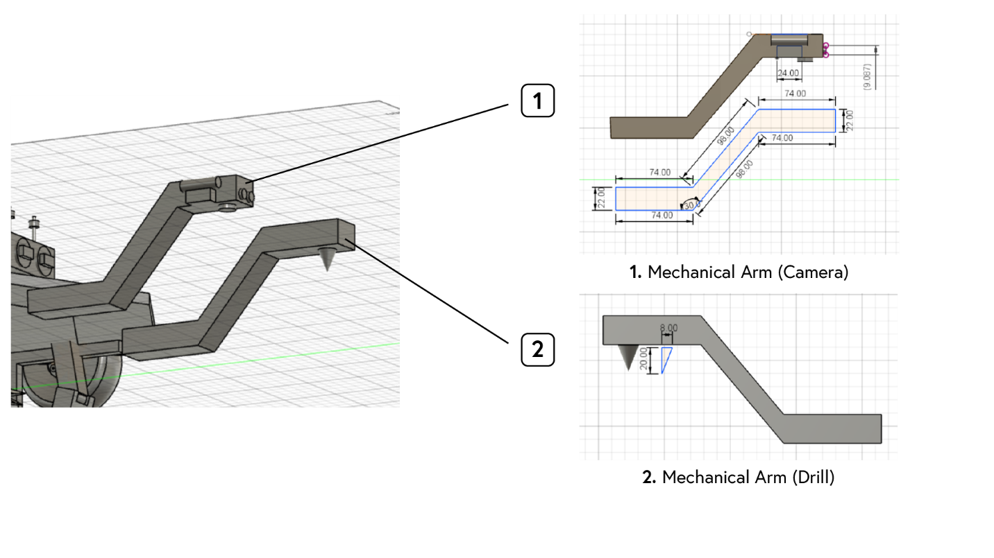

*Figure 5.* Roverpede’s mechanical arms.

Roverpede has two arms that extend from beneath of body segment #0, each providing different functions. The camera arm is mounted with laser, inspired by the Mars 2020’s SuperCam (Remote Micro-Imager), works simultaneously with the instrument package RIMFAX to analyze rocks and their elemental composition through a vaporization process (Wiens, n.d.). Next, the drill arm is responsible for surface penetration and sample collection, delivery, and analysis. By analyzing rocks beforehand with the laser and RIMFAX, the drill is optimized to be used only when needed; as a result, there will be improvements in the drill’s condition and durability throughout its venture. Moreover, having separate arms for cameras and drilling allows for wider movement, increasing precision and accuracy when trying to identify areas of interest.

**Computer Hardware**

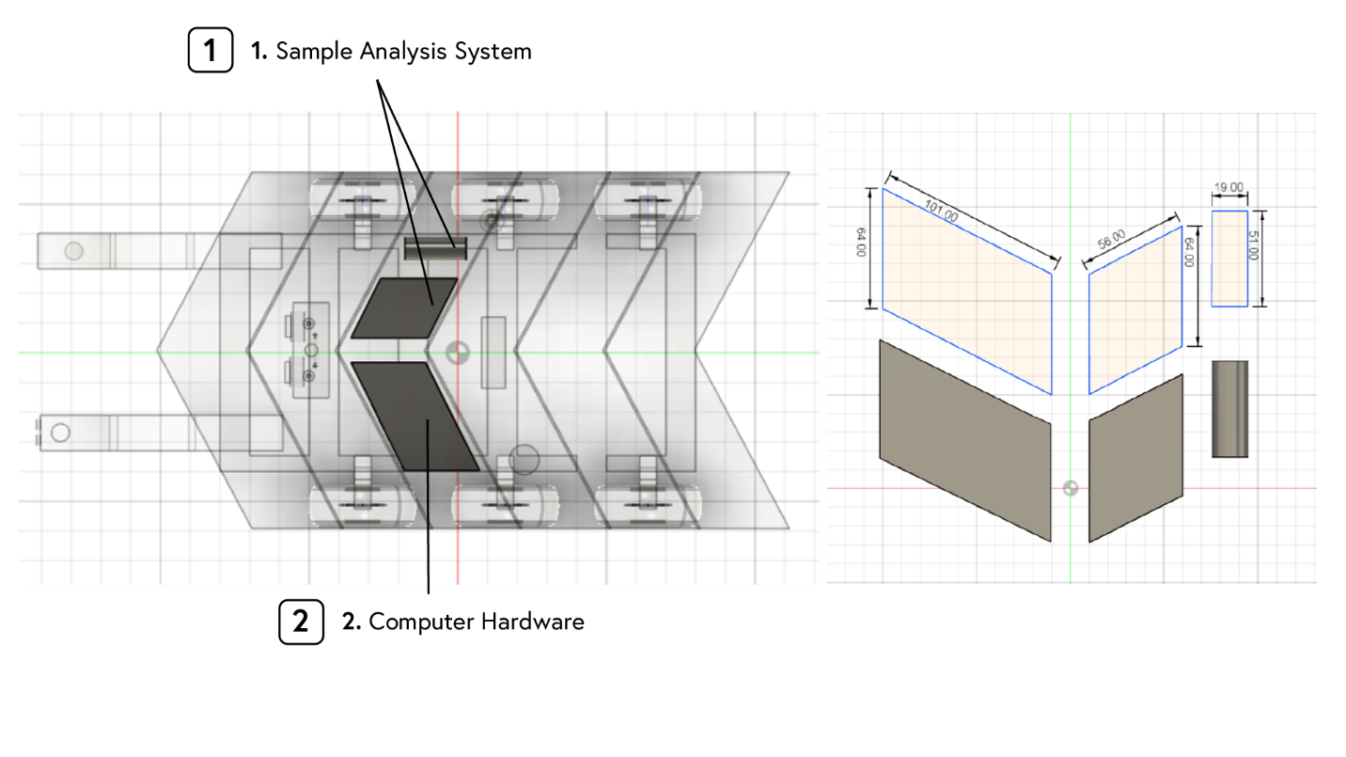

*Figure 6.* Roverpede’s computer hardware and sample analysis system.

Roverpede’s computer hardware is placed next to the sample analysis system, beneath body segment #2. As the brain, computer hardware is inarguably the most important body part of the rover. Consequently, Roverpede carries two identical computer modules — one acts as a spare — their central processors are built to tolerate radiation from its power source (MMRTG) and Mars’s environment, the high impact of initial landing, and hardware shaking. The brain is also equipped with inertial sensors to ensure safe operations during incline/uneven surface traveling: a compass to determine the direction, an accelerometer to report speed, and a gyroscope to sense turning motions (Lawson, 2012). During operation, the brain is responsible for many computer processes, health control, information transmission, and general operation. Equally important, the sample analysis system stores its samples inside a tube, breaks down its content, transfer the refined samples to the computer hardware for analysis, finalize its data, and relay any significant finding or important information back to the scientists at home.

**Navigation Hardware and Communication Hardware**

*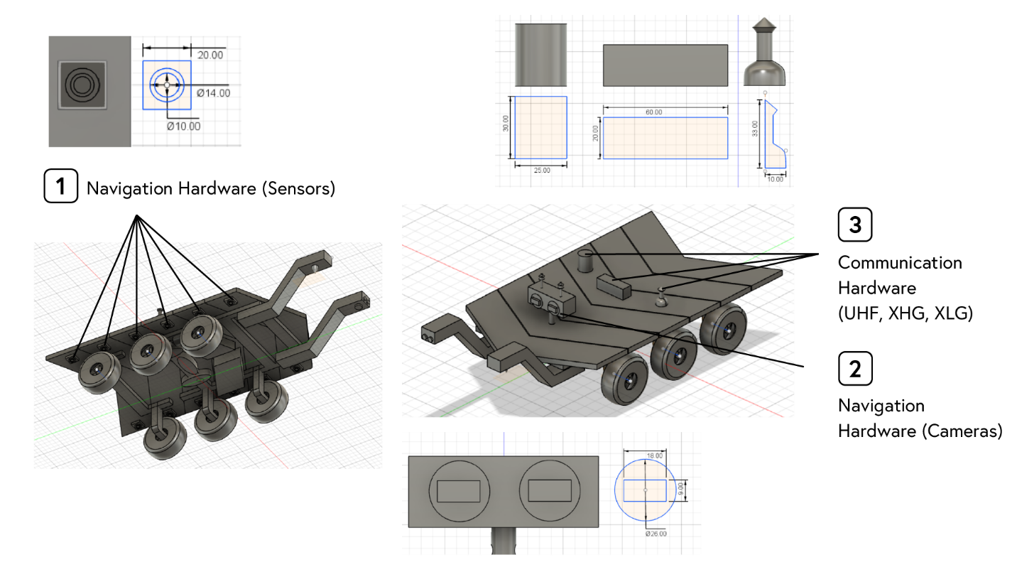Figure 7.* Roverpede’s navigation and communication hardware.

Roverpede is surrounded by cameras and sensors, performing multiple tasks at all times: terrain identification, sample analysis, and positioning. Hazard sensors are mounted around the rover, beneath the solar panel wings. The sensors individually assess each Roverpede’s body segment relative position above ground; this is especially beneficial and necessary when traveling on rough surfaces, Roverpede can always maintain its balance and composure, minimizing the risk of tipping over or shaking stress on internal hardware. Following, the main navigation hardware acts as Roverpede’s head and is adjusted on body segment #1. When in action, the camera head rises above the body, capable of omnidirectional observation. Theoretically, Roverpede always has full views above and below itself. Next, the communication hardware consists of the same technology from Mars 2020: Ultra-High Frequency antenna (UHF), X-band High-Gain antenna (XHG), and X-band Low-Gain antenna (XLG); these packages are placed on body segment #3, alongside the MMRTG power source. Similarly, Roverpede’s omnidirectional communication hardware yields the benefit of transmitting data at any time without having to readjust the rover’s position. Within the three devices, UHF allows Roverpede to communicate with Earth through NASA's orbiters around Mars, XHG allows Roverpede to send data at high rates back to Earth, and XLG allows Roverpede to receive signals and transmits data at low rates to the Deep Space Network antennas on Earth (“Communications,” n.d.).

References

Bechtel, R. (2013, October). Multi-Mission Radioisotope Thermoelectric Generator (MMRTG) [PDF file]. Retrieved November 30, 2019, from https://mars.nasa.gov/internal_resources/788/.

Communications. (n.d.). Retrieved from https://mars.nasa.gov/mars2020/mission/rover/communications/.

Granath, B. (2012, October 5). Scientists Developing Ways to Mitigate Dust Problem for Explorers. *NASA.* Retrieved from https://www.nasa.gov/content/scientists-developing-ways-to-mitigate-dust-problem-for-explorers.

Hamran, S.-E. (n.d.). Radar Imager for Mars' Subsurface Exploration (RIMFAX). *NASA.* Retrieved from https://mars.nasa.gov/mars2020/mission/instruments/rimfax/.

Kilkenny, N. S. (2017, October 26). Reinventing the Wheel. *NASA.* Retrieved from https://www.nasa.gov/specials/wheels/.

Lawson, S. (2012, April 6). Ten Ways Your Smartphone Knows Where You Are. *PC World.* Retrieved from https://www.pcworld.com/article/253354/ten_ways_your_smartphone_knows_where_you_are.html.

Malik, T. (2017, March 21). Breaks Found in Curiosity Mars Rover's Wheel. *Space.* Retrieved from https://www.space.com/36161-curiosity-mars-rover-wheel-breaks-found.html.

Manfredi, J. A. R. (n.d.). Mars Environmental Dynamics Analyzer (MEDA). *NASA.* Retrieved from https://mars.nasa.gov/mars2020/mission/instruments/meda/.

Savage, S. (2010, November 15). Fiberglass. *Redorbit.* Retrieved from https://www.redorbit.com/reference/fiberglass/.

Wiens, R. (n.d.). SuperCam. *NASA.* Retrieved from https://mars.nasa.gov/mars2020/mission/instruments/supercam/.