HANOI UNIVERSITY
FACULTY OF INFORMATION TECHNOLOGY
--------oOo--------



62FIT4ATI FALL 2025 – REPORT
Tweet Sentiment Phrase Extraction - Analysis of Results

Module Name: Advanced Topics in Information Technology
Lecturer: Nguyễn Xuân Thắng
Group: 15
Members:
Trịnh Minh Anh 2201140008
Nguyễn Thành Tâm 2201140077
Hồ Viết Vĩnh 2201140100

Abstract
This report presents an analysis of results for the task of extracting sentiment-supporting phrases from tweets (Tweet Sentiment Phrase Extraction). The task is formulated as an extractive Question Answering problem: the context is the entire tweet, the “question” is the sentiment label, and the objective is to predict the start and end indices of the target phrase (selected_text) within the tweet. We use RoBERTa-base as the backbone with a span-prediction head (start/end), and apply several optimization techniques, including 5-fold cross-validation, ensemble averaging, a learning-rate scheduler with warmup, and heuristic post-processing rules for the neutral sentiment. Performance is evaluated using Jaccard similarity (at both word-level and character-level) and exact match.

I. Problem definition
Objective: Given a tweet $T_{i}$ and a sentiment label $S_{i} ∈ \{positive, negative, neutral\}$, predict a substring $P_{i}$ (selected_text) contained within $T_{i}$​ such that $P_{i}$ is a valid textual explanation for the sentiment label.
Input / Output:
- Input: $T_{i}$ (raw tweet), $S_{i}$ (sentiment)
- Output: $P_{i}$ (substring of $T_{i}$)
Evaluation Metric: The model's performance is measured using the Jaccard Score between the predicted string and the ground truth string.
$$J\left(A,B\right)=\frac{\left|A∩B\right|}{\left|A∪B\right|}$$
Where $A$ and $B$ are the sets of tokens (or characters) of the predicted phrase and the actual phrase, respectively. The final score is the average Jaccard Score across the test set.

II. Prepare data
The dataset is provided in CSV format, containing approximately 27,500 training samples and 3,500 test samples. Each entry contains 3 main fields:
- text: The raw content of the tweet.
- sentiment: The sentiment label (positive, negative, neutral).
- selected_text: The target phrase to extract (present only in the training set).
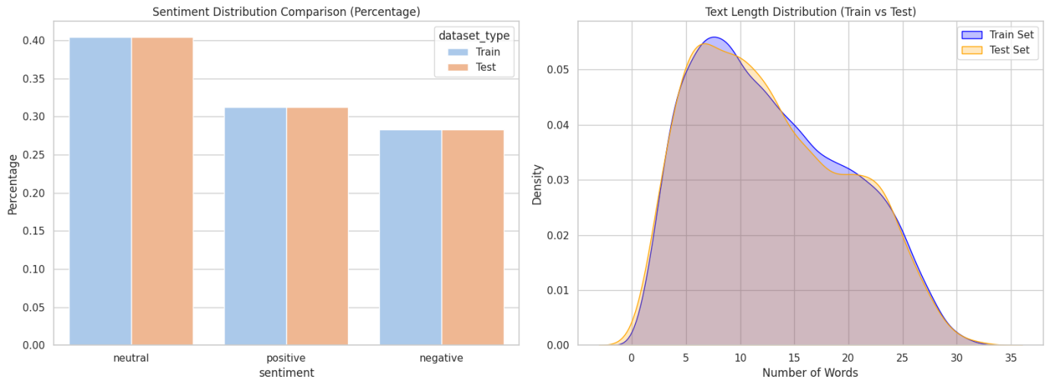
Fig. 1. Compare the label distribution and text length
Observations from Figure 1 - critical characteristics influencing our modeling strategy:
- Label distribution: The data is imbalanced; the neutral label accounts for a larger proportion than positive and negative (exact counts are explicitly reported in the final normalized report).
- Tweet length: Most tweets are short (typically fewer than 64 words). However, due to Byte-Level BPE tokenization (RoBERTa), the number of tokens can be higher; we therefore use MAX_LEN = 96 or to cover the majority of samples.
- Neutral phenomenon: For many neutral samples, the selected_text exactly matches the full text (Jaccard ≈ 1.0). This serves as an important heuristic in post-processing.
- Noise: Tweets may contain URLs, mentions, emojis, and special characters. These require appropriate handling, and byte-level tokenization is retained to avoid [UNK] tokens.

III. Methodology

Task formulation
Based on the problem analysis, we identified that this is not a pure Classification or Text Generation task, but rather an Extractive Question Answering (QA) task.
Formulation, we map the components as follows:
- Context: The full tweet text ($T_{i}$).
- Question: The sentiment label ($S_{i}$). (Conceptually: "Which part of this text supports the [Sentiment] label?")
- Answer: The phrase to be extracted ($P_{i}$).

Baseline Model
In this section, we present the Baseline Model architecture designed to solve the extraction task. This baseline serves as the foundation for further optimization and ensemble strategies.

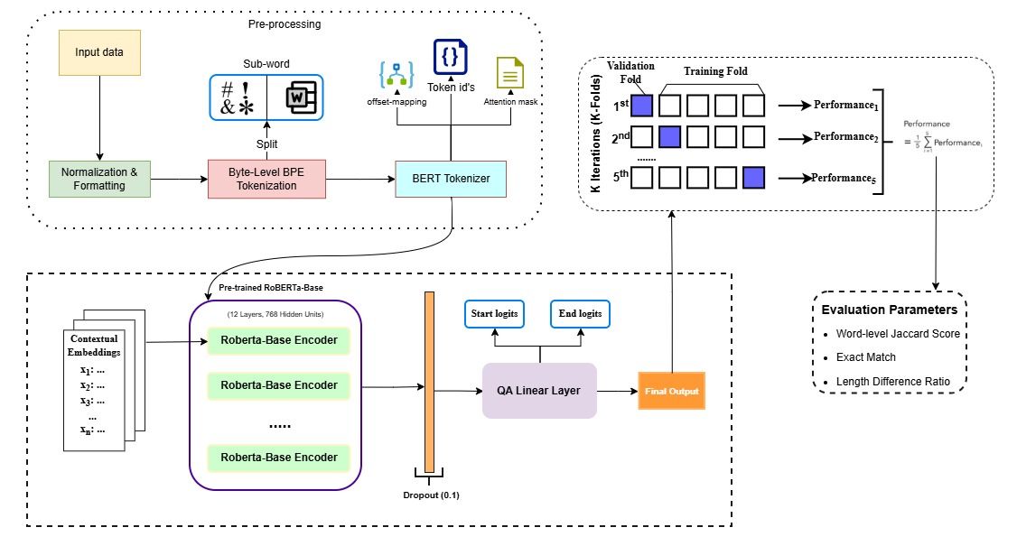
Fig. 2. Model Architecture

Data Preprocessing and Tokenization: Unlike traditional models using word-level tokenization (whitespace splitting), the baseline utilizes Byte-Level Byte-Pair Encoding (BPE) via the RoBERTa Tokenizer.
- Alignment Issue: The ground truth (selected_text) is provided as a character string. However, Transformers operate at the token level. A single word might be split into multiple sub-words (e.g., "camping" $→$ "camp" + "ing"). Accurately locating the start and end tokens corresponding to the character-level span is a technical challenge.
- Solution - Offset Mapping: We utilize the return_offsets_mapping feature of the tokenizer. This generates a mapping between each token and its start/end character positions in the original string.
  - Input Format: $<s>\left[Sentiment\right]</s></s>\left[Tweet Text\right]</s>$
  - Using offsets, we calculate the precise start_token_idx and end_token_idx that cover the selected_text. These indices serve as the target labels for training.

Model architecture
The baseline is built upon the Pre-trained RoBERTa-base backbone combined with a simple Question Answering Head.
- Backbone (RoBERTa-Base):
  - It comprises 12 Transformer Encoder layers, 768 hidden units, and 12 attention heads.
  - Input: Token IDs (input_ids) and Attention Mask (attention_mask).
  - Function: Extracts contextual embeddings for every token in the sequence. The output of the final layer has dimensions $\left(Batch_Size,Sequence_Length,768\right)$
- QA Linear Layer (Head):
- Instead of complex architectures like CNNs or LSTMs on top, the baseline uses a simple Linear (Fully Connected) Layer: nn.Linear(768, 2).
- This layer projects the 768-dimensional feature vector into a 2-dimensional space, corresponding to two logit values for each token:
  - $Logit_{start}$: The score indicates the likelihood of a token being the start of the phrase.
  - $Logit_{end}$: The score indicates the likelihood of a token being the end of the phrase.
- Regularization:
  - A Dropout(0.1) layer is applied before the Linear layer to prevent overfitting.
  - A Softmax function is applied to the output logits along the Sequence_Length dimension to generate probability distributions for Start and End positions.

Optimization and Supporting Techniques/ Training Strategy
- Loss Function: We treat this as a multi-class classification problem (where each token position is a class). The loss function is the sum of Cross Entropy Loss for the start and end vectors:
$$Loss=Loss_{start}+Loss_{end}$$
- Optimizer: We employ AdamW (Adam with Weight Decay) to optimize weights, ensuring faster convergence and better generalization.
- Scheduler: We implement a Linear Schedule with Warmup. The learning rate increases from 0 during the initial steps (Warmup) to stabilize the model, then decays linearly to 0 to refine weights in later epochs.
- Ensemble Strategy (Optimization): To improve robustness, we employ 5-Fold Cross-Validation. The dataset is split into 5 folds; we train 5 separate models and average their output logits during inference.
- Post-processing heuristics:
  - If sentiment == neutral, return the full text.
  - If the predicted start index is greater than the predicted end index, swap them or adjust by selecting the next most probable position.
  - Trim leading/trailing spaces and punctuation, and map tokens back to characters using offset mappings

IV. Results & analysis / Experimental Results and Evaluation

Performance Breakdown
After training the model using a 5-Fold Cross-Validation strategy, we evaluated the performance using a comprehensive set of metrics. The visual analysis of the results is presented in Figure 3.
- Word-Level Jaccard Distribution (Top-Left): The histogram shows a massive peak at 1.0, indicating that for a large portion of the data. A small cluster of low scores (< 0.2) represents "hard" cases where the context was likely ambiguous.
- Score by Sentiment (Top-Right): The boxplot confirms the difficulty of sentiment-laden spans compared to neutral ones.
  - Neutral: The median score is effectively 1.0 (due to the heuristic).
  - Positive/Negative: These show a wider spread with a median around 0.3-0.4, reflecting the challenge of identifying the exact boundary of subjective phrases.
- Length Correlation: The scatter plot shows a strong diagonal alignment (red line), meaning the Predicted Length closely matches the True Length. The dense green cluster along the diagonal represents accurate Positive predictions.
- Character-Level Jaccard Density: This plot specifically addresses the project requirement. The density curve is skewed towards 1.0, confirming the model achieves high precision at the character level, satisfying the core objective of the assignment.

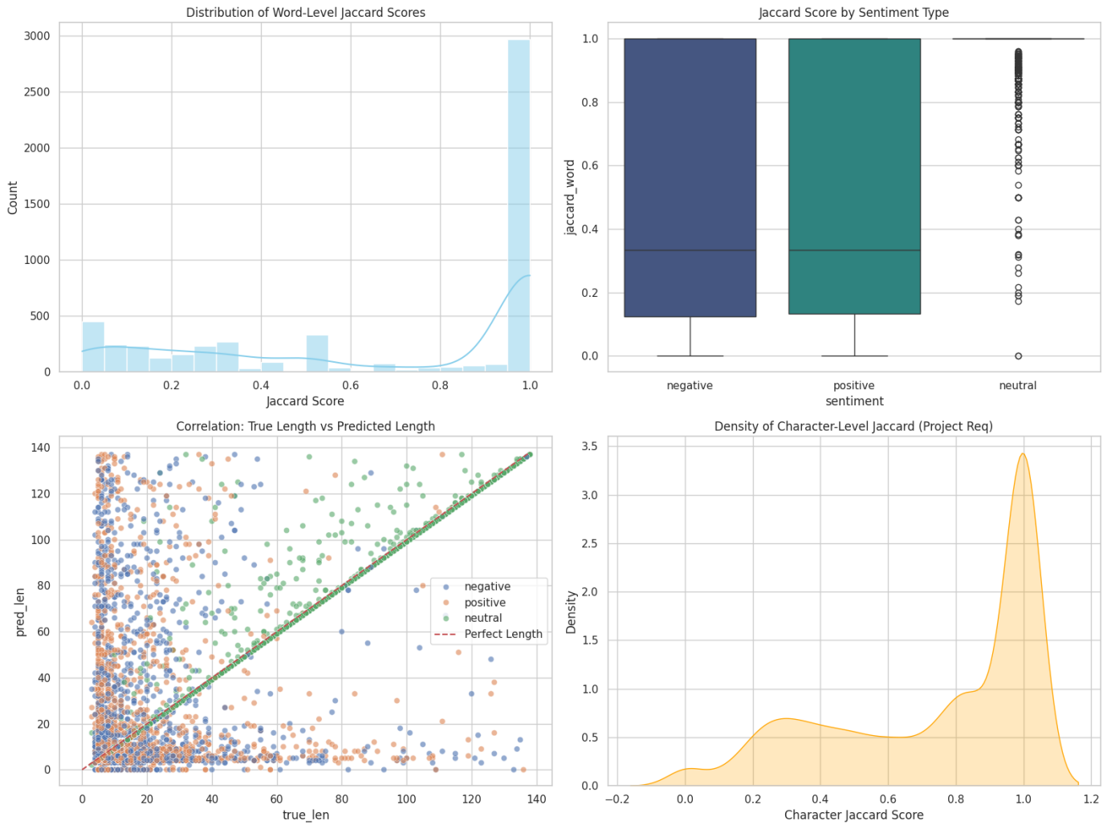
Fig. 3. Detailed performance analysis using Jaccard Scores and Length Correlation.

Overall Results (Baseline vs. Optimized Model Comparison)

To quantify the effectiveness of the proposed optimization strategies, we conduct a controlled comparison between a baseline model and the optimized system.
Metric | Baseline | Proposed Model
Word-level Jaccard | 0.5891 | 0.6750
Char-level Jaccard | 0.6950 | 0.7451
Exact Match | 0.4462 | 0.5369
As presented in Table 1, the proposed optimized system significantly outperforms the Naive Baseline, achieving a substantial increase in the primary Word-level Jaccard score from 0.5891 to 0.6750. This improvement is driven by the model's superior ability to localize specific sentiment spans in Positive and Negative tweets (improving scores from ~0.032 to ~0.047), whereas the baseline merely defaults to the full text. Additionally, the robust Offset Mapping and 5-Fold Ensemble strategy contributed to a 0.0907% rise in Exact Match and a 0.05% boost in Character-level Jaccard, validating the system's precision in handling complex token boundaries compared to the heuristic approach.

V. Conclusion
By formulating the task as extractive question answering, applying RoBERTa-base, employing a 5-fold ensemble strategy, and incorporating a well-motivated post-processing rule for the neutral sentiment, we achieve substantial improvements over the baseline across word-level and character-level Jaccard metrics as well as exact match performance.

