***Coffee House Admin***

I. Review 1

* **The Object of The Project...............................................................................................01**
* **Functional Requirements................................................................................................02**
* **Development Environment.............................................................................................03**

II. Review 2

* **Use Case Diagram...........................................................................................................03**
* **Class Diagram.................................................................................................................15**
* **Sequence Diagram..........................................................................................................16**
* **ERD..................................................................................................................................18**
* **Table Relationship Diagram..........................................................................................26**

**III. Review 3**

* **Interface Design**

REVIEW 1

**The Object of The Project**

This project’s target is creating a system for admin to manage store . Admin will be accessible to manage all products and categories of store when login with valid username and password for admin. This system provides the following facilities:

* + Review all statistical data of categories.
  + Viewing, adding, updating, removing, and restoring all products and categories.

**Functional Requirements**

Following is a list of functionalities of the system:

* Admin must have use valid username and password to login to the system
* After login successfully, admin is navigated to the home page.

At home page, admin can review all statistical data of categories about number of products which use those categories, or the percent of used categories in the store.

* Admin can navigate to products management page, there is some functions for admin to view product’s detail, add new product, update products, delete products or restore deleted products. Admin can also use filter to find products that they want to search by product’s name.
* In the products data table of products management page, admin can sort the products by products’ name, price or remain products’ quantity. Admin can also move backward or forward between pages and can choose the number of products which are showed in each page.
* Admin can navigate to categories management page where admin can add new category, update categories, delete categories or restore deleted categories.

**Development Environment**

* OS: Windows 10 Home Single Language
* Design Architecture: 3-Tier
* Environment: Microsoft .NET Core 3.1
* Frontend Framework: @Angular/9.0.6
* Connecting and Querying Database: Microsoft Entity Framework Core 3.1
* Database Management System: Microsoft SQL Server 18
* IDE: Microsoft Visual Studio 2019
* Text Editor: Microsoft Visual Studio Code
* Web Server: IIS (Internet Information Services) Express

REVIEW 2

**Use Case Diagram**

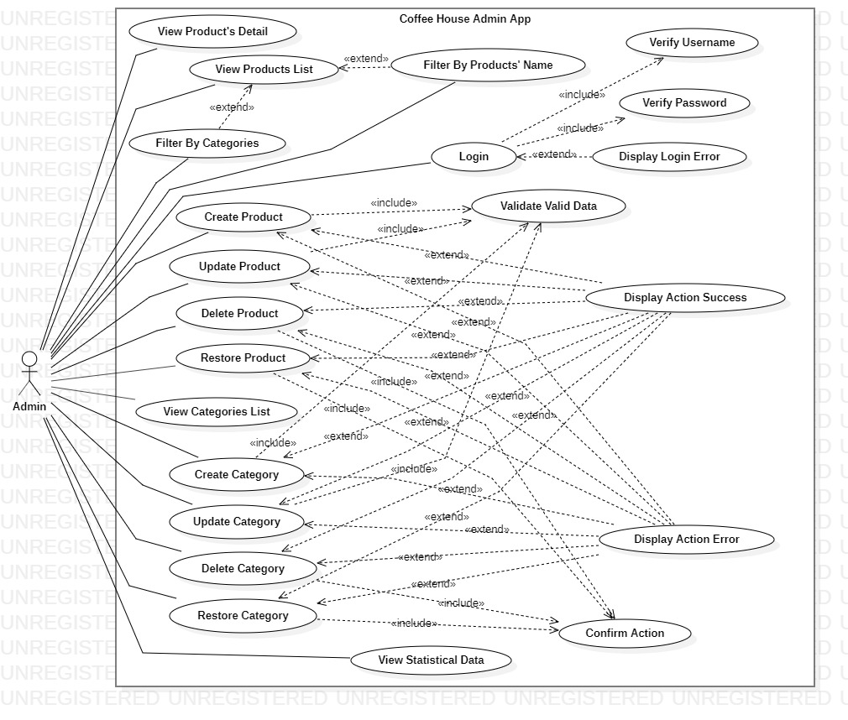

**Use Case Description**

1. **Actor:**

**Admin:** The person that manages and maintains application.

1. **Use Cases:**

|  |  |
| --- | --- |
| **Usecase** | Login |
| **Short Description** | Login to system to use functions of admin. |
| **Pre-Conditions** |  |
| **Post-Conditions** |  |
| **Main flow** | _Admin inputs the login information : Username and Password  _Admin clicks on the Login button or press Enter key.  _System checks the Username and Password.  _If Username and Password are valid, system will navagate admin to Home Page. |
| **Alternative flow(s)** | _If Username field or Password field is invalid form or blank when admin types, errors will be displayed and Login button will be disabled.  _When the Login button is clicked or Enter key is pressed, if Username or Password is invalid, system will notify Login Error on the login page. |

|  |  |
| --- | --- |
| **Usecase** | View Products List |
| **Short Description** | View products list to manage them. |
| **Pre-Conditions** |  |
| **Post-Conditions** |  |
| **Main flow** | _Admin clicks on Products Management on sidebar to navigate to Products Management page.  _Admin views all products that have in store.  _Admin clicks on Previous or Next button to move between pages, click on First Page or Last Page button to move to first or last page.  _Admin clicks on columns’ header of Product’s Name, Quantity and Price to sort products list that are based on them.  _Admin clicks on Category Filter buttons to list products that are based on their categories.  _Admin input to filter field to filter products by products’ name. |
| **Alternative flow(s)** |  |

|  |  |
| --- | --- |
| **Usecase** | View Product’s Detail |
| **Short Description** | View product’s detail and manage it. |
| **Pre-Conditions** |  |
| **Post-Conditions** |  |
| **Main flow** | _Admin clicks on product’s name on products table in Products Management page to navigate to Product Detail page.  _Admin clicks on Back to Products List button to navigate back to Products Management page.  _Admin clicks on Edit button if he/she wants to edit that product.  _Admin clicks on Delete if he/she wants to delete that product. |
| **Alternative flow(s)** |  |

|  |  |
| --- | --- |
| **Usecase** | Create New Product |
| **Short Description** | Create new product and add it to products list. |
| **Pre-Conditions** |  |
| **Post-Conditions** |  |
| **Main flow** | _Admin clicks on Add New Product button in Products Management page.  _Admin fills out all information about new product.  _Admin clicks on Create button or press Enter key to create product.  _If product is created successfully, system will navigate admin to Products Management page. And system will notify success message. |
| **Alternative flow(s)** | _If any field of form is invalid when admin types or chooses or when admin skippes any field, an error message will be showed below that field.  _If any error message still exists, admin cannot submit form.  _If any field of form is dirty and admin still doesn’t submit that form, a confirm message will be showed when admin navigate to other routes.  _If product’s name existed, an error message will be showed. |

|  |  |
| --- | --- |
| **Usecase** | Update Product |
| **Short Description** | Edit data of specified product. |
| **Pre-Conditions** |  |
| **Post-Conditions** |  |
| **Main flow** | _Admin clicks on Edit button on Products Table in Products Management page.  _Admin edits any information of specified product.  _Admin clicks on Save button or press Enter key to save changes.  _If product is updated successfully, system will navigate admin to Products Management page. And system will notify success message. |
| **Alternative flow(s)** | _If any field of form is invalid when admin types or chooses, an error message will be showed below that field.  _If any error message still exists, admin cannot submit form.  _If any field of form is dirty and admin still doesn’t submit that form, a confirm message will be showed when admin navigate to other routes.  _If product’s name existed, an error message will be showed. |

|  |  |
| --- | --- |
| **Usecase** | Delete Product |
| **Short Description** | Delete specified product. |
| **Pre-Conditions** |  |
| **Post-Conditions** |  |
| **Main flow** | _Admin clicks on Delete button on Products Table in Products Management page.  _Admin clicks on Delete button in Product Detail page.  _Admin clicks on Delete button in Product Edit page.  _A confirm message will be showed to ensure that admin want to delete that product or not.  _If admin clicks on Ok button, product will be deleted.  _If product is deleted successfully, system will navigate admin to Products Management page. And system will notify success message. |
| **Alternative flow(s)** | _If admin clicks on Cancel button, nothing will happen. |

|  |  |
| --- | --- |
| **Usecase** | Restore Product |
| **Short Description** | Restore specified deleted product. |
| **Pre-Conditions** |  |
| **Post-Conditions** |  |
| **Main flow** | _Admin clicks on Restore button on Products Table in Products Management page.  _Admin clicks on Restore button in Product Detail page.  _A confirm message will be showed to ensure that admin want to restore that product or not.  _If admin clicks on Ok button, product will be restored.  _If product is restored successfully, system will navigate admin to Products List page. And system will notify success message. |
| **Alternative flow(s)** | _If admin clicks on Cancel button, nothing will happen. |

|  |  |
| --- | --- |
| **Usecase** | View Statistical Data |
| **Short Description** | View statistical data of categories |
| **Pre-Conditions** |  |
| **Post-Conditions** |  |
| **Main flow** | _Admin clicks on Home on sidebar to navigate to Home page.  _Admin views statistical data of categories about number of products use those categories and percent of categories that’re used in store. |
| **Alternative flow(s)** |  |

|  |  |
| --- | --- |
| **Usecase** | View Categories List |
| **Short Description** | View categories list to manage them. |
| **Pre-Conditions** |  |
| **Post-Conditions** |  |
| **Main flow** | _Admin clicks on Categories Management on sidebar to navigate to Categories Management page.  _Admin views all categories that have in store. |
| **Alternative flow(s)** |  |

|  |  |
| --- | --- |
| **Usecase** | Create New Category |
| **Short Description** | Create new category and add it to categories list. |
| **Pre-Conditions** |  |
| **Post-Conditions** |  |
| **Main flow** | _Admin clicks on Add New Category button in Categories Management page.  _Admin fills out category’s name field.  _Admin presses Enter key to create new category.  _If category is created successfully. System will notify success message. |
| **Alternative flow(s)** | _Admin clicks on clear button to clear all data on category’s name field.  _If category’s name field is blank when admin presses Enter Key, an error message will be showed below and that form isn’t submitted.  _ If category existed, an error message will be showed. |

|  |  |
| --- | --- |
| **Usecase** | Update Category |
| **Short Description** | Update specified category. |
| **Pre-Conditions** |  |
| **Post-Conditions** |  |
| **Main flow** | _Admin clicks on Edit button of any category in Categories Management page.  _Admin edits category’s name field.  _Admin presses Enter key to save changes.  _If category is updated successfully. System will notify success message. |
| **Alternative flow(s)** | _Admin clicks on clear button to clear all data on category’s name field.  _If category’s name field is blank when admin presses Enter Key, an error message will be showed below and that form isn’t submitted.  _ If category existed, an error message will be showed. |

|  |  |
| --- | --- |
| **Usecase** | Delete Category |
| **Short Description** | Delete specified category. |
| **Pre-Conditions** |  |
| **Post-Conditions** |  |
| **Main flow** | _Admin clicks on Delete button of any category in Categories Management page.  _A confirm message will be showed to ensure that admin want to delete that category or not.  _If admin clicks on Ok button, category will be deleted.  _If category is deleted successfully. System will notify success message. |
| **Alternative flow(s)** | _If admin clicks on Cancel button, nothing will happen. |

|  |  |
| --- | --- |
| **Usecase** | Restore Category |
| **Short Description** | Restore specified category. |
| **Pre-Conditions** |  |
| **Post-Conditions** |  |
| **Main flow** | _Admin clicks on Restore button of any category in Categories Management page.  _A confirm message will be showed to ensure that admin want to restore that category or not.  _If admin clicks on Ok button, category will be restored.  _If category is restored successfully. System will notify success message. |
| **Alternative flow(s)** | _If admin clicks on Cancel button, nothing will happen. |

**Class Diagram**

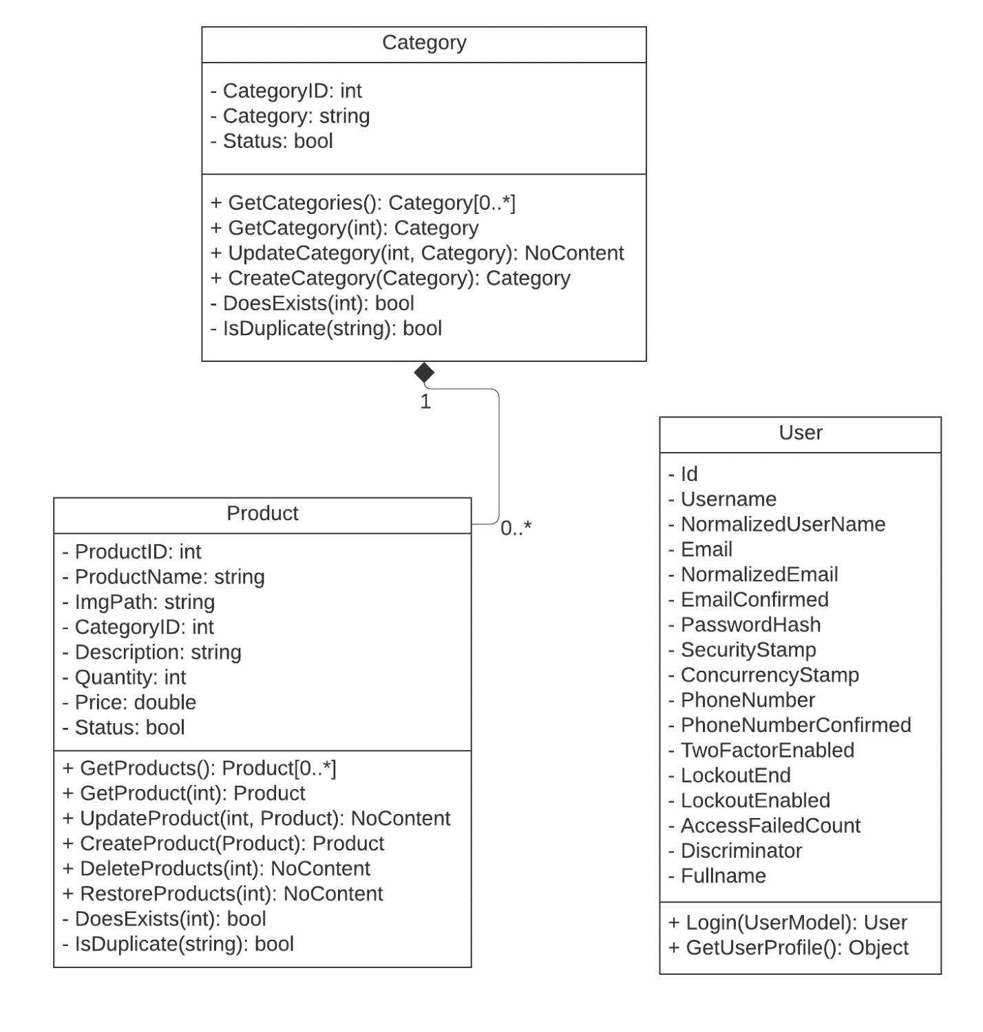

**Entity Relationship Diagram (ERD)**

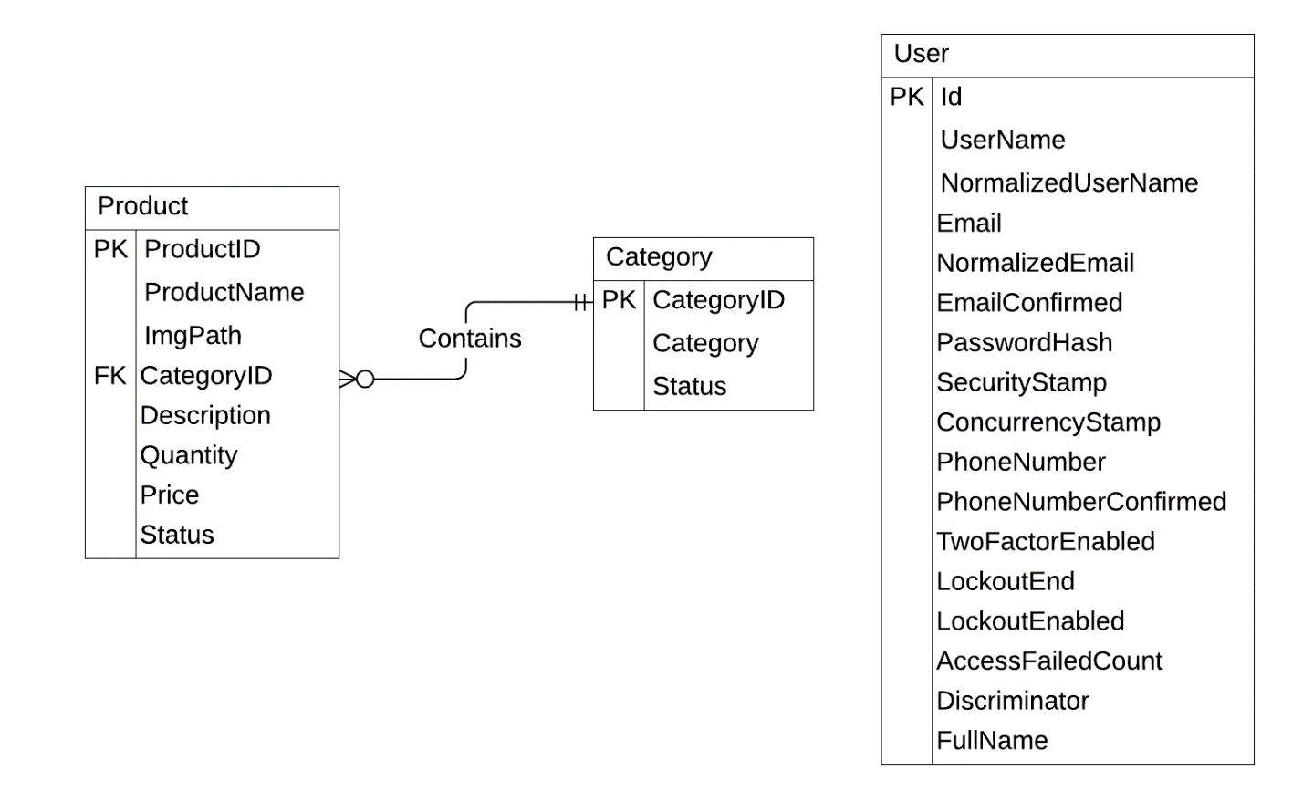

**Tables Design**

1. **User:**

|  |  |  |  |  |
| --- | --- | --- | --- | --- |
| **No.** | **Column Name** | **Data Type** | **Check** | **Description** |
| 1 | Id (PK) | nvarchar(450) | Not Null | User’s ID |
| 2 | UserName | nvarchar(256) | Not Null | User’s name |
| 3 | NormalizedUserName | nvarchar(256) |  | User’s normalized name |
| 4 | Email | nvarchar(256) | Not Null | User’s email |
| 5 | NormalizedEmail | nvarchar(256) |  | User’s normalized email |
| 6 | EmailConfirmed | bit |  | User’s confirmed email |
| 7 | PasswordHash | nvarchar(MAX) | Not Null | User’s hashed password |
| 8 | SecurityStamp | nvarchar(MAX) |  | User’s security stamp |
| 9 | ConcurrencyStamp | nvarchar(MAX) |  | User’s concurrency stamp |
| 10 | PhoneNumber | nvarchar(MAX) |  | User’s phone number |
| 11 | PhoneNumberConfirmed | bit |  | User’s confirmed phone number |
| 12 | TwoFactorEnabled | bit |  | User’s enabled two factor |
| 13 | LockoutEnd | datetimeoffset(7) |  | User’s lockout end time |
| 14 | LockoutEnabled | bit |  | User’s enabled lockout |
| 15 | AccessFailedCount | bit |  | User’s failed count access |
| 16 | Discriminator | nvarchar(MAX) |  | User’s discriminator |
| 17 | FullName | nvarchar(256) | Not Null | User’s fullname |

1. **Category:**

|  |  |  |  |  |
| --- | --- | --- | --- | --- |
| **No.** | **Column Name** | **Data Type** | **Check** | **Description** |
| 1 | CategoryID (PK) | int | Not Null | Category’s ID |
| 2 | Category | varchar(256) | Not Null | Category’s name |
| 3 | Status | bit | Not Null | Category’s status |

1. **Product:**

|  |  |  |  |  |
| --- | --- | --- | --- | --- |
| **No.** | **Column Name** | **Data Type** | **Check** | **Description** |
| 1 | ProductID (PK) | int | Not Null | Product’s ID |
| 2 | ProductName | varchar(256) | Not Null | Product’s name |
| 3 | ImgPath | varchar(256) |  | Product’s path of image |
| 4 | CategoryID (FK) | int | Not Null | Product’s id of category |
| 5 | Description | text | Not Null | Product’s description |
| 6 | Quantity | int | Not Null | Product’s quantity |
| 7 | Price | float | Not Null | Product’s price |
| 8 | Status | bit | Not Null | Product’s status |

**Tables Relationship Diagram**

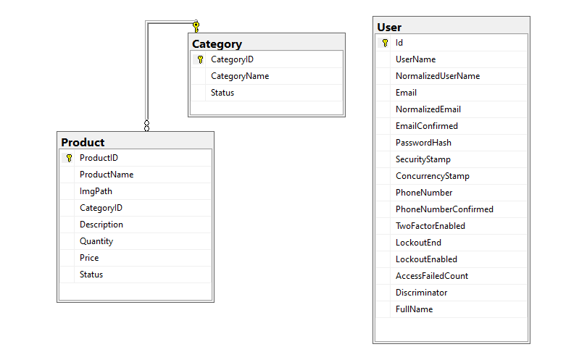

REVIEW 3

**Interface Design**

1. **Login Form:**

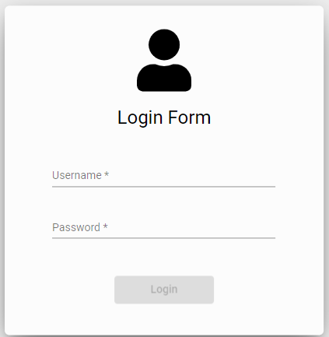

|  |  |  |  |  |  |
| --- | --- | --- | --- | --- | --- |
| **Name** | **Type** | **Event** | **Validation** | **Description** | **Status** |
| Username | Input (Text) | OnKeyup | String, not null | Input Admin’s username |  |
| Password | Input (Text) | OnKeyup | String, not null | Input Customer’s password |  |
| Login | Button | OnClick, OnKeyup |  | Login |  |

1. **Sidebar Menu:**

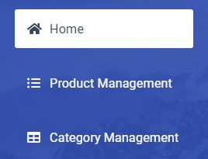

|  |  |  |  |  |  |
| --- | --- | --- | --- | --- | --- |
| **Name** | **Type** | **Event** | **Validation** | **Description** | **Status** |
| Home | Button | OnClick |  | Navigate to Home Page |  |
| Product Management | Button | OnClick |  | Navigate to Product Management Page |  |
| Category Management | Button | OnClick |  | Navigate to Category Management Page |  |

1. **Navbar Menu:**

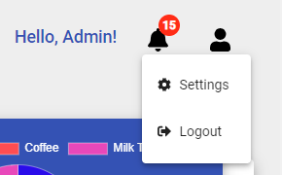

|  |  |  |  |  |  |
| --- | --- | --- | --- | --- | --- |
| **Name** | **Type** | **Event** | **Validation** | **Description** | **Status** |
| Welcome | Text |  |  | Welcome when admin login successfully |  |
| User Icon | Button | OnClick |  | Show account’s menu |  |
| Logout | Button | OnClick | Confirm | Logout |  |

1. **Statistical Data of Categories:**

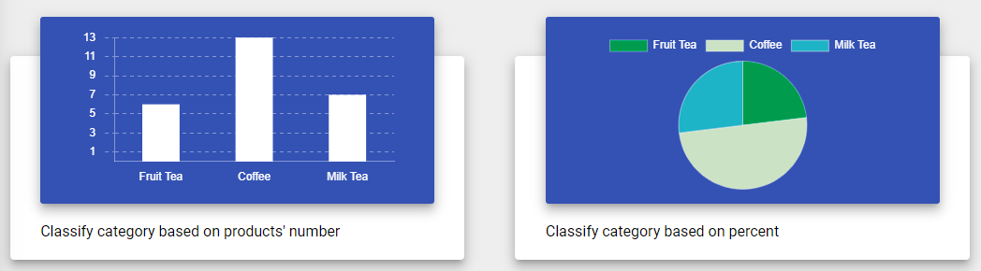

|  |  |  |  |  |  |
| --- | --- | --- | --- | --- | --- |
| **Name** | **Type** | **Event** | **Validation** | **Description** | **Status** |
| Chart | Canvas |  |  | Show categories’s statistical data |  |
| Label | Button | OnClick |  | Filter categories of pie chart |  |

1. **ProductsManagement Page’s Navbar:**



|  |  |  |  |  |  |
| --- | --- | --- | --- | --- | --- |
| **Name** | **Type** | **Event** | **Validation** | **Description** | **Status** |
| Add New Product | Button | OnClick |  | Navigate to product adding page |  |
| Search Box | Input (Text) | OnKeyup | String, not null | Filter products by name |  |

1. **Product Management Table’s Header:**

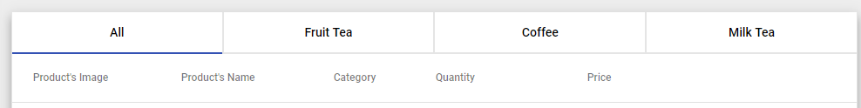

|  |  |  |  |  |  |
| --- | --- | --- | --- | --- | --- |
| **Name** | **Type** | **Event** | **Validation** | **Description** | **Status** |
| Categories’ Name | Button | OnClick |  | Filter products by categories |  |
| Columns’ Label | Text, Button | OnClick |  | Sort Products By Products’ Name, Quantity and Price |  |

1. **Product Management Table’s Rows:**

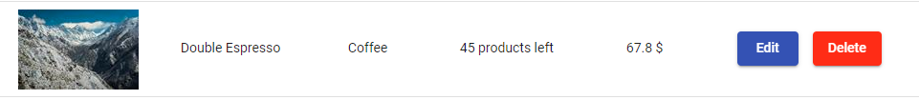

|  |  |  |  |  |  |
| --- | --- | --- | --- | --- | --- |
| **Name** | **Type** | **Event** | **Validation** | **Description** | **Status** |
| Image, Product’s Name, Category, Quantity, Price | Text |  |  | Information of products |  |
| Edit | Button | OnClick |  | Navigate to products’ editting page |  |
| Delete | Button | OnClick | Confirm | Delete specified product |  |

1. **Product Management Table’s Paging:**

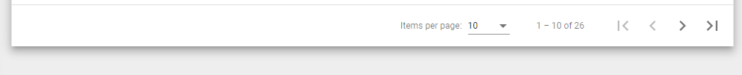

|  |  |  |  |  |  |
| --- | --- | --- | --- | --- | --- |
| **Name** | **Type** | **Event** | **Validation** | **Description** | **Status** |
| Products per page | Select | OnClick |  | Edit number of showed products per page |  |
| Next, Prev | Button | OnClick |  | Move to previous or next page |  |
| First, Last | Button | OnClick |  | Move to first page or last page |  |

1. **Category Management’s Header:**

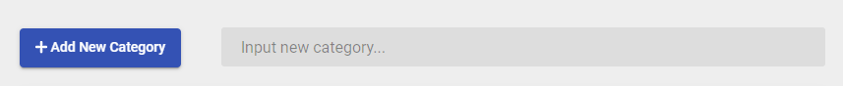

|  |  |  |  |  |  |
| --- | --- | --- | --- | --- | --- |
| **Name** | **Type** | **Event** | **Validation** | **Description** | **Status** |
| Add New Category | Button | OnClick |  | Show adding input box |  |
| Input New Category | Input (Text) | OnKeyup | String, not null | Add new category |  |

1. **Category List:**

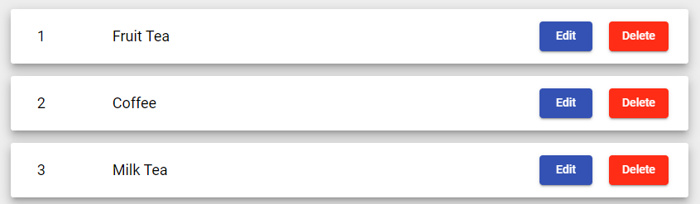

|  |  |  |  |  |  |
| --- | --- | --- | --- | --- | --- |
| **Name** | **Type** | **Event** | **Validation** | **Description** | **Status** |
| Category Name | Text |  |  | Show category’s name |  |
| Edit | Button | OnClick |  | Show edit box |  |
| Delete | Button | OnClick | Confirm | Delete specified category |  |

1. **Category’s Edit Box:**



|  |  |  |  |  |  |
| --- | --- | --- | --- | --- | --- |
| **Name** | **Type** | **Event** | **Validation** | **Description** | **Status** |
| Category Edit Box | Input (Text) | OnKeyUp | String, not null | Edit Category’s Name |  |
| Clear | Button | OnClick |  | Clear edit text box |  |

1. **Product’s Detail:**

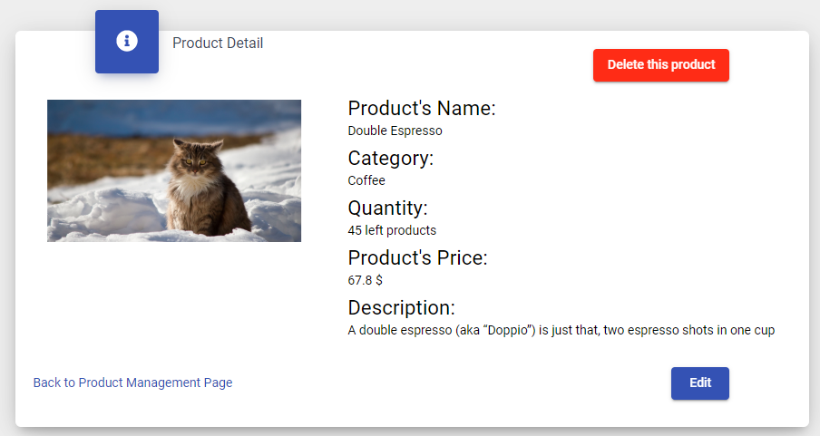

|  |  |  |  |  |  |
| --- | --- | --- | --- | --- | --- |
| **Name** | **Type** | **Event** | **Validation** | **Description** | **Status** |
| Product’s Name, Category, Quantity, Product’s Price, Description | Text |  |  | Information of product |  |
| Edit | Button | OnClick |  | Navigate to product editting page |  |
| Delete | Button | OnClick | Confirm | Delete product |  |
| Back to Product Management Page | Button | OnClick |  | Navigate to product management page |  |

1. **Product Adding Form:**

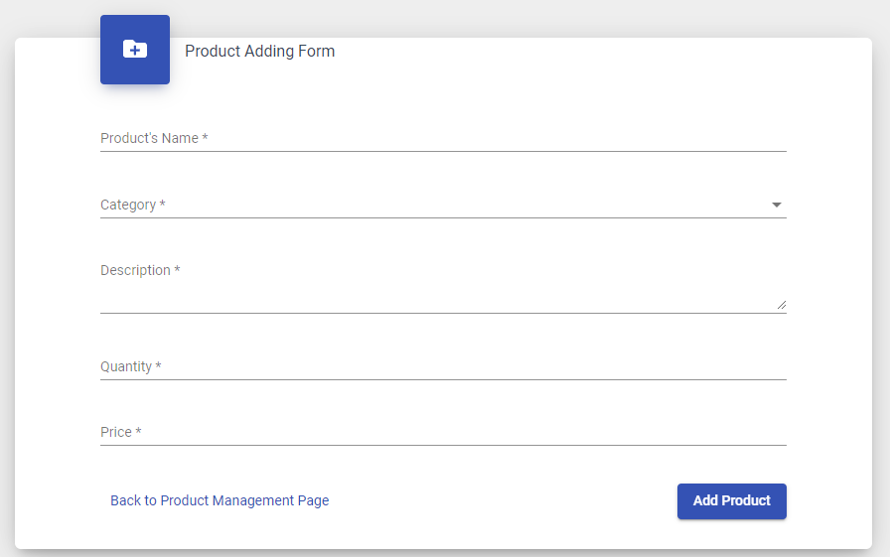

|  |  |  |  |  |  |
| --- | --- | --- | --- | --- | --- |
| **Name** | **Type** | **Event** | **Validation** | **Description** | **Status** |
| Product’s Name | Input (Text) | OnKeyup | String, not null | Input product’s name |  |
| Category | Select | OnClick | Not null | Select product’s category |  |
| Description | Textarea | OnKeyup | String, not null | Input product’s description |  |
| Quantity | Input (Text) | OnKeyup | String integer | Input product’s quantity |  |
| Price | Input (Text) | OnKeyup | String real number | Input product’s price |  |
| Add Product | Button | OnClick |  | Add product to products list |  |
| Back to Product Management Page | Button | OnClick |  | Navigate to product management page |  |

1. **Product Editting Form:**

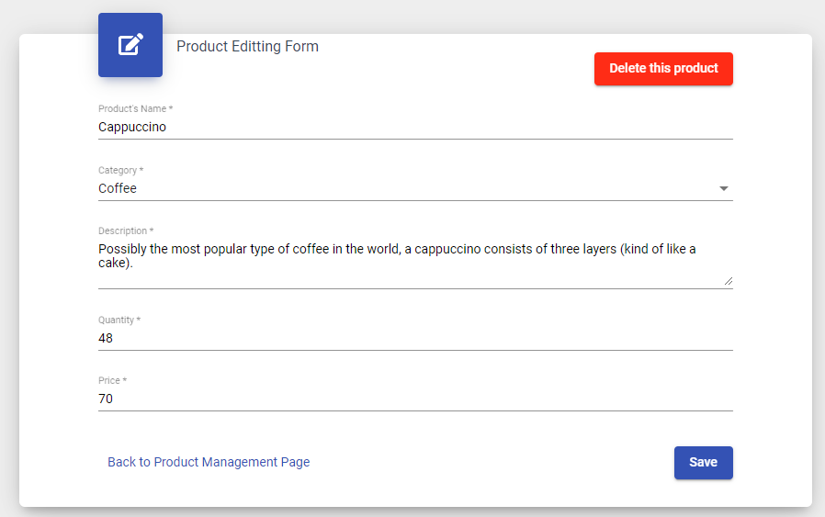

|  |  |  |  |  |  |
| --- | --- | --- | --- | --- | --- |
| **Name** | **Type** | **Event** | **Validation** | **Description** | **Status** |
| Product’s Name | Input (Text) | OnKeyup | String, not null | Input product’s name |  |
| Category | Select | OnClick | Not null | Select product’s category |  |
| Description | Textarea | OnKeyup | String, not null | Input product’s description |  |
| Quantity | Input (Text) | OnKeyup | String integer | Input product’s quantity |  |
| Price | Input (Text) | OnKeyup | String real number | Input product’s price |  |
| Save | Button | OnClick |  | Save product’s changes |  |
| Delete | Button | OnClick | Confirm | Delete Product |  |
| Back to Product Management Page | Button | OnClick |  | Navigate to product management page |  |