# Configurar Front End

## Fron End Laravel

Crear una nueva view (new file -> index.blade.php)

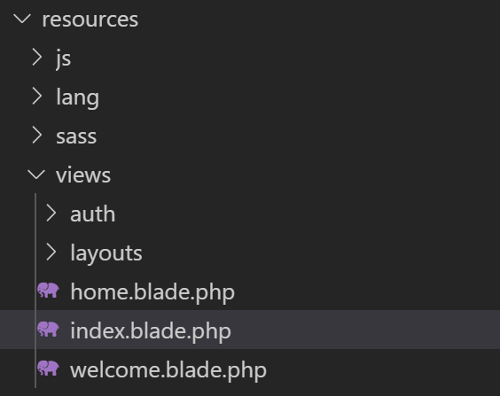

<!doctype html>

<html lang="{{ str_replace('_', '-', app()->getLocale()) }}">

<head>

    <meta charset="utf-8">

    <meta name="viewport" content="width=device-width, initial-scale=1">

    <!-- CSRF Token -->

    <meta name="csrf-token" content="{{ csrf_token() }}">

    <title>{{ config('app.name', 'Laravel') }}</title>

    <!-- Scripts -->

    <script src="{{ asset('js/app.js') }}" defer></script>

    <!-- Fonts -->

    <link rel="dns-prefetch" href="//fonts.gstatic.com">

    <link href="https://fonts.googleapis.com/css?family=Nunito" rel="stylesheet">

    <!-- Styles -->

    <link href="{{ asset('css/app.css') }}" rel="stylesheet">

</head>

<body>

    <div id="index">

    </div>

</body>

</html>

Ahora desde la carpeta routes -> web.php

<?php

use Illuminate\Support\Facades\Route;

/*

|--------------------------------------------------------------------------

| Web Routes

|--------------------------------------------------------------------------

|

| Here is where you can register web routes for your application. These

| routes are loaded by the RouteServiceProvider within a group which

| contains the "web" middleware group. Now create something great!

|

*/

Route::get('/', function () {

    return view('index');

});

## Fron end React

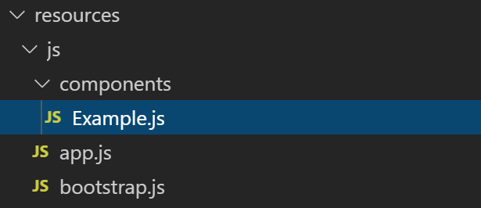

Se puede renombrar a Index.js

Cambiar también en app.js

require('./components/Index');

import React from 'react';

import ReactDOM from 'react-dom';

function Index() {

    return (

        <div className="container">

            <div className="row justify-content-center">

                <div className="col-md-8">

                    <div className="card">

                        <div className="card-header">Example Component</div>

                        <div className="card-body">I'm an example component!</div>

                    </div>

                </div>

            </div>

        </div>

    );

}

export default Index;

if (document.getElementById('index')) {

    ReactDOM.render(<Index />, document.getElementById('index'));

}