# React

<https://www.npmjs.com/package/axios>

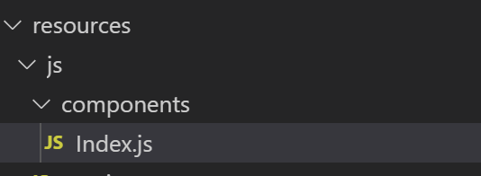

import React from 'react';

import ReactDOM from 'react-dom';

import Axios from 'axios';

function Index() {

    return (

        <div className="container">

            <div className="row justify-content-center">

                <div className="col-md-8">

                    <div className="card">

                        <div className="card-header">Index Component</div>

                        <div className="card-body">I'm an Index component!</div>

                    </div>

                </div>

            </div>

        </div>

    );

}

export default Index;

if (document.getElementById('index')) {

    ReactDOM.render(<Index />, document.getElementById('index'));

}

axios.get('api/products')

    .then((response) => {

        console.log(response.data)

    })

    .catch(function (error) {

        // handle error

        console.log(error);

      })

Devuelve los productos en <http://127.0.0.1:8000/> en la consola.

