Date: 26/09/2019

1. Write a program with Student as abstract class and create derive classes Engineering, Medical and Science from base class Student. Create the objects of the derived classes and process them and access them using array of pointer of type base class Student.

Date: 19/09/2019

1. Class polygon contains data member width and height and public method set_value() toassign values to width and height.
Class Rectangle and Triangle are inherited from polygon class. Both the classes contain public method calculate_area() to calculate the area of Rectangle and Triangle.
Use base class pointer to access the derived class object and show the area calculated.

2. Write a program to create a class shape with functions to find area of and display the name of the shape and other essential component of the class. Create derived classes circle, rectangle and trapezoid each having overridden functions area and display. Write a suitable program to illustrate virtual functions.

Date: 06/09/2019

1. Write a C++ program to implement the following level of inheritance and test your program accordingly.
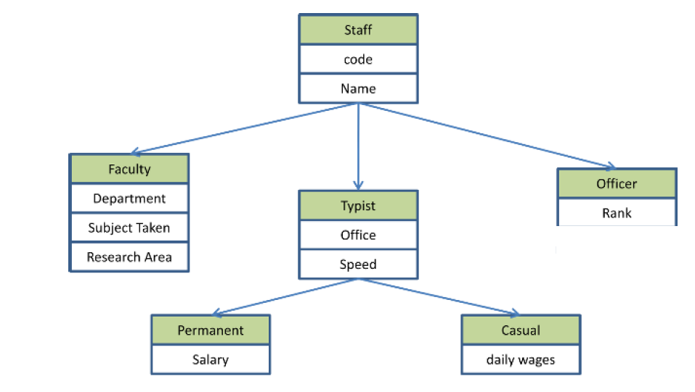

2. Write a C++ program to add, subtract and multiply two complex objects using friend function.
3. Write a program to find the maximum of two numbers using friend function.
Note :- Here one number is a member of one class and the other number is a member of the other class.

Date: 30/08/2019

………………….Result of a student is dependent on his/her examination mark and extracurricular marks. create four classes Student, Examination, Extracurricular, Result. The data members and member functions of different classes are given below.
Result Class
Data member:
total
Member Fn:
Cal_total()
comment()
//to calculate total marks and display comment whether the student have passed or not

Student Class
Data member:
Name
Roll No
Member Fn:
get_details()
display_details()
//to get and display Name and Roll No of a student

Extracurricular Class
Data member:
painting,, music
Member Fn:
get_score()
display_total()
//to get and display the total marks in painting and music

Examination Class
Data member:
test1,test2
Member Fn:
cal_average()
display_average()
//to calculate and display the average mark of a student

class Examination and Extracurricular are inherited from Student and Result is multiple inherited from Examination and Extracurricular. Write a C++ program to test the above problem.
2. Create two classes DM and DB which store the value of distances. DM stores distances in metres and centimeters and DB in feet and inches. Write a program that can read values for the class objects and one object of DM or DB.
Use a friend function to carry out the addition operation. The object that stores the results may be a DM object or DB object, depending on the units in which the results are required.
The display should be in the format of feet and inches or metres and centimeters depending on the object on display.

Date: 22/08/2019
- WAP in C++ to add two numbers using single inheritance. Accept these two numbers from the user in base class and display the sum of these two numbers in derived class.
- In a bank, different customers have savings account. Some customers may have taken a loan from the bank. So bank always maintains information about bank depositors and borrowers.
WAP in C++ to design a base class Customer (name, phone-number). Derive a class Depositor (accno, balance) from Customer. Again, derive a class Borrower (loan-no, loan-amt) from Depositor.
Write necessary member functions to read and display the details of ‘n’ customers.
- A University and a Company have jointly taken a project. Class University contains name of the university, department to which the project is assigned, person to whom the project is assigned. A function display is there to display the information. Class Company contains name of the company, Number of Engineers assigned, amount invested to do the project. A function display is there to display the information. Class Project is inherited from University and Company. It contains type of project, duration of project, amount granted to complete the project. A function display() displays the related information. Write a C++ program to implement this and display all information except amount invested by company from Project class.

Date: 09/08/2019
- WAP in C++ to overload ‘<’ operator to compare two Distance classes.
- WAP in C++ to overload ‘!’ operator to change the case of a given string.
…………………….3.WAP in C++to design a base class Person (name, address, phone_no). Derive a class Employee (eno, ename) from Person. Derive a class Manager (designation, department name, basic-salary) from Employee. Write a menu driven program to: a. Accept all details of 'n' managers.
b. Display manager having highest salary

Date: 31/07/2019

1. Write a program in c++ to overload + , - , * operator to addition , subtraction and multiplication of 2(two) complex objects created by user respectively.
2. WAP in C++ to overload ‘+’ operator to concatenate two strings.

Date: 25.07.2019
1. Create a class called time that has separate int member data for hours, minutes and seconds. One constructer should initialize it to 0, and another should it initialize it fixed values. A member function should display it in 11:59:59 format. The final member function should add two objects of type time passed as arguments.
A main () should create two initialized time objects and one that is not initialized. Then it should add two initialized values together, leaving the result in the third time variable. Finally it should display the value of this third variable.
2. Design a class Polar which describes a point using polar coordinates radius and angle . This requires first the conversion of points into rectangular co-ordinates , then adding the corresponding rectangular co-ordinates and finally converting the result back into polar co-ordinates .
You need to use the following trigonometric formulae:
x= r * cos(a);
y = r* sin (a);
a= atan(x/y); // arc tangent
r = sqrt(x * x + y * y);

