一、Activiti Designer 5.14.1插件安装

1)在eclipse中菜单help->Install New software中，点击add

[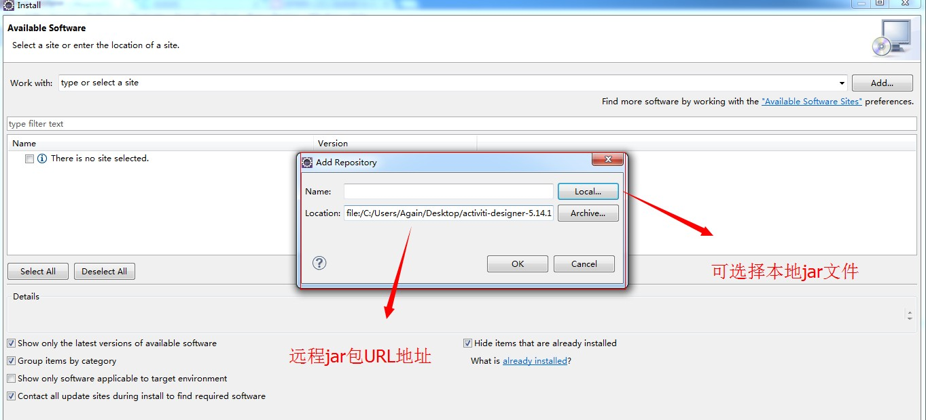](http://static.oschina.net/uploads/space/2014/0413/135936_1VLI_1032948.jpg)

a、可输入远程url地址安装http://www.activiti.org/designer/update（这里由于activiti访问很慢，下载基本下载不来，所以不推荐。）

b、可适用翻墙软件,翻墙访问<http://www.activiti.org/designer/archived/activiti-designer-5.14.1.zip>，下载Activiti Designer 5.14.1压缩包至本地，解压后，在由本地安装,安装方法可参照上图。由于是本地安装，拔掉网线或断开网络速度会有质的提升。

[**下载插件：Activiti Designer 5.15**](http://download.csdn.net/detail/yixiaoping/8520659)(已经下载好了，老师发给你门activiti-designer-5.15.0.zip)

2)安装过程中错误处理

a、错误：

Cannot complete the install because one or more required items could not be found.

  Software being installed: Activiti Eclipse BPMN 2.0 Designer 5.14.1 (org.activiti.designer.feature.feature.group 5.14.1)

  Missing requirement: Activiti Eclipse BPMN 2.0 Designer 5.14.1 (org.activiti.designer.feature.feature.group 5.14.1) requires 'org.eclipse.emf.transaction 1.4.0' but it could not be found

b、解决办法

但具体到本机环境有所不同，具体如下，以下是本机解决方案，如下：

org.eclipse.emf.validation.ui_1.7.0.201403111711.jar、

org.eclipse.emf.workspace_1.5.1.201306111400.jar、

org.eclipse.emf.validation_1.8.0.201403111711.jar

org.eclipse.emf.transaction_1.4.0.201306111400.jar；

上面四个jar包都在eclipse安装activiti需装eclipse插件20140410.zip里面，老师会发给你门

把这四个文件拷贝到自己的eclipse的plugin文件夹下面，重启eclipse再次安装activiti插件就可以了。